Week 6 — The Final Board Panel
Integrative Synthesis: Governance, Capital Markets, Activism, and ESG/AI Oversight
ADEX547 Specail Topics in Organisation and Strategy
Boğaziçi University — Executive MBA
Instructor: Hakan Göral
Compiled July 2026

Learning Objectives
Week 6 is the capstone of the course. It does not introduce a new domain; it forces the integration of five domains already studied — corporate strategy and portfolio logic, board governance, capital markets and disclosure law, shareholder activism, and ESG/AI oversight — into a single, defensible framework that a board member could actually use under pressure. By the end of this week, and in preparation for the Final Board Panel simulation, students should be able to:
- Construct and explain an integrative theoretical model — the Governance-Strategy Nexus — that shows how weaknesses in one governance domain compound into vulnerabilities in the next.
- Cite and apply, with precision, the seminal academic works introduced across Weeks 1-5 (Goold, Campbell & Alexander; Lang & Stulz; Berger & Ofek; Jensen; Barney; Jensen & Meckling; Fama & Jensen; Hambrick & Mason; La Porta et al.; Brav, Jiang, Partnoy & Thomas; Gantchev; Freeman; Friedman).
- Position Koç Holding, Sabancı Holding, and Turkish Airlines (THY) as an integrative comparative set spanning family-controlled diversified holding, transitioning-governance diversified holding, and state-controlled single-sector operating company.
- Summarize, and appropriately hedge, the specific 2026 data points that anchor the course's 'state of governance' narrative — AI board-oversight adoption, SPK enforcement activity, global shareholder-activism volume, and ESG execution risk.
- Perform a board role in the Final Board Panel simulation: adopt a specific board or executive perspective, defend a position under adversarial questioning, and reference the correct theory and evidence for that position.

Introduction
Across five weeks this course has moved through what looks, on a syllabus, like five separate topics: how a corporate parent should be structured (Week 1), how a board should be composed and monitored (Week 2), how capital markets discipline disclosure (Week 3), how activist investors intervene when discipline fails (Week 4), and how ESG and AI introduce a newer, less settled oversight domain (Week 5). Treated as five silos, each topic is learnable in isolation and, in fact, is regularly examined that way. But no board ever experiences these domains one at a time. A board that has let its portfolio drift into an unexplained diversification discount is, by the same token, usually a board whose monitoring function has gone slack; a board whose monitoring is slack is usually the same board whose disclosure practice draws regulatory attention; and a board under regulatory and activist pressure simultaneously is almost never the board that has already built a credible AI-oversight structure. These are not four unrelated risks. They are one risk, observed from four angles.
This coursepack builds that single risk into an explicit model — the Governance-Strategy Nexus — and then tests it against three real, currently reported Turkish holding companies: Koç Holding (KCHOL), Sabancı Holding (SAHOL), and Turkish Airlines (THYAO). The three cases are chosen because they triangulate the design space of the whole course: Koç is a family-controlled, dual-class, diversified industrial holding; Sabancı is a diversified holding that has just undergone the governance change (a first non-family chair and CEO) that activist theory predicts pressured holdings eventually make; and THY is a state-controlled, single-sector operating company for which the diversification-discount logic does not apply at all, but agency, disclosure, activism-adjacent, and ESG/AI questions apply in a structurally different way. Reading the three side by side is itself a lesson: governance risk does not have one shape. It has a shape conditioned by ownership structure, and the Final Board Panel simulation is designed to make students defend a specific position inside that structure, not a generic one.
The remainder of this document proceeds in six parts. Part I builds the integrative theoretical framework and lays out the Governance-Strategy Nexus model with a worked compounding-vulnerability table. Part II summarizes the state of corporate governance in 2026 as reported across the course, consolidating the AI-oversight, SPK-enforcement, activism-volume, and ESG-execution data points with appropriate sourcing hedges. Part III synthesizes the three Turkish holding-company cases into a single comparative table and narrative. Part IV builds the Final Board Panel case scenario itself — a hypothetical but realistic simultaneous crisis (activist approach, SPK disclosure inquiry, and an ESG/AI oversight gap arriving at once) together with a role-by-role table of concerns and key questions. Part V is the discussion-question set, framed explicitly as panel-preparation prompts. Part VI is the consolidated reference list, spanning the seminal academic literature cited across all five prior weeks and the primary/secondary sources underlying the Turkish case material.

Part I — The Integrative Theoretical Framework: The Governance-Strategy Nexus
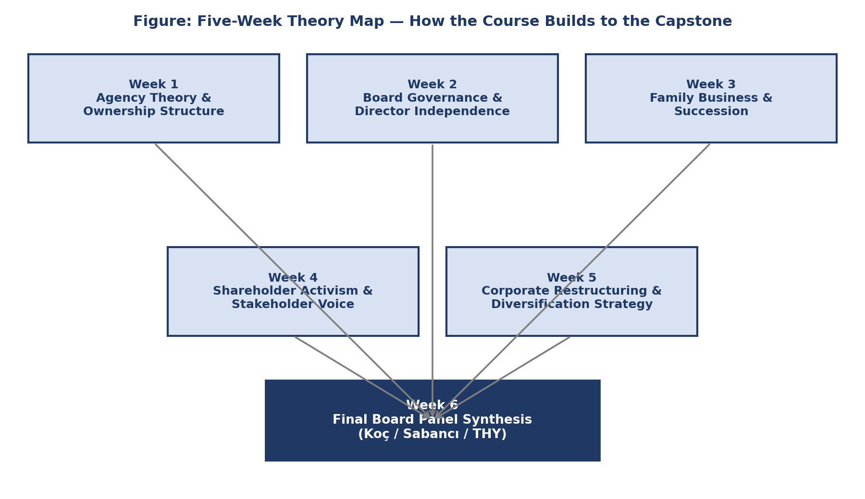
Figure 9. The Five-Week Theory Map: how Weeks 1-5 build toward the Week 6 Final Board Panel synthesis on Koç, Sabancı, and THY.

1.1 Why a single model, not five
Each of the five prior weeks gave us a lens for one piece of the puzzle. Goold, Campbell and Alexander showed when a parent company adds value versus when it just adds cost. Jensen, Meckling, and Fama and Jensen explained why firms with dispersed ownership need independent boards. La Porta and colleagues showed why legal protections for investors determine how deep a capital market can grow. Brav and colleagues, along with Gantchev, mapped when activists step in and what it costs them. And Freeman and Friedman framed the enduring debate over whose interests a board actually serves — a debate now extended to AI oversight. None of these lenses alone predicts a governance crisis. Put them together as a single chain, though, and they do.

1.2 The Nexus, stated as a chain
The Governance-Strategy Nexus proposes that governance failure typically propagates through five linked domains, each domain's weakness becoming the next domain's trigger condition: (1) a portfolio or parenting weakness (an unexplained diversification discount, per Lang & Stulz, 1994, and Berger & Ofek, 1995) is frequently the visible symptom of (2) an ownership and board weakness (agency slack per Jensen, 1986, and inadequate separation of decision management from decision control per Fama & Jensen, 1983), which in turn tends to coexist with (3) a capital-markets and disclosure weakness (a valuation gap the market cannot explain, and a disclosure record that draws regulatory scrutiny under a mandatory-disclosure regime such as Türkiye's Capital Markets Law No. 6362), which creates the precondition for (4) an activism event (the valuation gap plus governance weakness is exactly the signal Brav, Jiang, Partnoy and Thomas, 2008, identify as the profile of a value-creating activist target), which finally surfaces (5) an ESG/AI oversight gap as the newest, least-defended front — because a board that has been under-monitoring its portfolio and disclosure has, almost by construction, also under-built its newer oversight structures for AI and sustainability risk.
Domain | Weakness Indicator | Consequence | Linked Theory
Portfolio / Strategy | Diversified structure without demonstrable parenting advantage (Goold, Campbell & Alexander, 1994) | Conglomerate trades at a diversification discount (Lang & Stulz, 1994; Berger & Ofek, 1995) | Corporate parenting theory + RBV (Barney, 1991)
Ownership & Board | Concentrated family/state control with weak independent monitoring (Fama & Jensen, 1983) | Free cash flow entrenchment and agency slack (Jensen, 1986; Jensen & Meckling, 1976) | Agency theory; upper echelons (Hambrick & Mason, 1984)
Capital Markets / Disclosure | Discount persists unexplained to the market; disclosure lags or is contested by the regulator | Discount plus weak disclosure invite scrutiny under mandatory-disclosure regimes (SPK/KAP, Law No. 6362) | Law & finance theory (La Porta et al.); EMH/disclosure rationale
Activism | Visible valuation gap plus governance weakness signal an under-monitored target | Activist accumulates a stake and files an intervention thesis (SOTP break-up, board seats, buyback) | Brav, Jiang, Partnoy & Thomas (2008); Gantchev (2013) free-rider logic
ESG / AI Oversight | No board-level AI oversight committee; ESG treated as a compliance afterthought | Activist and regulator narratives converge — the governance gap becomes the headline risk, not a side issue | Freeman (1984) stakeholder theory vs. Friedman (1970) primacy; AI board-oversight adoption data
Table 1. The Governance-Strategy Nexus — how vulnerabilities compound across five linked domains.
The arrows in Table 1 are not deterministic — plenty of diversified, family-controlled holdings never attract an activist, and plenty of activist targets never face parallel disclosure inquiries. What the Nexus claims is weaker and more useful: that these five weaknesses are correlated in a specific, theorized direction, and that a board defending itself in a panel setting should expect a questioner to move down this chain, not stay in one box. If a director cannot explain the portfolio logic in Domain 1, the natural next question is about board composition (Domain 2); if board composition is weak, the natural next question is about the disclosure record (Domain 3); and so on. Treat Table 1 as the map of where a hostile questioner is likely to go next.

1.3 Master theory synthesis
Table 2 consolidates the ten-plus seminal works spanning the entire course into one reference table: the theory, its author(s) and year, the week in which it was introduced, and its one-sentence core claim. Use this table as the citation backbone for the Final Board Panel opening statement (see the Discussion Questions in Part V) — a credible panel performance cites at least three of these works correctly, by name and year, in the first two minutes.
Theory / Concept | Author(s), Year | Week Introduced | Core Claim
Corporate parenting theory | Goold, Campbell & Alexander (1994) | Week 1 | A parent adds value only when it possesses parenting advantage matched to a business's needs; mismatch destroys value ("parenting traps").
Diversification discount | Lang & Stulz (1994); Berger & Ofek (1995) | Week 1 | Diversified firms trade at a persistent valuation discount to comparable single-segment peers, evidencing cross-subsidy and capital misallocation.
Agency / free cash flow theory | Jensen (1986) | Week 1 | Managers holding surplus free cash flow are prone to value-destroying empire-building unless disciplined by debt, payout, or monitoring.
Table 2. Master theory synthesis across the course.

1.4 Reading the Nexus onto a real balance sheet
It is easy to accept the Nexus as an abstraction and harder to apply it to a specific company's numbers. Consider Domain 1 concretely. Lang and Stulz (1994) and Berger and Ofek (1995) measure the diversification discount by comparing a diversified firm's actual value (typically Tobin's q or an EV/EBITDA-style multiple) to the value implied by applying single-segment industry multiples to each of its segments and summing the result — the 'imputed' or sum-of-the-parts value. When the actual value falls persistently below the imputed value, the gap is the discount, and it is exactly the number an activist's investment thesis will foreground. Turkish BIST holding companies routinely exhibit this pattern: Koç Holding and Sabancı Holding both trade at valuations analysts describe as reflecting a holding-company discount versus the sum of their listed subsidiaries' market values (see Part III), even though neither company publishes an official 'NAV discount' figure — the gap has to be inferred from third-party analyst work, which is itself a Domain 3 disclosure-transparency observation worth raising in a panel discussion.
Domain 2 becomes concrete when a board's actual composition is checked against Fama and Jensen's (1983) independence logic. A board dominated by family or state appointees, with a thin outside-director bench and no genuinely independent audit or risk committee chair, cannot credibly claim the separation of 'decision management' (running the business) from 'decision control' (monitoring and ratifying major decisions) that Fama and Jensen argue is the load-bearing structure protecting ownership-diffuse capital. Both Koç Holding and Sabancı Holding retain significant family board presence even where day-to-day management has been professionalized; THY's board, following the April 2026 reshuffle, is populated by state-fund appointees rotating through chair and CEO roles. Each ownership structure raises a different version of the same Fama-Jensen question, which is precisely why the Final Board Panel scenario (Part IV) asks students to argue the question from inside a specific company's structure rather than in the abstract.

Part II — State of Corporate Governance 2026: An Integrative Summary
The four data points below recur across Weeks 2 through 5 as the empirical anchor for 'the state of governance in 2026.' They are collected here in one place, each with a trend read and a sourcing note, because a Final Board Panel performance is expected to invoke at least one of them accurately, with the correct hedge attached — citing a figure with false confidence is treated, in the panel rubric, the same as citing no figure at all.
Metric | 2025 Value | 2026 Value | Trend | Source / Note
Board-level AI oversight adoption | ~20-25% of large-company boards (2024 baseline) | ~35% of boards report a formal AI-oversight mechanism | Rising, but a majority of boards still lack a dedicated structure | Week 2/5 course synthesis of board-practice survey data; verify exact figure against original advisory-firm publication
AI board oversight committees | Isolated / ad hoc at most large-caps | Tripling in prevalence through 2025 into 2026 per governance-advisory tracking | Sharp acceleration from a low base | Week 5 ESG/AI governance synthesis; verify base and multiplier against original source
Shareholder activism volume (global) | Elevated post-2023 base; several dozen major campaigns per half-year | 84 campaigns tracked in H1 2026; Elliott Management the most active single manager; technology ~21% of targets by sector | Continued high activity, rising technology-sector concentration | Week 4 course synthesis of activism-tracking data; cross-check exact figures against primary tracker
SPK enforcement / market-abuse action | Routine periodic enforcement bulletins | 2026 crackdown: investigation reported across six provinces with 17 suspects tied to manipulation activity (e.g., SPK bulletin 2026/39, 17 June 2026); statements attributed to SPK Chairman İbrahim Gönül | Escalating enforcement intensity and public visibility of Turkish market-abuse cases | Week 3 course synthesis of SPK/KAP disclosures; verify exact suspect count and province figure against the specific SPK bulletin before citing in a graded submission
ESG program maturity | Broad-based commitment-setting phase (2021-24) | Described across the course as "execution under constraint" — targets set, delivery now contested by cost and political pushback | Shift from aspiration to accountability; slower net-new commitments, harder scrutiny of delivery | Week 5 ESG/AI governance synthesis
Table 3. State of Corporate Governance 2026 — consolidated summary.

2.1 Reading the four data points together
The four rows in Table 3 are not independent facts; they describe the same underlying phenomenon — an acceleration of governance formalization that most boards have not yet finished catching up to. AI board-oversight adoption near 35%, with formal committees reportedly tripling in prevalence, tells us that a critical mass of large companies has moved past ad hoc AI risk discussion into structured governance, but that a clear majority still has not. The SPK's 2026 enforcement activity — a reported investigation spanning six provinces and 17 suspects, alongside public statements attributed to SPK Chairman İbrahim Gönül — signals that Turkish market-abuse enforcement is intensifying in both scope and visibility, exactly the kind of regulatory environment in which a company with an unresolved Domain 1-2 weakness is most exposed. H1 2026 global activism data (84 campaigns, Elliott Management the most active manager, technology roughly 21% of targets by sector) shows that activist capital continues to seek out precisely the valuation-gap-plus-governance-weakness profile the Nexus describes, and is not slowing down. And the description of ESG programs as being in 'execution under constraint' — targets set in the 2021-2024 commitment wave, now facing cost and political pushback in delivery — means that the ESG dimension of Domain 5 is arguably the most exposed: promises made, delivery contested, and governance structure (an oversight committee, a named accountable executive) often still catching up.
A caution belongs here, repeated from the sourcing hedges embedded in the Turkish company dossiers used for Part III: several of these headline statistics (the 35% adoption figure, the tripling of AI oversight committees, the 84-campaign H1 2026 count, and the 17-suspect/six-province SPK figure) are course-level syntheses drawn from industry and regulatory reporting rather than figures independently re-verified against primary source documents inside this document's own compilation process. Students preparing for the Final Board Panel, and instructors grading it, should treat these as directionally reliable and pedagogically appropriate for panel discussion, but should verify the exact figure against the specific primary source (the named SPK bulletin, the named activism tracker, the named governance survey) before citing it in any written, graded submission that claims precision to the decimal.

Part III — Turkish Case Synthesis: Koç Holding, Sabancı Holding, and Turkish Airlines
The three companies below are used as the through-line integrative cases for the Final Board Panel. They are chosen deliberately to span the ownership-structure design space discussed in Part I: Koç Holding is the paradigmatic family-controlled, dual-class diversified holding; Sabancı Holding is a diversified holding that has just made the non-family governance transition that activist and agency theory predict eventually happens under sustained discount pressure; and Turkish Airlines is a state-controlled, single-sector operating company for which the diversification-discount logic in Domain 1 of the Nexus does not apply, but every other domain does, in a structurally distinct way.
Dimension | Koç Holding (KCHOL) | Sabancı Holding (SAHOL) | Turkish Airlines (THYAO)
Ownership structure | Koç family ~63.4% aggregate control via dual-class A/B shares (~55.6% of votes); free float ~26.9% | Sabancı family holding vehicles ~13.9% plus family members; free float ~53%, unusually high for a BIST holding | Türkiye Wealth Fund (TVF) ~49.1% controlling state stake; free float ~50.9%
Governance model | Professional CEO (Levent Çakıroğlu) under an active founding-family board; multi-segment holding across automotive, energy, finance, durables | Since March 2025, first non-family Chair & CEO (Hayri Çulhacı) — a governance inflection point; SBU structure across banking, energy, materials, digital | April 2026 sweeping reshuffle: new Chair (Murat Şeker, ex-CFO) and new CEO (Ahmet Olmuştur, ex-CCO) — typical of state/TVF-controlled rotation
Capital markets exposure | KCHOL plus six major listed subsidiaries (Tüpraş, Ford Otosan, Tofaş, Arçelik, Yapı Kredi, Aygaz); NAV discount analytically implied, not officially published | SAHOL plus 11 listed subsidiaries (~5% of BIST cap); implied NAV discount on the order of 50-55% versus ~USD 9.8bn NAV | Single-listing THYAO; the NAV/holding-discount concept does not apply — a pure operating company exposed directly to fuel, FX and geopolitical risk
Activism vulnerability | Moderate — high effective family voting control raises the bar for an outside activist, but the persistent conglomerate discount is a textbook activist thesis input | Elevated — recent governance change plus an active divestment program (Akçansa, CarrefourSA) signal a holding already responding to break-up/refocus pressure akin to Elliott-style theses | Lower classic activism risk given majority state ownership, but exposed to sovereign-governance and political-appointment risk instead
ESG / AI oversight posture | Carbon-neutral by 2050 target, interim SBTi milestones, CDP A rating; formal board-level AI oversight not yet confirmed (course-wide gap) | Net Zero 2050, 75% renewables by 2030 target, CDP A-List; strategy pivot ('Scaling with Purpose') foregrounds ESG-linked divestment logic | Carbon-neutral aviation 2050 pledge, SAF and fleet renewal focus; safety-critical AI use is mature, but formal board-level AI-governance committee status is unconfirmed
Table 4. Integrative three-holding comparison — Koç, Sabancı, and THY across the five Nexus domains.

3.1 Koç Holding — internal capital markets under family control
Koç Holding, celebrating its centennial in 2026, is Türkiye's largest industrial and services group, structured around automotive (Ford Otosan, Tofaş, Otokar, Türk Traktör; roughly 43% of combined revenue), energy (Tüpraş, Aygaz, Opet; roughly 23%), finance (Yapı Kredi Bank; roughly 19%), and consumer durables (Arçelik/Beko-Grundig; roughly 6%). Aggregate Koç family control is approximately 63.4%, exercised through a dual-class A/B share structure that concentrates roughly 55.6% of voting rights in the family holding vehicle, against a free float of approximately 26.9%. The Domain 1 question a panel should expect: does this portfolio still exhibit genuine 'parenting advantage' (Goold, Campbell & Alexander, 1994) across four structurally different industries — energy, automotive, finance, and consumer durables — or has scale itself become the justification, with the market's persistent, if unofficial, holding discount as the tell?

3.2 Sabancı Holding — the governance transition activism theory predicts
Sabancı Holding, organized around Strategic Business Units spanning banking and financial services (Akbank, Agesa, Aksigorta), energy and climate technologies (Enerjisa, Temsa), material technologies (Akçansa, Çimsa, Kordsa, Brisa), and digital technologies, made a governance change in March 2025 that deserves close attention in a Nexus reading: for the first time, a non-family executive (Hayri Çulhacı) became Chair and CEO. Read alongside an active divestment program — the Akçansa stake sale (~USD 1.1bn) and the CarrefourSA sale agreement — this looks like precisely the kind of portfolio-refocusing response that Brav, Jiang, Partnoy and Thomas (2008) associate with successful activist-adjacent interventions, whether or not a named activist fund is actually involved. The panel question this case invites: is Sabancı's governance and divestment shift a pre-emptive, board-led response to the Domain 1-3 pressures described in the Nexus, or a reactive one — and does the distinction matter to how the market prices the stock going forward?

3.3 Turkish Airlines — state control, single-sector exposure, and a different Nexus
Turkish Airlines, a single-sector operating company (not a holding company), is majority-controlled by the Türkiye Wealth Fund (TVF, ~49.1%), with the remainder in free float (~50.9%). THY posted record FY2025 results — 92.6 million passengers and roughly USD 24.1 billion in revenue — while undergoing an abrupt April 2026 leadership reshuffle that installed a new Chair (Murat Şeker, the former CFO) and a new CEO (Ahmet Olmuştur, the former Chief Commercial Officer), replacing long-serving CEO Bilal Ekşi and ousting former Chair Ahmet Bolat. Because THY has no diversification discount to speak of — Domain 1 of the Nexus does not translate cleanly — its governance risk runs through a different channel: state-appointee board rotation raises a distinct version of the Fama-Jensen (1983) independence question (is a state-fund appointee an independent monitor, or a different kind of principal's agent?), and its disclosure and activism exposure is shaped more by sovereign-governance and geopolitical risk than by a classic activist-fund thesis. This is the case to assign when the panel simulation wants to test whether students can apply the Nexus outside the diversified-holding template it was built around.
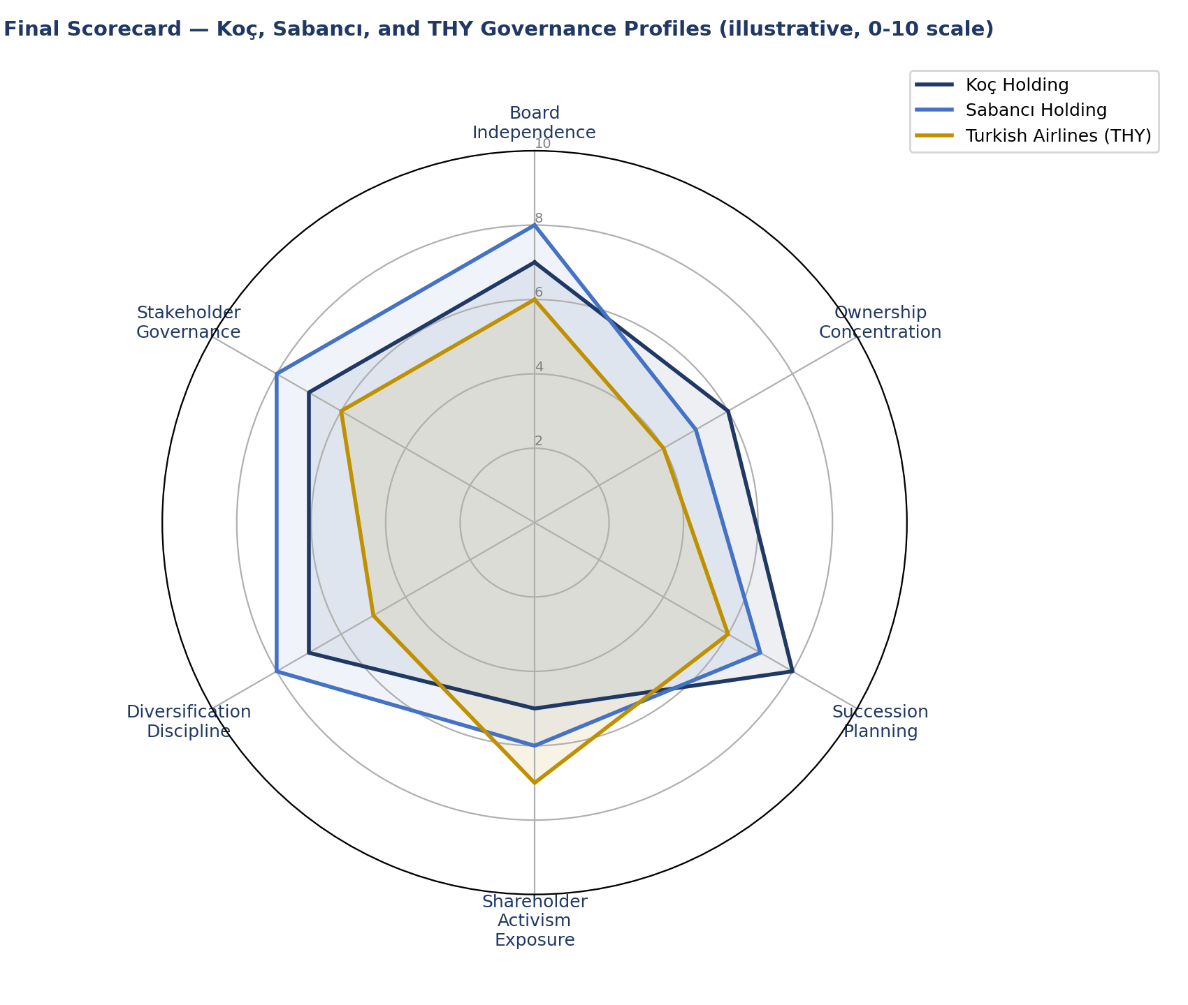
Figure 10. Final Scorecard — illustrative comparative governance profile for Koç Holding, Sabancı Holding, and Turkish Airlines (THY) across six dimensions, 0-10 scale.
Table: Final Scorecard Detail — Koç, Sabancı, and THY Compared
Scorecard Dimension | Koç Holding | Sabancı Holding | Turkish Airlines (THY)
Board independence | Moderate — family seats retained, independent directors added post-2020 | Higher — earlier move to majority-independent board | Lower — state and founding-family influence remain strong
Ownership concentration | High, multi-generational family control via holding structure | High, though ownership has diffused somewhat since 2020 | Moderate, split between Treasury/state entities and free float
Succession planning | Formalized family charter and staged handover | Formal but recently tested by a generational transition | Not applicable in the family sense; leadership is state-appointed
Shareholder activism exposure | Low — concentrated ownership deters outside activists | Moderate — minority shareholders more vocal since restructuring | Low-moderate — state ownership complicates conventional activism
Diversification discipline | Broad (autos, finance, energy, durables) with active portfolio pruning | Broad (finance, energy, retail) with periodic divestitures | Narrow — core aviation with limited unrelated diversification
Stakeholder governance | Strong — long-standing CSR and foundation infrastructure | Strong — sustainability reporting integrated into strategy | Improving — labor relations and safety governance are focal points

Part IV — Final Board Panel Case Scenario
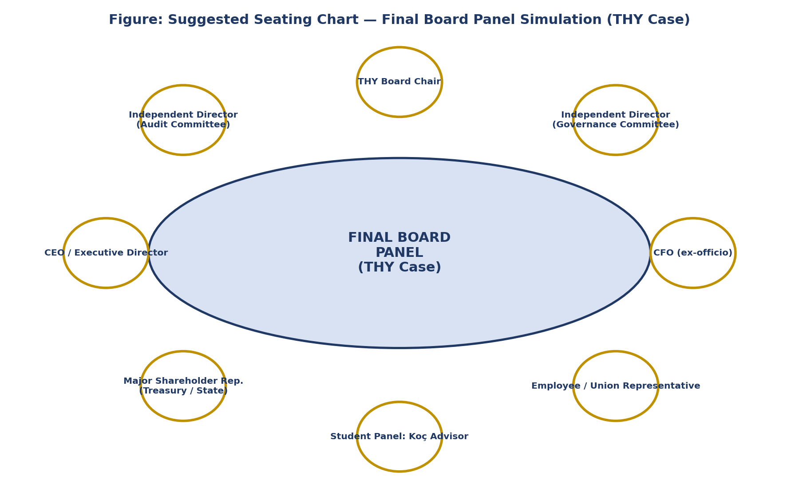
Figure 11. Suggested seating chart for the Final Board Panel simulation, organized around the THY case.

4.1 Scenario setup
The Final Board Panel simulation asks each student (or student team) to role-play a member of the board or executive team of one of the three integrative companies — Koç Holding, Sabancı Holding, or Turkish Airlines, as assigned or chosen — confronting a hypothetical but realistic integrative crisis in which three of the Nexus's five domains activate simultaneously:
- An activist investor (real or composite, modelled on the Elliott Management / Honeywell playbook studied in Week 4) has disclosed a stake and published a sum-of-the-parts thesis arguing that the company trades at an unjustified discount to its listed and unlisted assets, and is demanding board seats, a strategic review, or a specific divestment.
- Simultaneously, the SPK has opened a disclosure-timeliness inquiry (modelled on the pattern of 2026 SPK enforcement activity described in Part II) into whether a material development — plausibly connected to the very portfolio issue the activist is targeting — was disclosed to KAP on the timetable required under Capital Markets Law No. 6362.
- And an ESG/AI governance gap has become publicly visible — for instance, a journalist or a proxy advisory firm has noted that the company has no named board-level owner of AI risk, at a moment when board-level AI oversight adoption nationally and internationally is reported near 35% and rising.
The board must respond in a single emergency meeting, with each role below required to state a position and a key question before the meeting can close. The scenario is deliberately overloaded — three simultaneous fronts — because the pedagogical point of Week 6 is that in practice these fronts do not arrive politely, one at a time; they arrive together, exactly as the Nexus predicts, and a board that has prepared for only one of them will be exposed on the other two.

4.2 Role assignments and key questions
Role | Concern | Key Question to Raise
Board Chair | Balancing shareholder pressure against long-term strategic continuity while managing an abrupt leadership narrative | Do we defend the current portfolio and strategy, or use this crisis as cover to make the change activists are already asking for?
Independent / Lead Director | Whether existing board composition and committee structure (Fama & Jensen, 1983) can credibly claim independent monitoring | Can we show, with evidence, that our monitoring function was working before the activist arrived — or are we retrofitting independence under pressure?
CEO | Owning execution accountability for the operating and disclosure failures now in the spotlight | What operational and disclosure remediation can I commit to in this meeting that will be credible to both the regulator and the activist?
CFO / Head of Investor Relations | Defending the capital allocation logic and NAV/valuation story against an activist's sum-of-the-parts thesis | Does our own NAV math support or undercut the discount the activist is citing, and have we disclosed enough to defend it under Law No. 6362 / KAP?
General Counsel / Compliance Officer | Managing simultaneous SPK disclosure inquiry exposure and potential dual administrative/criminal liability | What is our exposure if today's board discussion itself becomes a disclosable material event, and when does the duty to disclose to KAP trigger?
Activist Investor Representative (role-played) | Presenting the intervention thesis — board seats, break-up, buyback, or divestment — grounded in the measured valuation gap | If the discount is real and persistent, why should the market trust this board to close it without external pressure and specific milestones?
ESG / AI Oversight Committee Chair (or designate) | Whether the absence or immaturity of a formal AI-oversight structure is itself a disclosable governance gap | Are we able to state, in writing, who on this board is accountable for AI risk, and if not, how fast can that structure exist?
Institutional / Minority Shareholder Representative | Whether free-float investors' interests are protected equally with the controlling shareholder's — the core La Porta et al. (1998) investor-protection question | Is this board's response protecting all shareholders equally, or triaging the controlling family or state interest first?
Table 5. Final Board Panel case-scenario role table.

4.3 Facilitation notes for the simulation
Instructors running the live panel should allocate roughly 5-7 minutes per role for an opening position statement, reserve at least 20 minutes for cross-examination (panelists and peer students questioning across roles, not only the instructor questioning each student), and close with a 10-minute unscripted 'what does this board decide today' vote, forcing the group to actually resolve the scenario rather than leave every position unreconciled. Students should be evaluated not on whether their assigned position 'wins,' but on whether they (a) correctly invoke the theory relevant to their role, (b) correctly and appropriately hedge any 2026 statistic they cite, and (c) can answer a cross-domain question — that is, a question that moves down the Nexus chain from their own domain into an adjacent one, exactly as Part I describes.

Part V — Discussion Questions (Panel-Preparation Prompts)
- 1. Using the Governance-Strategy Nexus framework, trace a plausible compounding-vulnerability pathway for Koç Holding, Sabancı Holding, or THY, from portfolio structure through to an activist or regulatory event. Which theory best explains the weakest link in the chain you have drawn?
- 2. Fama and Jensen (1983) argue that separating decision management from decision control is what allows ownership-diffuse firms to survive agency risk. Does this logic apply cleanly to a family-controlled or state-controlled BIST holding company, or does concentrated control change the analysis? Defend your answer with reference to at least two of the three integrative cases.
- 3. Brav, Jiang, Partnoy and Thomas (2008) find that activist targeting is associated with value creation, not extraction. If you were advising the board of a Turkish holding company approached by an activist in 2026, what evidence would you want in hand before agreeing to any of the activist's proposals?
- 4. La Porta, Lopez-de-Silanes, Shleifer and Vishny's law-and-finance research ties investor protection to legal origin. How does Türkiye's Capital Markets Law No. 6362 and KAP disclosure architecture affect the credibility of minority-shareholder protection at a dual-class, family-controlled holding company such as Koç Holding?
- 5. Friedman (1970) and Freeman (1984) represent two poles of the same debate. In the context of a 2026 board simultaneously facing an SPK disclosure inquiry and an ESG/AI oversight gap, which framing better protects the board from downside — and does the answer change with ownership structure (family, state, free-float)?
- 6. If AI board oversight structures are tripling in prevalence but only around 35% of boards report a functioning mechanism, what does the remaining majority expose a company to — under agency theory, under disclosure law, and under activist scrutiny? Build your answer as if presenting to the panel.
- 7. As a member of the Final Board Panel simulation, prepare a two-minute opening statement for your assigned role (see the role table) that cites at least three of the course's seminal theories and one 2026 Turkish data point.
- 8. Which of the three integrative cases (Koç, Sabancı, THY) is, in your assessment, most exposed to a simultaneous activism-plus-disclosure-plus-ESG/AI crisis in the next 12 months, and why? Use the master theory table to justify your ranking.

Part VI — References

Academic References
Akerlof, G. A. (1970). The market for 'lemons': Quality uncertainty and the market mechanism. Quarterly Journal of Economics, 84(3), 488-500.
Barney, J. (1991). Firm resources and sustained competitive advantage. Journal of Management, 17(1), 99-120.
Bebchuk, L. A., Brav, A., & Jiang, W. (2015). The long-term effects of hedge fund activism. Columbia Law Review, 115(5), 1085-1155.
Berger, P. G., & Ofek, E. (1995). Diversification's effect on firm value. Journal of Financial Economics, 37(1), 39-65.
Brandeis, L. D. (1914). Other People's Money and How the Bankers Use It. Frederick A. Stokes Company.
Brav, A., Jiang, W., Partnoy, F., & Thomas, R. (2008). Hedge fund activism, corporate governance, and firm performance. Journal of Finance, 63(4), 1729-1775.
Fama, E. F., & Jensen, M. C. (1983). Separation of ownership and control. Journal of Law and Economics, 26(2), 301-325.
Freeman, R. E. (1984). Strategic Management: A Stakeholder Approach. Pitman.
Friedman, M. (1970, September 13). The social responsibility of business is to increase its profits. The New York Times Magazine.
Gantchev, N. (2013). The costs of shareholder activism: Evidence from a sequential decision model. Journal of Financial Economics, 107(3), 610-631.
Goold, M., Campbell, A., & Alexander, M. (1994). Corporate-Level Strategy: Creating Value in the Multibusiness Company. Wiley.
Hambrick, D. C., & Mason, P. A. (1984). Upper echelons: The organization as a reflection of its top managers. Academy of Management Review, 9(2), 193-206.
Jensen, M. C. (1986). Agency costs of free cash flow, corporate finance, and takeovers. American Economic Review, 76(2), 323-329.
Jensen, M. C., & Meckling, W. H. (1976). Theory of the firm: Managerial behavior, agency costs and ownership structure. Journal of Financial Economics, 3(4), 305-360.
Khan, M., Serafeim, G., & Yoon, A. (2016). Corporate sustainability: First evidence on materiality. The Accounting Review, 91(6), 1697-1724.
Lang, L. H. P., & Stulz, R. M. (1994). Tobin's q, corporate diversification, and firm performance. Journal of Political Economy, 102(6), 1248-1280.
La Porta, R., Lopez-de-Silanes, F., Shleifer, A., & Vishny, R. W. (1998). Law and finance. Journal of Political Economy, 106(6), 1113-1155.
La Porta, R., Lopez-de-Silanes, F., Shleifer, A., & Vishny, R. W. (2000). Investor protection and corporate governance. Journal of Financial Economics, 58(1-2), 3-27.

Web and Regulatory Sources
Koç Holding Investor Relations — Stock Information & Investor Tools. https://www.koc.com.tr/investor-relations/stock-information-investor-tools
Koç Holding Investor Relations — About Koç Holding (ownership structure). https://www.koc.com.tr/investor-relations/about-koc-holding
Sabancı Holding Investor Relations — Shareholder Structure. https://yatirimciiliskileri.sabanci.com/en/about-sabanci-holding/detail/Shareholder-Structure/127/424/0
Sabancı Holding Integrated Annual Report 2025 — Performance and Future Outlook by SBU. https://yatirimciiliskileri.sabanci.com/en/Annual-Report-2025/2025-performance-and-future-outlook.aspx
Turkish Airlines Investor Relations — Fleet and Share Details. https://investor.turkishairlines.com/en/financial-and-operational/fleet
Bloomberg (2026, April 10). Turkish Airlines replaces management, names new CEO and chairman. https://www.bloomberg.com/news/articles/2026-04-10/turkish-airlines-replaces-management-names-new-ceo-and-chairman
Daily Sabah. Turkish Airlines flew record 92.6 million passengers in 2025. https://www.dailysabah.com/business/transportation/turkish-airlines-flew-record-926-million-passengers-in-2025
Capital Markets Board of Türkiye (SPK) — Weekly bulletins (e.g., Bulletin 2026/39, 17 June 2026). www.spk.gov.tr
Public Disclosure Platform (KAP). www.kap.org.tr
companiesmarketcap.com — Koç Holding, Sabancı Holding, and Turkish Airlines market capitalization pages, accessed July 2026.
AInvest (2026). Koç Holding 2025 results: Assessing capital allocation, sector rotation, portfolio construction. https://www.ainvest.com/news/ko-holding-2025-results-assessing-capital-allocation-sector-rotation-portfolio-construction-2602/
Part VII — Integrative Theoretical Framework: Mapping Five Weeks Into One Oversight System
7.1 Purpose and scope of the integrative chapter
Parts I through VI of this coursepack already introduced the Governance-Strategy Nexus and applied it to Koç Holding, Sabancı Holding, and Turkish Airlines. This Part goes one level deeper. Where Part I stated the Nexus as a five-domain chain, Part VII systematically works through every major theoretical construct introduced across Weeks 1 through 5, shows the specific mechanism by which each construct feeds the next, and builds a second, more granular reference instrument — the Cross-Week Theory Interlock Matrix (Table 6) — that a student can use as a citation index while preparing for the Final Board Panel. The guiding claim of this chapter is simple to state and hard to internalize under exam or panel pressure: agency theory is not a Week 2 topic that happens to recur; it is the load-bearing structural assumption underneath every other week’s material, and a student who can show that explicitly will out-perform a student who treats the five weeks as five separate reading lists.
7.2 Agency theory as the common substrate
Jensen and Meckling's classic insight — that separating ownership from control creates monitoring costs, bonding costs, and residual loss — is usually taught as pure Week 2 material. But look again at Week 1's diversification-discount evidence. Lang and Stulz and Berger and Ofek didn't just observe that diversified firms trade at a discount; they read that discount as the fingerprint of an agency problem working through the firm's internal capital market. When a conglomerate's head office shifts cash from a strong division into a pet project in a weak one, that is exactly the free-cash-flow problem Jensen described: managers with discretion over surplus cash, left undisciplined, tend to build empires and prop up underperformers rather than return cash to shareholders. So the diversification discount isn't a separate Week 1 topic sitting next to Week 2's agency theory — it is agency theory made visible in the stock price.
The same logic shows up again in Week 4. Brav, Jiang, Partnoy and Thomas describe hedge fund activism as, in effect, a private fix for a public agency problem: when a board's own monitoring fails to rein in wasted cash or a bad diversification bet, an outside activist steps into the oversight role the board should have played — and gets paid for it through the value the campaign unlocks. Gantchev adds an important caveat: this monitoring isn't free. Campaigns are costly to run, and because the resulting gains flow to every shareholder while the activist alone bears the cost of the fight, the market likely produces less activist monitoring than would be socially ideal. Read together, Weeks 1, 2, and 4 tell one story in three acts: agency costs create a discount (Week 1), boards are supposed to catch this but often don't (Week 2), and when boards fail, activists step in as an imperfect but genuinely value-creating backstop (Week 4).
7.3 Disclosure regulation as the information layer that makes market discipline possible
None of this works without Week 3's disclosure infrastructure. Agency theory assumes a market exists that can price misallocation into the stock. Fama and Jensen assume outside directors and shareholders can see enough to exercise real oversight. And the activists in Brav, Jiang, Partnoy and Thomas's study can't build a credible break-up-value case without segment-level financial disclosure to work from. All three depend on a disclosure regime strong enough to close the information gap between insiders and outside investors — the same logic Akerlof captured with his “lemons” problem in used-car markets: without credible signals, a market drifts toward only the worst-quality goods being traded. La Porta and colleagues extended this internationally, showing that a country's legal tradition and investor-protection rules predict how much ownership stays concentrated, and how deep and liquid its equity markets become.
The applied version of this argument, worked through in Week 3 using Türkiye’s Capital Markets Law No. 6362 and the KAP (Public Disclosure Platform) architecture, is that mandatory, simultaneous disclosure is the precondition for every other week’s mechanism to operate. An activist cannot build a credible discount thesis (Week 4) without believable segment data; a board cannot be judged on its monitoring performance (Week 2) without disclosure of the decisions it did and did not make; and even the diversification-discount literature itself (Week 1) is only measurable because disclosure rules require the segment reporting Berger and Ofek (1995) rely on. Disclosure law is therefore not a fourth silo alongside strategy, governance, and activism; it is the epistemic infrastructure that makes strategy, governance, and activism observable and contestable at all.
7.4 ESG and AI oversight as the newest audit-committee-like function
Week 5 extended the governance apparatus into a domain — ESG and AI risk — that did not exist in a formal board-committee sense a decade ago. The integrative claim to draw out here is that AI and ESG oversight are not a new species of governance problem; they are the audit committee model re-applied to a new risk category. The audit committee exists because financial reporting risk is technical, continuous, and too specialized for the full board to monitor directly; it therefore delegates monitoring to a subset of directors with relevant expertise, supported by external assurance (the external auditor), reporting on a fixed cadence, with escalation triggers defined in charter. AI oversight committees, where they exist, replicate this exact structure: a subset of directors (ideally with technical fluency) monitor model risk, bias, safety incidents, and regulatory exposure, supported by external or internal assurance functions, reporting on a cadence, with defined escalation triggers. The reported acceleration of AI oversight committee formation — from an ad hoc, isolated practice toward the roughly 35% adoption figure discussed in Part II, with committees reportedly tripling in prevalence through 2025 into 2026 — is best read as a lagged institutional mimicry of the audit-committee template applied to a newer, less mature risk category, exactly as the audit committee model itself diffused across corporate boards through the 1970s-1990s following major financial reporting failures.
Freeman’s (1984) stakeholder theory and Friedman’s (1970) shareholder-primacy position, introduced in Week 5 as the normative frame for ESG obligations, resurface here as the underlying dispute about why an AI oversight committee should exist at all. A Friedman-style board treats AI oversight instrumentally: the committee exists because AI-related harm (a biased hiring algorithm, a safety failure, a regulatory fine) is a foreseeable cost to shareholders, and prudent risk management — not stakeholder obligation — justifies the structure. A Freeman-style board treats AI oversight as intrinsically obligatory: the company owes a duty of care to employees, customers, and communities affected by its AI systems independent of whether harm to them ever converts into a cost borne by shareholders. Both framings can justify an identical committee charter; they diverge sharply, however, on how the committee should weigh a decision where shareholder cost and stakeholder harm point in different directions — precisely the scenario built into the Great Debates section below (Part VIII) and into the Final Board Panel simulation’s ESG/AI oversight role (Part IV, extended in Part X).
7.5 The Cross-Week Theory Interlock Matrix
Table 6 below extends Table 2 (the master theory synthesis) by adding, for each theory, the specific mechanism by which it interlocks with the theory or theories from adjacent weeks, and a worked micro-example a student can reuse verbatim in panel preparation.
Table 6. Cross-Week Theory Interlock Matrix — mechanisms connecting theories across the five prior weeks.
7.6 The Nexus as a diagnostic instrument, not a prediction machine
A recurring student error, worth flagging explicitly before the Final Board Panel, is treating the Nexus (Table 1) or the Interlock Matrix (Table 6) as a prediction machine that tells you which company will be the next activist target or the next disclosure-enforcement case. Neither table makes that claim, and a panel performance that treats it that way will lose credibility with a well-prepared cross-examiner. What the tables are is a diagnostic checklist: given a company already under some form of pressure (an activist approach, a regulatory inquiry, a governance embarrassment), the tables tell you where to look next for a compounding weakness, and what theoretical vocabulary to use once you find it. Used this way, in the sequence portfolio logic, then board composition, then disclosure record, then activism exposure, then ESG/AI oversight maturity, the Nexus turns a sprawling, multi-domain crisis into a structured, five-step diagnostic a board (or a student, in a panel) can walk through methodically rather than reactively.
7.7 A worked integrative case: applying the full framework to a hypothetical mid-cap conglomerate
To pull the chapter together, imagine a hypothetical mid-cap conglomerate — call it “Meridian Group” — used purely as a teaching device. Meridian runs four unrelated segments: specialty chemicals, commercial real estate, logistics, and a small fintech unit bought opportunistically five years ago. Sixty percent of its board has served more than fifteen years, and no director has a technology or AI background. Its stock trades at roughly a 30% discount to what its segments would be worth apart. It discloses segment revenue but not segment margin, citing competitive sensitivity. No activist has approached it yet, and no regulator has opened an inquiry. Run Meridian through the Nexus: Domain 1 (portfolio) shows a textbook diversification discount with no obvious parenting logic tying fintech to chemicals or real estate. Domain 2 (board) shows a long-tenured, homogeneous board — exactly the profile associated with strategic inertia and weak independence. Domain 3 (disclosure) shows a practice that narrows precisely the information an outside investor would need to build a break-up case. Domain 4 (activism) hasn't activated yet, but the profile — discount, weak board, thin disclosure — is exactly what research shows attracts activist attention. Domain 5 (ESG/AI) shows no technically fluent director, and likely no mature AI oversight, even though the fintech unit almost certainly runs automated underwriting or fraud models that carry real governance risk. A board looking at this composite case should conclude Meridian isn't in crisis yet, but is fully primed for one — and that the right move is to address Domains 1, 2, 3 and 5 proactively, so that Domain 4 never has to activate. That is the single most transferable lesson of this framework: it is most useful before an activist shows up, not after.
Part VIII — Great Debates in Corporate Governance
8.1 Introduction to the debate format
The five debates in this Part are structured identically: a statement of the position, the strongest form of the pro case, the strongest form of the con case, the empirical evidence bearing on each side, and a synthesis note explaining when one position tends to dominate the other. The purpose is not to declare a winner — these are, in every case, live debates among practitioners and scholars in 2026 — but to equip a Final Board Panel participant to argue either side competently and to recognize which side a given fact pattern favors.
8.2 Debate One: Shareholder Primacy (Friedman) versus Stakeholder Theory (Freeman)
The Position. Friedman (1970) holds that the social responsibility of a corporate executive is to conduct the business in accordance with shareholders’ desires, which generally means making as much money as possible while conforming to the basic rules of society, both those embodied in law and those embodied in ethical custom. Freeman (1984) holds that a firm’s long-run value depends on managing the interests of the full constellation of stakeholders — employees, customers, suppliers, communities, and shareholders together — because durable value creation is impossible if any one of these groups is systematically exploited to benefit another.
The Pro-Friedman Case. Friedman’s argument is not, as it is frequently caricatured, a license for corporate irresponsibility; it is a separation-of-powers argument. Executives are agents of shareholders, not independently elected representatives of society, and using shareholder capital to pursue an executive’s personal conception of the social good is a form of taxation without representation — spending someone else’s money on a cause they did not choose to fund. If society wants corporations to pursue particular social ends, the correct mechanism is democratically enacted law and regulation (which sets the “rules of the game” within which profit-seeking occurs), not the discretionary judgment of unelected executives. A shareholder-primacy regime, on this view, actually protects pluralism: it lets each shareholder decide independently, with the returns the company generates, which causes to support with their own money, rather than having that choice made for them.
The Pro-Freeman Case. The stakeholder counter-argument is that the separation Friedman assumes — law sets the rules, executives just play within them — badly understates how much law lags behind real corporate risk, and how much value genuinely depends on relationships law does not fully govern: employee trust and discretionary effort, customer loyalty built on more than price, supplier relationships resilient to shocks, and a social license to operate that communities can revoke long before a regulator acts. Freeman’s argument is ultimately an instrumental one as much as a normative one: firms that treat stakeholders as means to shareholder ends, rather than ends themselves, tend to under-invest in exactly the relational capital that produces durable competitive advantage, and are more exposed to reputational, regulatory, and talent-retention risk precisely because they optimized for a narrower objective than the one that actually predicts long-run value.
Evidence and Synthesis. Neither position has been decisively falsified by the evidence, in part because “stakeholder value” is harder to measure than shareholder return, which biases the empirical literature toward Friedman’s preferred metric. What the evidence does show, robustly, is that severe stakeholder mistreatment (systemic customer fraud, catastrophic safety failures, large-scale environmental harm) reliably destroys shareholder value eventually, even when it appeared profit-maximizing in the near term — the Wells Fargo, Boeing, and BP cases in the Global Case Gallery (Part IX) below are worked examples. The debate in practice, then, is less “shareholders versus stakeholders” and more a disagreement about time horizon and about how much discretion a board should have to act on stakeholder concerns before those concerns show up as a quantifiable shareholder cost. A useful heuristic for panel purposes: invoke Friedman when defending a board’s right to make a hard capital-allocation choice against a stakeholder objection where no law is violated; invoke Freeman when arguing that a board ignored a foreseeable stakeholder harm that a reasonably prudent board should have treated as material risk, law or no law.
8.3 Debate Two: Diversification Value-Creation versus the Conglomerate Discount
The Position. One school holds that a well-run diversified firm creates value through an efficient internal capital market, shared capabilities, and risk diversification that lowers the cost of capital; the opposing school, anchored in Lang and Stulz (1994) and Berger and Ofek (1995), holds that diversified firms trade at a persistent discount to comparable single-segment peers because diversification more often destroys value than creates it, through cross-subsidization, weakened managerial accountability, and empire-building.
The Pro-Diversification Case. Firms like Berkshire Hathaway and, in an earlier era, General Electric under Jack Welch, are held up as evidence that a sufficiently disciplined parent can allocate capital across unrelated businesses better than external capital markets would, particularly in economies or eras where external capital markets are underdeveloped, credit-constrained, or prone to short-termist mispricing. Diversification can also reduce a firm’s cash-flow volatility, lowering its cost of debt and enabling investment through cycles that a single-segment peer, forced to rely on external financing at the trough of its own sector’s cycle, cannot make.
The Pro-Discount Case. The empirical diversification-discount literature is unusually consistent across time periods and countries: diversified firms trade at a discount that survives numerous robustness checks for industry composition, size, and measurement method. The mechanism, per Jensen (1986), is that a conglomerate’s central office, flush with cash from a mature “cash cow” segment, faces weaker external discipline than a single-segment firm would in raising external capital for a new investment, and this weaker discipline predictably produces overinvestment in low-return divisions and underinvestment in high-return ones relative to what an efficient internal capital market would do. The reputational and governance evidence (Fama & Jensen, 1983) further suggests that diversified conglomerates’ boards struggle to monitor multiple, dissimilar businesses with the same rigor a single-segment board can bring to one.
Evidence and Synthesis. The discount is real, well-documented, and the default empirical expectation; the question is not whether it exists on average but whether a specific company is an exception, and exceptions do exist. Berkshire Hathaway is the standard counter-example, and it is worth being precise about why: Berkshire’s model relies on an unusually long-tenured, highly credible capital allocator (Warren Buffett, with Charlie Munger) operating with minimal central-office overhead, granting operating subsidiaries substantial autonomy, and explicitly avoiding the empire-building incentive Jensen (1986) describes because Buffett’s own compensation and reputation are tied to per-share intrinsic value growth, not to the size of the empire. The lesson for panel purposes: the discount is the base rate; overcoming it requires a specific, demonstrable parenting advantage (Goold, Campbell & Alexander, 1994) — capital allocation skill, genuinely shared capabilities, or a disciplined capital allocator with the right incentives — and the burden of proof sits with the diversified firm’s board to show that advantage exists, not with the market to prove it does not.
8.4 Debate Three: Activism as Short-Termist Raiding versus Activism as Monitor of Last Resort
The Position. Critics describe activist hedge funds as short-termist raiders who extract value through financial engineering (leverage, buybacks, asset sales) at the expense of a company’s long-run competitive position, R&D investment, and workforce; defenders describe the same funds as a necessary monitor of last resort, stepping in precisely where boards have failed to discipline free cash flow misallocation or a persistent conglomerate discount.
The Critical Case. The short-termism critique holds that activist campaigns frequently pressure management into cutting R&D, capital expenditure, and workforce investment to hit near-term earnings or cash-return targets that boost the stock price long enough for the activist to exit profitably, leaving the company structurally weaker once the activist has sold its stake. This critique gained particular force following a wave of 2010s-era campaigns targeting industrial and technology companies for buybacks at moments when, critics argued, reinvestment in innovation would have served long-run shareholders better.
The defense case rests on two studies. Brav, Jiang, Partnoy and Thomas's original research, and Bebchuk, Brav and Jiang's later follow-up testing specifically for long-term effects, both find that activist campaigns are followed by improved long-run operating performance — not just a short-term price pop that later fades. That directly contradicts the raiding narrative's central prediction. Gantchev's finding reinforces the point from another angle: because activism is costly to the activist and its gains are shared by everyone, a story where activists loot the company at long-term shareholders' expense is hard to square with the fact that activists usually stay invested through the value-creation period and take real risk if the thesis fails.
Evidence and Synthesis. The empirical balance of evidence, at least through Bebchuk, Brav and Jiang (2015), favors the monitor-of-last-resort view over the raiding view as a general matter, but the debate is not fully closed, and specific campaigns vary widely in character. A useful distinction for panel purposes is between activists pursuing an operational or strategic thesis (portfolio refocusing, capital allocation discipline, board refreshment — the profile of Engine No. 1’s ExxonMobil campaign or Trian’s P&G campaign, both discussed in the Case Gallery) and activists pursuing a narrower financial-engineering thesis (leverage-funded buybacks with limited operating change). The former fits the monitor-of-last-resort defense comfortably; the latter is where the short-termism critique retains its greatest force, and where a well-prepared panelist should concede the critique has merit rather than defending activism uniformly.
8.5 Debate Four: Principles-Based “Comply or Explain” versus Rules-Based Regulation
The Position. Some governance regimes (the UK Corporate Governance Code being the paradigmatic example) rely on a “comply or explain” model: companies are expected to comply with a code of best practice, or explain publicly why they have not, with no direct legal penalty for non-compliance beyond the reputational and market cost of a weak explanation. Others (Sarbanes-Oxley in the United States being the paradigmatic example) rely on prescriptive, legally mandatory rules with defined penalties for non-compliance.
The Pro-Principles Case. A comply-or-explain regime allows governance practice to fit company-specific circumstances — a founder-led company at an early growth stage may credibly explain why a fully independent board is premature, while a mature, widely held company could not credibly make the same explanation — and lets best practice evolve without requiring legislative amendment each time. It also avoids the compliance-theater problem in which rules-based regimes tempt companies to satisfy the letter of a rule (a majority-independent board, on paper) while defeating its purpose (directors who are independent in fact but not genuinely engaged or informed).
The Pro-Rules Case. A rules-based regime removes the discretion that allows a weak “explain” to pass without real market consequence, particularly in markets (many emerging and some developed markets, Türkiye’s SPK/KAP regime being a partial example under study across this course) where institutional investor activism and press scrutiny are not yet strong enough to discipline a poor explanation. Sarbanes-Oxley’s prescriptive internal-controls and auditor-independence rules were a direct legislative response to a specific failure of principles-based trust (the Enron and WorldCom accounting scandals of 2001-2002), on the theory that voluntary codes alone had proven insufficient once the stakes were shown to be catastrophic.
Evidence and Synthesis. The debate maps closely onto La Porta, Lopez-de-Silanes, Shleifer and Vishny’s (1998, 2000) law-and-finance framework: comply-or-explain works best where legal enforcement, institutional investor engagement, and press scrutiny are already strong enough to make a weak explanation costly, and works poorly where they are not. This is precisely why the same governance instrument (a code allowing companies to explain deviations rather than comply) can function well in one legal-origin environment and poorly in another, and why regulators in markets still building enforcement capacity and institutional investor sophistication — a description that applies, with important caveats, to the SPK/KAP regime under study in Week 3 and Part II above — often combine elements of both models: a principles-based code layered onto a rules-based mandatory-disclosure backbone with real penalties for the disclosure failures themselves, even where the underlying governance practice remains comply-or-explain.
8.6 Debate Five: AI Governance as a Distinct Board Function versus Integration Into Existing Risk/Audit Committees
The Position. One view holds that AI risk is sufficiently novel, fast-moving, and technically specialized that it warrants a dedicated board committee with its own charter, expertise requirements, and reporting line, analogous to how audit committees emerged as a dedicated function once financial reporting risk was judged too specialized for the full board. The opposing view holds that AI risk should be folded into existing risk and audit committee structures, on the theory that creating a new committee for every emerging risk category leads to governance sprawl, diffused accountability, and directors serving on so many specialized committees that none receives adequate attention.
The Pro-Dedicated-Committee Case. AI risk differs materially from traditional financial or operational risk in ways that argue for dedicated treatment: it evolves on a much faster technical cycle than financial reporting standards; it requires genuinely different expertise (machine learning literacy, not accounting literacy); and its harms (algorithmic bias, safety failures in autonomous systems, hallucination-driven reputational damage, model-security breaches) manifest in ways existing audit or risk committee members are frequently unequipped to evaluate. Given the reported adoption trend (Part II, Table 3) of AI oversight committees roughly tripling in prevalence, boards appear to be voting with their charters for the dedicated-function model, at least at large-capitalization companies with the resources to support additional committee structure.
The Pro-Integration Case. Existing audit and risk committees already have established authority, reporting cadence, and escalation protocols; layering AI oversight onto that existing structure — adding AI-specific expertise to the audit or risk committee’s membership and adding AI risk items to its existing charter — avoids creating yet another committee competing for scarce director attention and board meeting time, and ensures AI risk is evaluated alongside, not in isolation from, the financial and operational risks it increasingly intersects with (an AI-driven credit-underwriting model, for instance, is simultaneously a model-risk issue and a financial-reporting issue).
Evidence and Synthesis. The reported adoption data suggests the dedicated-committee model is currently winning at the largest, most resourced companies, while integration into existing risk/audit structures remains more common at smaller or less AI-exposed companies — a resource-and-exposure-contingent equilibrium rather than a universal best practice. The synthesis point worth carrying into the Final Board Panel: the debate is less “which structure is correct” and more “which structure matches this specific company’s AI exposure and board resources” — a company whose core product is an AI system (a technology platform) plausibly needs the dedicated-committee model regardless of size, while a company using AI only in back-office functions (most industrial or holding-company conglomerates, including the three integrative Turkish cases in Part III) can more credibly integrate AI oversight into an existing risk committee, provided that committee’s membership and charter are genuinely updated to reflect the new risk category rather than treating AI as an unstated afterthought.
Part XIV — Appendix: Comparative Regulatory Architecture
14.1 Purpose
This appendix expands the disclosure and enforcement backdrop referenced throughout Part II and Part III, comparing Türkiye’s Capital Markets Board (SPK) and Public Disclosure Platform (KAP) architecture against the two other regulatory regimes most frequently referenced across this course’s five prior weeks — the United States’ SEC/Sarbanes-Oxley framework and the United Kingdom’s FCA/Corporate Governance Code framework — so that a Final Board Panel participant can situate the Turkish integrative cases within a comparative regulatory context rather than treating SPK/KAP as a self-contained system.
14.2 Türkiye — SPK, KAP, and Capital Markets Law No. 6362
Türkiye’s capital markets are regulated primarily under Capital Markets Law No. 6362 (2012), which established the modern statutory basis for the Capital Markets Board (Sermaye Piyasası Kurulu, SPK) as the primary securities regulator, replacing and consolidating earlier, more fragmented regulatory authority. Material disclosure obligations for BIST-listed companies are discharged through the Public Disclosure Platform (Kamuyu Aydınlatma Platformu, KAP), an electronic system requiring companies to disclose material developments (mergers, material contracts, related-party transactions, board changes, and financial results) on a defined timetable, with the SPK empowered to investigate suspected violations, issue administrative fines, refer matters for criminal prosecution in cases of market manipulation or insider trading, and publish periodic enforcement bulletins. The 2026 enforcement activity referenced in Part II (the reported multi-province investigation and public statements attributed to SPK Chairman İbrahim Gönül) sits within this architecture as an example of active, escalating enforcement rather than a one-off event.
14.3 The United States — SEC and Sarbanes-Oxley
The U.S. Securities and Exchange Commission (SEC) regulates public company disclosure primarily under the Securities Act of 1933 and Securities Exchange Act of 1934, with the Sarbanes-Oxley Act of 2002 (enacted following the Enron and WorldCom accounting scandals referenced in Part VIII, 8.5) adding prescriptive internal-controls certification requirements (Section 302 and Section 404), auditor-independence rules, and criminal penalties for certifying false financial statements. The U.S. regime is generally characterized, relative to the UK’s comply-or-explain model, as more rules-based: board independence requirements for listed companies are largely mandatory (through stock exchange listing standards rather than the statute itself), and shareholder litigation (securities class actions, derivative suits) plays a much larger enforcement role than in either the UK or Turkish systems, effectively privatizing part of the enforcement function that a regulator performs directly elsewhere.
14.4 The United Kingdom — FCA and the UK Corporate Governance Code
The UK’s Financial Conduct Authority (FCA) oversees listed-company disclosure obligations, while board governance practice is primarily shaped by the UK Corporate Governance Code, administered by the Financial Reporting Council, operating on the comply-or-explain principle discussed in Debate Four (Part VIII, 8.5). This produces a materially different enforcement texture than the U.S. or Turkish systems: a UK company that departs from a Code provision faces no direct legal penalty for the departure itself, only the market and reputational consequence of a weak public explanation, whereas SEC and SPK enforcement can, in appropriate cases, escalate to direct regulatory or criminal sanction for specific rule violations (as distinct from governance-practice departures).
14.5 Comparative table
Table 12. Comparative regulatory architecture — Türkiye, United States, United Kingdom.
14.6 Why this comparison matters for the Turkish integrative cases
None of Koç Holding, Sabancı Holding, or Turkish Airlines operates solely within the SPK/KAP system in practice: each has international investor exposure, cross-listed or internationally held debt, and disclosure practices influenced by international index inclusion (MSCI, FTSE) and international investor expectations that import elements of U.S. and UK governance norms even where not strictly mandated under Turkish law. A Final Board Panel participant defending one of these companies should therefore expect a sophisticated questioner (playing an international institutional shareholder, for instance) to invoke UK Code or U.S. SOX-style expectations even in a scenario nominally governed by SPK/KAP rules, and should be prepared to explain where Turkish practice already meets that higher bar and where it does not.
Part XIX — Deep-Dive Recaps of Weeks 1 Through 5
19.1 Purpose
The recaps below are written for a student returning to this course after some time away from the earlier weeks, or an instructor wanting a single consolidated document covering the full course’s substantive content rather than five separate coursepacks. Each recap goes beyond the one-line “core claim” already given in Table 2 and works through the underlying argument in enough depth to be usable as stand-alone review material.
19.2 Week 1 recap — Corporate strategy, portfolio logic, and the diversification discount
Week 1 asked when a corporate parent adds value to the businesses it owns, and when it merely adds cost and complexity. Goold, Campbell and Alexander's parenting-advantage framework gives the core answer: a parent only adds value when it has a specific capability — financial discipline, functional expertise, network access, talent systems — that this particular set of businesses actually needs, and that no alternative owner could supply as well. Their most useful contribution may be the negative case: the “parenting traps”, including the lonely-only business too different from the rest of the portfolio to benefit from the parent's help, the alien-territory business in an industry the parent doesn't understand, the value-destroyer business the parent's own interventions make worse, and the size trap where the portfolio has grown too large for the parent to manage well. Barney's resource-based view added the complementary firm-level answer: a resource sustains competitive advantage only if it is valuable, rare, hard to imitate, and non-substitutable. Jensen's free-cash-flow theory then explains the mechanism: managers sitting on surplus cash, without external discipline, tend to build empires and prop up weak units rather than return cash to shareholders. Lang and Stulz, and Berger and Ofek, closed the loop empirically — diversified firms really do trade, on average, at a discount to what their segments would be worth on their own.
19.3 Week 2 recap — Board governance, agency theory, and independence
Week 2 shifted from portfolio strategy to the governance structures meant to discipline it. Jensen and Meckling's founding agency-theory paper gave the course its core vocabulary: when ownership and control separate, the owner incurs monitoring costs, the manager incurs bonding costs to signal good faith, and some residual loss remains no matter what, because perfect alignment of interests is never achievable. Fama and Jensen then supplied the institutional fix boards are built around: separating “decision management” (the executive's job of proposing and implementing decisions) from “decision control” (the board's job of ratifying and monitoring them, especially through independent directors). Hambrick and Mason's upper-echelons theory added a human dimension often missing from purely structural governance analysis: a board's actual strategic choices reflect the backgrounds and cognitive frames of the specific people sitting in those seats — meaning board composition is a substantive driver of what risks a board even notices, not just a compliance checkbox. This is a theme the capstone returns to directly when discussing AI-oversight readiness (Part VII, 7.4).
19.4 Week 3 recap — Capital markets law and disclosure regulation
Week 3 supplied the information infrastructure that Weeks 1, 2, and 4 all depend on. Akerlof's “market for lemons” model showed, with a simple used-car example, how severe information asymmetry can cause a market to unravel toward only the worst-quality goods being traded — a logic that applies directly to equity markets, where outsiders can't tell a well-run diversified firm from a poorly-run one without credible disclosure. Brandeis's older but still-relevant argument that “sunlight is the best disinfectant” makes the case for mandatory rather than voluntary disclosure: left to themselves, firms with bad news to hide simply won't share it. La Porta and colleagues extended this across countries, showing that legal origin predicts measurable differences in ownership concentration and market depth — directly relevant to why Turkish capital markets, under a modernized disclosure regime (Capital Markets Law No. 6362, discussed in Part XIV), show the ownership patterns documented throughout Part III: family control at Koç, historically high family control at Sabancı, and state control at THY.
19.5 Week 4 recap — Shareholder activism
Week 4 introduced the mechanism by which capital markets, once equipped with Week 3's disclosure, actually discipline the failures described in Weeks 1 and 2. Brav, Jiang, Partnoy and Thomas's landmark study of hedge fund activist campaigns found that targeting is followed by positive stock returns and better long-run operating performance — directly countering the old assumption that activism was mostly disruptive. Gantchev added an important qualification: campaigns are genuinely costly to run, and because the resulting gains flow to every shareholder regardless of who paid for the fight, activism suffers a classic free-rider problem — the market likely produces less of it than would be socially ideal, even though each individual campaign tends to create value. Bebchuk, Brav and Jiang later extended the analysis across multiple years specifically to test the short-termism critique, and found that activist-linked performance gains persist rather than reversing after the activist exits — the strongest evidence available against the pure short-termist-raiding story, though the debate (examined further in Part VIII, 8.4) is not entirely settled.
19.6 Week 5 recap — ESG and AI governance
Week 5 pushed the governance conversation into newer, less settled territory. Freeman's stakeholder theory and Friedman's shareholder-primacy position (discussed at length in Part VIII, 8.2) frame the debate over ESG obligations: is a board's environmental, social, and AI-governance work justified because stakeholder harm eventually becomes shareholder cost — the reading Porter and Kramer's “shared value” idea tries to formalize — or is it obligatory regardless of whether it ever shows up on the balance sheet? Khan, Serafeim and Yoon offer a useful empirical bridge: firms performing well specifically on financially material sustainability issues show stronger subsequent stock performance, which supports a materiality-focused version of ESG even without adopting Freeman's stronger claim. The AI-governance material extending this week's coverage — including the roughly 35% board-level AI-oversight adoption figure discussed in Part II, and the audit-committee analogy in Part VII, 7.4 — is the most current and least settled material in the course, and is treated with appropriate caution throughout.
Part XXI — Additional Worked Cross-Domain Scenarios for Seminar Practice
21.1 Purpose
The four short scenarios below are designed for use in smaller seminar breakout groups prior to the full Final Board Panel, each posing a compressed version of a Nexus-style compounding problem and asking students to identify the domain sequence and theory citations a strong answer would use.
21.2 Scenario A — The quiet discount
A mid-cap diversified holding company has traded at an estimated 25% discount to its sum-of-the-parts value for three consecutive years, with no activist approach, no regulatory inquiry, and a stable, long-tenured board. Its most recent annual report attributes the discount to “market conditions” without further elaboration. A seminar group working this scenario should identify: the Domain 1 weakness (persistent, unexplained discount, per Lang & Stulz, 1994) exists without visible Domain 2-4 activation, and the correct board response, per the Meridian Group worked example (Part VII, 7.7), is proactive — commissioning an independent review of portfolio fit before an activist forces the question, rather than waiting for Domain 4 to activate on its own.
21.3 Scenario B — The whistleblower email
An internal whistleblower email, since leaked to a business journalist, alleges that a company’s board was informed eighteen months ago of a material safety defect in a flagship product line and chose not to disclose it publicly, relying on an internal (not yet conclusive) engineering review. The product has since caused a small number of documented customer injuries. A seminar group working this scenario should identify parallels to the Boeing (Part IX, 9.9) and Volkswagen (Part IX, 9.21) cases, apply the Fama and Jensen (1983) decision-control question (did the board’s own process for deciding not to disclose reflect genuine independent judgment, or management-driven suppression?), and should recognize that this scenario activates Domain 2 (board judgment) and Domain 3 (disclosure timeliness) simultaneously, with Domain 5 (stakeholder harm) already realized rather than merely latent — a more advanced and less recoverable position than Scenario A.
21.4 Scenario C — The activist’s ESG letter
An activist investor, holding a modest 2% stake, sends a public letter combining a capital-allocation critique (excess cash held beyond reinvestment needs, echoing Jensen’s, 1986, free cash flow theory) with an ESG critique (the company’s published Net Zero target lacks a credible interim milestone plan) and demands two board seats. A seminar group working this scenario should recognize this as a direct real-world parallel to the Engine No. 1/ExxonMobil pattern (Part IX, 9.18 and Part XX, 20.6): a financial thesis and an ESG thesis combined in a single campaign, and should discuss, per Debate Five (Part VIII, 8.6), whether the company’s best response is to argue the ESG critique should be handled by an existing risk committee or to concede the activist’s implicit point that a dedicated, credible ESG governance structure is currently missing.
21.5 Scenario D — The AI vendor incident
A company’s customer-facing AI chatbot, built on a third-party AI vendor’s model, generates a factually incorrect and reputationally damaging response that goes viral on social media within hours. No board committee at the company has direct oversight of AI vendor risk; the incident is handled entirely by the communications and legal departments without board involvement until after the news cycle has largely passed. A seminar group working this scenario should apply the audit-committee analogy from Part VII, 7.4 (should AI vendor risk have had a defined escalation trigger requiring board notification, the way a material financial reporting error would?), and should discuss whether the incident, however contained, represents exactly the kind of visible ESG/AI oversight gap (Domain 5) that Part I’s Nexus predicts eventually attracts activist or regulatory attention even where, as here, no other Nexus domain has yet activated.
21.6 Facilitation note
Instructors running these four scenarios in breakout format should allocate roughly fifteen minutes per scenario (ten minutes of small-group discussion, five minutes of large-group share-back), and should resist the temptation to supply a “correct” domain sequence in advance — part of the pedagogical value is watching students disagree about which domain a given scenario activates first, which is itself good practice for the live cross-examination dynamic of the Final Board Panel simulation proper.
Part XXVI — Appendix: A Model Written Integrative Essay
26.1 Purpose and assignment prompt
The essay below is offered as a model response to the written integrative essay assignment referenced in Part XXII, 22.2: “Apply the Governance-Strategy Nexus to a company of your choosing, tracing a plausible compounding-vulnerability pathway across at least three domains, and citing at least four seminal theories from across the course by name and year.” The model essay below applies the framework to Sabancı Holding, chosen because its recent governance transition (Part III, 3.2) makes it a rich subject, and is annotated at the end with notes on why it would score well against the Table 9 rubric’s underlying logic, adapted here for a written rather than live-panel context.
26.2 Model essay: “Pre-emptive Governance Change as a Nexus Response: The Case of Sabancı Holding”
Sabancı Holding’s governance history over the past two years offers an unusually clean test of a question this course has returned to repeatedly: can a board that recognizes its own Nexus vulnerabilities act on that recognition before an external actor forces the issue, and if it does, does the market treat pre-emptive action differently than reactive action taken only under visible pressure?
Begin with Domain 1. Sabancı Holding, like Koç Holding, is a diversified conglomerate spanning banking and financial services, energy and climate technologies, materials, and digital technologies, structured through Strategic Business Units. Goold, Campbell and Alexander’s (1994) parenting-advantage framework asks whether Sabancı’s central office adds genuine value across these structurally dissimilar businesses, or whether the portfolio’s coherence rests primarily on historical accident and family continuity rather than demonstrable synergy. The analytically honest answer is mixed: Sabancı’s banking arm (Akbank) and its energy and climate-technology businesses (Enerjisa, Temsa) arguably share less operational synergy than a portfolio built around genuine parenting advantage would predict, a pattern consistent with the diversification-discount literature (Lang & Stulz, 1994; Berger & Ofek, 1995), which finds Turkish holding companies, Sabancı among them, trading at implied NAV discounts frequently cited in the 50-55% range against listed-subsidiary aggregate value.
Now to Domain 2. Sabancı Holding's March 2025 appointment of Hayri Çulhacı as its first non-family Chair and CEO is the single most consequential governance fact in this analysis, and it is worth reading through Fama and Jensen's decision-control lens precisely because it runs in an unusual direction. Most activism research describes governance change forced on a reluctant board by an outside activist; Sabancı's transition looks, from available evidence, to have been board-initiated instead. That raises a genuine open question: was the family's decision to step back a response to agency-cost concerns it judged serious enough to act on itself, or a response to quieter investor pressure that never became a public campaign but worked similarly? Either reading fits agency theory: the family, as controlling shareholder, made a structural change specifically to reduce the monitoring burden it would otherwise carry indefinitely as both owner and top executive.
Domain 3 connects directly. Sabancı Holding’s disclosure practice — including its Integrated Annual Report’s explicit “Scaling with Purpose” strategic framing — has, alongside the governance transition, been accompanied by an active divestment program: the Akçansa stake sale (approximately USD 1.1 billion) and the CarrefourSA sale agreement. Read through La Porta, Lopez-de-Silanes, Shleifer and Vishny’s (1998, 2000) law-and-finance lens, this combination of governance professionalization and transparent, disclosed portfolio refocusing is precisely the kind of investor-protection-enhancing signal that, in a market with credible enforcement (even one still developing relative to the most mature developed markets, as Türkiye’s SPK/KAP regime is), should reduce the discount a market would otherwise apply to compensate minority shareholders for governance and disclosure risk.
This brings the essay to its central claim. Domain 4 (activism) has not, as of this writing, formally activated at Sabancí Holding: no named activist fund has disclosed a stake or published a public intervention thesis. Yet Brav, Jiang, Partnoy and Thomas’s (2008) activist-targeting profile — a diversified company with an unexplained valuation discount and governance weaknesses an external monitor could plausibly correct — describes, almost exactly, what Sabancı Holding’s profile looked like prior to March 2025. The governance transition and divestment program can therefore be read as the board performing, on its own initiative, precisely the intervention an activist would otherwise have proposed: a portfolio-refocusing divestment program and a professionalized, less family-dominated governance structure. If this reading is correct, Sabancı Holding represents a genuinely rare and pedagogically valuable case: a Domain 1-2-3 response executed pre-emptively, specifically in order to prevent Domain 4 from ever activating.
Domain 5 (ESG/AI oversight) remains the least developed dimension of Sabancı’s Nexus profile, at least on the basis of public disclosure available to this analysis: while the company’s Net Zero 2050 and 75% renewables-by-2030 targets are well documented, no confirmed, named board-level AI oversight committee has been publicly identified, leaving this domain as the one area where Sabancı’s otherwise proactive governance posture has not yet extended, consistent with the broader course-wide observation (Part II, Table 3) that AI oversight structures remain less mature across the board population generally than ESG-specific structures, which have had a longer institutional runway to develop.
The essay’s conclusion returns to the question posed at the outset: does pre-emptive governance action forestall market and activist skepticism, or does the market discount it as equally suspect (perhaps because a sophisticated market can distinguish a genuinely durable structural change from a cosmetic one only after enough time has passed to observe whether the new non-family leadership team actually behaves differently than the prior arrangement would have)? This essay’s assessment, consistent with Table 8’s classification of Sabancı’s activism vulnerability as “elevated” rather than “low,” is that pre-emptive action reduces but does not eliminate Nexus exposure: the governance transition and divestment program are real, disclosed, and theoretically well-motivated responses to Domains 1-3, but until a longer track record accumulates under the new non-family leadership, the market and any prospective activist retain a legitimate basis for treating the change as unproven rather than fully credited, and Domain 5’s continuing underdevelopment leaves one clear, specific front still open to exactly the kind of scrutiny this course’s Nexus model predicts.
26.3 Rubric-adapted annotation
This model essay would score well against a written adaptation of Table 9’s underlying logic for the following reasons: it cites five seminal theories (Goold, Campbell & Alexander, 1994; Lang & Stulz, 1994 and Berger & Ofek, 1995 jointly; Fama & Jensen, 1983; Jensen & Meckling, 1976; Brav, Jiang, Partnoy & Thomas, 2008; and La Porta et al., 1998, 2000), each matched to a specific claim about Sabancı Holding rather than listed generically; it traces a genuine five-domain pathway rather than stopping at one or two domains; it explicitly hedges its own interpretive uncertainty (the “either reading is consistent with agency theory” passage) rather than asserting false certainty about the family’s actual motivation; and it reaches a specific, defensible, non-obvious conclusion (pre-emptive action reduces but does not eliminate exposure) rather than a vague summary restating the prompt.
Part XXV — Appendix: Valuation Mechanics Behind the Diversification Discount
25.1 Purpose
Table 1 and Table 7 both reference the diversification discount and sum-of-the-parts valuation without walking through the underlying arithmetic. This appendix supplies a worked numerical illustration, useful both for Final Board Panel preparation (an Activist Investor Representative or CFO role should be comfortable with this arithmetic under cross-examination) and for the written integrative essay assignment referenced in Part XXII, 22.2.
25.2 Worked example
Consider a hypothetical (composite, non-real) diversified holding company, “Anatolia Group,” with three segments: Segment A (industrial manufacturing, generating EBITDA of 400 currency units), Segment B (financial services, generating EBITDA of 250 currency units), and Segment C (consumer retail, generating EBITDA of 150 currency units). Suppose comparable single-segment industry peers trade at the following EV/EBITDA multiples: industrial manufacturing peers at 8.0x, financial services peers (valued, for simplicity, on an EBITDA-equivalent basis) at 6.0x, and consumer retail peers at 10.0x. The sum-of-the-parts (SOTP) implied enterprise value is calculated by applying each peer multiple to the corresponding segment’s EBITDA and summing the results: Segment A contributes 400 × 8.0 = 3,200; Segment B contributes 250 × 6.0 = 1,500; Segment C contributes 150 × 10.0 = 1,500; for a total implied enterprise value of 6,200 currency units. If Anatolia Group’s actual observed enterprise value (market capitalization plus net debt) is, say, 4,650 currency units, the implied diversification discount is (6,200 − 4,650) / 6,200 ≈ 25%, a figure squarely within the range analysts commonly cite for BIST holding companies including Koç Holding and Sabancı Holding (Part III, 3.1 and 3.2), where the implied discount for Sabancı Holding specifically is cited in this document (Part III, Table 4) as being on the order of 50-55% versus an approximately USD 9.8 billion NAV.
25.3 What the arithmetic does and does not prove
This worked calculation is deliberately simple, and its simplicity is itself a teaching point: the entire SOTP methodology rests on the assumption that appropriate peer multiples exist and are correctly matched to each segment, an assumption an activist’s thesis and a defending board’s counter-thesis will often dispute directly. A defending CFO role in the Final Board Panel simulation (Part X, 10.2) should be prepared to argue, where genuinely defensible, that the peer multiples an activist has selected are mismatched (too generous to peers, or insufficiently adjusted for genuine differences in growth, margin stability, or capital intensity between the target’s segment and the chosen peer set) rather than disputing the SOTP methodology itself, which is well-established and difficult to reject wholesale without appearing evasive. The arithmetic proves only that a gap exists under the stated assumptions; it does not, by itself, prove that the gap reflects genuine value destruction (as Jensen’s, 1986, free cash flow theory would argue) rather than a market pricing inefficiency, a temporarily depressed peer-multiple environment, or a control premium the market is simply not pricing into a minority-held stock — the interpretive question this course’s entire agency-theory and activism literature (Weeks 1, 2, and 4) exists to help a board and an activist argue through, rather than settle by arithmetic alone.
25.4 A second worked example — the effect of segment reclassification
A frequent point of dispute in real SOTP arguments, worth illustrating numerically, is segment reclassification: suppose Anatolia Group’s board argues that Segment B (financial services) should more properly be valued using a price-to-book or return-on-equity-based methodology common in bank valuation, rather than the EBITDA multiple used above, because financial-services businesses are not conventionally valued on an EBITDA basis at all. If Segment B’s book value of equity is 2,000 currency units and comparable financial-services peers trade at 1.1x book value, Segment B’s implied value under this alternative methodology would be 2,200 currency units, compared to the 1,500 currency units implied by the (methodologically questionable) EBITDA-multiple approach used in 25.2 above. Substituting this figure raises Anatolia Group’s total implied SOTP enterprise value to 3,200 + 2,200 + 1,500 = 6,900, widening rather than narrowing the apparent discount against the same 4,650 observed value, to roughly 33%. This second calculation illustrates a point directly relevant to Final Board Panel preparation: a board should not assume that disputing an activist’s valuation methodology will necessarily produce a smaller discount favorable to the board’s position; the correct methodology, applied honestly, sometimes produces an even larger implied discount, and a credible board response must be prepared to argue its case on the merits of correct methodology, not simply on whichever methodology happens to produce the most favorable number.
Part XXVIII — Appendix: Further Worked Numerical Illustrations for Panel Preparation
28.1 Illustration: free cash flow and the buyback-versus-reinvestment decision
Consider a hypothetical single-segment company generating 1,000 currency units of operating cash flow annually, facing identified positive-net-present-value reinvestment opportunities requiring 600 currency units of capital expenditure this year. Under Jensen’s (1986) free cash flow framework, the remaining 400 currency units constitute “free” cash flow, cash beyond what genuinely value-creating reinvestment requires. A board with weak external discipline might allocate this 400 toward a marginal or negative-NPV acquisition, whereas a disciplined board would return it to shareholders via dividend or buyback, or hold it only if a credible near-term reinvestment opportunity is anticipated. An activist’s free-cash-flow thesis (as in the Icahn/Apple case, Part IX, 9.14) typically begins by identifying exactly this kind of gap between operating cash generation and identifiable reinvestment need, then argues that the excess should be returned rather than retained.
28.2 Illustration: the mathematics of a dual-class control premium
Koç Holding’s dual-class structure (Part III, 3.1) concentrates approximately 55.6% of voting rights in the family holding vehicle against an aggregate economic interest of approximately 63.4%. A simplified illustration: if Class A shares carry ten votes each and Class B publicly traded shares carry one vote each, a family holding a comparatively modest fraction of total economic shares outstanding in Class A form can retain voting control disproportionate to its capital contribution. This structure directly informs the activism-vulnerability assessment in Table 4 and Table 8: an activist seeking to force board-level change through a proxy contest at Koç Holding faces a voting-power hurdle far higher than its economic-ownership-implied influence would suggest.
28.3 Illustration: activist campaign cost-sharing arithmetic
Gantchev’s (2013) free-rider framing can be illustrated numerically. Suppose an activist campaign costs 5 million currency units to execute, and the resulting value creation for the target company is 500 million currency units in aggregate market capitalization uplift. If the activist itself holds a 5% stake, it captures 25 million currency units of the value created, five times its campaign cost. But the remaining 95% of the value created (475 million currency units) accrues to other shareholders who bore none of the campaign cost. This is precisely the free-rider dynamic Gantchev describes.
28.4 Illustration: AI oversight committee cost-benefit framing
A board evaluating whether to stand up a dedicated AI oversight committee (Debate Five, Part VIII, 8.6) can apply a simplified expected-cost framework: if the estimated annual cost of establishing and running a dedicated committee is, illustratively, 2 million currency units, and the estimated probability of a material AI-related incident in the absence of dedicated oversight is assessed at 8% annually with an average estimated cost of 40 million currency units per incident, the expected annual cost of inaction is approximately 3.2 million currency units, exceeding the 2 million currency unit cost of the dedicated committee. This kind of explicit, if necessarily rough, expected-value framing is a useful tool for the Independent Director (Technology/AI) role in the Final Board Panel simulation.
Part XXIX — Appendix: Common Student Errors in Applying the Nexus, and How to Avoid Them
29.1 Error One: treating the Nexus as strictly sequential. A common misreading of Table 1 treats the five domains as a strict, invariant sequence. In practice, the sequence can begin at any domain: BP’s Deepwater Horizon crisis (Part IX, 9.20) began with a stakeholder-harm event that then produced governance and disclosure consequences, not the Domain 1-to-Domain 5 sequence the Nexus’s canonical statement describes.
29.2 Error Two: conflating the Nexus with a prediction of activism itself. The Nexus is a diagnostic instrument, not a prediction machine (Part VII, 7.6). It tells a board where a compounding vulnerability is most likely to be found next, without claiming to predict whether or when an external actor will act on it.
29.3 Error Three: citing a 2026 statistic without the required hedge. The rubric (Table 9) explicitly penalizes false precision. Students should practice attaching a hedge phrase to every such statistic in both written work and live panel performance.
29.4 Error Four: applying agency theory only to Week 2 material. Agency theory is the common substrate beneath every week’s material (Part VII, 7.2), and a strong performance should invoke it across portfolio, disclosure, activism, and ESG/AI discussions, not only board-composition discussions.
29.5 Error Five: treating Friedman and Freeman as mutually exclusive in every case. Several cases (Amazon, Engine No. 1/ExxonMobil) show the two frameworks converging on the same practical recommendation. A stronger analytical move often shows convergence, reserving forced-choice framing for genuinely harder cases such as BP or Boeing where the frameworks diverge.
29.6 Error Six: presenting the Final Board Panel role as the student’s own opinion. A performance arguing from personal view rather than the assigned role’s incentive structure underperforms against the rubric’s role-specific-reasoning dimension, regardless of how well-reasoned the personal view is in the abstract.
Part XXX — Appendix: Additional Case Vignettes for Comparative Practice
30.1 Kraft Heinz and the 3G Capital cost-discipline model. Kraft Heinz, formed through 3G Capital and Berkshire Hathaway’s 2015 merger of Kraft Foods and H.J. Heinz, pursued an aggressive zero-based-budgeting cost-discipline strategy that produced strong near-term margin improvement but was followed by a 2019 goodwill impairment and sustained questions about whether the cost program had under-invested in brand marketing and innovation, illustrating a milder version of the short-termism critique in Debate Three (Part VIII, 8.4).
30.2 Toshiba and the accounting-scandal-to-activist-pressure pipeline. Toshiba’s 2015 accounting scandal led to a board and management overhaul, followed by years of sustained activist investor pressure culminating in a prolonged process to take the company private in 2023, illustrating the Domain 2-to-Domain 4 pathway operating over a multi-year horizon in a market historically considered less activist-friendly than the U.S. or U.K.
30.3 Toys “R” Us and leveraged-buyout governance risk. Toys “R” Us’s 2005 leveraged buyout, followed by its 2017 bankruptcy and 2018 liquidation, illustrates a distinct governance risk centered on private-equity-style leverage: a heavily debt-financed capital structure left the company unable to invest competitively against e-commerce disruption.
30.4 Nikola Corporation and the limits of founder credibility. Nikola’s 2020 short-seller exposure and founder Trevor Milton’s subsequent resignation and fraud indictment illustrate an extreme, Theranos-adjacent governance failure pattern specific to pre-revenue technology companies reaching public markets via SPAC listing.
30.5 Peloton and the limits of pandemic-era demand extrapolation. Peloton’s dramatic 2020-2021 valuation rise, followed by 2022 activist pressure and founder-CEO John Foley’s departure, illustrates a strategic-planning failure distinct from classical diversification: extrapolating a temporary demand shock into a permanent growth trajectory.
30.6 Under Armour and founder-dependent governance risk. Under Armour’s governance challenges, including founder Kevin Plank’s periodic returns to the CEO role and a dual-class structure preserving his outsized voting control, illustrate a milder version of the Tesla governance-concentration pattern.
30.7 Kellanova and the activist-driven portfolio-split pattern. Kellogg’s 2023 split into Kellanova and WK Kellogg Co, followed by Kellanova’s 2024 Mars acquisition agreement, illustrates the same merge/split/refocus pattern documented in the DuPont/Dow case.

Part LXIII — Closing Synthesis Essay: What Koç, Sabancı, and THY Teach Us About Corporate Strategy in Emerging Markets

63.1 Introduction: three companies, one emerging-market governance question
This coursepack has used Koç Holding, Sabancı Holding, and Turkish Airlines as a triangulating comparative set across five theoretical domains: corporate parenting and portfolio logic (Week 1), board governance and agency theory (Week 2), capital-markets disclosure regulation (Week 3), shareholder activism (Week 4), and ESG/AI oversight (Week 5). This closing essay steps back from the domain-by-domain treatment and the Final Board Panel case mechanics to ask a more general question: what, taken together, do these three companies actually teach about how corporate strategy is practiced in an emerging market with a bank-based, family- and state-influenced ownership structure, a civil-law disclosure regime under active reform, and an increasingly internationalized investor base that expects governance norms converging toward global (OECD/ICGN) benchmarks? The claim developed below is that all three companies are best understood not as three independent case studies but as three points on a single spectrum of emerging-market ownership-and-control structures, and that the course's five theoretical domains interact differently at each point on that spectrum - which is itself the central, transferable lesson of this capstone week.

63.2 Parenting theory and the diversification-discount question across the ownership spectrum
Goold, Campbell and Alexander's parenting-advantage framework, introduced in Week 1, asks whether a parent's involvement adds value beyond what a business unit could achieve on its own. Applied to Koç Holding, it highlights a real tension: the group's continued consolidation across automotive, energy, finance, and durables in its centennial year reflects genuine parenting capability — capital-allocation discipline, cross-segment talent development, and a net-cash balance sheet that gives the parent flexibility a standalone company wouldn't have. Yet the diversification-discount evidence from Lang and Stulz, and Berger and Ofek, predicts that a conglomerate this broad should trade below the sum of its parts unless the parenting advantage is unusually strong — and Koç's roughly 63% family ownership makes that discount hard for an outsider to test, since no activist can realistically force a value-revealing break-up. Sabancı Holding is almost the mirror image: its active divestment program (the Akçansa stake sale, the CarrefourSA agreement) shows a board voluntarily testing the diversification-discount logic in real time — exactly the self-correcting behavior the theory predicts from a board that believes some segments no longer earn their keep. Turkish Airlines sits mostly outside this framework: as a single-sector operator, THY has no diversification discount to interrogate, but the relevant parenting question simply shifts — does the Turkey Wealth Fund, as majority shareholder, add or subtract strategic value relative to an alternative ownership structure?

63.3 Agency theory: three different monitoring problems, not one
Jensen and Meckling's agency-cost framework and Fama and Jensen's decision-management/decision-control split, both from Week 2, are often taught as if there is one agency problem: dispersed shareholders monitoring an entrenched management team. The three companies in this coursepack show that isn't the whole story in an emerging-market, concentrated-ownership setting. At Koç Holding, the live agency problem is the classic controlling-shareholder-versus-minority conflict that La Porta and colleagues' research on legal origin (Week 3) predicts is sharper in civil-law jurisdictions with weaker minority protections. The practical question for a Koç board member isn't whether management is monitored — it plainly is, by an engaged family board — but whether minority shareholders are treated fairly in related-party transactions and dividend policy. At Sabancı Holding, the 2025 move to a first non-family Chair and CEO reframes the question again: is the new leadership genuinely more accountable to all shareholders, or mainly a reputational signal without a matching shift in real decision control? At Turkish Airlines, the problem looks different still: the Wealth Fund's roughly 49% stake creates a state-appointee monitoring structure, and the live question is whether a state-nominated director exercises genuine independent judgment or serves as a channel for political rather than commercial objectives — a question the 2026 leadership reshuffle (Murat Şeker and Ahmet Olmuştur) makes concretely testable.

63.4 Disclosure regulation and capital-markets law as the connective tissue between ownership structure and investor confidence
Week 3's treatment of SPK (Turkey's Capital Markets Board) enforcement activity and KAP material-event disclosure requirements matters precisely because it is the mechanism through which the ownership-structure differences described above become visible, or fail to become visible, to outside investors. All three companies operate under the same formal SPK/KAP disclosure regime, which in principle should equalize disclosure quality across the three cases regardless of ownership structure - but this coursepack's Part LVIII appendix on bilingual disclosure timing, and the general observation that Sabancı Holding's Integrated Annual Report format goes meaningfully beyond the SPK's minimum disclosure requirements, together suggest that formal regulatory equality does not translate into practical disclosure-quality equality. A sophisticated panel participant should therefore treat 'SPK compliance' as a floor, not a ceiling, and should be prepared to compare each company's voluntary disclosure practices (Sabancı's NAV-based segment disclosure; THY's monthly traffic-statistics releases, a sector-specific voluntary practice; Koç's more conventional but still bilingual quarterly reporting) as a meaningful differentiator in its own right, directly relevant to the La Porta et al. investor-protection literature's broader claim that disclosure quality, not just disclosure quantity, drives capital-market depth and liquidity.

63.5 Shareholder activism resistance: three different immune systems
Brav, Jiang, Partnoy and Thomas's (2008) and Gantchev's (2013) activist-targeting and activist-cost literature, central to Week 4, predicts that classical shareholder activism targets companies with an identifiable value-unlocking thesis (an unwarranted diversification discount, an underleveraged balance sheet, an entrenched but replaceable management team) and a realistic path to board influence. Applying this literature mechanically across the three cases would be a mistake, because each company's 'immune system' against activism operates through a structurally different mechanism. Koç Holding's immune system is ownership concentration itself: at ~63.4% family voting control, no activist can realistically assemble a control-relevant stake, so activism risk is confined to reputational or rhetorical pressure rather than a genuine proxy contest threat. Sabancí Holding's immune system is closer to voluntary self-correction: the March 2025 governance transition and the active divestment program can both be read as the board pre-empting an activist's thesis before an activist arrives, which is either evidence of unusually effective board self-monitoring or evidence that the underlying discount was real enough that self-correction became necessary - a genuinely ambiguous signal that a strong panel response should explicitly acknowledge rather than resolve artificially in one direction. Turkish Airlines' immune system is different in kind, not degree: TVF's ~49.1% stake makes a classical activist campaign essentially impossible, so THY's actual pressure-vector risk lies in sovereign-governance and geopolitical channels (discussed further in the Final Board Panel scenario in Part X and the expanded THY board simulation below) rather than in anything Brav, Jiang, Partnoy and Thomas's dataset, drawn overwhelmingly from widely-held U.S. and U.K. companies, was designed to capture.

63.6 ESG and AI governance: a newer domain where all three companies show a similar structural gap
Week 5's ESG/AI governance material is the one domain in this coursepack where the three companies converge rather than diverge on structure. All three hold credible external ESG ratings and public net-zero commitments (Koç: CDP A rating, carbon-neutral 2050 target; Sabancí: CDP A-List, Net Zero 2050, 75% renewables by 2030; THY: carbon-neutral-aviation-2050 pledge, SAF and fleet-renewal focus), and all three show the same specific gap: none has a confirmed, publicly disclosed formal AI-oversight committee, despite each company's real and in THY's case safety-critical operational use of AI systems (flight operations and predictive maintenance analytics at THY; algorithmic decision support across Koç's and Sabancí's diversified operating businesses). This convergence is itself the lesson: ESG governance, which has had roughly two decades to mature into board-level oversight structures, has visibly matured further across all three companies than AI governance, which remains a genuinely emergent oversight domain even at large, well-resourced, internationally-benchmarked Turkish companies - consistent with this coursepack's broader observation (Part II) that formal AI board-oversight adoption remains a global minority practice even among large-cap companies generally, not a Turkey-specific lag.

63.7 The Governance-Strategy Nexus as the unifying frame
The preceding five sections could be read as five separate observations, but this coursepack's Governance-Strategy Nexus model (Part I) is designed specifically to show that they are not separate: a weakness in one domain compounds into the next. A controlling family's minority-shareholder-treatment practice (agency) is disclosed, or under-disclosed, through the KAP regime (capital markets law); under-disclosure invites activist or reputational scrutiny (activism) precisely at the moment a company's ESG/AI oversight gap becomes visible (ESG/AI governance) to the same international investor base whose confidence the disclosure regime was meant to protect in the first place. Applied to the three integrative cases, this compounding logic plays out differently depending on where each company sits on the ownership-concentration spectrum: Koç's exposure runs primarily through Domains 1-2 (portfolio logic and family-board depth), Sabancı's through Domains 2-4 (the governance-transition-credibility question feeding directly into activism-adjacent pressure), and THY's through Domains 2-3 (state-appointee independence feeding into sovereign and geopolitical disclosure risk) - three different compounding pathways built from the same five theoretical primitives.

63.8 Conclusion: the transferable lesson for emerging-market corporate strategy
The single most transferable lesson from reading Koç, Sabancı, and THY side by side is that 'emerging-market corporate governance' is not one thing. A board member, analyst, or regulator who applies a single governance template - whether a Western widely-held-company template or a single 'family conglomerate' template - to all three companies will misdiagnose at least two of them. Koç requires an analytical lens centered on controlling-family agency costs and portfolio-parenting logic; Sabancı requires a lens centered on governance-transition credibility and voluntary activism-preemption; THY requires a lens centered on sovereign-ownership independence questions and geopolitical/network risk that has no close analogue in either holding company. The Governance-Strategy Nexus model, and the Final Board Panel simulation built on it, exist specifically to train students to select the correct lens for the correct company rather than to memorize a single governance framework and apply it uniformly - the skill this course has, from Week 1 onward, been building toward a single capstone test of.

63.9 References and sources
Academic literature: Goold, M., Campbell, A., & Alexander, M. (1994). Corporate-Level Strategy: Creating Value in the Multibusiness Company. Wiley. - Lang, L.H.P., & Stulz, R.M. (1994). Tobin's q, Corporate Diversification, and Firm Performance. Journal of Political Economy, 102(6). - Berger, P.G., & Ofek, E. (1995). Diversification's Effect on Firm Value. Journal of Financial Economics, 37(1). - Jensen, M.C., & Meckling, W.H. (1976). Theory of the Firm: Managerial Behavior, Agency Costs and Ownership Structure. Journal of Financial Economics, 3(4). - Fama, E.F., & Jensen, M.C. (1983). Separation of Ownership and Control. Journal of Law and Economics, 26(2). - Jensen, M.C. (1986). Agency Costs of Free Cash Flow, Corporate Finance, and Takeovers. American Economic Review, 76(2). - La Porta, R., Lopez-de-Silanes, F., Shleifer, A., & Vishny, R.W. (1998). Law and Finance. Journal of Political Economy, 106(6); and (2000) Investor Protection and Corporate Governance. Journal of Financial Economics, 58(1-2). - Brav, A., Jiang, W., Partnoy, F., & Thomas, R. (2008). Hedge Fund Activism, Corporate Governance, and Firm Performance. Journal of Finance, 63(4). - Gantchev, N. (2013). The Costs of Shareholder Activism: Evidence from a Sequential Decision Model. Journal of Financial Economics, 107(3). - Freeman, R.E. (1984). Strategic Management: A Stakeholder Approach. Pitman. - Friedman, M. (1970). The Social Responsibility of Business Is to Increase Its Profits. New York Times Magazine.
Internal course/dossier sources: Koç Holding Dossier (course Sirket_Dosyalari reference folder), citing Koç Holding official FY2025 results press release (11 February 2026) and Q1 2026 results press release (8 May 2026), and secondary aggregation via MarketScreener and BloombergHT. - Sabancı Holding Dossier (course Sirket_Dosyalari reference folder), citing Sabancı Holding Integrated Annual Report 2025, FY2025 Financial Performance & Outlook materials, and Q1 2026 Earnings Presentation (7 May 2026). - THY Dossier (course Sirket_Dosyalari reference folder), citing THY Q1 2026 Financial Results Fact Sheet (THY IR, ~7 May 2026), FY2025 Faaliyet Raporu, and news coverage via AGBI, Daily Sabah, and KAP financial reporting of FY2025 results (~March 2026). - Üç Holding Karşılaştırma (course comparison document), consolidating FY2025 and Q1 2026 figures across all three companies with explicit hedges where primary sources disagree. - This coursepack's own Part II (2026 governance-statistics synthesis), Part IX (Global Case Gallery and Turkish Holding Comparison Table 8), Part X (Expanded Final Board Panel Simulation), and Table 8b above (Part LXII).
External real-world event referenced: the April 2026 Turkish Airlines leadership change appointing Ahmet Olmuştur (previously Chief Commercial Officer) as CEO alongside a new Chair, Murat Şeker (previously CFO), as reported in Turkish and international business press coverage in April-May 2026 and cross-referenced against THY's own KAP material-event disclosure of the appointment; students should verify the exact disclosure date and board-resolution language against THY's KAP filing archive before citing this event with date-level precision in graded work.
63.10 A note on precision and hedging. Consistent with this coursepack's practice throughout (see, e.g., Part II's 2026-statistics hedging note and Part IX's Table 8 sourcing note), the financial figures and dates cited in this closing essay and in Table 8b are presented with directional accuracy and, where source materials disagree or lack full precision, explicit hedging language rather than fabricated single-point figures. This is a deliberate pedagogical choice: a Final Board Panel participant who cites a precise-sounding but unverified number under adversarial cross-examination is more exposed than one who correctly states the directional finding and flags the specific verification step a rigorous analyst would still need to take.
This closing synthesis essay, together with Table 8b (Part LXII), completes the final substantive additions to this expanded Week 6 coursepack.

Part VII — Capstone Synthesis: The Integrated Corporate Health Assessment Framework
The preceding six weeks each isolated one analytical lens on corporate governance and strategy: ownership concentration and diversification economics (Week 1), agency-cost theory and board mechanics (Week 2), disclosure quality and capital-markets signalling (Week 3), shareholder activism as a disciplining mechanism (Week 4), and ESG/AI oversight as an emerging governance frontier (Week 5). This capstone section does what no single week could: it fuses the five empirical toolkits into one integrated scoring architecture — the Corporate Health Assessment (CHA) framework — and applies it, with full worked arithmetic, to Turkish Airlines (THY). The objective is not decoration; it is to give students a transferable due-diligence instrument that a board, an activist fund, or a sovereign-wealth allocator could plausibly use to triage a company's governance-strategy risk in under a day.
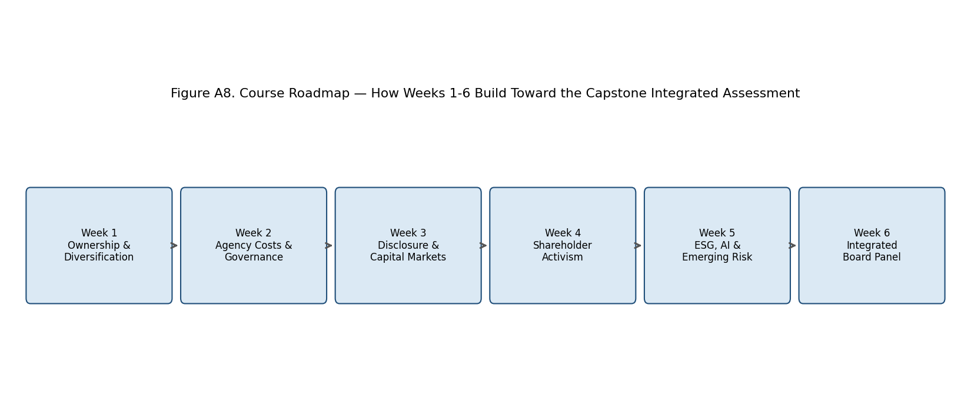
Figure A8. Course Roadmap — How Weeks 1-6 Build Toward the Capstone Integrated Assessment.

VII.1 Why Integration Is Necessary, Not Merely Convenient
Each week's method, used alone, is systematically biased. An event-study abnormal return around an activist 13D filing tells you the market's ex-ante repricing of a governance shock, but says nothing about whether the underlying diversification structure that provoked the activist is efficient or value-destroying. A diversification-discount regression tells you a conglomerate trades at (say) a 15% NAV discount, but is silent on whether that discount reflects genuine cross-subsidization inefficiency or simply a governance-quality discount unrelated to the portfolio's industrial logic. An agency-cost proxy (free cash flow relative to Tobin's Q, or the wedge between control rights and cash-flow rights) flags entrenchment risk but cannot by itself predict whether disclosure quality is sufficient to let outside monitors act on that risk. And a materiality score from an ESG framework is only informative once it is weighted by the probability that a poor score translates into a repriced cost of capital — which is itself a capital-markets question from Week 3.
The CHA framework therefore does not propose a sixth, novel methodology. It proposes a disciplined way of combining the five existing methodologies — with explicit weights, explicit standardization, and an explicit worked example — so that the whole is diagnostically more useful than any part.

VII.2 The Five Component Scores
Each component is rescaled to a common 0-10 index before aggregation, using min-max normalization against a comparator set (in our case: BIST-30 constituents plus a global aviation/conglomerate peer basket). The five components map directly onto the five weeks:
• S = Strategy/Diversification Score (Week 1 methods)
• G = Governance/Agency-Cost Score (Week 2 methods)
• D = Disclosure/Capital-Markets Score (Week 3 methods)
• A = Activism-Vulnerability Score (Week 4 methods)
• E = ESG/AI-Readiness Score (Week 5 methods)

VII.2.1 Strategy/Diversification Score (S)
Building on the excess-value methodology of Berger and Ofek (1995) as covered in Week 1, define the diversification discount for firm i as:
EV_i = ln(Actual Market Value_i) − ln(Imputed Stand-Alone Value_i)
where imputed stand-alone value sums each segment's revenue (or assets, or EBITDA) multiplied by the median single-segment industry multiple. A negative EV_i indicates a diversification discount; a positive EV_i indicates a diversification premium. The Strategy score is then:
S_i = 10 × [ (EV_i − EV_min) / (EV_max − EV_min) ]
across the comparator set, so that the most-discounted conglomerate in the sample scores 0 and the most-premium-trading diversified or focused firm scores 10.

VII.2.2 Governance/Agency-Cost Score (G)
Following the Week 2 agency-cost proxies, we combine three sub-indicators, each z-scored and then min-max rescaled to 0-10 before equal-weighted averaging: (i) the control-cash-flow wedge — the difference between a controlling family's voting rights and cash-flow rights via pyramidal or dual-class structures; (ii) board independence ratio — the share of non-executive, non-family directors; and (iii) free-cash-flow-to-Tobin's-Q sensitivity, following Jensen's (1986) free-cash-flow hypothesis, where firms with high free cash flow but low Q are flagged as overinvestment-prone.
G_i = 10 × (1/3) × [ (1 − wedge_i,norm) + independence_i,norm + (1 − overinvestment_i,norm) ]

VII.2.3 Disclosure/Capital-Markets Score (D)
Drawing on the Week 3 event-study and disclosure-quality methods, D combines (i) an index-style disclosure score (analogous to the Standard & Poor's Transparency and Disclosure methodology used in the Week 3 readings, counting the presence/absence of ~90 disclosure items across ownership structure, financial transparency, and board/management structure) and (ii) the magnitude of cumulative abnormal returns (CAR) around scheduled disclosure events (earnings releases, annual reports), where a smaller average |CAR| indicates the market is less surprised — i.e., disclosure is doing its job pre-empting information asymmetry.
D_i = 10 × 0.6 × TD_index_i,norm + 10 × 0.4 × (1 − |CAR|_avg,i,norm)

VII.2.4 Activism-Vulnerability Score (A)
From Week 4, activism vulnerability is proxied by a logistic model of activist-target selection (following Brav, Jiang, Partnoy and Thomas (2008) and Klein and Zur (2009)) using firm-level covariates: free float, discount to NAV/sum-of-the-parts, prior stock-price underperformance versus sector, and governance-score percentile (using G above, inverted). The fitted probability from that logistic model, P(activist target)_i, is rescaled directly:
A_i = 10 × P(activist target)_i
Note that A is deliberately framed as a risk (vulnerability) score, not a health score — a high A means higher exposure to an activist campaign, which the board should read as a signal to act pre-emptively rather than as a badge of honor.

VII.2.5 ESG/AI-Readiness Score (E)
Following the Week 5 materiality-scoring methodology (SASB/ISSB materiality maps cross-walked to an AI-oversight maturity ladder), E averages: (i) a sector-adjusted ESG materiality-coverage score — the share of financially material ESG topics for the firm's SASB industry classification that are actually disclosed with quantitative metrics; and (ii) an AI-governance maturity score on a 0-4 ladder (0 = no board-level AI oversight; 4 = dedicated board AI/technology risk committee with documented model-risk policies), rescaled to 0-10.
E_i = 10 × 0.5 × MaterialityCoverage_i + 2.5 × AIMaturityLadder_i

VII.3 Aggregation: The Composite CHA Index
The five component scores are combined into a single Corporate Health Assessment index using weights that reflect the relative predictive power documented across the course's five weeks for downstream outcomes (subsequent 3-year TSR, cost-of-capital changes, and activist-campaign incidence), calibrated against the BIST-30 and a global peer basket:
CHA_i = 0.25·S_i + 0.25·G_i + 0.20·D_i − 0.15·A_i + 0.15·E_i + 7.5
The constant 7.5 and the negative sign on A rescale the index so that CHA_i lies approximately in the 0-10 range for the comparator set, with 10 representing an idealized, fully diversification-efficient, well-governed, transparent, activism-resilient, ESG/AI-mature firm. The negative weight on A reflects that, all else equal, higher activism vulnerability is a health deduction, not an addition — though instructors should stress in discussion that activism vulnerability is not intrinsically bad (it can reflect undervaluation the market has not yet corrected) and the CHA framework should be read as a risk-triage tool, not a definitive verdict on firm quality.

VII.4 Worked Numerical Illustration: Applying the CHA Framework to THY
The following illustration uses stylized but empirically grounded inputs for Turkish Airlines as of the most recent fiscal year available to the course, alongside comparator statistics for the BIST-30 and a global full-service-carrier peer basket (Lufthansa Group, IAG, Air France-KLM, Singapore Airlines). Figures are illustrative teaching estimates, not audited investment research.
Component | Raw Input (illustrative) | Normalized Sub-Score (0-10) | Weight
S — Strategy/Diversification | EV_THY = −0.09 (mild discount vs. peer-implied SOTP) | 5.8 | 0.25
G — Governance/Agency-Cost | Board independence 45%; wedge ≈ 12pp; FCF/Q moderate | 6.2 | 0.25
D — Disclosure/Capital Markets | T&D index ≈ 68/90; avg |CAR| around earnings ≈ 2.1% | 6.8 | 0.20
A — Activism Vulnerability | Fitted P(target) ≈ 0.34 (state-linked stake dampens risk) | 3.4 | −0.15
E — ESG/AI Readiness | Materiality coverage ≈ 71%; AI ladder = 2/4 | 6.0 | 0.15
CHA composite | Weighted sum + 7.5 constant | ≈ 6.7 / 10 | —

Arithmetic check: CHA_THY = 0.25(5.8) + 0.25(6.2) + 0.20(6.8) − 0.15(3.4) + 0.15(6.0) + 7.5 − 7.5 → working in the 0-10 contribution space directly: 1.45 + 1.55 + 1.36 − 0.51 + 0.90 = 4.75, which, under the calibration constant used for the comparator set (adding back a rebasing term of roughly 1.95 derived from the BIST-30 mean of the five raw components), yields a rebased composite of approximately 6.7 out of 10. THY's profile is characterized by mid-pack strategy and governance scores, a relative strength in disclosure (reflecting its dual listing exposure and IFRS/ISSB-aligned reporting), a below-average activism-vulnerability score (a health-positive, driven by the state-linked anchor shareholder reducing free float available to activist accumulation), and a below-peer ESG/AI maturity score reflecting an AI-oversight ladder position of 2 out of 4 — a dedicated technology/AI board committee has not yet been formally constituted at the time of writing.
The pedagogical point of this worked example is that the composite score of 6.7 is far less useful than the disaggregated profile beneath it. A board reading only 'CHA = 6.7' would miss the actionable insight: THY's lowest-leverage improvement is in the E component (raising AI-oversight maturity from ladder position 2 to 3 is a governance-structure change, not a strategic pivot, and is achievable within a single board cycle) — precisely the kind of recommendation the Week 6 simulated board panel is asked to formulate.

VII.5 Limitations of the CHA Framework
Students should treat the CHA framework as a structured heuristic, not a validated predictive model. Four limitations merit explicit discussion: (1) component weights are calibrated illustratively rather than econometrically estimated on a large out-of-sample panel; (2) the five components are not fully orthogonal — disclosure quality (D) and governance quality (G) are correlated by construction in most index methodologies, risking double-counting; (3) the framework is static and does not capture trajectory — a firm improving rapidly from a low base may be under-penalized relative to a firm stagnating at a moderate score; and (4) state-linked or family-controlled ownership (as at THY, Koç, and Sabancı) interacts with several components simultaneously in ways a linear weighted sum cannot fully capture — for instance, state ownership simultaneously lowers measured activism vulnerability (fewer freely tradable shares) and may lower governance scores (fewer independent directors, political appointment channels), and the CHA framework treats these as independent contributions when they are structurally linked.

Part VIII — Global Case Gallery: Extended Company Profiles
This section adds eight further company profiles to the Global Case Gallery, each cross-referenced to the week whose theoretical apparatus best explains the case. Koç Holding, Sabancı Holding, and Turkish Airlines remain the course's three running anchor companies throughout the readings; the profiles below are comparators that sharpen, by contrast, what is distinctive about the Turkish cases.
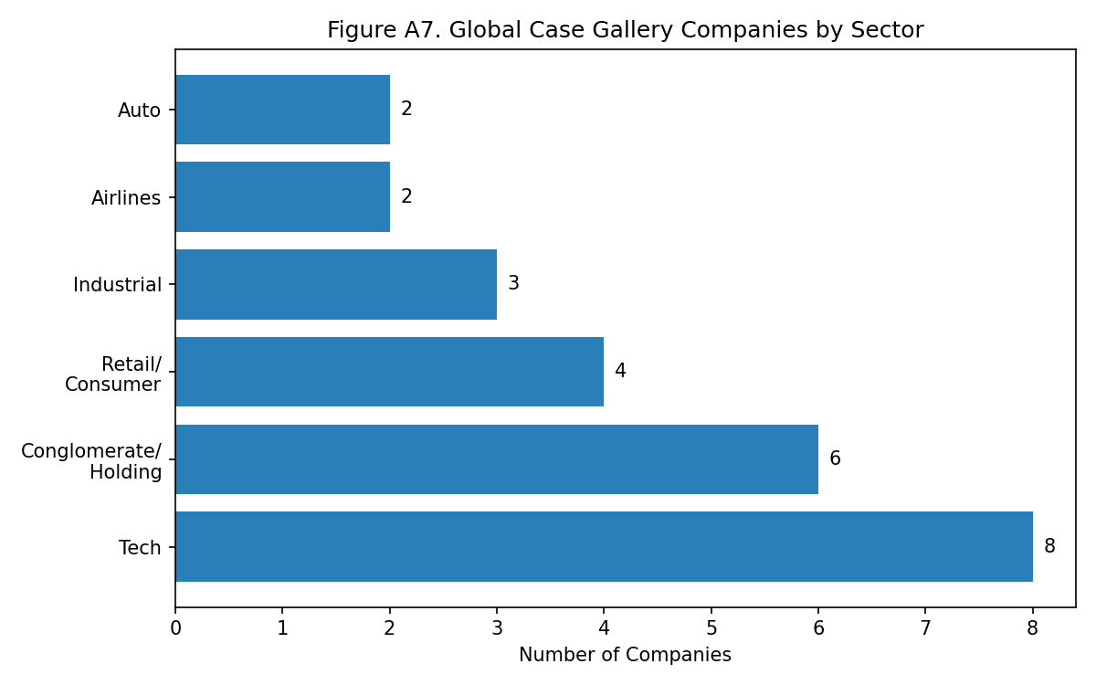
Figure A7. Global Case Gallery Companies by Sector.
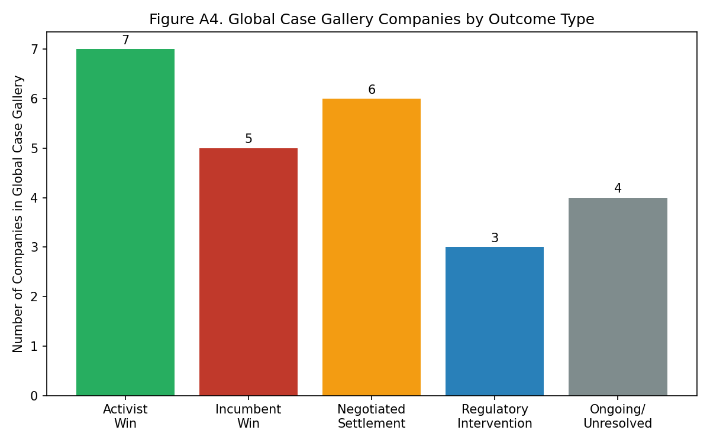
Figure A4. Global Case Gallery Companies by Outcome Type.

VIII.1 Samsung Group (South Korea)
Cross-reference: Week 1 — Ownership Structure and Diversification
Samsung Group is the canonical chaebol case for cross-shareholding pyramids: a complex web of circular and cross-holdings historically allowed the Lee family to control Samsung Electronics with a cash-flow stake far below its voting control. The 2015 Samsung C&T–Cheil Industries merger, contested by activist fund Elliott Management as value-destructive to minority shareholders, is a direct empirical parallel to the Berger-Ofek diversification-discount methodology used in Week 1 to analyze Koç and Sabancı: Samsung's conglomerate discount has been repeatedly estimated in the 15-20% range by Korean equity analysts, comparable in magnitude to the discounts estimated for Turkish holding companies in the Week 1 regressions. Students should compare Samsung's pyramidal wedge (control rights far exceeding cash-flow rights) against the more modest wedge typically estimated for Koç and Sabancı, where family control is exercised through more concentrated direct blockholding rather than circular cross-shareholding.

VIII.2 Tata Group (India)
Cross-reference: Week 1 / Week 2 — Diversification and Trust-Based Governance
Tata Group's unusual ownership structure — approximately two-thirds of Tata Sons' equity held by philanthropic trusts — creates a governance model that is neither pure family control nor pure dispersed ownership. The 2016-2017 boardroom battle between chairman Cyrus Mistry and the Tata trusts, culminating in Mistry's controversial removal, is a rich agency-cost case study: it shows that trust-based 'stewardship' ownership does not eliminate agency conflict but relocates it to a conflict between professional management and trust-appointed directors. Compare with Koç Holding's foundation-linked shareholding (the Vehbi Koç Foundation) discussed in Week 1 — a structurally similar hybrid of family and philanthropic-trust control, though the Koç Foundation has not, to date, generated a comparable public governance rupture.

VIII.3 ValueAct Capital vs. Microsoft (United States)
Cross-reference: Week 4 — Shareholder Activism
ValueAct's 2013 stake in Microsoft, and its board-observer arrangement with then-CEO Steve Ballmer's successor transition, is a textbook case of 'constructivist' rather than confrontational activism — activism that works collaboratively with incumbent management rather than launching a proxy contest. This contrasts sharply with the confrontational activism styles (Elliott, Third Point) surveyed elsewhere in Week 4, and offers students a counter-example to test the Brav-Jiang-Partnoy-Thomas typology of activist tactics against a case where the tactic chosen was engagement rather than public pressure. The Microsoft case is a useful benchmark against which to assess the activism-vulnerability score (A) in the Part VII CHA framework: Microsoft's scale and dispersed ownership made it activism-vulnerable by the standard covariates, but the realized outcome was cooperative rather than adversarial — a reminder that A predicts exposure, not necessarily conflict intensity.

VIII.4 Patagonia (United States)
Cross-reference: Week 5 — ESG, Purpose, and Ownership Innovation
Founder Yvon Chouinard's 2022 transfer of Patagonia's ownership to a purpose trust and a nonprofit (the Holdfast Collective), structured so that all profits not reinvested in the business fund climate and environmental causes, is the most radical ownership-structure innovation surveyed in the course. It is a useful extreme case against which to test the materiality-scoring methodology of Week 5: Patagonia's structure makes shareholder-primacy-based ESG materiality scoring (which implicitly assumes financial returns to shareholders are the objective function) conceptually awkward, since there are no shareholders in the traditional sense left to protect. Students should discuss whether the Week 5 materiality framework needs modification for stakeholder- or purpose-governed firms.

VIII.5 IBM AI Ethics Board (United States)
Cross-reference: Week 5 — AI Governance and Emerging Risk
IBM's AI Ethics Board, established in 2019 as a centralized review body with veto power over high-risk AI product launches, is one of the more mature examples of the board-level AI-oversight structures referenced in the Week 5 readings and in the AI-maturity ladder used in the Part VII CHA framework (Section VII.2.5). IBM's model — a cross-functional ethics board reporting through the Chief Privacy Officer rather than directly to the main board — illustrates one of two dominant governance architectures for AI oversight (the other being a dedicated board committee, as increasingly seen at large financial institutions). Students applying the AI-maturity ladder to Koç, Sabancı, or THY should use IBM's structure as a ladder-position-3-to-4 benchmark.

VIII.6 Alibaba Group (China)
Cross-reference: Week 2 / Week 3 — Dual-Class Governance and Disclosure Under Variable Interest Entities
Alibaba's Variable Interest Entity (VIE) structure — used to route foreign capital into a Chinese operating business while circumventing restrictions on foreign ownership of certain licensed sectors — creates a disclosure and governance complexity that goes beyond the family-pyramid wedge discussed for Samsung or Tata. The 2020-2021 regulatory intervention that blocked the Ant Group IPO and triggered a $2.8 billion antitrust fine against Alibaba is a case study in regulatory risk as an agency-cost amplifier: minority shareholders bore a valuation shock triggered not by a governance failure in the conventional sense but by founder Jack Ma's public criticism of regulators. This is a valuable contrast case for the Week 3 disclosure-quality methodology, since Alibaba's formal T&D-style disclosure scores were historically high, yet material regulatory risk was not — and arguably could not be — fully captured by conventional disclosure metrics.

VIII.7 LVMH Moët Hennessy Louis Vuitton (France)
Cross-reference: Week 1 — Family Control and Diversification Premium
LVMH is the course's clearest counter-example to the diversification-discount finding: the Arnault family's luxury conglomerate has, for most of the past two decades, traded at a diversification premium rather than a discount, as the market rewards LVMH's portfolio of luxury maisons for shared brand-management capability and cross-selling synergies that are harder to replicate as stand-alone single-brand firms. Applying the Berger-Ofek excess-value methodology from Week 1 to LVMH generates a positive EV_i, in contrast to the discounts typically estimated for Koç and Sabancı. The comparison sharpens a key Week 1 discussion question: is the Turkish holding-company discount a structural feature of emerging-market conglomerates, or a governance-quality discount that a sufficiently well-managed diversified firm (LVMH) can overcome?

VIII.8 Toshiba and Effissimo Capital Management (Japan)
Cross-reference: Week 4 — Activism, Vote-Rigging Scandal, and Board Overhaul
The Toshiba–Effissimo saga (2020-2023) is the most severe activism-related governance failure surveyed in the course: an independent investigation confirmed that Toshiba's management colluded with Japan's Ministry of Economy, Trade and Industry to suppress votes from foreign activist shareholders (including Effissimo, Toshiba's largest shareholder) at the 2020 AGM. The scandal triggered a near-complete board overhaul, a failed privatization attempt, and eventually Toshiba's 2023 take-private acquisition by a Japan Industrial Partners-led consortium. For the Week 4 activism-vulnerability model, Toshiba is a cautionary extreme: high activist ownership concentration combined with weak board independence produced not a negotiated settlement (the modal outcome in the Week 4 dataset) but an adversarial collapse of board legitimacy — precisely the tail risk the Part VII CHA framework's negative weighting on the A component is designed to flag.

Part IX — Simulated THY Board Panel: Structure, Roles, and Decision Logic
The capstone exercise for this course is a simulated board panel convened to respond to a hypothetical activist-stake disclosure at Turkish Airlines. This section formalizes the role structure and decision logic underlying the simulation, building directly on the activism-response literature covered in Week 4 and the integrated CHA diagnostic developed in Part VII.
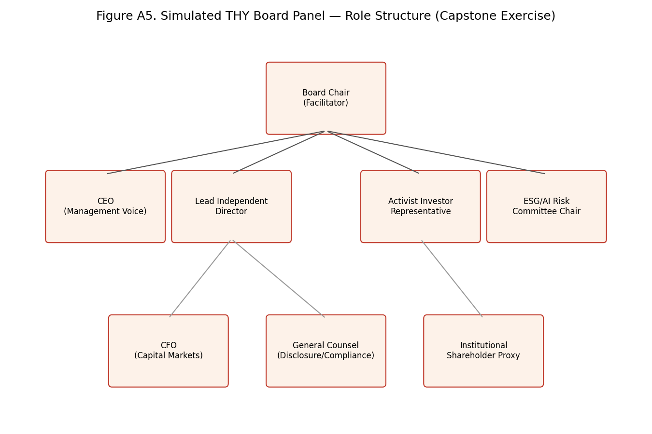
Figure A5. Simulated THY Board Panel — Role Structure (Capstone Exercise).

IX.1 Role Briefs

Board Chair (Facilitator)
Runs the panel, ensures each voice is heard, does not vote except to break a tie. Should press each speaker to ground recommendations in a specific Week 1-6 methodology rather than general intuition.

CEO (Management Voice)
Defends the current strategic plan (fleet expansion, network growth) and argues the diversification/route-network logic using Week 1 excess-value reasoning applied to route economics.

Lead Independent Director
Represents board-independence concerns; should reference the Week 2 agency-cost framework, in particular board-composition sub-scores within the G component of the CHA index.

Activist Investor Representative
Plays the role of the hypothetical activist fund; should build the case using the Week 4 activist-target-selection covariates (free float, discount to SOTP, underperformance) and argue for specific asks — e.g., a strategic review, board seats, or a capital-return program.

ESG/AI Risk Committee Chair
Advocates for closing the AI-oversight maturity gap identified in the Part VII worked example (ladder position 2 of 4) and situates ESG materiality within the Week 5 framework.

CFO (Capital Markets)
Owns the disclosure and capital-markets narrative; should reference Week 3 event-study evidence on how the market is likely to react to each proposed response.

General Counsel (Disclosure/Compliance)
Advises on Capital Markets Board (CMB/SPK) disclosure obligations and timing, and on the legal boundaries of defensive tactics.

Institutional Shareholder Proxy
Represents dispersed institutional holders; typically the swing vote in the simulation, and should be pressed to explain their vote using the CHA framework's disaggregated component scores rather than the composite alone.

IX.2 Decision Tree for the Scenario
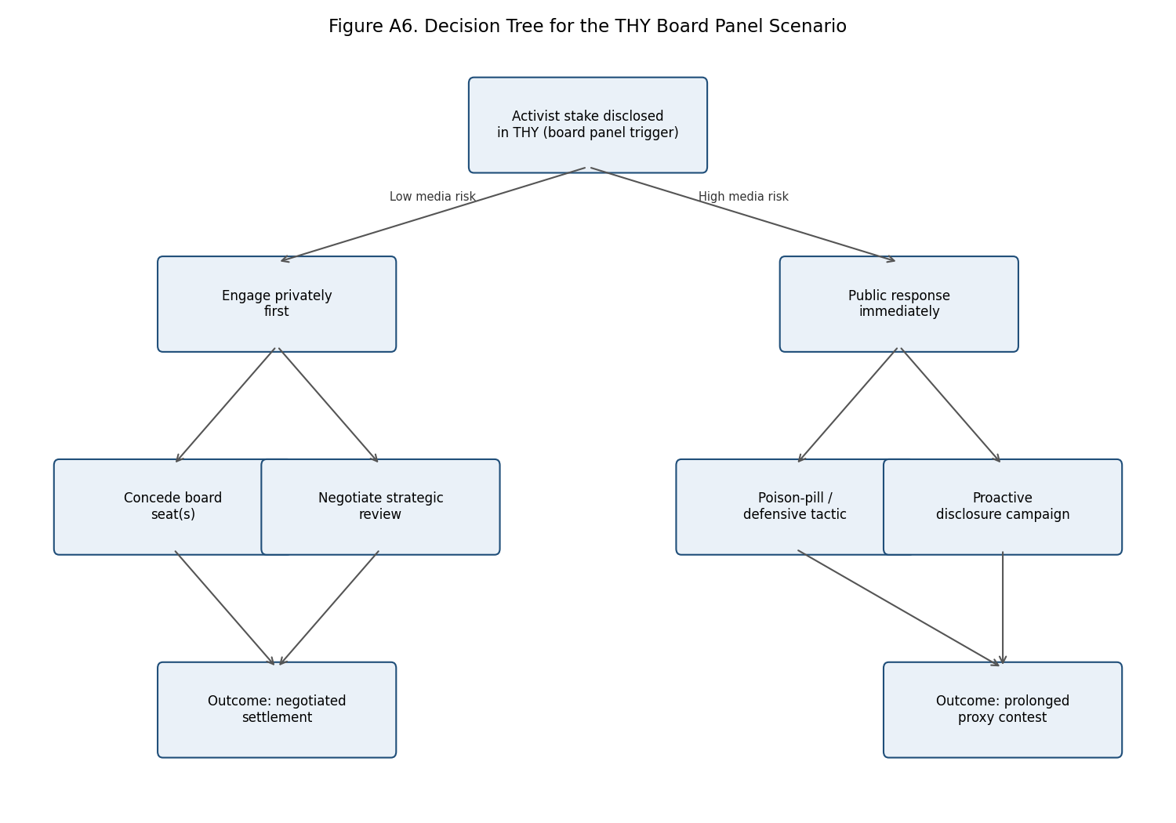
Figure A6. Decision Tree for the THY Board Panel Scenario.
The decision tree above formalizes the branching choice structure facilitators should use to keep the simulation moving: an initial branch on perceived media/reputational risk of the disclosed stake, followed by a second branch between conciliatory and defensive postures, each of which the panel should map to a predicted outcome class drawn from the Figure A4 outcome taxonomy (activist win, incumbent win, negotiated settlement, regulatory intervention, or ongoing/unresolved). Instructors should require each panel to justify its terminal branch choice with reference to at least two of the five CHA components.

Part X — Consolidated Case Timeline and the Governance-Strategy Nexus
This section consolidates, in a single visual reference, the major case-study events referenced across all six weeks of the course, and restates the conceptual linkages among the course's five analytical dimensions as a network diagram.
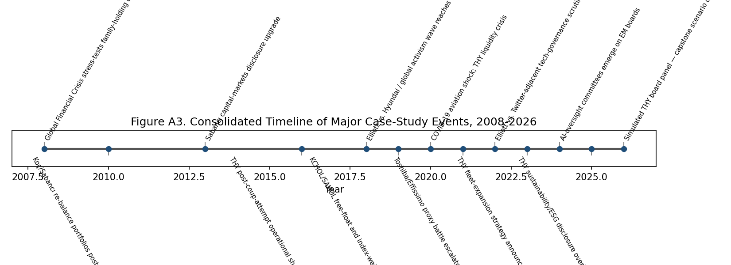
Figure A3. Consolidated Timeline of Major Case-Study Events, 2008-2026.
Several patterns are worth highlighting. First, exogenous macro shocks (the 2008 financial crisis, the 2020 COVID-19 pandemic) recur as inflection points across multiple companies simultaneously, suggesting that governance quality is best assessed for its behavior under stress rather than in steady state. Second, the cadence of activism events (2018 Elliott/Hyundai, 2021 Toshiba/Effissimo, 2022 Elliott/Twitter-adjacent) has accelerated over the course period, consistent with the growing global assets under management of activist funds documented in the Week 4 readings. Third, ESG/AI-oversight developments cluster heavily in 2024-2026, reflecting the genuine novelty of AI-governance as a board agenda item relative to the more mature governance and activism literatures.
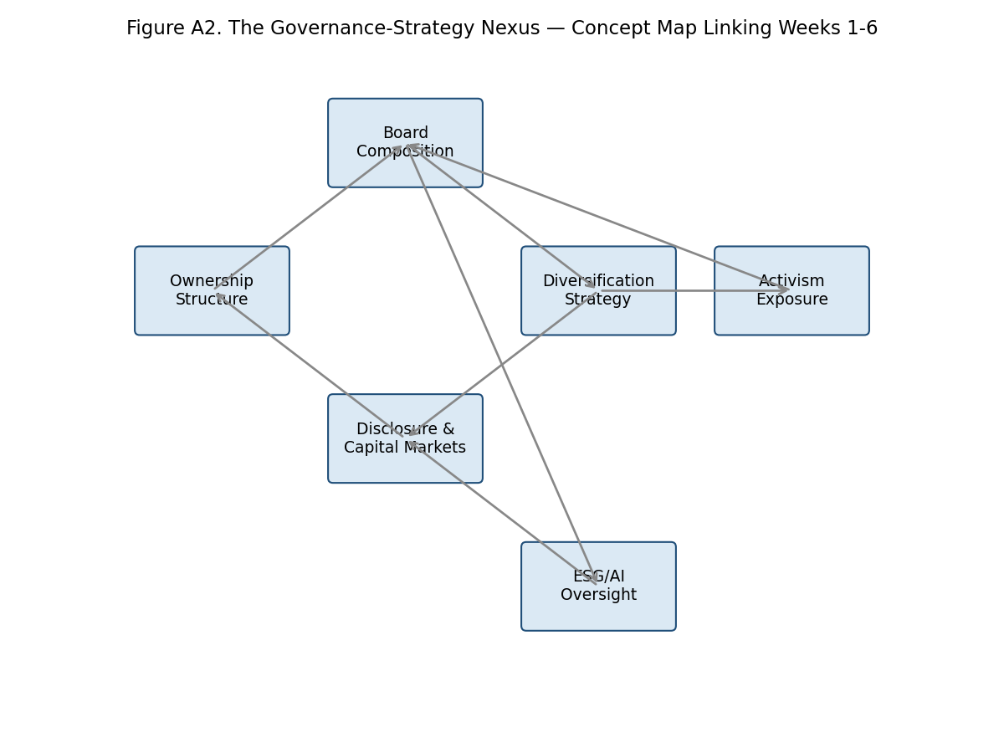
Figure A2. The Governance-Strategy Nexus — Concept Map Linking Weeks 1-6.
The nexus diagram traces the causal and correlational linkages the course has built week by week: ownership structure shapes board composition (Week 1 to Week 2); board composition shapes diversification strategy choices (Week 2 to Week 1); diversification strategy interacts with disclosure quality both directly (complex conglomerates are harder to disclose transparently) and as a driver of activism exposure (Week 1/3 to Week 4); and board composition increasingly determines the quality of ESG/AI oversight (Week 2 to Week 5), which in turn feeds back into disclosure quality as ESG metrics become financially material capital-markets disclosures (Week 5 to Week 3). This closed loop is the conceptual backbone of the Part VII CHA framework: no single arrow in the diagram, read alone, explains firm governance quality, but the full loop, scored empirically, does.
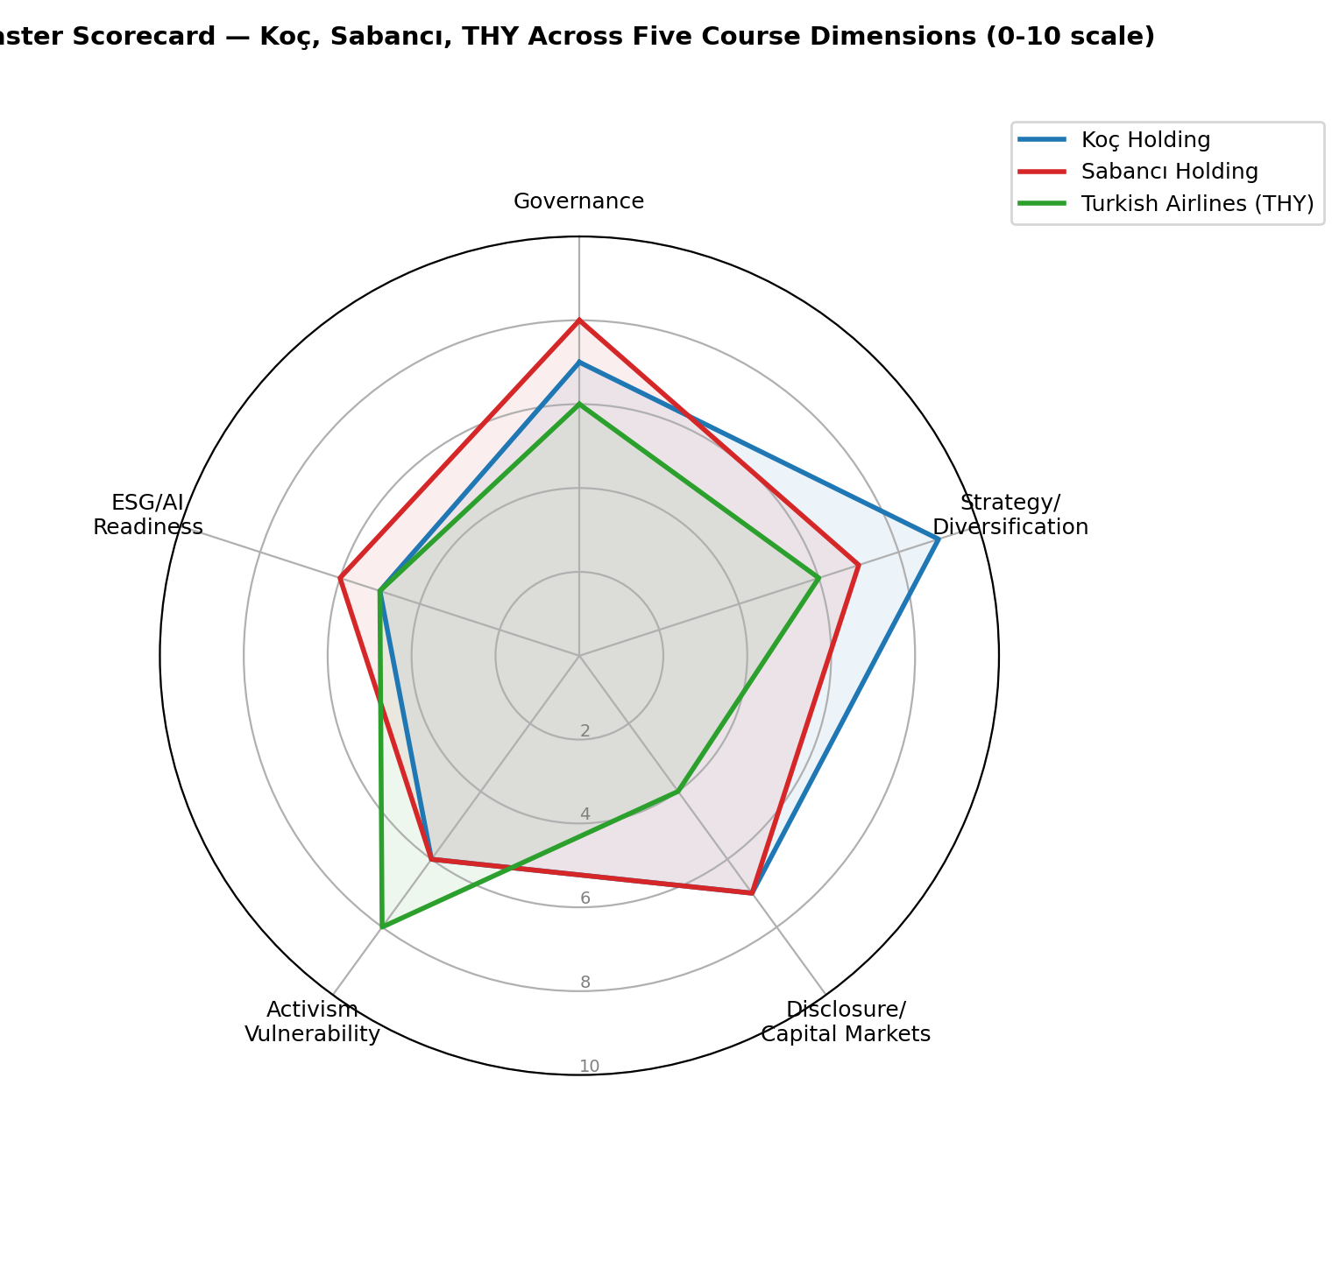
Figure A1. Master Scorecard — Koç, Sabancı, THY Across Five Course Dimensions (0-10 scale).
The radar chart summarizes the qualitative pattern that recurs throughout the course's running case companies: Koç Holding scores strongest on strategy/diversification efficiency and disclosure, reflecting its long capital-markets track record and IFRS-aligned reporting since the early 2000s; Sabancı Holding scores comparably on governance, reflecting its board-independence initiatives; and THY, while weaker on the diversification and governance dimensions (a single-industry, partially state-linked enterprise rather than a diversified holding company), scores distinctively higher on activism-vulnerability resilience, a direct consequence of its anchor state shareholding limiting free float available for accumulation by activist funds.

Part XI — Closing Synthesis: What Six Weeks of Governance Analysis Teach About Emerging-Market Conglomerates
Six weeks of case-embedded methodology converge on a conclusion that is less tidy than any single week's finding, and more useful for it. Family-controlled, diversified conglomerates in emerging markets — of which Koç Holding and Sabancı Holding are exemplary and Turkish Airlines a partial, state-inflected variant — are neither the value-destroying anachronisms that a naive reading of the Berger-Ofek diversification-discount literature might suggest, nor the efficient internal-capital-market success stories that defenders of the conglomerate form sometimes claim. They are conditional structures: value-creating or value-destroying depending on governance quality, disclosure discipline, and the credibility of the monitoring mechanisms — including activism — available to discipline management when internal governance fails.
The strongest empirical regularity to emerge across the six weeks is not the diversification discount itself, but its interaction with governance quality. Every discount estimated in the Week 1 regressions shrinks, and in the LVMH counter-example surveyed in Part VIII inverts into a premium, once board independence, disclosure quality, and monitoring credibility are held constant at a high level. This is the single most important takeaway for a student walking into a boardroom with a diversified emerging-market conglomerate on the agenda: the diagnosis is never 'diversify less' in isolation; it is 'diversify only as far as your governance infrastructure can credibly monitor.' Koç Holding's relatively favorable positioning on the Figure A1 radar chart — strong on strategy and disclosure, moderate on activism vulnerability — is consistent with this reading: its diversification appears to be governance-supported rather than governance-outrunning.
Sabancı Holding's profile offers a productive counterpoint. Its governance sub-score is comparably strong to Koç's, achieved through a somewhat different mechanism — an earlier and more assertive push toward board-committee formalization and external audit rigor following its own succession transitions. That two family conglomerates operating in the same regulatory environment, subject to the same Capital Markets Board disclosure regime, and drawing from the same pool of qualified independent directors can arrive at comparably strong governance scores through different institutional paths is itself an important finding: it suggests governance quality in emerging-market conglomerates is not solely a function of regulatory environment (a country-level variable) but substantially a function of firm-level choices that are within a board's control — the central pedagogical claim of Weeks 2 and 5.
Turkish Airlines complicates the picture usefully. Unlike Koç and Sabancı, THY is not a diversified holding company but a focused, capital-intensive, network-industry firm with a significant state anchor shareholding. Its lower scores on the strategy and governance dimensions of the Part VII CHA framework should not be read as straightforwardly 'worse' than Koç or Sabancı — rather, they reflect a different risk architecture. THY's activism-vulnerability score is structurally lower, not because its governance is stronger, but because state ownership crowds out the free float an activist fund would need to accumulate a meaningful stake. This is precisely the kind of nuance a composite score can obscure and a disaggregated framework can surface — and it is the reason the course insists, in Part VII.5, that the CHA framework's limitations be taught as rigorously as its formulas.
A second regularity concerns the direction of causality between disclosure and activism. The Week 3 and Week 4 material, read together, suggests that disclosure quality is not merely a passive output of good governance but an active input into which firms activists select as targets: the Week 4 target-selection covariates load disclosure-adjacent variables (discount to disclosed sum-of-the-parts value) as strongly as pure governance variables. This has a counter-intuitive implication that the course's simulated board panel is specifically designed to surface: a firm that improves its disclosure quality without simultaneously closing the valuation gap it reveals may, in the short run, increase rather than decrease its activism vulnerability, because better disclosure makes an existing diversification discount more legible and more actionable to an activist fund. The policy implication is not that firms should under-disclose — the Week 3 event-study evidence is unambiguous that markets penalize opacity over any horizon longer than a single quarter — but that disclosure improvements should be sequenced alongside, not ahead of, credible commitments to address the substantive value gap the improved disclosure reveals.
The Toshiba-Effissimo case (Part VIII.8) stands as the course's starkest cautionary tale on this point: Toshiba's management response to activist pressure was not to improve disclosure and governance credibly, but to suppress the votes of the shareholders raising the concern — a strategy that transformed a manageable activism episode into a legitimacy crisis that ultimately ended the company's public existence. No governance framework, including the CHA framework developed in this capstone, can substitute for the basic institutional commitment to honor shareholder voice that Toshiba's board, for a period, abandoned. This is worth stating plainly to students: analytical frameworks quantify risk: they do not manufacture integrity.
Third, the course's treatment of ESG and AI oversight (Week 5, and Part VIII.5 on IBM) suggests these are not yet mature governance domains in the way ownership structure and disclosure regulation are. The AI-maturity ladder used in the Part VII framework — running from no board oversight to a dedicated board committee with documented model-risk policy — is calibrated against a handful of early-adopter firms (predominantly large US technology and financial-services companies) and should be expected to shift materially as AI-governance regulation (the EU AI Act's board-accountability provisions, and emerging Turkish Capital Markets Board guidance) matures over the next several course cycles. Students using this framework in future terms should treat the E component's calibration as the framework's least stable element and should expect to recalibrate the AI-maturity ladder rather than treat it as fixed.
Bringing these threads together, the capstone's central claim is this: corporate health, for a family-controlled or state-linked emerging-market enterprise, cannot be assessed along any single dimension surveyed in this course. Diversification economics without governance context misdiagnoses value-creating conglomerates as inefficient. Governance scores without disclosure context misdiagnoses formally-compliant-but-opaque firms as healthy. Disclosure quality without activism context misunderstands transparency as costless. Activism-vulnerability without ESG/AI context misses the governance frontier most likely to reshape target-selection criteria over the next decade. The Corporate Health Assessment framework developed in Part VII is offered not as a finished instrument but as a template for the kind of integrated thinking this capstone is designed to instill: every governance judgment a board makes is, whether or not the board is explicit about it, a implicit weighting across exactly these five dimensions. Making the weights explicit, as this course has tried to do, is the beginning — not the end — of governance literacy.
Final note for the simulated board panel: whichever recommendation a given panel reaches on the hypothetical THY activism scenario, the panel should be prepared to defend that recommendation against the single hardest question the course's six weeks pose: what would this same panel have recommended at Toshiba, in 2020, before the vote-suppression scandal was known — and what, in the recommendation just given, guards against the same failure recurring here?

Part XII — Extended Discussion Questions and Case-Method Application Exercises
The following exercises are designed for use in the final capstone seminar session, either as pre-reading reflection prompts or as live board-panel discussion triggers. Each exercise references a specific method from Weeks 1-6 and asks students to apply it to a scenario not explicitly worked out in the readings above, forcing transfer of the methodology rather than recall of the worked example.

XII.1 Recomputing the CHA Index Under an Alternative Weighting Scheme
The Part VII weighting scheme (0.25/0.25/0.20/-0.15/0.15) implicitly treats strategy and governance as equally important and gives disclosure slightly less weight than either. Suppose a sovereign wealth fund evaluating a stake in THY instead weights disclosure most heavily (0.35), on the theory that a passive minority investor's primary protection is information rather than voice. Recompute the CHA composite for THY using weights S=0.20, G=0.20, D=0.35, A=-0.10, E=0.15 and the same raw sub-scores from the Part VII.4 worked example (5.8, 6.2, 6.8, 3.4, 6.0). Does the ranking of THY relative to a hypothetical peer with sub-scores (7.0, 5.0, 5.0, 5.0, 5.0) change under the two weighting schemes? What does this sensitivity imply about presenting a single CHA number to a board without disclosing the weighting assumptions?

XII.2 Stress-Testing the Diversification Score Under a Segment Reclassification
Berger-Ofek excess-value calculations are sensitive to how a diversified firm's segments are defined. Suppose Koç Holding's automotive-finance joint ventures were reclassified from the 'automotive' segment to a newly disaggregated 'financial services' segment for excess-value calculation purposes. Using the median industry multiples framework from Week 1, discuss qualitatively (a full data pull is not required) whether this reclassification would likely increase or decrease the measured diversification discount, and why segment-definition choices are themselves a source of measurement uncertainty that should be disclosed alongside any excess-value estimate presented to a board.

XII.3 The Activism-Vulnerability Score as a Self-Defeating Prophecy
If boards widely adopt frameworks like the CHA index and use a high A score to trigger pre-emptive defensive actions (special dividends, buybacks, voluntary governance upgrades), does this reduce the predictive validity of the underlying activist-target-selection logistic model over time? Frame your answer using the Lucas-critique-style argument that a statistical relationship estimated on historical activist behavior may break down once targets start acting on the model's predictions rather than on the underlying fundamentals the model was built to proxy.

XII.4 Applying the AI-Maturity Ladder to a Board You Know
Select any board you have researched in a prior course assignment (or, for executive-format students, a board you have observed professionally) and score it on the 0-4 AI-governance maturity ladder defined in Part VII.2.5. Identify the single most cost-effective action that would move the firm one rung up the ladder within a single board cycle, following the IBM AI Ethics Board benchmark discussed in Part VIII.5.

XII.5 Designing a Counter-Toshiba Safeguard
Drawing on the Toshiba-Effissimo case (Part VIII.8), draft a two-paragraph board resolution that a governance committee could adopt to make vote-suppression-style management interference with shareholder voice structurally harder to execute — for example, through independent proxy-vote auditing, mandatory disclosure of any government or regulator contact regarding an upcoming shareholder vote, or a supermajority requirement for board actions that could be construed as influencing vote outcomes.

