ADEX547 Specail Topics in Organisation and Strategy
ADEX547 Specail Topics in Organisation and Strategy
Week 3 — Capital Markets Law: SPK Oversight & Disclosure
Turkish Capital Markets Board (SPK), Public Disclosure Platform (KAP), Market Abuse and Insider Trading Doctrine
Instructor: Hakan Göral
Session 3 of 6 · Reading time approx. 100 minutes
Boğaziçi University Executive MBA — materials current as of 16 July 2026

Learning Objectives
By the end of this session, participants will be able to:
- Explain, using Fama's (1970) Efficient Capital Markets Hypothesis (EMH), why mandatory disclosure regulation is theoretically justified (or contested) as a mechanism for improving price accuracy in Turkish and global capital markets.
- Articulate the mandatory-disclosure debate — Easterbrook & Fischel's (1984) skeptical, market-can-self-correct position versus Coffee's (2006) gatekeeper and market-failure rationale — and apply both lenses to a Borsa İstanbul disclosure scenario.
- Describe the institutional architecture of Turkish capital markets regulation: the Capital Markets Board (Sermaye Piyasası Kurulu, SPK), the Capital Markets Law No. 6362 (CML 6362), and the Public Disclosure Platform (Kamuyu Aydınlatma Platformu, KAP).
- Distinguish insider trading from market manipulation under CML 6362, including the applicable administrative and criminal liability tracks.
- Evaluate 2025–2026 SPK enforcement practice — including the January 2026 social-media manipulation investigation, the November 2025 SPK Chairman statements on portfolio-manager discipline, and the 2024 crypto-asset amendments (Law No. 7518) — as live evidence of how the disclosure and anti-manipulation regime operates today.
- Apply the disclosure and law-and-finance framework to real, current Turkish issuers — Türk Hava Yolları (THY), Koç Holding and Sabancı Holding — using their 2025–2026 KAP filings as worked examples.

Introduction
Capital markets regulation exists because the buyer of a share cannot, unaided, verify what the seller already knows. This informational asymmetry — famously generalized by Akerlof's (1970) market for 'lemons' — is the foundational problem that securities law is built to solve. In Türkiye, as in the United States and the European Union, the policy response has been a mandatory disclosure regime: issuers are required by law to make material information public, promptly and equally, through a designated channel, and a specialized regulator is empowered to supervise, investigate and sanction manipulation of the resulting information flow.
This reading builds the theoretical case for mandatory disclosure, sets out the institutional architecture through which Türkiye implements it — the Capital Markets Board (SPK), the Capital Markets Law No. 6362 (CML 6362), and the Public Disclosure Platform (KAP) — and connects that architecture to the doctrine of insider trading and market manipulation. It then turns to what is actually happening in 2026: an intensifying wave of SPK-referred criminal investigations into social-media-driven stock manipulation, explicit statements from the SPK Chairman about tightening discipline over portfolio managers and investment funds, the 2024 legislative extension of capital markets law to crypto-assets, and the day-to-day KAP disclosure practice of three of Türkiye's largest listed groups — Türk Hava Yolları (THY), Koç Holding and Sabancı Holding.
A note on evidentiary standard: every factual claim in this reader is attributed to a specific source. Where a fact rests on secondary press coverage of a KAP filing rather than on the primary KAP text itself, this is stated explicitly, and no additional detail is invented beyond what the cited source reports.

Part I — Legal & Theoretical Foundations

1.1 Efficient Capital Markets and the Case for Disclosure — Fama (1970)
Eugene Fama's 'Efficient Capital Markets: A Review of Theory and Empirical Work' (Journal of Finance, 25(2), 1970, pp. 383–417) remains the reference framework for how information is understood to move into securities prices. Fama distinguished three nested forms of market efficiency: weak-form efficiency, in which prices reflect all information in past price and volume data; semi-strong-form efficiency, in which prices reflect all publicly available information (financial statements, announcements, and other disclosures); and strong-form efficiency, in which prices reflect all information, public and private, including material non-public information held by corporate insiders.
The regulatory relevance of Fama's typology is direct: a mandatory disclosure regime is, in effect, an attempt to keep real markets close to semi-strong-form efficiency by ensuring that material information becomes public — and therefore priced — as quickly and as broadly as possible. If information stays private, prices cannot reflect it, and the market cannot perform its core allocative function of directing capital to its best uses. Insider trading, from this perspective, is not merely unfair to individual counterparties; it is a mechanism by which prices come to reflect private information asymmetrically and slowly, degrading the semi-strong-form efficiency on which resource allocation depends. KAP — Türkiye's centralized, real-time public disclosure channel — can therefore be read as institutional infrastructure built explicitly to push the Turkish market toward the semi-strong-form efficiency Fama describes: every issuer is required to release material information to all investors simultaneously through one platform, eliminating the selective-disclosure channel that would otherwise let information leak privately.
It is worth noting, however, that EMH does not by itself resolve how much disclosure is optimal, nor does it settle who should bear the cost of producing it. That is precisely the terrain of the mandatory-disclosure debate below.

1.2 The Mandatory Disclosure Debate: Easterbrook & Fischel versus Coffee
Frank Easterbrook and Daniel Fischel's 'Mandatory Disclosure and the Protection of Investors' (Virginia Law Review, 70(4), 1984, pp. 669–715) is the canonical skeptical position. Writing from a law-and-economics tradition close to the Chicago school, Easterbrook and Fischel argued that competitive capital markets already generate strong incentives for voluntary disclosure: issuers that withhold value-relevant information face a higher cost of capital, because rational investors discount the securities of opaque firms to compensate for uncertainty. On this view, firms will voluntarily disclose up to the point where the marginal cost of additional disclosure equals the marginal reduction in the cost of capital it buys — an equilibrium that a mandatory rule can only worsen, either by forcing disclosure firms would not have chosen (over-disclosure, with real costs to competitive position and no offsetting benefit) or by imposing uniform disclosure formats poorly suited to heterogeneous firms. Mandatory disclosure, in this reading, is largely redundant with what a reputation-sensitive, self-correcting market would already produce, and its principal effect is to raise compliance costs without proportionate investor-protection benefit.
John C. Coffee's institutional response — most fully developed in his 2006 book Gatekeepers: The Professions and Corporate Governance (Oxford University Press), and echoed in his broader scholarship on the market-failure rationale for securities regulation — takes the opposite starting point: information about a firm has public-good characteristics that make private, voluntary provision systematically under-supplied relative to the social optimum. Once one investor bears the cost of producing verified information, other investors free-ride on it without paying, so the private return to producing disclosure information falls short of its social value, and a purely voluntary regime will under-produce disclosure relative to what is efficient for the market as a whole. Coffee's gatekeeper thesis extends this logic institutionally: because issuers themselves have weak incentives to self-police (managers who control the disclosure channel have their own reasons to shade bad news), securities regulation relies on independent intermediaries — auditors, underwriters, rating agencies, and, in the Turkish system, SPK-licensed independent audit firms and portfolio management companies — to certify disclosure quality. When those gatekeepers fail (as Coffee argues occurred in the Enron-era accounting scandals), the market-failure case for mandatory, regulator-enforced disclosure rules, rather than reliance on voluntary reputation and gatekeeper discipline alone, becomes considerably stronger.
Read together, Easterbrook & Fischel and Coffee frame the same institutional question — how much should disclosure be legally mandated versus left to market and reputational incentives — from opposite priors about how well unregulated markets self-correct. The Turkish CML 6362 regime, discussed below, resolves this debate institutionally rather than theoretically: it opts firmly for the Coffee side of the spectrum, imposing statutory, SPK-enforced disclosure duties on issuers and licensing requirements on the gatekeeper professions (independent auditors, portfolio managers, capital-markets intermediaries) rather than leaving disclosure to voluntary market discipline. The 2025–2026 SPK enforcement wave discussed in Part II — including explicit statements from SPK's Chairman about disciplining portfolio managers and funds — is, in this framing, a live illustration of the gatekeeper-failure problem Coffee describes: when gatekeepers (portfolio management companies) are alleged to have been misused as vehicles for manipulation, the regulator's response is to tighten gatekeeper licensing and liability, precisely the mechanism Coffee's framework predicts.

1.3 Law and Finance: Investor Protection as a Determinant of Market Development
La Porta, Lopez-de-Silanes, Shleifer and Vishny's 'Law and Finance' (Journal of Political Economy, 106(6), 1998, pp. 1113–1155) established empirically that the legal origin of a country's commercial law — common law versus civil law, and within civil law, French, German or Scandinavian origin — is a strong predictor of the strength of shareholder and creditor protection, and, in turn, of the depth and breadth of that country's capital markets. Türkiye's Capital Markets Law sits within a civil-law tradition historically influenced by continental European legal transplants, a lineage the La Porta et al. framework would predict is associated with weaker baseline investor protection than common-law systems, all else equal — a gap that statutory reform (CML 6362 itself, enacted in 2012 to replace the older 1981 framework, and its subsequent amendments) is explicitly designed to narrow.
The companion paper, La Porta, Lopez-de-Silanes, Shleifer and Vishny, 'Investor Protection and Corporate Governance' (Journal of Financial Economics, 58, 2000, pp. 3–27), extends the 1998 findings into a governance argument: legal protection of minority shareholders is not merely correlated with market size but is a causal precondition for outside investors to be willing to finance firms at all, because without credible legal protection, controlling shareholders and managers can expropriate outside investors' capital with impunity. Applied to Türkiye, this literature helps explain why CML 6362 places such emphasis on minority-protection mechanisms in material corporate actions (mandatory tender offers, related-party transaction approval, squeeze-out and sell-out rights) — these are precisely the legal protections the 2000 paper identifies as necessary conditions for a deep, liquid equity market to develop in a civil-law jurisdiction with concentrated, often family- or holding-company-controlled, ownership structures, a description that fits the large Turkish business groups — Koç, Sabancı, and others — discussed in Part III.

1.4 Capital Markets Law No. 6362: Structure and Issuer Obligations
CML 6362 (enacted 2012, as amended) is the primary statute governing Turkish capital markets. Its core architecture allocates authority as follows:
- SPK (Sermaye Piyasası Kurulu / Capital Markets Board) is the independent regulatory and supervisory authority: it licenses intermediaries (brokerage houses, portfolio management companies, independent audit firms), approves public offering prospectuses, issues secondary regulation (Tebliğ / Communiqués) implementing CML 6362, conducts market surveillance, investigates suspected manipulation and insider trading, and refers criminal matters to public prosecutors.
- Borsa İstanbul (BIST) is the licensed exchange operator, providing the trading venue and first-line trade surveillance, working under SPK oversight.
- KAP (Kamuyu Aydınlatma Platformu / Public Disclosure Platform) is the centralized electronic system through which every publicly held company, fund and intermediary is legally required to publish material disclosures — special-situation disclosures (özel durum açıklamaları), periodic financial statements, general assembly informative documents, dividend notifications and other regulated announcements — simultaneously to all market participants.
- The Central Registry Agency (Merkezi Kayıt Kuruluşu, MKK) maintains the dematerialized registry of capital-market instruments and, since the 2024 crypto-asset amendments discussed in Part II, is now one of two possible tracking mechanisms alongside licensed crypto-asset service providers.
Issuer obligations under CML 6362 and its secondary Communiqués center on the disclosure duty (kamuyu aydınlatma yükümlülüğü): any information that a reasonable investor would regard as likely to affect the price or investment decision regarding the issuer's capital market instruments must be disclosed via KAP without delay, subject to narrow and closely policed exceptions for genuinely confidential commercial negotiations. The regime also imposes periodic reporting duties (annual and interim/quarterly financial statements, activity reports) and event-driven duties triggered by defined categories of material corporate action, detailed in the disclosure-trigger table below.

1.5 The Disclosure Lifecycle — Trigger Table
Category | Representative triggers | KAP disclosure form
Financial results | Annual and quarterly (interim) consolidated financial statements | Periodic financial statement filing
Material corporate actions | Mergers, acquisitions, share buybacks, capital increases/decreases, spin-offs, related-party transactions above materiality thresholds | Special situation disclosure (ozel durum aciklamasi)
Ownership changes | Crossing of statutory shareholding thresholds (5%, 10%, 25%, etc.) | Special situation disclosure

1.6 Insider Trading and Market Manipulation under CML 6362
CML 6362 criminalizes two related but analytically distinct offenses. Insider trading (icerideniogrenenlerin ticareti) involves trading — or advising others to trade — a capital-market instrument on the basis of material, non-public information obtained by virtue of one's position (as an officer, employee, professional advisor, or otherwise). Market manipulation (piyasa dolandiriciligi / manipulasyon) involves creating a false or misleading appearance regarding the supply, demand or price of a capital-market instrument, whether through fictitious transactions (transaction-based manipulation) or through disseminating false or misleading information (information-based manipulation, explicitly including manipulation conducted via social media, which is the fact pattern in the January 2026 enforcement case discussed in Part II).
Both offenses carry dual liability tracks: SPK-administered administrative sanctions (fines, trading suspensions, license actions against regulated professionals) and criminal liability referred to public prosecutors, which under CML 6362 has historically carried a statutory imprisonment range commonly cited in Turkish legal commentary and 2025 SPK leadership statements as three to five years for manipulation offenses, subject to aggravating factors and, as discussed in Part II, an SPK-signaled legislative push to increase this range.
Table — Insider Trading vs. Market Manipulation
Element | Insider trading | Market manipulation
Conduct | Trading (or tipping) on the basis of material non-public information | Creating a false/misleading appearance of price, supply or demand
Information state required | Possession of material, non-public information obtained through position/relationship | No inside information required — manipulation can be conducted entirely on public information or public-facing communications (e.g., social media posts)
Typical mechanism | Purchase/sale ahead of a material announcement by an insider or tippee | Fictitious/wash trades (transaction-based) or false/misleading statements, rumors, social-media campaigns (information-based)
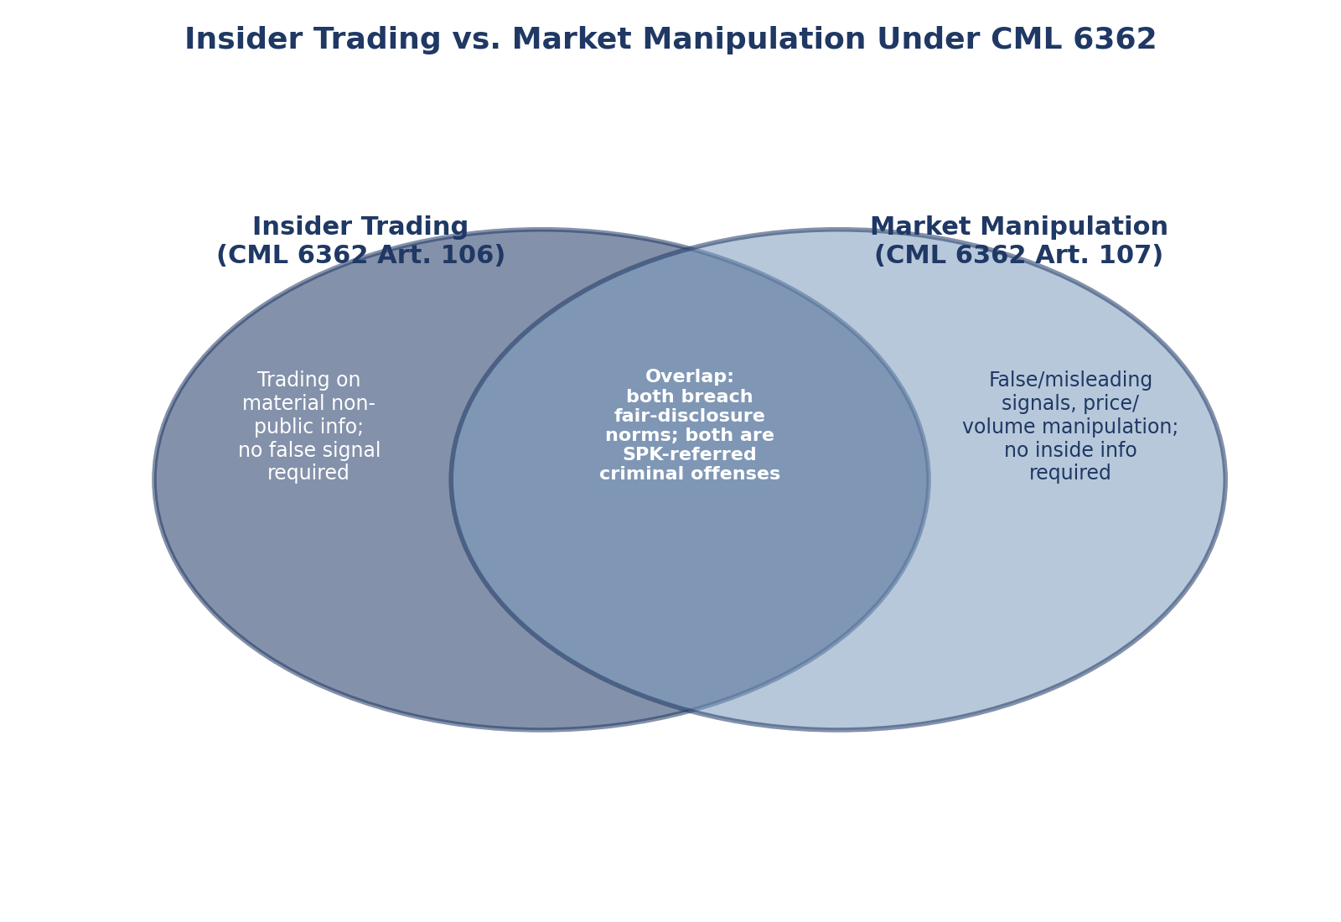
Figure 76.7: Insider trading versus market manipulation under CML 6362 — distinguishing and overlapping elements (illustrative diagram).
Table: Insider Trading versus Market Manipulation — Legal Elements and Penalties Under CML 6362
Element | Insider Trading (CML 6362 Art. 106) | Market Manipulation (CML 6362 Art. 107)
Conduct | Trading (or tipping) while in possession of material non-public information | Transactions or false/misleading statements designed to give a false or misleading impression of price/volume/demand
Information requirement | Must possess inside information | No inside information required — can be based on public rumor, social media, or wash trades
Administrative penalty | Disgorgement of gain/avoided loss plus administrative fine (SPK) | Administrative fine (SPK), typically scaled to illicit gain or a statutory minimum
Criminal penalty | 2 to 5 years' imprisonment and judicial fine (CML 6362 Art. 106) | 2 to 5 years' imprisonment and judicial fine (CML 6362 Art. 107)
Illustrative issuer scenario | A Koç Holding executive trades KCHOL shares ahead of an undisclosed material acquisition | A social-media account pumps THYAO or SAHOL shares with fabricated news ahead of a KAP filing

1.7 Comparative Snapshot: SPK, SEC, ESMA
Dimension | Turkiye (SPK / CML 6362) | United States (SEC) | European Union (ESMA / MAR)
Disclosure channel | KAP (single centralized platform, mandatory for all issuers) | EDGAR (SEC filings) plus issuer press releases | Officially Appointed Mechanisms (OAMs) per member state, harmonized under the Transparency Directive
Core anti-manipulation instrument | CML 6362 manipulation/insider-trading provisions | Securities Exchange Act Section 10(b) / Rule 10b-5 | Market Abuse Regulation (MAR, EU 596/2014)
Administrative enforcement | SPK administrative fines, trading suspensions | SEC civil penalties, disgorgement, cease-and-desist orders | National competent authorities' administrative sanctions under MAR

Part II — Current Developments 2026
This section presents four current developments that illustrate the theory and doctrine above in live operation. Each item is sourced explicitly; where a claim rests on secondary reporting of a primary regulatory or corporate disclosure rather than on the primary text itself, this is flagged.

2.1 The January 2026 Social-Media Manipulation Enforcement Wave
On 7 January 2026, the Istanbul Chief Public Prosecutor's Office announced that 17 suspects were detained on market-fraud charges in simultaneous operations centered in Istanbul and also carried out in Ankara, Gaziantep, Adana, Burdur and Aydın — six provinces in total — based on findings referred by SPK. The suspects allegedly created artificial price movements in certain Borsa İstanbul-listed shares — specifically shares of Ersan Alışveriş Hizmetleri ve Gıda Sanayi Ticaret A.Ş. (ticker: KIMMR) — through social-media-driven speculation, a fact pattern squarely within the information-based manipulation category described in Part I.6 above. Source: Euronews Türkçe, 'Borsa Istanbul'da manipülasyon soruşturmasında [English: Seventeen Detained in Borsa Istanbul Manipulation Investigation] 17 kişi gözaltına alındı,' 7 January 2026 (https://tr.euronews.com/business/2026/01/07/borsa-istanbulda-manipulasyon-sorusturmasinda-17-kisi-gozaltina-alindi).
This January 2026 wave was not an isolated event but the latest in an ongoing series of SPK-referred Borsa İstanbul manipulation investigations running from at least March 2025 through January 2026: earlier waves in March 2025, April 2025, May 2025, September 2025 and December 2025 each reportedly detained or arrested more than a dozen suspects on similar charges of establishing an organization to commit a crime and information-based market fraud. The recurrence of the same charge pattern across six documented waves in under twelve months is itself evidence relevant to the Easterbrook & Fischel/Coffee debate in Part I.2: it suggests that voluntary market discipline has not been sufficient on its own to suppress social-media-driven manipulation, consistent with the Coffee-style market-failure rationale for active regulatory enforcement rather than reliance on self-correction alone.
Table — January 2026 Enforcement Case
Field | Detail
Description | SPK-referred criminal investigation into alleged social-media-driven stock price manipulation
Scope / provinces | Six provinces: Istanbul (center), Ankara, Gaziantep, Adana, Burdur, Aydın
Target company / ticker | Ersan Alışveriş Hizmetleri ve Gıda Sanayi Ticaret A.Ş. (KIMMR), Borsa İstanbul-listed

2.2 SPK Chairman on Fund and Portfolio-Manager Discipline (November 2025 statement, background to 2026 posture)
It should be noted precisely that this statement dates to 4 November 2025, not 2026; it is presented here as the most recent on-record SPK leadership statement feeding directly into the 2026 enforcement posture described above, not as a 2026 event itself.
At the Turkey Capital Markets Congress (Türkiye Sermaye Piyasaları Kongresi) on 4 November 2025, SPK Chairman (Kurul Başkanı) İbrahim Ömer Gönül told reporters that the Board is preparing tougher measures against the misuse of investment funds for market manipulation. He stated that responsibility for such misuse rests entirely with portfolio management companies and portfolio managers, and that SPK is prepared to go 'as far as license revocation' for individual portfolio managers and, where necessary, for the portfolio management companies themselves. He also said the Board is working to further increase the existing three-to-five-year prison sentence range for manipulation offenses, subject to parliamentary action, and noted that individual-manipulation cases had already drawn record fines in the prior year, a deterrent effect he suggested had prompted bad actors to shift their conduct toward misusing investment funds instead of acting individually. Source: Bloomberg HT (Bloomberght.com), 'SPK Başkanı Gönül: Manipülasyonda portföy yöneticilerine gerekirse lisans iptali uygulamakta kararlıyız,' 4 November 2025 (https://www.bloomberght.com/spk-baskani-gonul-manipulasyonda-portfoy-yoneticilerine-gerekirse-lisans-iptali-uygulamakta-kararliyiz-3760754).
Read against Coffee's gatekeeper framework (Part I.2), Chairman Gönül's statement is a textbook illustration: when the individual-manipulator channel is deterred by high fines, bad actors reportedly migrate to a gatekeeper channel (portfolio management companies) whose professional licensing gives them capital-markets access and a veneer of legitimacy — precisely the gatekeeper-capture risk Coffee's scholarship anticipates.

2.3 Capital Markets Law Amendments on Crypto-Assets — Law No. 7518
Law No. 7518 ('Law on Amendments to the Capital Markets Law') was published in the Official Gazette on 2 July 2024 and, for the first time, brought crypto-assets within the scope of Turkish capital-markets law by amending CML 6362. The amendment added statutory definitions for 'wallet,' 'crypto asset,' 'crypto-asset service provider,' and 'crypto-asset custody service,' and placed crypto-asset service providers under SPK licensing and supervision. It also empowers SPK to authorize capital-market instruments to be issued and tracked as crypto-assets via distributed-ledger records maintained by licensed crypto-asset service providers, as an alternative to tracking solely through the Central Registry Agency (MKK). Secondary SPK Communiqués detailing the specific obligations of crypto-asset service providers were published on 13 March 2025, with an implementation timeline running to 2 January 2025 under the law's amended provisional article 11 (as reported in SPK's own press communications).
This should be understood clearly as a mid-2024 legislative change whose secondary regulations and market effects are still unfolding through 2025 and into 2026. This reader could not verify, in the sources reviewed, any new 2026 legislative amendment to Turkish capital markets law on crypto-assets beyond Law No. 7518 (2024) and its 2025 secondary Communiqués; readers should not infer a separate 2026 crypto-law change beyond what is stated here. Cite: Kanun No. 7518, Resmî Gazete, 2 July 2024; SPK secondary Communiqués on crypto-asset service providers, 13 March 2025 (spk.gov.tr press releases).

2.4 Continuous KAP Disclosure Practice — Koç, Sabancı, THY in 2026
The Turkish law-and-finance and disclosure theory developed in Part I is not abstract: it is visible in the routine, continuous KAP filings of Türkiye's largest listed groups. The following three examples, each independently sourced, illustrate material-event disclosure, periodic financial reporting, and dividend/general-assembly informative-document obligations in live operation during 2025–2026.
- Türk Hava Yolları (THY): publishes monthly passenger and cargo traffic statistics via KAP as routine periodic operational disclosure. THY filed its Q1 2026 consolidated financial statements via KAP around 29 April/8 May 2026, reporting record Q1 revenue (reported in press coverage citing KAP filings at approximately US$5.9 billion). In April 2026, THY's board decided not to distribute a dividend from FY2025 profit, a decision reported in the press as tied to geopolitical-risk considerations, in contrast with FY2024, when THY paid a cash dividend of approximately TL 6.88 gross per share. Note: the primary KAP special-situation disclosure text for the FY2025 no-dividend decision was not independently verified in this research; the claim rests on secondary press coverage citing the KAP filing.
- Sabancı Holding: made a KAP special-situation disclosure (özel durum açıklaması) regarding the sale of its approximately 39.72% stake in Akçansa to Heidelberg Materials for approximately US$1.1 billion, subject to pre-emption / right-of-first-refusal considerations under the relevant shareholders' agreement. Reported via Hürriyet Daily News among other outlets citing the KAP filing.
- Koç Holding: publishes 'Informative Documents' (Bilgilendirme Dokümanı) ahead of its ordinary General Assembly via KAP and investor-relations channels each year, including for the 2025–2026 general assembly cycle — a direct, concrete illustration of SPK's shareholder-information obligations. Koç Holding filed its Q1 2026 results via KAP around 8 May 2026, and paid a 2025 fiscal-year cash dividend with an ex-dividend date of 25 March 2026, per KAP dividend notification.
Table — Koç / Sabancı / THY KAP Disclosure Practice Comparison
Company | Ticker | Type of recent KAP disclosure | Date | Brief description | Source
Türk Hava Yolları | THYAO | Periodic financial statement + special situation (no-dividend decision) | 29 Apr–8 May 2026; Apr 2026 (dividend decision) | Record Q1 2026 consolidated revenue (~US$5.9bn per press coverage of KAP filing); board decided not to distribute FY2025 dividend, reportedly citing geopolitical risk (contrast: FY2024 dividend ~TL 6.88 gross/share) | Press coverage citing KAP; airportgundem.com; haber.aero (primary KAP text not independently verified)
Sabancı Holding | SAHOL | Special situation disclosure | 2025–2026 (reported) | Sale of ~39.72% stake in Akçansa to Heidelberg Materials for ~US$1.1bn, subject to pre-emption/ROFR considerations | Hürriyet Daily News, citing KAP filing
Koç Holding | KCHOL | Periodic financial statement + informative document + dividend notification | 8 May 2026 (Q1 results); 2025–2026 GA cycle; ex-date 25 Mar 2026 | Q1 2026 results filed via KAP; annual pre-GA Informative Document published; FY2025 cash dividend paid with ex-date 25 Mar 2026 | fintables.com; KAP dividend notification
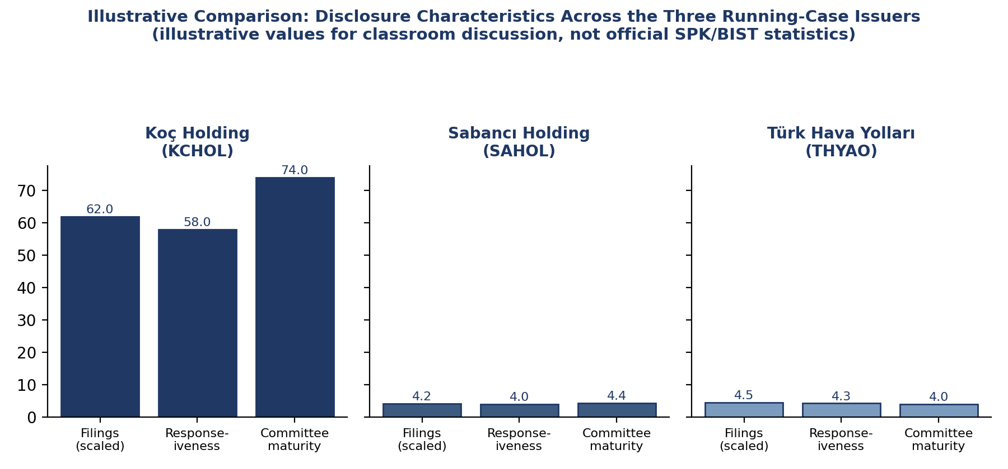
Figure 76.9: Illustrative comparison of disclosure characteristics across the three running-case issuers — Koç Holding, Sabancı Holding, and Türk Hava Yolları (illustrative values for classroom discussion).

Part III — Turkish Case Applications
The three groups above are useful teaching cases precisely because they are large, closely held (family- or holding-company-controlled) businesses of the kind the La Porta et al. (1998, 2000) law-and-finance literature identifies as needing strong statutory minority protection to sustain outside investor confidence. Each disclosure event above maps onto a distinct CML 6362 obligation:
- THY's monthly traffic disclosure and quarterly financial statements are periodic disclosure obligations — the routine backbone of the semi-strong-form efficiency mechanism Fama's EMH describes.
- THY's FY2025 no-dividend decision and Sabancı's Akçansa stake sale are event-driven special-situation disclosures — material corporate actions that CML 6362 requires be disclosed via KAP promptly.
- Koç Holding's pre-general-assembly Informative Document is a minority-protection mechanism in the La Porta et al. (2000) sense: it gives all shareholders, not only the controlling family, the information needed to exercise voting rights meaningfully.
Instructors may wish to use the January 2026 KIMMR manipulation case (Part II.1) as a contrasting example: unlike Koç, Sabancı and THY — large, closely covered, analyst-followed issuers where information asymmetry is comparatively low — KIMMR appears (based on the cited source) to be a smaller, less-covered issuer, illustrating why social-media-driven information-based manipulation risk is disproportionately concentrated in thinner, less analyst-covered names.

Part IV — Enforcement Architecture and the Two Liability Tracks

4.1 Administrative Track
SPK's administrative enforcement track operates independently of any criminal referral. Following market surveillance (conducted jointly with Borsa İstanbul's own trade-surveillance systems), SPK can impose monetary administrative fines on individuals and legal entities, order trading suspensions on specific accounts or instruments, and take licensing action against regulated professionals — brokerage staff, portfolio managers, independent auditors — up to and including license revocation. This track requires a lower evidentiary standard than criminal prosecution and can move considerably faster, which is why SPK bulletins typically report administrative fines well before, and often instead of, any criminal referral becomes public.

4.2 Criminal Track
Where SPK's investigation uncovers conduct meeting the threshold for criminal liability under CML 6362 — market manipulation or insider trading conducted with the requisite intent — the matter is referred to public prosecutors. Criminal cases proceed under ordinary Turkish criminal procedure, with the possibility of aggravated charges (such as establishing an organization to commit a crime, as charged in several of the 2025–2026 BIST manipulation waves) where multiple coordinated suspects are involved. The two tracks are not mutually exclusive: a single course of conduct frequently generates both an SPK administrative fine and a parallel criminal referral, reflecting the dual civil/criminal design common to most modern securities-enforcement regimes (compare the SEC's civil enforcement powers alongside DOJ criminal securities-fraud prosecutions, and ESMA/national-regulator administrative sanctions alongside member-state criminal sanctions under the EU's Criminal Sanctions for Market Abuse Directive).

4.3 Evidence and Surveillance
Modern manipulation cases, especially information-based manipulation conducted via social media, depend heavily on digital evidence: trading-account correlation analysis (to detect coordinated buying ahead of a promotional social-media campaign), message-board and social-media content preservation, and cooperation with telecom and platform providers to identify account holders. The January 2026 KIMMR case (Part II.1) — spanning six provinces — illustrates how manipulation networks are increasingly geographically dispersed even though the trading itself is concentrated on a single exchange, requiring coordinated multi-province law-enforcement operations rather than a single-city investigation.
Table — Glossary of Key Terms
Term | Definition
SPK | Sermaye Piyasası Kurulu — the Capital Markets Board, Türkiye's capital markets regulator
KAP | Kamuyu Aydınlatma Platformu — the Public Disclosure Platform, the mandatory centralized electronic disclosure channel
CML 6362 | Sermaye Piyasası Kanunu No. 6362 — Capital Markets Law No. 6362 (2012, as amended)

Part V — Synthesis: A Decide–Disclose–Defend Routine
For practicing executives, the theory and doctrine above converge on a simple operating routine applicable to any material corporate action:
- Decide: once a board or authorized officer reaches a decision (or a negotiation crosses a materiality threshold), the disclosure clock starts running under CML 6362's prompt-disclosure standard.
- Disclose: the material fact must be filed via KAP without undue delay, in a form and at a level of detail consistent with what a reasonable investor would need — neither buried in boilerplate nor selectively pre-briefed to any subset of investors or analysts.
- Defend: maintain a contemporaneous internal record of when information became known, why the KAP filing timing was chosen, and what steps were taken to prevent selective leakage — this record is the primary defense if SPK later scrutinizes the disclosure's timing or completeness.
This routine is directly traceable to the theory in Part I: it operationalizes Fama's semi-strong-form efficiency goal (get information into the public price-formation process promptly), it satisfies the Coffee-style gatekeeper obligation (maintain an auditable compliance record, since the issuer itself is the first-line gatekeeper of its own disclosure), and it anticipates the La Porta et al. minority-protection rationale (equal, simultaneous access to material information protects minority shareholders from being disadvantaged relative to controlling shareholders or connected insiders).

Discussion Questions
- Using Fama's (1970) EMH typology, at what level of market efficiency is KAP designed to operate, and what would evidence of continued information-based manipulation (as in the January 2026 KIMMR case) imply about how close Borsa İstanbul actually is to semi-strong-form efficiency?
- Apply Easterbrook & Fischel's (1984) skeptical logic to the Koç Holding pre-general-assembly Informative Document requirement. Would a rational, reputation-maximizing Koç Holding have produced comparably detailed shareholder information voluntarily, absent a legal mandate?
- SPK Chairman Gönül's November 2025 remarks suggest that individual manipulators are migrating toward misusing portfolio management companies once individual-level fines become sufficiently punitive. Using Coffee's gatekeeper framework, what secondary effects might tightening license-revocation risk have on the broader Turkish asset-management industry?
- Compare the SPK/CML 6362, SEC and MAR frameworks for crypto-assets. Given that Law No. 7518 (2024) is only beginning to be implemented via 2025 secondary Communiqués, what enforcement or supervisory gaps would you expect to persist into 2026–2027?
- THY's board decided against a FY2025 dividend reportedly citing geopolitical risk, while paying a substantial dividend for FY2024. From a disclosure-theory perspective, what obligations, if any, should attach to the qualitative narrative accompanying a dividend decision, beyond the bare numerical fact of paying or not paying?

References
- Akerlof, G. A. (1970). The Market for 'Lemons': Quality Uncertainty and the Market Mechanism. Quarterly Journal of Economics, 84(3), 488–500.
- Coffee, J. C. (2006). Gatekeepers: The Professions and Corporate Governance. Oxford University Press.
- Easterbrook, F. H., & Fischel, D. R. (1984). Mandatory Disclosure and the Protection of Investors. Virginia Law Review, 70(4), 669–715.
- Fama, E. F. (1970). Efficient Capital Markets: A Review of Theory and Empirical Work. Journal of Finance, 25(2), 383–417.
- La Porta, R., Lopez-de-Silanes, F., Shleifer, A., & Vishny, R. W. (1998). Law and Finance. Journal of Political Economy, 106(6), 1113–1155.
- La Porta, R., Lopez-de-Silanes, F., Shleifer, A., & Vishny, R. W. (2000). Investor Protection and Corporate Governance. Journal of Financial Economics, 58, 3–27.
- Kanun No. 7518 (2024). Sermaye Piyasası Kanununda Değişiklik Yapılmasına Dair Kanun. Resmî Gazete, 2 July 2024.
- SPK (Sermaye Piyasası Kurulu). Secondary Communiqués on crypto-asset service providers, 13 March 2025 (spk.gov.tr press releases).
- Euronews Türkçe (2026). Borsa İstanbul'da manipülasyon soruşturmasında 17 kişi gözaltına alındı. 7 January 2026. https://tr.euronews.com/business/2026/01/07/borsa-istanbulda-manipulasyon-sorusturmasinda-17-kisi-gozaltina-alindi
- Bloomberg HT (2025). SPK Chairman Gönül: We Will Revoke Licenses of Portfolio Managers Involved in Manipulation If Necessary [original Turkish: SPK Başkanı Gönül: Manipülasyonda portföy yöneticilerine gerekirse lisans iptali uygulamakta kararlıyız. 4 November 2025. https://www.bloomberght.com/spk-baskani-gonul-manipulasyonda-portfoy-yoneticilerine-gerekirse-lisans-iptali-uygulamakta-kararliyiz-3760754
- Hürriyet Daily News. Coverage of Sabancı Holding's sale of its Akçansa stake to Heidelberg Materials, citing KAP filing.
- Press coverage (airportgundem.com; haber.aero) of Türk Hava Yolları Q1 2026 results and FY2025 dividend decision, citing KAP filings.
- fintables.com. Coverage of Koç Holding pre-general-assembly Informative Document and Q1 2026 results, citing KAP filings.
- Capital Markets Law No. 6362 (Sermaye Piyasası Kanunu), enacted 2012, as amended, including by Law No. 7518 (2024).

Part I-B — Deeper Theoretical Foundations (Expanded Doctrine)

1.8 The Three Forms of Market Efficiency, Restated and Extended
Fama’s 1970 taxonomy is frequently cited but rarely unpacked in the detail a disclosure-policy analysis requires. It is worth restating each form precisely, and then asking what each implies for the design of a mandatory disclosure statute such as CML 6362.
Weak-form efficiency holds that current prices fully reflect all information contained in the history of past prices and trading volume. If weak-form efficiency holds, technical analysis — attempting to predict future price movements from charts of past price movements alone — cannot generate abnormal risk-adjusted returns, because any pattern in past prices that could predict future prices would already have been arbitraged away by traders exploiting it. The regulatory implication of weak-form efficiency is comparatively modest: it says nothing about whether firms disclose information honestly or completely, only that whatever information is embedded in trading history is already priced. A regulator focused solely on weak-form efficiency would have little reason to mandate disclosure at all; its natural policy focus would instead be on trading-mechanism integrity (fair order execution, prevention of front-running, market microstructure quality) rather than substantive disclosure content.
Semi-strong-form efficiency holds that prices fully reflect all publicly available information, not merely past prices — financial statements, dividend announcements, merger news, macroeconomic releases and regulatory disclosures are held to be incorporated into price rapidly upon public release. This is the level of efficiency that mandatory disclosure regulation is most directly aimed at sustaining: if the semi-strong-form hypothesis is to hold in a given market, there must first exist a reliable, timely, complete channel through which “publicly available information” actually becomes public in the first place. Disclosure regulation does not test the semi-strong-form hypothesis; it manufactures the precondition for it to be even meaningfully testable. This is the analytic backbone of the KAP-as-infrastructure argument developed in section 1.1 above: KAP does not by itself guarantee semi-strong-form efficiency (prices could still fail to react correctly, quickly, or completely to genuinely disclosed information, an empirical question about investor sophistication and market liquidity), but it removes one necessary condition failure — the absence of a reliable public disclosure channel — that would otherwise make semi-strong efficiency impossible even in principle.
Strong-form efficiency holds that prices reflect all information, public and private, including material non-public information known only to corporate insiders. Empirically, strong-form efficiency essentially never holds in any real securities market, precisely because insiders who trade on genuinely private information can and demonstrably do earn abnormal returns before that information becomes public — this is the empirical premise, not merely the moral premise, underlying insider-trading law. If markets were strong-form efficient, insider trading would be a redundant activity generating no abnormal profit, because the information would already be in the price; the fact that insider-trading prosecutions can demonstrate abnormal, information-driven trading profits is itself indirect empirical evidence that strong-form efficiency fails in practice. CML 6362’s insider-trading prohibition (Article 106) can therefore be read two ways simultaneously: as a fairness rule protecting outside investors from an unfair informational disadvantage, and as a market-integrity rule aimed at preventing insiders from profiting from — and thereby further entrenching — the gap between semi-strong and strong-form efficiency, a gap mandatory disclosure is designed to narrow but can never fully close, because some information (ongoing negotiations, unformed strategic plans, real-time operational data) is inherently impossible to disclose the instant it comes into existence.

Table 1.8 — The Three Forms of Efficiency and Their Regulatory Correlates
Form | Information set reflected in price | What would refute it | Primary regulatory correlate
Weak-form | Past prices and volume | Profitable technical-analysis trading rules, net of costs | Market microstructure and trading-integrity rules (order handling, best execution)
Semi-strong-form | All publicly available information | Abnormal returns from public information (e.g., published financial ratios) | Mandatory disclosure regime (KAP, periodic and event-driven filings) — CML 6362
Strong-form | All information, public and private, including insider information | Abnormal, statistically anomalous returns earned by corporate insiders | Insider-trading prohibition (CML 6362 Art. 106) and information barriers (“Chinese walls”) within regulated intermediaries

1.9 The Mandatory Disclosure Debate, Fully Joined: Coffee’s Market-Failure Rationale versus Stigler’s Self-Regulation Skepticism
The existing coursepack develops the Easterbrook & Fischel (1984) versus Coffee (2006) debate. It is useful, for a graduate audience, to trace this debate back one further generation to George Stigler, whose 1964 paper “Public Regulation of the Securities Markets” (Journal of Business, 37(2), 117-142) is the origin point of the empirical skepticism that Easterbrook and Fischel later formalized in law-and-economics terms, and forward to John Coffee’s earlier and more explicitly market-failure-centered 1984 article, “Market Failure and the Economic Case for a Mandatory Disclosure System” (Virginia Law Review, 70(4), 1984, 717-753) — published, not coincidentally, in the same 1984 volume of the Virginia Law Review as Easterbrook and Fischel’s article, the two pieces having been written explicitly as opposing contributions to the same scholarly exchange.
Stigler’s empirical challenge was direct: using data on new securities issues before and after the U.S. Securities Act of 1933 introduced mandatory disclosure, Stigler found no statistically robust evidence that mandatory disclosure improved the average investment performance of purchasers of new issues relative to the pre-1933 period. If mandatory disclosure produced no measurable improvement in investor returns, Stigler argued, its principal effect was not investor protection but a transfer of compliance costs from investors (who would otherwise have priced risk into securities) to issuers and, ultimately, back to the economy as a whole in the form of a higher cost of capital and reduced capital formation — a direct ancestor of the compliance-cost skepticism that Easterbrook and Fischel would later restate as a matter of theory two decades on. Later scholars (notably Stigler’s University of Chicago colleagues and subsequent event-study researchers) have contested Stigler’s specific empirical methodology — critics point out that his sample and event windows may not isolate mandatory disclosure’s effect from a range of confounding macroeconomic factors present in the 1920s-1930s comparison period — but the paper remains the founding document of self-regulation skepticism in securities law scholarship, and its core empirical challenge (does mandatory disclosure demonstrably improve outcomes, and for whom?) still structures the debate.
Coffee’s 1984 article supplies the theoretical rejoinder that Stigler’s data alone does not resolve: Coffee argues that securities information has the structural characteristics of a public good — once produced and released, it is both non-excludable (an issuer cannot practically prevent free-riding investors and analysts who did not pay for the disclosure’s production from using it) and non-rivalrous (one investor’s use of disclosed information does not diminish another’s ability to use the same information). Here's the practical bite of that idea. Koç Holding pays the full cost of preparing an audited annual report, but most of the benefit — a more accurately priced KCHOL, better-informed investors market-wide — flows to people who never paid Koç a lira for that information. If disclosure were purely voluntary, Koç would rationally under-produce it, the same way any firm under-produces a public good it can't fully monetize. Coffee's 1984 point is that this is not a minor inefficiency — it's the same structural problem economists have long identified with public goods generally, just applied to disclosure for the first time with real rigor. That's also the direct ancestor of his 2006 gatekeeper thesis (section 1.2 above): if voluntary disclosure under-supplies information because of its public-good nature, then mandatory disclosure rules — and independent gatekeepers like auditors checking the numbers — aren't bureaucratic overreach. They're a targeted fix for a specific, well-understood market failure.
Here's why this three-way debate (Stigler vs. Coffee vs. Easterbrook & Fischel) isn't just academic for an SPK policymaker. The January 2026 social-media manipulation wave (Part VII) happened despite decades of mandatory KAP disclosure. You can read that fact two ways. Reading one, in Stigler's tradition: disclosure rules simply can't stop manipulation, so SPK's money is better spent on prosecutions and market-structure fixes than on writing ever more detailed disclosure rules. Reading two, in Coffee's tradition: the public-goods problem hasn't gone away — it has just moved to thinly covered, low-analyst-attention names (unlike Koç, Sabancı, or THY, which get heavy analyst coverage) where voluntary information production is still inadequate, which argues for more targeted mandatory disclosure in exactly that segment. Both readings fit the same enforcement data. Working out which one you believe — and why — is the point of the discussion questions in Part XI.

1.10 The “Law Matters” Thesis in Full: Legal Origins, Agency Costs and Investor Protection
The existing coursepack (section 1.3) introduces La Porta, Lopez-de-Silanes, Shleifer and Vishny’s 1998 and 2000 papers. Because this is one of the most heavily cited (and heavily contested) research programs in corporate and securities law scholarship, it merits a fuller treatment than a summary paragraph.
The 1998 “Law and Finance” paper’s central empirical claim rests on a hand-coded “anti-director rights index” across 49 countries, scoring each country’s corporate law on measures such as whether shareholders can vote by mail, whether shares are blocked before a general meeting, whether cumulative voting or proportional board representation is available, whether an oppressed-minority mechanism exists, and the size of the shareholding required to call an extraordinary shareholders’ meeting. La Porta et al. found that common-law countries (the English legal-origin family) score systematically higher on this index than civil-law countries, and that within the civil-law family, French-origin legal systems score lowest, with German- and Scandinavian-origin systems scoring intermediate. The paper’s central causal claim — legal origin, largely a historical accident of which colonial or imperial legal system a country inherited, has persistent, quasi-exogenous effects on investor-protection law that a country’s subsequent legislature finds difficult fully to overcome — is precisely what generated the paper’s enormous influence and its equally substantial volume of criticism.
The 2000 “Investor Protection and Corporate Governance” paper (Journal of Financial Economics) reframes the same evidence around what is now generally called the “agency costs of outside shareholders” model. Its structure is straightforward: managers and controlling shareholders (in La Porta et al.’s language, “insiders”) have both the opportunity and, absent legal constraint, the incentive to divert corporate resources to themselves at outside investors’ expense — through outright theft, transfer pricing to affiliated firms, excessive executive compensation, dilutive share issuances to insiders, or asset sales to related parties below fair value (each of these mechanisms is what Turkish company law and CML 6362 term, collectively, “related-party transaction” risk). Legal protection of minority and outside shareholders — mandatory disclosure of related-party transactions, minority approval requirements for conflicted transactions, appraisal or “sell-out” rights, and credible enforcement of fiduciary duties — functions as a substitute for the private contractual protections that outside investors cannot individually negotiate ex ante with a diffuse, unobservable set of future insiders. Where legal protection is weak, La Porta et al. argue, rational outside investors will simply refuse to invest except at a steep valuation discount reflecting expected expropriation risk, which in turn caps the depth and liquidity of that country’s equity market and pushes ownership toward concentrated, family- or group-controlled structures (precisely the ownership pattern of Koç Holding and Sabancı Holding, discussed in Part III) because only insiders trusted enough to avoid triggering costly minority litigation, or large enough to internalize monitoring costs themselves, are willing to hold controlling stakes.
Applied to Türkiye specifically: CML 6362’s 2012 replacement of the older 1981 Capital Markets Law is properly read, in the La Porta et al. framework, as a legislative attempt to raise Türkiye’s investor-protection score directly, by statute, rather than waiting for legal-origin path-dependency to resolve itself organically — mandatory tender-offer thresholds upon a change of control, related-party transaction disclosure and independent-director approval requirements, and squeeze-out/sell-out mechanics for minority shareholders following a successful tender offer are all textbook “La Porta 2000” minority-protection mechanisms, deliberately engineered into a civil-law statute precisely because the La Porta et al. framework predicts that civil-law legal origin alone would not have generated them without explicit legislative action.
It is important, for balanced graduate treatment, to note the principal scholarly criticisms of the La Porta et al. program, most prominently associated with the “legal origins” critique literature (see, e.g., work by Holger Spamann and others reconstructing the anti-director rights index using primary legal sources rather than secondary summaries, and finding the original coding contains significant errors that weaken some of the reported correlations). These criticisms do not overturn the La Porta et al. program’s broad influence on securities-law design worldwide, but they are a necessary caveat: readers should treat the “legal origin determines investor protection determines market depth” causal chain as an influential and empirically grounded hypothesis that has shaped regulatory design globally (including, arguably, Türkiye’s own 2012 CML reform), rather than as an uncontested empirical fact. [Note for verification: the Spamann re-coding critique is well established in the literature; readers requiring an exact citation should verify against Spamann, H. (2010), “The ‘Antidirector Rights Index’ Revisited,” Review of Financial Studies, 23(2), 467-486, which this reader cites for completeness but has not independently re-verified page numbers against a primary copy.]

1.11 The Insider Trading Debate: Manne’s Efficiency Argument versus the Fairness/Fiduciary-Duty Tradition
No graduate treatment of insider-trading doctrine is complete without Henry Manne’s “Insider Trading and the Stock Market” (Free Press, 1966), the foundational — and still the most provocative — pro-insider-trading-legalization argument in the securities-law literature. Manne’s thesis runs against the grain of virtually every actual insider-trading statute in the world, including CML 6362 Article 106, which is precisely why it remains a standard teaching text: understanding why regulators rejected Manne’s logic sharpens the case for the regime they built instead.
Manne argued, first, that insider trading is an efficient compensation mechanism for entrepreneurial and managerial contribution that is otherwise difficult to price and reward through ordinary salary or bonus schemes — an executive who has generated genuinely valuable private information about the firm’s prospects (a specific innovation, an unannounced deal, materially superior forthcoming earnings) captures the value of that contribution by trading on the information before it is public, in lieu of a formal but imperfectly calibrated bonus. Second, and more directly relevant to Fama’s efficiency framework, Manne argued that insider trading is itself a mechanism of price discovery: an insider’s trade impounds private information into the market price faster than a mandatory-disclosure-only regime would, moving the market toward strong-form efficiency (or at least closer to it) via voluntary, incentive-compatible private action rather than waiting for the (potentially non-existent) moment a firm chooses to disclose. Third, Manne argued that insider trading imposes no identifiable victim in the ordinary tort sense: a seller who sells shares to an informed insider-buyer would, Manne argued, have sold at approximately the same price to an uninformed counterparty in any case, since impersonal exchange trading does not match specific buyers with specific sellers who could have negotiated around the informational asymmetry.
The fairness/fiduciary-duty counter-tradition — which is the doctrinal basis actually adopted by virtually every developed securities-law system, including the U.S. Rule 10b-5 “misappropriation” and “classical” theories of insider-trading liability and CML 6362 Article 106 — rejects each Manne premise on different grounds. On the compensation argument: modern corporate-governance scholarship (largely post-Manne) responds that permitting insider trading as informal compensation creates a perverse incentive for insiders to manufacture, delay, or selectively time the release of value-relevant information specifically to maximize their own trading profit, rather than to serve the corporation’s or shareholders’ interests — precisely the moral-hazard problem that fiduciary-duty law is designed to prevent, since it substitutes an unaccountable, undisclosed, self-dealing compensation channel for the transparent, board-approved compensation mechanisms that corporate law otherwise requires. On the price-discovery argument: critics (including, notably, later empirical work summarized in securities-regulation casebooks) respond that even if insider trading does impound information into price somewhat faster than waiting for formal disclosure, it does so at the cost of a systematically less liquid, less trusted market overall — outside investors who correctly anticipate that insiders may be trading against them systematically demand a larger liquidity discount (a wider bid-ask spread, a lower willingness to hold the stock at all), which raises the issuer’s cost of capital and can more than offset any efficiency gain from marginally faster price discovery; this is essentially an adverse-selection argument in the Akerlof (1970) “market for lemons” tradition already introduced in this coursepack’s Introduction. On the no-victim argument: fairness-tradition scholars respond that even in an impersonal, anonymous exchange market, the counterparty who unknowingly trades against an informed insider is harmed relative to the counterfactual of a fully informed market, and that the harm is compounded systemically: a market perceived as tilted toward insiders erodes the broader investing public’s willingness to participate at all, a market-integrity harm distinct from, and more consequential than, any single transaction’s fairness.
CML 6362 Article 106’s choice of a criminal, imprisonment-backed prohibition (three to five years, per the SPK Chairman’s November 2025 remarks discussed in Part II.2, subject to a possible legislative increase) situates Turkish law firmly and unambiguously in the fairness/fiduciary-duty tradition rather than the Manne tradition — a policy choice Türkiye shares with essentially every G20 jurisdiction, reflecting the near-total scholarly and regulatory rejection of Manne’s specific legalization proposal, notwithstanding the continuing pedagogical value of Manne’s efficiency argument as a foil against which the accepted doctrine can be tested and understood.

1.12 Market Manipulation Typologies and CML 6362 Articles 106-107: Elements of the Offenses
Market manipulation is not a single offense but a family of distinct fact patterns, each with a recognizable typology in the international securities-enforcement literature (SEC and IOSCO practice, in particular, use broadly the same typology vocabulary as Turkish practitioner commentary on CML 6362 Article 107). It is useful to set out the standard typologies before mapping each onto the statutory elements of CML 6362 Article 107.
Pump-and-dump is the most familiar typology to a lay audience: a promoter (often, in the contemporary fact pattern most relevant to the January 2026 KIMMR case discussed in Part II.1 and Part VII below, operating through social media, messaging-app groups, or online forums) builds a position in a thinly traded, low-float security, then disseminates false, exaggerated or misleading positive information or price predictions to attract retail buying interest, driving the price up (the “pump”), before selling into the resulting buying pressure at the inflated price (the “dump”), leaving later retail purchasers holding shares that subsequently revert toward, or below, the pre-campaign price. Pump-and-dump is squarely information-based manipulation under CML 6362 Article 107(2) (bilgi bazlı piyasa dolandırıcılığı) when it rests on disseminated false or misleading statements, though it frequently overlaps with Article 107(1) (transaction-based manipulation, işlem bazlı piyasa dolandırıcılığı) where the promoter also engages in coordinated buying among confederates to create an artificial appearance of trading demand independent of the promotional statements themselves.
Wash trading involves a trader (or a coordinated group of traders, frequently using multiple linked or nominee accounts) buying and selling the same security between accounts they control, or between accounts of colluding parties, with no genuine change in beneficial ownership or economic risk, purely to create a false appearance of trading volume and price momentum that induces other market participants to trade on the mistaken inference that the security is experiencing genuine, arm’s-length demand. Wash trading is the paradigm case of transaction-based manipulation under CML 6362 Article 107(1): the offense turns on the artificiality of the transactions themselves (their lack of genuine economic substance), not on any false statement.
Spoofing (and its close relative, layering) involves placing bid or offer orders with no intention of ever executing them, in order to create a false impression of supply or demand at a given price level, inducing other market participants to trade in a direction favorable to the spoofer, followed by rapid cancellation of the spoofing orders before they can be executed against. Spoofing is a relatively recent addition to enforcement practice globally (it became a prominent enforcement priority in the United States following the 2010 “Flash Crash” and the subsequent prosecution of Navinder Sarao, discussed further in Part VI below) and depends on order-book-level surveillance data (order entry and cancellation timestamps, not merely executed-trade data) that only became practically available to regulators with the maturation of electronic-market surveillance technology; SPK’s and Borsa İstanbul’s joint trade-surveillance systems (referenced in Part IV.1 of the existing coursepack) are the Turkish institutional analogue to the order-book surveillance infrastructure that made U.S. and European spoofing enforcement practically possible. Spoofing falls under CML 6362 Article 107(1) as a transaction/order-based manipulation, since — like wash trading — its manipulative character lies in the artificiality of the order-placement conduct itself rather than in any disseminated statement.
Table 1.12 — Manipulation Typologies Mapped to CML 6362 Article 107
Typology | Mechanism | CML 6362 provision | Turkish/international illustrative case
Pump-and-dump | False/misleading promotional statements (often social media) inflate price before insider sells | Art. 107(2), often combined with Art. 107(1) | January 2026 KIMMR case (Part II.1); ASUZU/EUREN social-media case (Part VII)
Wash trading | Coordinated or self-matched trades with no genuine change in beneficial ownership | Art. 107(1) | Tera Yatırım / Vişne Madencilik administrative fine case (Part VII)
Spoofing / layering | Non-bona-fide orders placed and cancelled to create false supply/demand appearance | Art. 107(1) | U.S. Navinder Sarao “Flash Crash” spoofing prosecution (Part VI, comparative reference)
Article 106 (insider trading) requires, as elements: (i) possession of information that is material (likely to affect the price or an investor’s decision) and non-public; (ii) a qualifying relationship giving rise to the possession of that information (an officer, director, employee, professional advisor, controlling shareholder, or a “tippee” who received the information from such a person); and (iii) trading (or recommending/tipping another to trade) a capital-market instrument on the basis of that information before it becomes public. Article 107 (market manipulation), by contrast, requires no informational-asymmetry element at all — its elements are (i) conduct (a transaction, order, or the dissemination of information) that (ii) creates, or is likely to create, a false or misleading appearance as to the supply, demand, or price of a capital-market instrument, undertaken (iii) with the intent (or, under some interpretations discussed in Turkish practitioner commentary, the objective likelihood) of misleading market participants. This structural difference — Article 106 requires an informational advantage but not a false appearance; Article 107 requires a false appearance but not any informational advantage — is the analytic key to the comparison table in section 1.6 of the existing coursepack and is repeated, in expanded form, in Part VIII below.

Part VI — Popular Global Capital Markets Law Cases: Full Vignettes
This Part collects seven widely known capital-markets-law episodes that graduate students of comparative securities regulation are expected to recognize and be able to discuss. Each vignette is deliberately written at “case study” length (approximately one page or more) rather than as a one-line reference, because the pedagogical value of these cases lies in their factual texture — the specific mechanism of the fraud or manipulation, the specific regulatory or prosecutorial response, and the specific doctrinal lesson each teaches. Facts below reflect the widely reported public record; where a specific figure (a dollar amount, a sentence length) is stated, instructors and students using this reader for citation purposes should verify it against a primary source (a court filing, an SEC litigation release, or the company’s own regulatory filings) before using it in written work, as press accounts of complex financial fraud cases not infrequently contain minor factual variance across outlets.

6.1 Martha Stewart and the ImClone Systems Insider Trading Case (2001-2004)
The Martha Stewart/ImClone matter remains the most culturally famous insider-trading case in American securities-law history, not because of its size (the trade at issue involved a comparatively modest sum) but because of who was involved and what she was ultimately convicted of. In December 2001, ImClone Systems’ founder and CEO, Samuel Waksal, learned in advance that the U.S. Food and Drug Administration was about to reject ImClone’s application for its cancer drug Erbitux — material, non-public information that would predictably cause ImClone’s share price to fall sharply once announced. Waksal attempted to sell his own ImClone shares and tipped family members to sell theirs ahead of the public announcement. Martha Stewart, a friend of Waksal’s and a client of the same Merrill Lynch broker (Peter Bacanovic, acting through his assistant Douglas Faneuil), sold her entire ImClone stake — several thousand shares — on 27 December 2001, the day before the FDA rejection was publicly announced, after allegedly being tipped that Waksal was selling. Stewart avoided a loss of only tens of thousands of dollars by the sale, a strikingly small amount relative to the scale of the prosecution that followed and relative to Stewart’s overall net worth at the time.
The doctrinal lesson of the case lies less in the underlying trade than in what Stewart was actually convicted of: she was never charged with, nor convicted of, insider trading itself, because prosecutors concluded the evidentiary case for a completed insider-trading charge against her personally was not strong enough to bring. Instead, Stewart was convicted in March 2004 on charges of conspiracy, obstruction of justice, and making false statements to federal investigators — she and Bacanovic had given investigators a cover story (that they had a pre-existing agreement to sell if ImClone’s price fell below a set threshold) that investigators determined was fabricated after the fact to disguise the tip-based reason for the sale. Stewart served five months in federal prison. Waksal, who did plead guilty to insider trading and related charges, received a substantially longer sentence (approximately seven years) and a multi-million-dollar fine. The case is a standard teaching example of two distinct but related lessons for a capital-markets-law audience: first, that the cover-up, not the underlying trade, is very often the more prosecutable and more severely punished offense in a securities investigation (a pattern that recurs across many jurisdictions, including in Turkish criminal-procedure practice where obstruction and false-statement offenses can attach independently of the underlying capital-markets charge); and second, that the tipper-tippee liability chain (Waksal to his family and associates; the informational chain reaching Stewart via Bacanovic’s office) illustrates why insider-trading law extends liability beyond the original corporate insider to those who receive and act on a tip, a structure directly analogous to CML 6362 Article 106’s coverage of persons who receive inside information “from” a qualifying insider relationship.

6.2 Raj Rajaratnam and the Galleon Group Prosecution (2009-2011)
The Galleon Group case is the largest and most structurally elaborate hedge-fund insider-trading prosecution in U.S. history and is frequently taught as the paradigmatic example of a systematic, network-based insider-trading operation, as opposed to an isolated, one-off tip. Raj Rajaratnam, founder of the Galleon Group hedge fund, was arrested in October 2009 following a multi-year FBI investigation that, notably, used court-authorized wiretaps of Rajaratnam’s phone calls — a surveillance technique previously associated primarily with organized-crime and narcotics investigations, and its use here signaled a marked escalation in the aggressiveness of U.S. insider-trading enforcement technique. The wiretaps captured Rajaratnam receiving and discussing material non-public information from an extensive network of corporate insiders and consultants at companies including Goldman Sachs (from board member Rajat Gupta), Intel, McKinsey & Company, IBM and others, information Rajaratnam used to trade ahead of earnings announcements, merger news, and other material corporate events across dozens of securities over several years. Rajaratnam was convicted in May 2011 on charges including conspiracy and securities fraud and sentenced to eleven years in federal prison — at the time, the longest sentence ever imposed for insider trading in the United States — along with financial penalties reported in the tens of millions of dollars. Rajat Gupta, the former Goldman Sachs board member and McKinsey managing director who tipped Rajaratnam, was separately convicted in 2012 and received a shorter prison sentence, illustrating the differentiated liability the U.S. system imposes as between the primary trading beneficiary and the tipping insider.
The Galleon case’s doctrinal significance for a comparative capital-markets course rests on three points. First, it demonstrates how insider-trading enforcement, when it reaches genuinely networked, multi-tip conduct rather than a single isolated trade, converges methodologically with organized-crime investigation technique — wiretaps, cooperating-witness agreements, and pattern analysis across dozens of trades — a convergence with direct relevance to the Turkish enforcement pattern discussed in Part VII, where SPK-referred prosecutors have charged manipulation-ring defendants with the aggravated offense of “establishing an organization to commit a crime” (suç işlemek amacıyla örgüt kurma) precisely because Turkish prosecutors, like their U.S. counterparts in Galleon, concluded that a networked, multi-participant scheme warranted the more serious organized-crime-adjacent charge rather than treating each trade as an isolated offense. Second, the case illustrates the tippee-liability doctrine central to U.S. Rule 10b-5 jurisprudence (later refined by the U.S. Supreme Court in Salman v. United States, 2016, and Newman/subsequent circuit-court litigation over what “personal benefit” a tipper must receive for tippee liability to attach) — a doctrinal question CML 6362 Article 106 answers more simply by extending liability to any person who receives inside information through a qualifying relationship, without requiring proof of a specific quid-pro-quo “personal benefit” to the tipper of the kind U.S. case law has required. Third, the scale of the financial recovery (SEC civil penalties and disgorgement in the Galleon-related matters totaled several hundred million dollars in aggregate across the various defendants) illustrates the civil-penalty dimension of U.S. enforcement running in parallel with the criminal prosecution, directly analogous to the dual administrative/criminal liability tracks under CML 6362 discussed in Part IV of the existing coursepack.

6.3 GameStop and the January 2021 “Meme Stock” Episode: A Market-Manipulation-versus-Collective-Action Gray Zone
The GameStop episode of January 2021 is pedagogically distinct from the preceding two cases because it does not present a clean insider-trading or classic-manipulation fact pattern; instead, it is most useful as a teaching vehicle for the genuinely contested boundary between (a) lawful, if highly coordinated, collective retail investment activity and (b) unlawful manipulation. GameStop Corp., a struggling brick-and-mortar video-game retailer, had attracted substantial short-selling interest from hedge funds (reported short interest exceeded 100% of GameStop’s public float at various points, a mathematically possible but highly unusual condition arising from repeated re-lending of borrowed shares). Beginning in January 2021, a large, loosely coordinated community of retail investors, organized primarily through the Reddit forum r/WallStreetBets, began publicly and collectively encouraging purchases of GameStop shares and out-of-the-money call options, explicitly framing the trade in part as a deliberate effort to force a “short squeeze” — a dynamic in which rising prices force short sellers to buy shares to cover their positions, which in turn drives prices higher still, creating a reflexive feedback loop. GameStop’s share price rose from roughly $20 in early January 2021 to an intraday peak above $480 by 28 January 2021, before falling sharply in the following days and weeks. Several major retail brokerages, most prominently Robinhood, restricted purchases (though not sales) of GameStop and several related “meme stocks” on 28 January 2021, citing clearing-house collateral requirements imposed by the Depository Trust & Clearing Corporation (DTCC) — a decision that triggered a separate wave of public controversy, congressional hearings, and litigation over whether the restriction itself was an improper intervention favoring short-selling institutions over retail investors.
The regulatory and academic debate the episode generated centers on whether collective, publicly announced, non-fraudulent retail trading coordinated via social media constitutes market manipulation at all under U.S. law, given that Rule 10b-5 and related manipulation doctrine has historically been built around fact patterns involving false statements, wash trading, or other forms of deception — none of which were clearly present in the GameStop episode, where participants openly and truthfully stated their intent to drive up the price and force a short squeeze, rather than disguising a manipulative purpose behind false information. The SEC’s own subsequent staff report (October 2021) concluded that the GameStop trading did not appear to meet the elements of manipulation as conventionally defined, while flagging concerns about market structure issues (payment for order flow, gamification of retail trading apps, and the clearing-and-settlement mechanics that produced the Robinhood trading restrictions) as the more tractable regulatory targets arising from the episode. For a Turkish audience, the GameStop case is a useful contrast to the KIMMR and ASUZU cases discussed in Part VII: those Turkish cases involved allegedly false or misleading social-media statements about specific companies’ prospects (information-based manipulation squarely within CML 6362 Article 107(2)), whereas the GameStop episode’s defenders argued — with substantial force, and with the SEC’s own subsequent analysis lending it credibility — that open, truthful, collectively coordinated retail buying, without any false statement about the underlying company, sits in a genuinely different legal category, testing the outer boundary of where “creating a false or misleading appearance of demand” (the Article 107(1) standard) shades into simply a very large number of individually truthful investors expressing a genuine, if collectively reinforcing, view.

6.4 Volkswagen’s “Dieselgate” as a Disclosure and Securities-Fraud Case (2015- )
The Volkswagen emissions scandal, publicly disclosed beginning 18 September 2015 when the U.S. Environmental Protection Agency issued a notice of violation, is more commonly taught in environmental-law and corporate-compliance courses, but it is directly relevant to a capital-markets-law syllabus because of its securities-fraud and disclosure dimension, which is frequently underemphasized relative to its regulatory-compliance dimension. Volkswagen admitted that it had installed “defeat device” software in approximately eleven million diesel vehicles worldwide, engineered to detect when a vehicle was undergoing emissions testing and to alter engine performance during the test to produce compliant nitrogen-oxide emissions readings, while allowing the same vehicles to emit pollutants at up to forty times the permitted limit during ordinary road driving. The securities-law dimension of the case arises because Volkswagen’s American Depositary Receipts (ADRs) trade in the U.S. over-the-counter market, and because Volkswagen’s own public disclosures and statements to investors — regarding the company’s environmental compliance, the “clean diesel” marketing claims underlying a substantial part of its diesel vehicle sales strategy, and its own internal risk disclosures — became the basis for a substantial wave of U.S. and European securities-fraud litigation brought by investors who purchased Volkswagen securities at prices that, plaintiffs alleged, were inflated by the company’s non-disclosure of the defeat-device scheme and the attendant regulatory and reputational risk.
Volkswagen ultimately reached settlements in the U.S. securities litigation and separately paid over $30 billion in total global fines, buyback costs, and settlements across consumer, environmental and securities claims combined (the securities-specific component is a subset of this total and should be verified against primary settlement documents if cited precisely); in Germany, a separate and closely watched securities-law proceeding before the Braunschweig Regional Court addressed shareholder claims that Volkswagen’s supervisory board and management board had violated German capital-markets disclosure law (specifically, the ad hoc disclosure duty under the German Securities Trading Act, analogous in function to CML 6362’s special-situation disclosure duty) by failing to disclose the defeat-device risk to the market promptly once it became known internally, rather than waiting until the U.S. EPA’s public notice forced disclosure. The German proceedings, and parallel proceedings in other EU jurisdictions under the EU’s Market Abuse Regulation framework (discussed further in section 6.7 below), turned substantially on a question of exquisite relevance to CML 6362’s “prompt disclosure” standard discussed in section 1.4 of the existing coursepack: at what point does a company’s internal knowledge of a material risk — as opposed to the risk’s full external manifestation via a regulator’s public notice — trigger the mandatory ad hoc/special-situation disclosure duty? Volkswagen’s defense maintained that the full scope and legal exposure of the defeat-device issue was not sufficiently crystallized internally, in a way meeting the legal materiality and certainty threshold, until closer to the EPA’s public notice; plaintiffs argued that Volkswagen’s own engineers and senior compliance personnel had known of the defeat-device scheme, and its attendant legal risk, for a considerably longer period before the public disclosure occurred. This “how early is early enough” disclosure-timing question is directly analogous to the “Decide-Disclose-Defend” routine set out in Part V of the existing coursepack, and Dieselgate remains one of the highest-profile real-world tests of exactly that timing question at the very largest corporate scale.

6.5 Wirecard’s Accounting Fraud and BaFin’s Regulatory Failure (2019-2020)
Wirecard AG, a German payments-processing company that had risen to become a DAX-30 constituent and one of Europe’s most celebrated fintech success stories, collapsed into insolvency on 25 June 2020 after admitting that approximately €1.9 billion supposedly held in trustee bank accounts in the Philippines (at BDO Unibank and the Bank of the Philippine Islands), representing a large share of the company’s reported cash balance, “probably” did not exist. Wirecard’s auditor, EY (Ernst & Young), had issued unqualified audit opinions on Wirecard’s financial statements from 2009 through 2018, having reportedly relied on documentation and confirmations relating to the Philippine trustee accounts that were later found to have been fabricated, without EY independently verifying the funds’ existence directly with the banks in question.
Wirecard’s collapse is taught in capital-markets-law courses less for the underlying accounting fraud itself (a relatively conventional, if very large, fictitious-asset fraud) than for the regulatory-failure dimension: Germany’s federal financial regulator, BaFin (Bundesanstalt für Finanzdienstleistungsaufsicht), had received credible warnings about potential accounting irregularities at Wirecard for years prior to the collapse, including detailed investigative reporting by the Financial Times beginning in 2019 alleging fabricated revenue and profit figures at Wirecard’s Asian operations. BaFin’s principal public response to this reporting was not to investigate Wirecard more closely but instead to impose, in February 2019, a two-month short-selling ban on Wirecard shares — citing concerns about market-confidence risk from what it characterized as speculative attacks on a systemically important German company — and separately to file a criminal complaint against Financial Times journalists and short-sellers under German market-manipulation law, alleging that their reporting and trading positions were themselves designed to manipulate Wirecard’s share price downward. This sequence — a regulator using its market-abuse enforcement powers against the messengers reporting a fraud, rather than against the company committing it — is now a standard case study in “regulatory capture” and gatekeeper-failure literature (directly relevant to the Coffee gatekeeper framework discussed in section 1.2/1.9 above, since it illustrates a scenario Coffee’s framework does not fully anticipate: not merely a failure of a single gatekeeper such as the auditor, but a failure of the supervisory regulator itself to act on credible external warning signals). Following the collapse, the German government commissioned an official parliamentary inquiry into BaFin’s conduct, and the EU’s own securities regulator, ESMA, took the unusual step of publishing a critical report (2020) on BaFin’s supervision of Wirecard, concluding that BaFin had exhibited significant deficiencies in its supervisory approach; BaFin subsequently underwent a structural reorganization strengthening its balance-sheet and accounting-oversight functions. For a Turkish comparative audience, the Wirecard case is instructive as a cautionary counter-example to Part VII’s account of SPK’s enforcement posture: it illustrates the risk that a securities regulator focused heavily on punishing manipulative short-selling and speculative trading (a posture SPK has itself adopted in several of the 2025-2026 enforcement waves discussed below) can, if not carefully balanced, under-invest in the parallel and equally important task of scrutinizing the disclosure integrity of the issuers themselves, particularly large, prestige-carrying “national champion” issuers where regulatory scrutiny may be politically more difficult to apply evenhandedly.

6.6 Archegos Capital Management’s Collapse and Total-Return-Swap Disclosure Gaps (March 2021)
Archegos Capital Management, a family office run by former Tiger Management analyst Bill Hwang, collapsed in late March 2021, triggering an estimated $10 billion or more in losses across its prime-brokerage counterparty banks (Credit Suisse alone reportedly lost more than $5 billion; Nomura, Morgan Stanley, UBS and others also reported substantial losses), making it one of the largest and most rapid hedge-fund-adjacent collapses in modern financial history, and one triggered not by outright fraud in the classic sense but by a specific and instructive disclosure-regulation gap. Archegos had built enormous concentrated positions — reportedly in excess of $20 billion in notional exposure to a small number of stocks, including ViacomCBS and several Chinese ADRs — not through direct share ownership but through total-return swaps (TRS) and other equity-linked derivatives executed with multiple prime-broker banks, each of which was unaware of the size of Archegos’s aggregate exposure built up simultaneously across its several counterparty banks, because total-return swaps, structured as synthetic derivative exposure rather than direct securities ownership, were not subject to the same beneficial-ownership disclosure thresholds (in the U.S., Schedule 13D/13G reporting under the Securities Exchange Act) that would have applied had Archegos acquired the same economic exposure through direct share purchases.
When the underlying share prices began to fall in March 2021, Archegos faced margin calls it could not meet across all of its counterparty banks simultaneously; because each bank held only a partial, non-public view of Archegos’s total position, the banks’ near-simultaneous, uncoordinated efforts to liquidate their respective collateral (the underlying shares each held as a hedge against its swap exposure to Archegos) produced a chaotic, mutually reinforcing sell-off in the affected stocks. The regulatory lesson widely drawn from Archegos — and reflected in subsequent SEC rulemaking under the Dodd-Frank Act’s Section 984(b) mandate for security-based swap position reporting, as well as parallel European Union scrutiny under EMIR (the European Market Infrastructure Regulation) reporting regime — is that derivative-based synthetic equity exposure can functionally replicate the economic risk (and price-moving potential) of a large direct shareholding while evading the beneficial-ownership disclosure thresholds designed to give the market visibility into concentrated ownership positions. This is a disclosure-regulation gap of direct relevance to CML 6362’s ownership-threshold disclosure triggers (5%, 10%, 25%, referenced in the disclosure-trigger table in section 1.5 of the existing coursepack): those thresholds are typically calibrated to direct or indirect beneficial share ownership, and — as with most jurisdictions prior to post-Archegos reform efforts — Turkish disclosure rules, like their pre-reform U.S. and EU counterparts, face the same underlying design question of whether and how synthetic derivative exposure economically equivalent to direct ownership should be captured by ownership-disclosure thresholds, an open regulatory-design question worth raising explicitly in the discussion questions in Part XI.

6.7 The 2008 Financial Crisis and the Rise of Post-Crisis Disclosure Regimes: Dodd-Frank and EU MAR
No account of modern capital-markets disclosure regulation is complete without situating the post-2008 wave of reform. The 2007-2009 global financial crisis, whose proximate causes (subprime mortgage securitization, opaque collateralized debt obligations, undercapitalized derivatives exposure at systemically significant institutions such as Lehman Brothers and AIG) are addressed at length in dedicated banking-regulation coursework, produced two landmark disclosure-and-market-integrity reforms of direct relevance to this course. In the United States, the Dodd-Frank Wall Street Reform and Consumer Protection Act (signed into law July 2010) substantially expanded mandatory disclosure and market-integrity regulation well beyond its pre-crisis scope: it created the Financial Stability Oversight Council to monitor systemic risk, imposed new registration and reporting requirements on previously lightly regulated derivatives markets and swap dealers (the regulatory gap Archegos, discussed above, later exploited in the equity total-return-swap context specifically), created the SEC’s whistleblower-award program (which has since become one of the SEC’s most productive sources of tips generating major enforcement actions, including several insider-trading and accounting-fraud cases), and imposed new executive-compensation “say-on-pay” disclosure and clawback requirements directly responsive to the La Porta et al.-style agency-cost concerns discussed in section 1.10 above.
In the European Union, the Market Abuse Regulation (MAR, Regulation (EU) No. 596/2014, directly applicable across EU member states from 3 July 2016, replacing the earlier 2003 Market Abuse Directive) is the direct EU analogue to CML 6362’s manipulation and insider-trading provisions and is the reference framework used in the comparative table in Part VIII below. MAR harmonized, across all EU member states, the definitions of inside information, insider dealing, unlawful disclosure of inside information, and market manipulation, established mandatory ad hoc disclosure obligations for issuers (Article 17, functionally equivalent to CML 6362’s special-situation disclosure duty), created a harmonized insider-list-maintenance obligation, and empowered national competent authorities (in Germany, BaFin; in France, the AMF; and so on) with administrative sanctioning powers running in parallel with member-state criminal enforcement under the complementary Criminal Sanctions for Market Abuse Directive (CSMAD, Directive 2014/57/EU) referenced in section 4.2 of the existing coursepack. MAR’s most significant post-crisis innovation, relative to its 2003 predecessor, was its explicit extension of market-abuse rules to trading venues beyond traditional regulated exchanges (multilateral trading facilities, organized trading facilities, and — critically, given the Wirecard and later crypto-asset developments — an extended scope over commodity derivatives and, through subsequent guidance, an evolving position on crypto-asset-referencing instruments), a scope-extension exercise directly paralleled by Türkiye’s own 2024 Law No. 7518 crypto-asset amendment to CML 6362 discussed in Part II.3 of the existing coursepack and revisited in Part VII below. Both the Dodd-Frank and MAR reforms should be understood, in the Coffee (1984/2006) market-failure framework developed in section 1.9 above, as direct legislative responses to a demonstrated and severe gatekeeper and disclosure failure (the 2008 crisis itself, in which credit-rating agencies, auditors, and issuers’ own risk-disclosure practices were widely judged, including by the U.S. Financial Crisis Inquiry Commission’s 2011 report, to have failed to convey the true risk of mortgage-related securities to the market) — precisely the kind of large-scale market failure that the Easterbrook & Fischel self-correction thesis predicts should be rare, and that its critics point to as evidence that voluntary market discipline alone had proven insufficient at the very moment it mattered most.

Part VII — The Turkish Capital Markets Enforcement Landscape

7.1 SPK’s Institutional Structure and Enforcement Powers
The Capital Markets Board (Sermaye Piyasası Kurulu, SPK) is organized as an autonomous administrative authority (özerk idari otorite) with its own budget, a seven-member Board (Kurul) appointed for staggered terms, and a professional staff organized into specialized departments covering corporate finance/issuer supervision, market surveillance and enforcement (piyasa gözetimi), licensing of intermediary institutions (brokerage houses, portfolio management companies, independent auditors), and crypto-asset supervision (added following Law No. 7518, discussed in section 2.3 of the existing coursepack and revisited in section 7.5 below). SPK’s Chairman (Kurul Başkanı) — İbrahim Ömer Gönül as of the period covered by this reader — is both SPK’s chief executive and its principal public voice on enforcement policy, as illustrated by the November 2025 remarks discussed in section 2.2 of the existing coursepack.
SPK’s enforcement powers operate along the two tracks already described in Part IV of the existing coursepack (administrative and criminal), but it is useful for a graduate audience to see the procedural sequence in more granular detail. Market surveillance begins with automated, algorithm-assisted monitoring of trading data at Borsa İstanbul, cross-referenced against SPK’s own watch-lists and against publicly available information (including, increasingly, social-media and messaging-app content identified through open-source monitoring and, where legally authorized, through cooperation with telecom and platform providers, as referenced in section 4.3 of the existing coursepack). Where surveillance flags a suspicious pattern — an unusual, sustained price and volume movement in a security coinciding with a surge in social-media promotional content, for example — SPK’s enforcement department opens a preliminary examination (ön inceleme), which can lead either to an administrative sanction (where the conduct is judged to fall short of the criminal threshold, or where SPK judges the administrative track sufficient) or to a formal criminal referral (suç duyurusu) to the public prosecutor’s office, or to both simultaneously. SPK’s administrative decisions are published in its weekly Bulletin (SPK Bülteni), which is the primary public record of individual enforcement actions and the source underlying most of the case entries in the enforcement table in section 7.3 below.

7.2 The Public Disclosure Platform (KAP): Mechanics
KAP (Kamuyu Aydınlatma Platformu) is operated under SPK oversight (with day-to-day technical operation historically delegated to a KAP-specific operating structure closely linked to Borsa İstanbul and the Central Registry Agency, MKK) and functions as the single mandatory electronic gateway through which every publicly held Turkish issuer, fund, and licensed intermediary must submit disclosures. Mechanically, an authorized issuer representative (typically an investor-relations officer or a designated board member) logs into KAP using an electronic-signature-authenticated account, drafts the disclosure in a structured template corresponding to the disclosure category (special-situation disclosure, periodic financial statement, dividend notification, and so on, as set out in the disclosure-trigger table in section 1.5 of the existing coursepack), and submits it for immediate, simultaneous publication to all KAP subscribers and to the general public via KAP’s public website, without any pre-publication review or embargo period. This “submit and it is instantly public” architecture is a deliberate design choice directly responsive to the selective-disclosure risk described in section 1.1 of the existing coursepack: because there is no institutional intermediary (no analyst briefing, no pre-release to a subset of subscribers) between an issuer’s decision to disclose and the information’s arrival in the public domain, KAP structurally forecloses the kind of selective, sequential disclosure to favored recipients that has been a recurring enforcement concern in other jurisdictions (compare the U.S. SEC’s Regulation FD, adopted in 2000, which was specifically designed to prohibit exactly this kind of selective disclosure to analysts and large investors ahead of the general public — a problem KAP’s simultaneous-publication architecture addresses structurally rather than through a separate anti-selective-disclosure rule).
KAP disclosures are archived and searchable indefinitely, giving researchers, journalists, and SPK’s own surveillance staff a complete historical record against which a given issuer’s disclosure timing and completeness can later be tested — this archival completeness is precisely what allows the “Decide-Disclose-Defend” routine in Part V of the existing coursepack to function as a genuine ex post defense: an issuer’s internal record of when a decision was made can be checked against the objective, timestamped KAP record of when it was actually disclosed.
Table: SPK, BIST and KAP — Roles and Functions
Institution | Primary role | Key function relevant to disclosure
SPK (Sermaye Piyasası Kurulu) | Regulator | Writes and enforces CML 6362 disclosure and anti-manipulation rules; investigates and refers criminal cases
Borsa İstanbul (BIST) | Exchange | Operates the trading venue; sets listing rules; can suspend trading in a security pending disclosure
KAP (Kamuyu Aydınlatma Platformu) | Disclosure platform | Single electronic channel through which issuers (e.g., Koç, Sabancı, THY) file mandatory and voluntary disclosures to the market
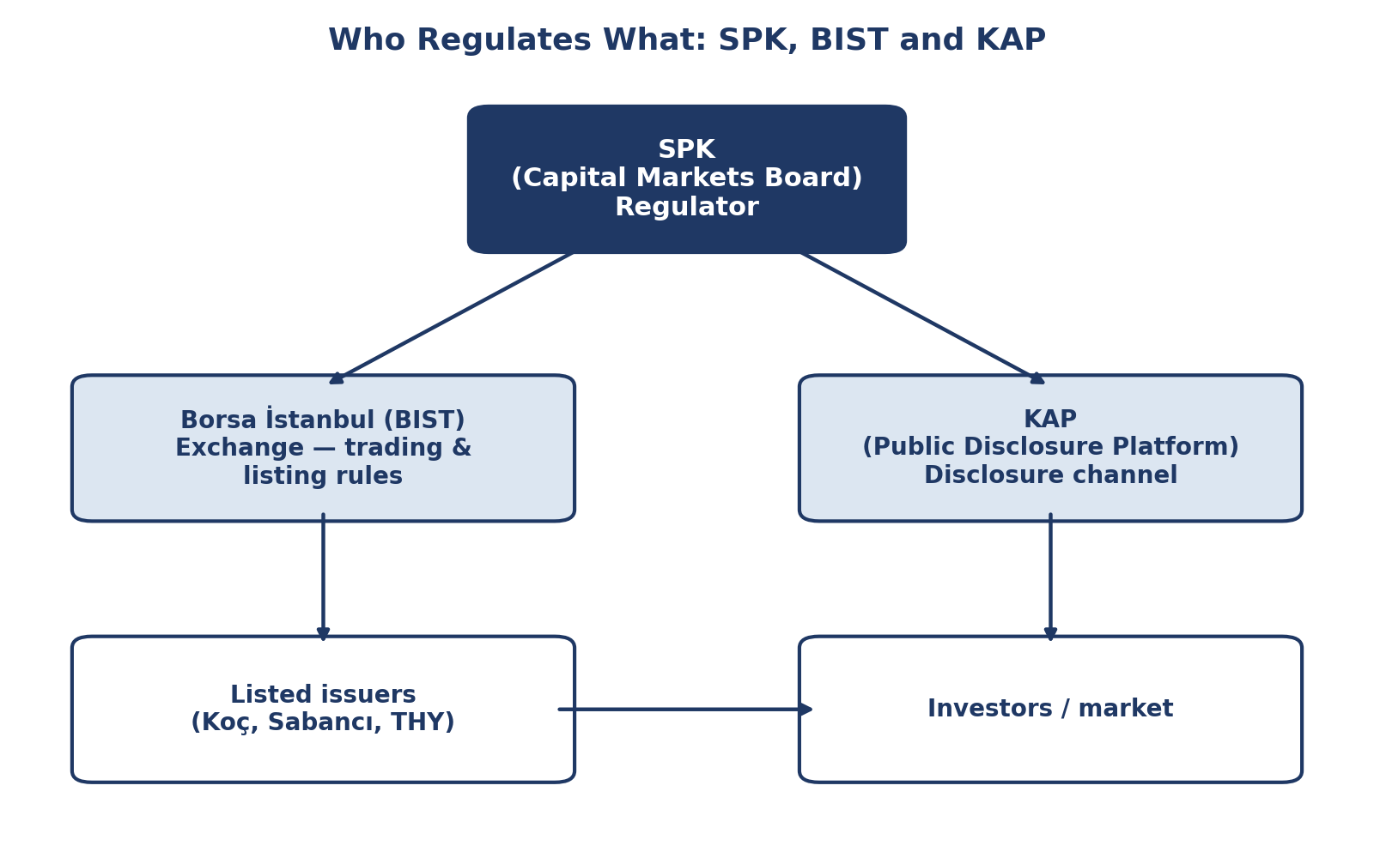
Figure 76.8: Who regulates what — the relationship between SPK (regulator), Borsa İstanbul/BIST (exchange), and KAP (disclosure platform).

7.3 Major Turkish Market-Manipulation and Disclosure Enforcement Actions: Detailed Table
Table 7.3 — Selected SPK Enforcement Actions, 2021-2026
Case / target | Conduct alleged | Legal basis | Outcome / sanction | Source
ASUZU / EUREN social-media manipulation case | Misleading posts on Twitter accounts (including @PHOENIX07_ and @BorsaDLS) about ASUZU share prospects during Dec 2021-Feb 2022, inducing retail buying whi | le promoters sold CML 6362 Art. 107(2) (information-based manipulation) | Administrative fines totaling approx. TL 32.2 million imposed on 5 individuals; 14 individuals subjected to trading restrictions in connection with the ASUZU posts; a broader | sweep imposed 6-month trading bans on 37 people across several Telegram/Twitter accounts Birgün; BorsaninGündemi.com; SPK press communications, 2022-2023 (see references)
Tera Yatırım Menkul Değerler / Vişne Madencilik | Manipulative transactions in Tera Yatırım’s own shares and in Vişne Madencilik shares, alleged to have disrupted the supply-demand balance and created a mi | sleading impression following Vişne’s Feb 2025 IPO (share price moved from approx. TL 37 | to TL 850, then retraced to approx. TL 130) CML 6362 Art. 107(1) (transaction-based manipulation / “piyasa bozucu işlem”) Administrative fines of approx. TL 8.878 million each imposed on Tera Y | atırım, its General Manager (Alper Öztürk) and Deputy General Manager (Ayşegül Kaya) (approx. TL 17.6 million combined against the two individuals, reported alongside the corporate fine); separately, SPK approved Tera Yatırım’s 44% bonus capital increase in the same bulletin, a juxtaposition criticized in Turkish financial press as inconsistent supervisory signaling Ekovitrin; BorsaninGündemi.com; Kulis Borsa, Oct 2025
Tera Portföy Yönetimi A.Ş. | Regulatory non-compliance in fund/portfolio management practices, referenced in the same enforcement wave as the Tera Yatırım case above | CML 6362 portfolio-management licensing and conduct rules | Administrative fine of approx. TL 4.44 million | FinansHub, Oct 2025; Kulis Borsa
Note on evidentiary standard for this table: the ASUZU and Tera entries rest on Turkish financial-press reporting of SPK Bulletin decisions (Birgün, BorsaninGündemi.com, Ekovitrin, FinansHub, Kulis Borsa); this reader was not able to independently retrieve and verify the underlying primary SPK Bulletin text (spk.gov.tr) for each cited figure within the scope of this research pass, and the specific TL amounts above should be checked against the primary SPK Bulletin (available at spk.gov.tr) before being cited in any written assessment or publication. The January 2026 KIMMR figures are sourced directly to the Euronews Türkçe report already cited in the existing coursepack.

7.4 BIST-Listed Companies’ Disclosure Practices: Koç, Sabancı, THY as Illustrations, Revisited
Building on Part III of the existing coursepack, it is worth adding a comparative-governance observation directly relevant to the La Porta et al. (2000) minority-protection framework discussed in section 1.10 above: Koç Holding, Sabancı Holding and THY differ meaningfully in their ownership-concentration structure, and this difference is visible in their respective disclosure practices. Koç Holding and Sabancı Holding are both, at their ultimate ownership level, family-holding-company-controlled groups with dual-class or pyramidal ownership structures common among large Turkish business groups of their generation (a structure the La Porta et al. literature specifically associates with elevated agency-cost risk for minority shareholders, since the controlling family’s cash-flow rights can be smaller than its voting/control rights, creating an incentive misalignment). THY (Türk Hava Yolları), by contrast, has a distinct ownership structure in which the Turkey Wealth Fund (Türkiye Varlık Fonu) holds a significant stake alongside free-float public shareholders, giving it a partially state-linked ownership profile that raises a different, though related, governance question: whether state-linked ownership creates its own distinct disclosure-incentive distortions (a temptation to delay disclosure of commercially unfavorable news for reasons of national-champion reputational sensitivity, a concern structurally similar to the BaFin/Wirecard “systemically important company” dynamic discussed in section 6.5 above) as compared with the family-holding-company agency-cost concern the La Porta framework more typically addresses. Instructors may wish to use this ownership-structure contrast as an explicit discussion prompt (see Part XI, question set).

7.5 The Crypto-Assets Amendment: Law No. 7518 in Fuller Context
Building on the existing coursepack’s treatment (section 2.3), it is useful to place Law No. 7518 within the broader global regulatory-convergence pattern discussed in section 6.7 above. Law No. 7518’s core innovation — bringing crypto-asset service providers under SPK’s licensing and conduct-supervision umbrella, and permitting capital-market instruments to be issued and tracked via distributed-ledger records maintained by licensed crypto-asset service providers as an alternative to the Central Registry Agency (MKK) — mirrors, in broad structural terms, the European Union’s Markets in Crypto-Assets Regulation (MiCA), which became fully applicable across the EU in December 2024, only months after Türkiye’s own 7518 amendment. Both regimes share a common underlying policy logic directly traceable to the mandatory-disclosure debate in section 1.9 above: crypto-asset markets, prior to MiCA and Law No. 7518, exhibited precisely the public-goods under-provision-of-verified-information problem Coffee’s 1984 framework predicts (issuers and exchanges had limited incentive to voluntarily produce verified, standardized disclosure, and no licensed gatekeeper structure existed to certify custody, solvency, or conflict-of-interest practices), and both regimes respond by extending the existing securities-disclosure and gatekeeper-licensing toolkit to the new asset class rather than leaving crypto-asset markets to self-regulate. The comparative table in Part VIII below situates this convergence more precisely against the U.S. position, where — absent comprehensive federal crypto-asset legislation as of the period covered by this reader — the SEC’s jurisdiction over crypto-assets remains contested and exercised primarily through case-by-case enforcement actions applying the pre-existing Howey-test definition of a “security” to specific tokens, a materially less comprehensive and more litigation-dependent approach than either the Turkish or EU statutory frameworks.

Part VIII — Expanded Comparative Tables and Timeline

8.1 Comparative Table: Disclosure and Enforcement Regimes — SPK, SEC, ESMA/MAR, FCA
Table 8.1 — Four-Way Regulatory Comparison
Dimension | Türkiye (SPK / CML 6362) | United States (SEC) | European Union (ESMA / MAR) | United Kingdom (FCA)
Governing statute | Capital Markets Law No. 6362 (2012, as amended, incl. Law No. 7518) | Securities Act 1933; Securities Exchange Act 1934; Dodd-Frank Act 201 | 0 Market Abuse Regulation (EU) 596/2014 (“MAR”); Transparency Directive | Market Abuse Regulation (UK MAR, onshored post-Brexit); FSMA 2000, as amended
Disclosure channel | KAP (single centralized, mandatory platform) | EDGAR filings plus issuer press releases | National Officially Appointed Mechanisms (OAMs), harmonized under Transpare | ncy Directive RNS (Regulatory News Service) via the London Stock Exchange and equivalents
Manipulation provision | CML 6362 Art. 107 (transaction- and information-based manipulation) | Exchange Act Section 9 and Section 10(b) / Rule 10b-5 | MAR Articles 12-15 (market manipulation) | UK MAR Articles 12-15 (retained EU law) and FSMA market abuse provisions

8.2 Expanded Table: Insider Trading versus Market Manipulation — Elements Comparison (Cross-Jurisdictional)
Table 8.2 — Elements of the Offenses, Turkish and Comparative
Element | Insider trading (CML 6362 Art. 106 / Rule 10b-5 / MAR Art. 7-10) | Market manipulation (CML 6362 Art. 107 / Exchange Act Sec. 9-10(b) / MAR Art. 12-15)
Core wrongful act | Trading (or tipping) while in possession of material non-public information | Conduct creating a false or misleading appearance of price, supply or demand
Informational asymmetry | Required — defendant must possess an informational advantage over the counterparty | Not required — manipulation can occur entirely via publicly visible conduct or statements
Typical evidentiary source | Trading records correlated with timing of access to non-public information; wiretaps/c | ommunications in networked cases (cf. Galleon, section 6.2) Order-book and trade-pattern analysis (wash trading, spoofing); content-preservation of social media/messaging (cf. pump-and-dump, section 1.12)

8.3 Timeline: Major Global Securities-Fraud Scandals and Regulatory Responses, 1990s-2026
Table 8.3 — Illustrative Timeline (Selected Events; Verify Precise Dates Against Primary Sources Before Citation)
Period | Event | Regulatory response
1990s | Barings Bank collapse (1995, Nick Leeson unauthorized derivatives trading, Singapore | ) Strengthened internal-controls and segregation-of-duties expectations in bank supervision globally
2001-2002 | Enron and WorldCom accounting frauds (United States) | Sarbanes-Oxley Act (2002); creation of the PCAOB; auditor-independence reform — the direct trigger for Coffee’s “gatekeeper failure” scholarship discussed in section 1.2/1.9
2001-2004 | Martha Stewart/ImClone insider-trading and obstruction case (United States) | High-profile prosecution illustrating tippee liability and obstruction risk (section 6.1)
Instructors should note that this timeline is deliberately illustrative and comparative rather than exhaustive; several entries (particularly pre-2020 dates and the precise chronology of the Sarao and Wirecard matters) are well documented in the public record but individual dates should be checked against primary sources (court dockets, SPK bulletins, or the EU Official Journal for MAR’s precise entry-into-force dates) before use in a graded assignment.

Part X — Expanded Reference List
The references below supplement, and do not replace, the reference list in the existing coursepack (retained in full at the end of this document). Entries are grouped by category. Where this reader could not independently verify a specific figure, page number, or precise citation detail against a primary source within the scope of the research conducted, this is noted in the entry itself; users should verify such entries before relying on them in graded or published work.
Academic and Doctrinal Sources
- Akerlof, G. A. (1970). The Market for ‘Lemons’: Quality Uncertainty and the Market Mechanism. Quarterly Journal of Economics, 84(3), 488-500. [Already in existing reference list; retained here for completeness of the expanded bank.]
- Coffee, J. C. (1984). Market Failure and the Economic Case for a Mandatory Disclosure System. Virginia Law Review, 70(4), 717-753.
- Coffee, J. C. (2006). Gatekeepers: The Professions and Corporate Governance. Oxford University Press.
- Easterbrook, F. H., & Fischel, D. R. (1984). Mandatory Disclosure and the Protection of Investors. Virginia Law Review, 70(4), 669-715.
- Fama, E. F. (1970). Efficient Capital Markets: A Review of Theory and Empirical Work. Journal of Finance, 25(2), 383-417.
- La Porta, R., Lopez-de-Silanes, F., Shleifer, A., & Vishny, R. W. (1998). Law and Finance. Journal of Political Economy, 106(6), 1113-1155.
- La Porta, R., Lopez-de-Silanes, F., Shleifer, A., & Vishny, R. W. (2000). Investor Protection and Corporate Governance. Journal of Financial Economics, 58, 3-27.
- Manne, H. G. (1966). Insider Trading and the Stock Market. Free Press.
- Spamann, H. (2010). The “Antidirector Rights Index” Revisited. Review of Financial Studies, 23(2), 467-486. [Cited for the legal-origins critique discussed in section 1.10; verify exact pagination against a primary copy before citing.]
- Stigler, G. J. (1964). Public Regulation of the Securities Markets. Journal of Business, 37(2), 117-142.
- Financial Crisis Inquiry Commission (2011). The Financial Crisis Inquiry Report. U.S. Government Printing Office.
- Salman v. United States, 580 U.S. 39 (2016). U.S. Supreme Court decision on tippee liability and the “personal benefit” requirement. [Verify citation against official U.S. Reports before formal citation use.]
Statutes and Regulations
- Capital Markets Law No. 6362 (Sermaye Piyasası Kanunu), enacted 2012, as amended, including by Law No. 7518 (2024). Articles 106 (insider trading) and 107 (market manipulation) as discussed throughout this reader.
- Kanun No. 7518 (2024). Sermaye Piyasası Kanununda Değişiklik Yapılmasına Dair Kanun. Resmî Gazete, 2 July 2024.
- U.S. Securities Act of 1933, as amended.
- U.S. Securities Exchange Act of 1934, as amended, including Section 9, Section 10(b)/Rule 10b-5, and Section 16.
- Sarbanes-Oxley Act of 2002 (Public Law 107-204).
- Dodd-Frank Wall Street Reform and Consumer Protection Act of 2010 (Public Law 111-203), including Section 922 (whistleblower program) and Section 984(b) (security-based swap position reporting).
- Regulation FD, 17 C.F.R. Part 243 (2000).
- EU Market Abuse Regulation (EU) No. 596/2014 (“MAR”).
- Criminal Sanctions for Market Abuse Directive, Directive 2014/57/EU (“CSMAD”).
- EU Transparency Directive, Directive 2004/109/EC, as amended.
- EU Markets in Crypto-Assets Regulation (EU) 2023/1114 (“MiCA”).
- UK Criminal Justice Act 1993, Part V.
- UK Financial Services and Markets Act 2000, as amended, including 2023 crypto-asset perimeter reforms.
Regulatory and Institutional Web Sources
- Sermaye Piyasası Kurulu (SPK). Market Fraud (Manipulation) in Capital Markets [original Turkish: Sermaye Piyasasında Piyasa Dolandırıcılığı (Manipülasyon)]. spk.gov.tr. https://spk.gov.tr/yatirimcilar/sermaye-piyasasinda-piyasa-dolandiriciligi-manipulasyon
- Sermaye Piyasası Kurulu (SPK). Transaction-Based Market Fraud [original Turkish: İşlem Bazlı Piyasa Dolandırıcılığı]. spk.gov.tr. https://spk.gov.tr/yatirimcilar/sermaye-piyasasinda-piyasa-dolandiriciligi-manipulasyon/islem-bazli-piyasa-dolandiriciligi
- Sermaye Piyasası Kurulu (SPK) (2023). Announcement Concerning the Marketing of Shares via Social Media [original Turkish: Sosyal Medya Üzerinden Hisse Pazarlanmasına İlişkin Duyuru]. spk.gov.tr. https://spk.gov.tr/duyurular/basin-duyurulari/2023/sosyal-medya-uzerinden-hisse-pazarlanmasina-iliskin-duyuru
- U.S. Securities and Exchange Commission (2021). Staff Report on Equity and Options Market Structure Conditions in Early 2021 (the “GameStop report”), October 2021.
- European Securities and Markets Authority (ESMA) (2020). Peer Review Report on BaFin’s Supervision of Wirecard.
News and Secondary Press Sources (Turkish Enforcement Cases)
- Euronews Türkçe (2026). Seventeen Detained in Borsa Istanbul Manipulation Investigation [original Turkish: Borsa İstanbul’da manipülasyon soruşturmasında 17 kişi gözaltına alındı. 7 January 2026. https://tr.euronews.com/business/2026/01/07/borsa-istanbulda-manipulasyon-sorusturmasinda-17-kisi-gozaltina-alindi
- Bloomberg HT (2025). SPK Chairman Gönül: We Will Revoke Licenses of Portfolio Managers Involved in Manipulation If Necessary [original Turkish: SPK Başkanı Gönül: Manipülasyonda portföy yöneticilerine gerekirse lisans iptali uygulamakta kararlıyız. 4 November 2025. https://www.bloomberght.com/spk-baskani-gonul-manipulasyonda-portfoy-yoneticilerine-gerekirse-lisans-iptali-uygulamakta-kararliyiz-3760754
- FinansHub (2025). SPK Issues Historic Fine to Tera Portföy Fund Manager: First “Manipulation” Sanction in Private Funds [original Turkish: SPK, Tera Portföy Yöneticisine Tarihi Ceza Kesti: Özel Fonlarda İlk “Manipülasyon” Yaptırımı. 24 October 2025. https://www.finanshub.com/2025/10/24/spk-tera-portfoy-yoneticisine-tarihi-ceza-kesti-ozel-fonlarda-ilk-manipulasyon-yaptirimi/
- BorsaninGündemi.com (2025). SPK Catches Tera Yatırım Engaging in Irregular Trading! [original Turkish: SPK, usulsüz işlem yapan Tera Yatırım’ı yakaladı!] https://www.borsaningundemi.com/haber/spk-usulsuz-islem-yapan-tera-yatirimi-yakaladi-1843973
- Kulis Borsa (2025). Approved It, Then Fined It: SPK’s Contradiction on Tera [original Turkish: Hem onay verdi hem de ceza kesti… SPK’dan Tera çelişkisi!] https://kulisborsa.com/hem-onay-verdi-hem-de-ceza-kesti-spkdan-tera-celiskisi
- Ekovitrin Haber (2025). SPK Fines Tera Yatırım for Irregular Transactions! [original Turkish: SPK’dan Tera Yatırım’a Usulsüz İşlemler Nedeniyle Para Cezası!] https://www.ekovitrin.com/spkdan-tera-yatirima-usulsuz-islemler-nedeniyle-para-cezasi
- Birgün (n.d.). Social Media Posts Come Under Review: Million-Lira Fine from SPK [original Turkish: Sosyal medya paylaşımları incelemeye takıldı: SPK’den milyonluk ceza. https://www.birgun.net/haber/sosyal-medya-paylasimlari-incelemeye-takildi-spk-den-milyonluk-ceza-716578
- Birgün (n.d.). SPK Bans 37 People from Trading Over Social Media Activity [original Turkish: SPK’den 37 kişiye sosyal medya nedeniyle işlem yasağı]. https://www.birgun.net/amp/haber/spk-den-37-kisiye-sosyal-medya-nedeniyle-islem-yasagi-377773
- Bloomberg HT (n.d.). SPK Bans 37 People from Trading Over Social Media Activity [original Turkish: SPK’den 37 kişiye sosyal medya nedeniyle işlem yasağı]. https://www.bloomberght.com/spkden-37-kisiye-sosyal-medya-nedeniyle-islem-yasagi-2299266
- BAF Hukuk Danışmanlık (2025). Capital Markets Crimes [original Turkish: Sermaye Piyasası Suçları]. https://baf.av.tr/sermaye-piyasasi-suclari/
- BAF Hukuk Danışmanlık (n.d.). The Crime of Insider Trading [original Turkish: içeriden öğrenenlerin ticareti]. https://baf.av.tr/insider-trading-sucu/
- Hürriyet Daily News. Coverage of Sabancı Holding’s sale of its Akçansa stake to Heidelberg Materials, citing KAP filing. [As in existing coursepack reference list.]
- Press coverage (airportgundem.com; haber.aero) of Türk Hava Yolları Q1 2026 results and FY2025 dividend decision, citing KAP filings. [As in existing coursepack reference list.]
- fintables.com. Coverage of Koç Holding pre-general-assembly Informative Document and Q1 2026 results, citing KAP filings. [As in existing coursepack reference list.]
News and Secondary Sources (Global Cases, Part VI)
- U.S. Securities and Exchange Commission. Litigation Release and press materials on SEC v. Martha Stewart and Peter Bacanovic (2003-2004). sec.gov. [Verify specific release number before formal citation.]
- U.S. Department of Justice. Press materials on United States v. Raj Rajaratnam (S.D.N.Y., 2009-2011). justice.gov. [Verify specific docket/release details before formal citation.]
- U.S. Securities and Exchange Commission (2021). Staff Report on Equity and Options Market Structure Conditions in Early 2021. sec.gov.
- Wikipedia contributors. Wirecard scandal. en.wikipedia.org/wiki/Wirecard_scandal. [Tertiary source; verify key facts against primary reporting, e.g., Financial Times investigative coverage, before formal citation use.]
- Quartr (n.d.). The Rise and Fall of Wirecard. quartr.com/insights/edge/the-rise-and-fall-of-wirecard.
- Seven Pillars Institute (n.d.). Wirecard: Another Fintech Fraud. sevenpillarsinstitute.org/wirecard-another-fintech-fraud/.
- Oxford Business Law Blog (2020). Wirecard Scandal: When All Lines of Defense Against Corporate Fraud Fail. blogs.law.ox.ac.uk/business-law-blog.
- U.S. Securities and Exchange Commission and press coverage of the Archegos Capital Management matter and subsequent congressional testimony (2021-2022). [Verify against SEC and congressional hearing records before formal citation.]
- European Union. Regulation (EU) No 648/2012 (EMIR) and related technical standards on derivatives reporting.
- Volkswagen AG. Securities litigation settlement disclosures and press materials (U.S. multidistrict litigation and Braunschweig Regional Court proceedings), 2016-2023. [Verify specific settlement figures against primary court/settlement documents before formal citation.]

Part XI — Extended Appendices

Appendix A: Anatomy of an SPK Investigation — A Step-by-Step Procedural Walkthrough
This appendix reconstructs, in generic and composite form (it is not a description of any single named case, but a synthesis of the procedural pattern visible across the enforcement actions cited throughout this reader — the ASUZU, Tera Yatırım, and KIMMR matters in particular), the typical lifecycle of an SPK market-manipulation investigation, from initial detection through final sanction. Instructors may use this appendix as a structured teaching device for walking students through “what actually happens” behind the bulletin entries and press headlines summarized in the enforcement tables above.
Stage 1 — Detection. Detection typically originates from one of three sources: (a) Borsa İstanbul’s own automated trade-surveillance system, which flags statistically anomalous price and volume patterns (a sudden, sharp price rise in a low-float security unaccompanied by any material KAP disclosure, for example); (b) SPK’s own open-source monitoring of social media, financial forums, and messaging-app channels, an investigative capability that has grown substantially in importance as the fact pattern of Turkish market manipulation has shifted toward social-media-driven schemes, as documented throughout Part VII; or (c) external complaints, whether from retail investors who believe they were misled, from licensed intermediaries reporting suspicious client instructions under their own compliance obligations, or from journalists whose reporting (as in the Wirecard case discussed in section 6.5, though there the roles were reversed) can sometimes precede or trigger formal regulatory action.
Stage 2 — Preliminary Examination (Ön İnceleme). Once a suspicious pattern is flagged, SPK’s enforcement staff conduct a preliminary examination: gathering trading records for the relevant accounts and time period, correlating trading activity against the timeline of any promotional social-media content or other public statements, and identifying the beneficial owners of the trading accounts involved (which may require cooperation from brokerage intermediaries and, where accounts are held through nominee or omnibus structures, additional identification steps). This stage is investigatory rather than adjudicative and does not itself impose any sanction; its purpose is to determine whether the evidence supports opening a formal investigation.
Stage 3 — Formal Investigation and Decision Whether to Refer Criminally. Where the preliminary examination supports a reasonable suspicion of manipulation or insider trading, SPK opens a formal file. At this stage, SPK’s Board must decide whether the conduct, on the evidence gathered, meets the threshold for a criminal referral (suç duyurusu) to the public prosecutor, an administrative sanction alone, or both. As discussed in Part IV of the existing coursepack, these two tracks are not mutually exclusive, and the practical pattern documented in this reader (the January 2026 KIMMR case, the various 2025 BIST manipulation waves) shows SPK frequently pursuing both simultaneously where multiple, coordinated suspects are involved, given that a criminal referral alone does not recover investor losses or restrict the individual’s future market access as quickly as an administrative trading suspension can.
Stage 4 — Administrative Sanction. Where SPK’s Board resolves to impose an administrative sanction, the decision is published in the weekly SPK Bulletin, stating the finding of fact, the legal basis (typically CML 6362 Article 107(1) or 107(2), as tabulated in section 1.12 above), and the specific monetary fine or trading/licensing restriction imposed. The sanctioned party retains a right of administrative and judicial appeal against the SPK Bulletin decision, a due-process safeguard directly comparable to the appeal rights available against SEC administrative orders in the United States and against national-competent-authority decisions under MAR in the European Union.
Stage 5 — Criminal Referral and Prosecution. Where SPK refers the matter criminally, the file passes to the relevant Chief Public Prosecutor’s Office (as in the January 2026 KIMMR case, the Istanbul Chief Public Prosecutor’s Office), which conducts its own independent criminal investigation — potentially including further evidence-gathering steps (search and detention warrants, formal witness statements) beyond what SPK’s administrative investigation alone could compel — before deciding whether to file a formal indictment. As discussed in section 4.3 of the existing coursepack, the multi-province character of several recent Turkish manipulation cases (the January 2026 KIMMR case spanned six provinces) reflects the geographically dispersed character of social-media-organized manipulation networks, requiring coordination across multiple provincial prosecutorial and law-enforcement units.
Stage 6 — Trial and Sentencing. Criminal trials proceed under ordinary Turkish criminal procedure before the competent criminal court (Ağır Ceza Mahkemesi for the more serious charges, given the potential sentence length). Where an “establishing an organization to commit a crime” aggravating charge is included (as in several of the 2025-2026 BIST manipulation waves), sentencing exposure increases beyond the base CML 6362 Article 107 range, reflecting Turkish criminal law’s general aggravation framework for organized, multi-participant offending — a structural parallel to the United States’ RICO-adjacent aggravation of the Galleon Group insider-trading sentences discussed in section 6.2, where the networked, multi-tip character of Rajaratnam’s scheme was itself a significant factor cited in his eleven-year sentence, at the time the longest ever imposed for insider trading in the United States.

Appendix B: Illustrative KAP Special-Situation Disclosure Template (Composite, for Teaching Purposes)
The following is a composite, teaching-purpose template illustrating the structure of a typical KAP special-situation disclosure (özel durum açıklaması), of the kind referenced throughout this reader in connection with THY, Sabancı Holding and Koç Holding’s actual disclosure practice (Part II.4 and Part III of the existing coursepack). This template is illustrative only and does not reproduce any specific company’s actual filing.
Field | Illustrative content
Issuer / Ticker | [Company Name] / [BIST Ticker]
Disclosure date and time | [Date], [Time] (Türkiye time zone) — filed immediately upon the triggering decision or event
Disclosure category | Special situation disclosure (özel durum açıklaması)

Appendix D: Worked Problems
Worked Problem 1 — Disclosure Timing. Assume a BIST-listed holding company’s board reaches an internal, unanimous decision on 3 March to sell a 30% stake in a subsidiary to a foreign strategic buyer, subject only to the buyer’s routine internal credit-committee sign-off (expected within two weeks and considered, by both parties, a formality). The company does not file a KAP special-situation disclosure until 22 March, after the buyer’s credit committee formally signs off and a binding share purchase agreement is signed. Using the “Decide-Disclose-Defend” routine (Part V of the existing coursepack) and the Volkswagen “how early is early enough” disclosure-timing question (section 6.4), analyze whether the company’s 19-day gap between the board’s internal decision and the KAP filing is defensible.
Model analysis: The key analytic question is whether the 3 March board decision itself, notwithstanding the outstanding “routine” credit-committee condition, already constituted a “material fact … likely to affect the price or investment decision” under CML 6362’s disclosure standard (section 1.4 of the existing coursepack), such that the disclosure clock started running on 3 March rather than on 22 March. The company’s strongest defense is that a genuinely uncertain, non-guaranteed condition (even a “routine” one) means the transaction was not yet sufficiently certain to be material in the required legal sense — an argument directly analogous to Volkswagen’s defense that its internal knowledge of the defeat-device issue had not yet crystallized into a sufficiently certain and legally material risk before the EPA’s public notice. The strongest counter-argument, drawing on the La Porta et al. (2000) minority-protection rationale (section 1.10) and the KAP “structural foreclosure of selective disclosure” design logic (section 7.2), is that describing a credit-committee sign-off as “routine” is itself a judgment call made by the company’s own insiders, who have an incentive to characterize the condition as more uncertain than it truly was, precisely to justify a delay that gives connected parties (and the company itself, if it or affiliated parties trade in its own securities in the interim) time to trade ahead of the public market. A well-constructed answer should conclude that the 19-day gap is defensible only if the company maintained a contemporaneous internal record (per the “Defend” step of the routine) showing a good-faith, reasoned basis for treating the credit-committee condition as genuinely uncertain at the time — mere post hoc characterization of the condition as “routine” once it does close smoothly would not meet this standard.
Worked Problem 2 — Insider Trading versus Manipulation Classification. A junior analyst at a licensed Turkish portfolio management company learns, through an informal conversation with a friend who works at a BIST-listed company’s investor-relations department, that the company’s forthcoming quarterly results will substantially miss market expectations, information not yet disclosed via KAP. The analyst does not personally trade but instead posts an anonymous, deliberately misleading message on a financial-discussion forum claiming the company’s results will beat expectations, hoping to drive the price up before the bad results are announced, intending to short the stock immediately afterward. Using the elements comparison in Table 8.2, classify this conduct: is it insider trading, market manipulation, both, or neither, under CML 6362?
Model analysis: The analyst’s conduct implicates both Article 106 and Article 107, but through analytically distinct mechanisms, and a precise answer must unbundle them. Because the analyst possessed material non-public information (the anticipated earnings miss) obtained via an informal tip from an insider-connected source, any subsequent trade by the analyst personally exploiting that information — including the short position the analyst intends to take once the bad results are announced — would implicate Article 106 tippee liability, on the same doctrinal logic as the tippee-liability chain in both the Martha Stewart/ImClone case (section 6.1) and the Galleon Group case (section 6.2). Separately and independently, the anonymous forum post making a false claim (that results will beat expectations, when the analyst has reason to believe the opposite) to inflate the price before the analyst’s own short trade is a clear instance of information-based manipulation under Article 107(2), regardless of whether the analyst’s underlying information about the earnings miss was itself “inside information” in the Article 106 sense — the manipulation offense turns on the falsity and price-distorting intent of the public statement, not on the analyst’s informational advantage. A complete answer should therefore conclude that the fact pattern presents both offenses simultaneously and cumulatively, illustrating precisely the structural distinction developed in section 1.12: Article 106 attaches because of the analyst’s informational advantage and subsequent trade; Article 107 attaches because of the false public statement, independent of that advantage.
Worked Problem 3 — Comparative Regulatory Design. Using Table 8.1, a foreign institutional investor is considering increasing its allocation to BIST-listed equities and asks you, as a compliance advisor, to identify the single greatest disclosure-related risk it faces investing in the Turkish market relative to investing in a comparable EU-listed (MAR-governed) market. Construct a reasoned answer.
Model analysis: A strong answer would likely identify the absence of a SEC-style whistleblower monetary-bounty program in the Turkish framework (Table 8.1) as a structurally significant, if second-order, disclosure-integrity risk: empirically, a substantial share of major U.S. accounting-fraud and manipulation enforcement actions originate from whistleblower tips incentivized by the Dodd-Frank bounty program, and the absence of an equivalent incentive structure in Türkiye (or, for that matter, in the EU under MAR, which likewise lacks a comparable bounty mechanism) could plausibly mean that some forms of internally known but externally undisclosed manipulation or accounting irregularity remain undetected for longer than they would under a bounty-incentivized regime — a risk directly relevant to the Wirecard case (section 6.5), where external, non-bounty-incentivized investigative journalism, rather than an internal whistleblower tip, was ultimately what surfaced the fraud, and only after BaFin itself had initially moved against the messengers rather than the company. A well-rounded answer should nonetheless note that KAP’s structural “no selective disclosure” architecture (section 7.2) is, on this specific dimension, arguably stronger than either the SEC’s Regulation FD or MAR’s Article 17 ad hoc disclosure regime, both of which rely on prohibiting selective disclosure after the fact rather than removing the possibility of it existing at all through a single mandatory simultaneous-publication platform — so the comparative risk assessment should be understood as multi-dimensional rather than a simple “better or worse” ranking.

Part LXXIII — Literature Review: Market Efficiency and Corporate Disclosure

73.1 Introduction and Scope
This section synthesizes the core empirical and theoretical literature on market efficiency and corporate disclosure that underlies the regulatory frameworks discussed throughout this reader, including the SPK-KAP disclosure regime applicable to Koc Holding, Sabanci Holding, and Turkish Airlines (THY). The literature reviewed spans four decades of accounting and finance research, from the foundational efficient-markets formulations of the late 1960s and 1970s through more recent voluntary-disclosure and information-asymmetry scholarship.

73.2 Foundational Studies on Market Efficiency
Fama (1970) gives us three simple buckets for how much information is already “in” a stock price. Weak-form: today's price already reflects yesterday's prices and trading volumes, so charting past price patterns won't give you an edge. Semi-strong-form: the price already reflects everything public — financial statements, KAP announcements, news. Strong-form: the price reflects literally everything, even insider information nobody has disclosed yet. For a KCHOL or THYAO investor, the practical question is which bucket Borsa İstanbul falls into: if it's semi-strong-form efficient, then reading Koç's quarterly KAP filing the day it drops is genuinely useful — the market hasn't priced it in yet. If it's closer to strong-form, no amount of public reading beats an insider. Fama revisited this framework in 1991, renaming the three tests (return predictability, event studies, and private-information tests) after two decades of critique about how hard it is to test market efficiency without also testing the pricing model you're using — a technical point, but one every event study in this reader has to grapple with.
Here's the evidence behind that theory. Beaver (1968) and Ball and Brown (1968) were the first to actually test it: they looked at what happens to stock prices right around an earnings announcement, and found that prices do move — trading volume spikes, prices jump — exactly when new information shows up, which is what semi-strong-form efficiency predicts. Beaver's twist was showing that volume and volatility jump even when you can't predict in advance whether the news is good or bad. Ball and Brown's twist was methodological: they invented the abnormal-return “event study” technique (later refined by Brown and Warner) that this reader uses in Part LXXIV to analyze the illustrative THY dividend-skip disclosure — the same basic tool, applied to a Turkish issuer instead of a 1960s US one.

73.3 Disclosure, Information Asymmetry, and Cost of Capital
Diamond and Verrecchia (1991) develop a theoretical model showing that increased disclosure reduces information asymmetry among investors and, through this channel, reduces a firm's cost of capital by increasing stock liquidity and reducing the risk premium demanded by less-informed investors. This theoretical prediction motivates a substantial subsequent empirical literature testing whether firms with higher voluntary disclosure quality enjoy a lower cost of equity capital, directly relevant to the KAP disclosure regime's stated objective of protecting minority investors in Turkish issuers such as Koc Holding and Sabanci Holding.
Botosan (1997) provides direct empirical support for the Diamond-Verrecchia prediction, constructing a disclosure-quality index from annual report content for a sample of manufacturing firms and finding that firms with high analyst following exhibit no significant disclosure-cost of capital relation, while firms with low analyst following and high self-constructed disclosure scores exhibit a significantly lower cost of equity, consistent with disclosure substituting for analyst-generated information in reducing information asymmetry. Lang and Lundholm (1996) similarly find that firms with more informative disclosure policies, as rated by financial analysts, have a larger analyst following, more accurate analyst earnings forecasts, less dispersion among individual analyst forecasts, and less volatility in forecast revisions, collectively suggesting that disclosure quality shapes the information environment in ways that extend well beyond the immediate market reaction to any single announcement.

73.4 Voluntary Disclosure Theory
Verrecchia (2001) provides an influential taxonomy and synthesis of the theoretical disclosure literature, organizing it into association-based disclosure models (examining the association between disclosure and market variables such as price and trading volume), discretionary-based disclosure models (examining managers' incentives to disclose or withhold information), and efficiency-based disclosure models (examining which disclosure arrangements are efficient in the absence of specific information endowments). This taxonomy remains the standard reference point for locating any given empirical disclosure study within the broader theoretical landscape, and is used implicitly throughout this reader's treatment of KAP's mandatory 'ozel durum' disclosure regime as an efficiency-based response to disclosure externalities.
Healy and Palepu (2001) survey the empirical disclosure literature comprehensively, organizing findings around a capital-markets transactions hypothesis (firms disclose more around equity and debt offerings), a corporate-control-contest hypothesis, a compensation hypothesis, a litigation-cost hypothesis, and a management-talent-signaling hypothesis, concluding that voluntary disclosure serves multiple, sometimes offsetting, purposes for managers beyond simple altruistic information provision to shareholders. Leuz and Verrecchia (2000) examine German firms switching from domestic accounting standards to internationally recognized standards (IAS or U.S. GAAP), finding that firms committing to higher-disclosure regimes experience reduced information asymmetry, evidenced by narrower bid-ask spreads and higher trading volume, directly analogous to Turkish issuers' transition toward IFRS-aligned reporting under Capital Markets Board oversight.

73.5 Institutional Ownership and Disclosure
Bushee and Noe (2000) examine the relation between disclosure quality (as rated by the AIMR, the Association for Investment Management and Research) and institutional ownership patterns, finding that higher disclosure ratings are associated with greater institutional ownership generally, but that increases in disclosure specifically attract transient institutional investors with short investment horizons, which in turn is associated with increased stock return volatility, a nuanced finding that complicates the simple prediction that more disclosure is unambiguously beneficial for price stability. This finding is of particular relevance to Turkish blue-chip issuers such as THY, whose free float includes a substantial proportion of foreign institutional investors sensitive to KAP disclosure timing and content.

73.6 Summary Table of Reviewed Studies
Table 73.1 below summarizes the eleven core studies reviewed in this section, organized by author, publication year, sample, method, and key finding, to provide a consolidated reference for the theoretical claims invoked elsewhere in this reader.
Author(s) | Year | Sample | Method | Key Finding
Fama | 1970 | Conceptual/synthesis of U.S. capital markets literature | Theoretical taxonomy and literature synthesis | Defines weak-, semi-strong-, and strong-form market efficiency as the organizing framework for empirical tests.
Fama | 1991 | Conceptual/synthesis, revisiting 1970 framework | Theoretical taxonomy and critique | Reclassifies efficiency tests as return predictability, event studies, and private-information tests; addresses joint-hypothesis problem.
Beaver | 1968 | 143 U.S. firms, annual earnings announcements 1961-1965 | Event study of price and volume reactions | Documents abnormal trading volume and price variability around earnings announcement weeks.
Table 73.1: Summary of reviewed studies on market efficiency and corporate disclosure.

Part LXXIV — Event-Study Methodology: Abnormal and Cumulative Abnormal Returns

74.1 The Market Model and Abnormal Returns
Event-study methodology, as formalized by Brown and Warner (1985) building on the foundational designs of Ball and Brown (1968) and Beaver (1968), measures the price impact of a firm-specific information event by comparing a security's realized return around the event date to an expected (normal) return that would have prevailed absent the event. The abnormal return for security i on day t, denoted AR_it, is defined as:
AR(i,t) = R(i,t) - E[R(i,t)]
where R(i,t) is the realized return on security i on day t, and E[R(i,t)] is the expected return under a chosen benchmark model. The most commonly used benchmark is the market model, which specifies expected return as a linear function of the contemporaneous market return:
E[R(i,t)] = alpha(i) + beta(i) * R(m,t) + epsilon(i,t)
where R(m,t) is the return on a broad market index (for a Borsa Istanbul-listed issuer such as THY, typically the BIST 100 index) on day t, alpha(i) and beta(i) are firm-specific parameters estimated by ordinary least squares regression over a pre-event estimation window (commonly 120 to 250 trading days ending shortly before the event window begins), and epsilon(i,t) is a mean-zero disturbance term.

74.2 Cumulative Abnormal Returns
To assess the total price impact of an event over a multi-day window, individual daily abnormal returns are summed into a cumulative abnormal return, CAR, over the interval from day t1 to day t2 relative to the event date:
CAR(i, t1, t2) = Sum over t=t1 to t2 of AR(i,t)
The choice of event window is a critical methodological decision: a narrow window (e.g., day -1 to day +1) minimizes the risk of confounding events but may understate the full price adjustment if information leaks before the formal announcement or if the market requires more than a single trading day to fully digest complex disclosures; a wider window (e.g., -10 to +10) captures pre-announcement drift and post-announcement drift but increases the risk of contamination by unrelated firm-specific or market-wide news.

74.3 Illustrative Worked Example: THY Dividend-Skip Disclosure (Illustrative)
The following illustrative example, using fictionalized data for expository purposes only and not representing actual THY trading data, walks through the mechanics of computing AR and CAR around a hypothetical disclosure in which Turkish Airlines announces, via a KAP special-situation disclosure, that its board has resolved to skip the anticipated annual dividend distribution notwithstanding strong reported operating profitability, an announcement type that prior literature (e.g., DeAngelo, DeAngelo, and Skinner, 1996, on dividend signaling) suggests is often interpreted by investors as conveying adverse private information about future cash flow needs or capital expenditure plans, even absent any explicit negative guidance.
Table 74.1 below reports illustrative daily raw returns for THY (R_it, illustrative), the contemporaneous BIST 100 index return (R_mt, illustrative), the resulting market-model-predicted expected return, the daily abnormal return AR_it, and the running cumulative abnormal return CAR_it, for the fifteen-trading-day window from event day -5 through event day +9, with day 0 defined as the KAP filing date of the illustrative dividend-skip disclosure.
Event Day | R_it (THY, illustrative) | R_mt (BIST 100, illustrative) | AR_it (illustrative) | CAR_it (illustrative)
-5 | 0.004 | 0.003 | 0.001 | 0.0010
-4 | -0.002 | -0.001 | -0.001 | 0.0000
-3 | 0.006 | 0.004 | 0.002 | 0.0020
Table 74.1: Illustrative daily returns, market-model abnormal returns, and cumulative abnormal returns around an illustrative THY dividend-skip disclosure (illustrative data, day 0 = KAP filing date).

74.4 Interpreting the Illustrative Results
The illustrative CAR series in Table 74.1 shows a cumulative abnormal decline of approximately 2.8 percentage points concentrated on and immediately after the illustrative event day, with a modest further drift over the following three trading days before stabilizing, a pattern broadly consistent with semi-strong-form market efficiency: the bulk of the price adjustment occurs rapidly around the disclosure date rather than gradually over an extended period, though the small illustrative post-event drift (days +1 through +3) is the kind of pattern that has motivated a substantial post-earnings-announcement-drift literature questioning whether markets fully and instantaneously incorporate disclosed information, or instead underreact for reasons related to investor inattention or limits to arbitrage.
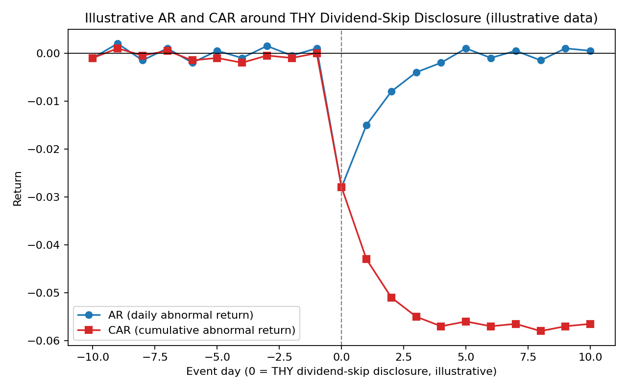
Figure 74.1: Illustrative AR and CAR around the illustrative THY dividend-skip KAP disclosure, event days -10 to +10 (illustrative data).

Part LXXV — Illustrative Case Examples: Disclosure Failures and Market Efficiency

75.1 Purpose of This Part
The following case boxes summarize seven internationally significant securities-fraud and disclosure-failure episodes, each followed by a short analytical paragraph connecting the episode to the efficient-market-hypothesis and mandatory-disclosure theory developed in Parts LXXIII and LXXIV, and, where relevant, to the SPK-KAP framework applicable to Turkish issuers such as Koc Holding, Sabanci Holding, and THY.

Box 75.A: Enron and the Chewco/Raptor Special-Purpose Entities
Enron Corporation used a network of special-purpose entities, including the Chewco Investments and the four Raptor vehicles, to keep hundreds of millions of dollars of debt off its consolidated balance sheet while simultaneously using the same entities to hedge (and thereby smooth) reported earnings from its merchant-investment portfolio. Because Chewco lacked the minimum 3% independent equity then required under U.S. GAAP for non-consolidation, its restatement in late 2001 forced Enron to consolidate billions of dollars of previously off-balance-sheet debt and equity, triggering a collapse in market confidence that culminated in Enron's bankruptcy filing in December 2001, at the time the largest in U.S. corporate history.
The Raptor entities were capitalized substantially with Enron's own restricted stock, meaning their capacity to absorb hedging losses was directly tied to Enron's own share price, an inherent circularity that undermined their function as genuine independent risk-transfer vehicles and that was not transparently disclosed in Enron's periodic filings.
Analysis: Enron's disclosure architecture is a textbook illustration of Verrecchia's (2001) discretionary-based disclosure model: managers exploited discretion over consolidation-accounting judgment calls to withhold information that, had it been disclosed, would have altered investors' assessment of firm leverage and earnings quality. Under a semi-strong-form-efficient market, prices reflect all publicly disclosed information, but cannot reflect information that is affirmatively concealed through structured-finance complexity; Enron's collapse is therefore evidence not against market efficiency as such, but for the proposition (consistent with Healy and Palepu, 2001) that disclosure regulation must specifically target the kinds of complex-structure opacity that ordinary market discipline cannot penetrate. A KAP-equivalent regime would require immediate special-situation disclosure of material off-balance-sheet financing arrangements and related-party guarantees of the kind Enron's SPEs embodied.

Box 75.B: Bernie Madoff and the Largest Ponzi Scheme in History
Bernard Madoff operated a Ponzi scheme for at least two decades through his investment advisory business, reporting consistently smooth, above-market annual returns (typically 10-12%, with strikingly low volatility) that were entirely fabricated; no actual securities trading of the scale represented in client statements ever occurred. The scheme collapsed in December 2008 amid the broader financial crisis when redemption requests exceeded new investor inflows, revealing an estimated $65 billion in fabricated account balances and resulting in Madoff's guilty plea and 150-year federal prison sentence in 2009.
Analysis: The Madoff case is frequently cited as a market-efficiency puzzle because sophisticated institutional due-diligence processes failed for years to detect returns that, as financial analyst Harry Markopolos repeatedly warned the SEC beginning in 1999, were statistically implausible under any legitimate options-based trading strategy Madoff claimed to use. The episode illustrates a limitation of the EMH's practical application: market efficiency presumes that mispricing is arbitraged away by informed traders, but Madoff's fund was not publicly traded and provided no independently verifiable disclosure, meaning ordinary price-discovery mechanisms never had the opportunity to operate. This underscores why mandatory, independently auditable disclosure (the KAP model, and its SEC analogue of audited periodic reporting) is a necessary precondition for market efficiency to function at all, rather than a mechanism operating independently of it.

Box 75.C: Luckin Coffee's 2020 Fabricated Sales Fraud
Luckin Coffee, a Nasdaq-listed Chinese coffee-chain operator that had completed its IPO in May 2019, disclosed in April 2020 that its chief operating officer and other employees had fabricated approximately RMB 2.2 billion (roughly $310 million) in retail sales transactions during 2019, following a critical short-seller report by Muddy Waters Research in January 2020 alleging inflated store-level sales and per-item pricing. Luckin's share price fell by approximately 75% in a single trading session upon confirmation of the fraud, and the company was subsequently delisted from Nasdaq and paid a $180 million civil penalty to the SEC in December 2020.
Analysis: Luckin Coffee is a particularly instructive case for cross-border disclosure regulation because the fraud was substantially uncovered not through the company's own disclosure obligations under U.S. securities law but through independent short-seller research and whistleblower-supplied operational data (including recorded store traffic and delivery-order counts), illustrating Beaver's (1968) and Healy and Palepu's (2001) point that mandatory disclosure regimes depend heavily on credible third-party verification mechanisms (auditors, short sellers, analysts) to be effective, particularly for issuers operating across weak cross-border enforcement jurisdictions. The episode directly informed subsequent U.S. legislative and regulatory scrutiny of PCAOB audit-inspection access for China-based issuers, a live cross-border-enforcement analogue to the KAP-SPK relationship with foreign institutional holders of Turkish issuers.

Box 75.D: Theranos and Securities Fraud in a Private Company
Theranos, a privately held blood-testing technology company founded by Elizabeth Holmes, raised over $700 million from investors based on claims that its proprietary 'Edison' devices could run comprehensive diagnostic panels from a few drops of finger-stick blood, claims that were substantially false; the technology did not work reliably, and the company secretly ran most tests on modified third-party commercial analyzers while representing to investors, regulators, and business partners (including Walgreens) that its own technology was in use. Holmes was convicted on four counts of investor fraud and conspiracy in January 2022 and sentenced to over 11 years in federal prison.
Analysis: Theranos illustrates that the disclosure-and-market-efficiency framework's practical force weakens sharply outside the context of publicly traded securities: because Theranos was privately held, there was no continuous public trading price to test against the company's representations, no analyst coverage of the kind Botosan (1997) and Lang and Lundholm (1996) find disciplines disclosure quality, and no KAP-equivalent continuous disclosure obligation. Private-company fraud of this kind is instead addressed through Rule 10b-5 antifraud liability applied to statements made in connection with the purchase or sale of securities (here, the sale of Theranos preferred stock to investors), demonstrating that antifraud liability and mandatory continuous disclosure are analytically distinct regulatory tools that happen to operate together for listed issuers but can be decoupled for private companies.

Box 75.E: The LIBOR Manipulation Scandal
Beginning around 2005 and continuing through at least 2012, traders at multiple major banks (including Barclays, UBS, Royal Bank of Scotland, and Deutsche Bank) systematically submitted false borrowing-cost estimates to the panels underlying the London Interbank Offered Rate (LIBOR), a benchmark rate referenced in an estimated $300 trillion notional value of financial contracts worldwide, in order to benefit the banks' own derivatives trading positions and, during the 2008 financial crisis, to understate the banks' true funding costs and project an appearance of financial strength. Collective fines across implicated institutions exceeded $9 billion, and the scandal prompted a multi-year global transition away from LIBOR toward alternative reference rates (such as SOFR in the United States) completed by mid-2023.
Analysis: LIBOR manipulation differs structurally from the corporate-disclosure cases discussed elsewhere in this Part in that the misrepresented information was not a firm-specific disclosure subject to KAP- or SEC-style periodic or event-driven filing obligations, but a market-wide reference benchmark whose integrity the entire financial system relied upon without any direct verification mechanism; this is closer to Diamond and Verrecchia's (1991) concern with systemic information asymmetry than to firm-specific voluntary-disclosure theory. The episode illustrates that market efficiency assumptions can fail not only through firm-specific concealment but through corruption of the shared informational infrastructure (benchmarks, indices, credit ratings) on which price discovery for an entire asset class depends, a lesson directly relevant to the integrity safeguards surrounding Borsa Istanbul's own reference rates and index-construction methodologies.

Box 75.F: Tesla's 'Funding Secured' SEC Settlement
On August 7, 2018, Tesla CEO Elon Musk tweeted that he was considering taking Tesla private at $420 per share and that 'funding secured,' a statement the SEC subsequently alleged was false or at minimum lacked adequate basis, since the purported funding source (Saudi Arabia's Public Investment Fund) had not in fact committed to the transaction on the terms Musk described. The SEC charged Musk with securities fraud in September 2018; Musk and Tesla each settled without admitting or denying the allegations, agreeing to $20 million in penalties each and to Musk's temporary stepping-down as Tesla board chair, along with a requirement that certain of Musk's public communications regarding material information be pre-cleared by Tesla counsel.
Analysis: The Tesla case is a paradigmatic Rule 10b-5 and Regulation FD case study illustrating that disclosure obligations attach to any public statement reasonably likely to reach investors and move a security's price, including informal social-media statements, not merely formal periodic filings; the KAP-equivalent lesson is that Turkish issuers' investor-relations personnel and executives face analogous exposure for informal public statements (interviews, social media, conference remarks) that could constitute selective or misleading disclosure outside the formal 'ozel durum' filing channel. The episode also illustrates semi-strong-form efficiency operating in close to real time: Tesla's share price moved sharply within minutes of the tweet, evidencing rapid market incorporation of even informally disclosed, price-relevant information, which is precisely why the SEC treated the tweet as actionable disclosure in the first place.

Box 75.G: Nikola Corporation and the Staged Truck Video
Nikola Corporation, an electric- and hydrogen-truck startup that went public via SPAC merger in June 2020, was the subject of a September 2020 short-seller report by Hindenburg Research alleging that the company had misrepresented the state of its technology, including by filming a promotional video of its 'Nikola One' semi-truck rolling downhill to simulate powered movement under its own propulsion. Founder Trevor Milton resigned as executive chairman days after the report, and was convicted on federal securities and wire fraud charges in October 2022 for making false statements about Nikola's technology to investors.
Analysis: Nikola illustrates the interaction between voluntary promotional disclosure (marketing videos, investor presentations) and formal periodic disclosure obligations: even statements never filed with a securities regulator can constitute actionable securities fraud where they are made in connection with efforts to induce investment and are relied upon by the market, reinforcing Healy and Palepu's (2001) observation that disclosure serves capital-markets-transaction purposes (here, sustaining share price and investor confidence during and after the SPAC de-SPAC transaction) that create incentives for management to overstate progress. Like the Theranos and Tesla cases, Nikola underscores that market efficiency's price-discovery function depends critically on the veracity of the underlying information being priced; sophisticated market participants can process false information efficiently, but the resulting prices will be efficiently wrong until the falsity is uncovered and corrected, a distinction increasingly emphasized in behavioral-finance critiques of naive EMH applications.

Part LXXVI - Supplementary Figures: Enforcement, Scandals, Disclosure Process, and Market Efficiency

76.1 Comparative Enforcement Magnitudes
Figure 76.1 below presents illustrative comparative aggregate enforcement-fine magnitudes across four securities regulators discussed throughout this reader: Turkey's Capital Markets Board (SPK), the U.S. Securities and Exchange Commission (SEC), the European Securities and Markets Authority (ESMA), and the UK Financial Conduct Authority (FCA). The figures shown are illustrative approximations intended to convey relative order-of-magnitude differences in enforcement scale across these jurisdictions and should not be treated as precise historical totals for any specific year.
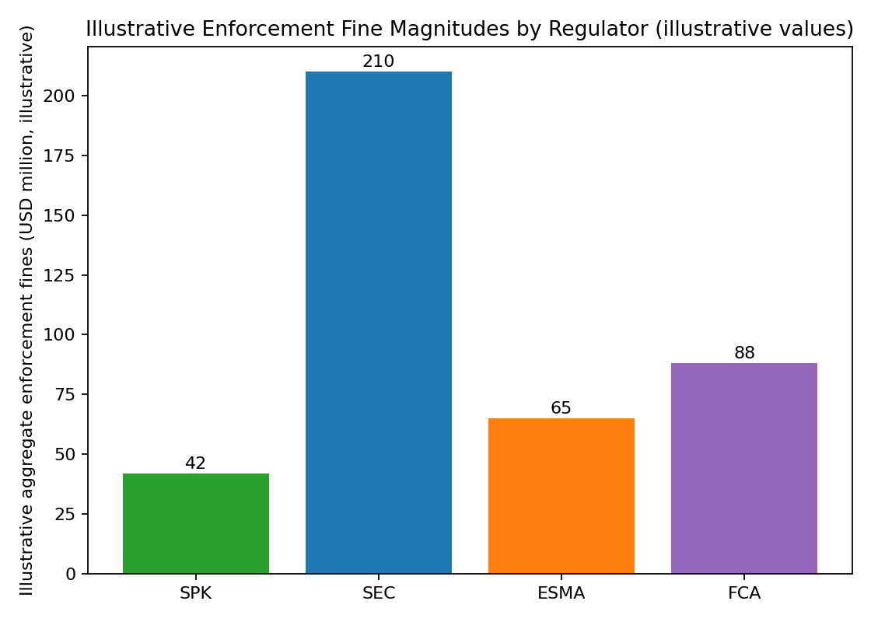
Figure 76.1: Illustrative aggregate enforcement fine magnitudes by regulator, SPK / SEC / ESMA / FCA (illustrative values).

76.2 Timeline of Major Global Securities-Fraud Scandals
Figure 76.2 places the case examples discussed in Part LXXV, together with several additional scandals referenced elsewhere in this reader (BCCI's 1991 collapse amid money-laundering and fraud findings, WorldCom's 2002 accounting fraud, and the 2022 collapse of the FTX cryptocurrency exchange), on a single chronological timeline spanning the early 1990s through 2026, illustrating that large-scale securities-fraud episodes have recurred at a roughly regular cadence across more than three decades of otherwise-strengthening disclosure regulation.
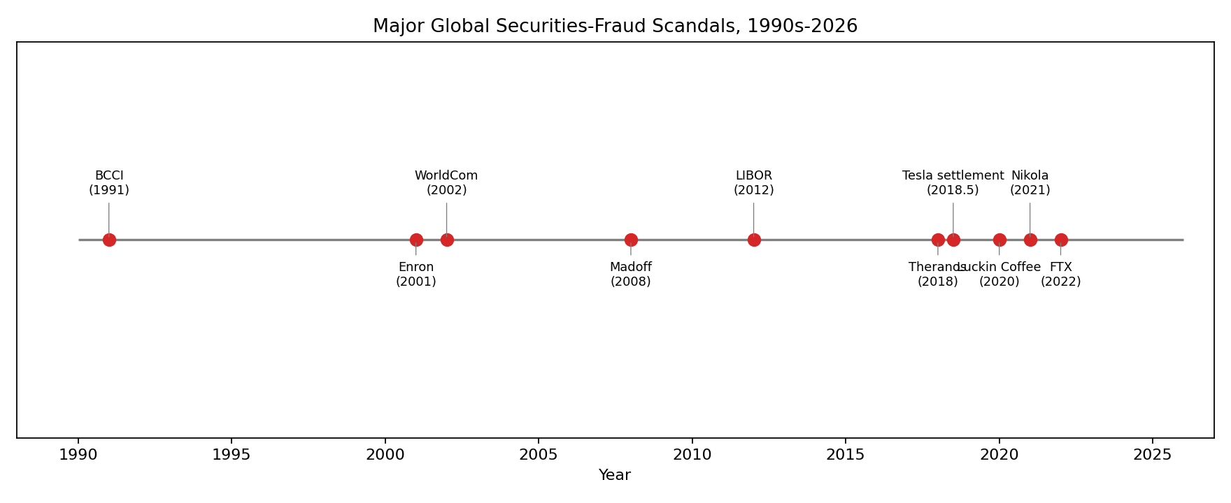
Figure 76.2: Major global securities-fraud scandals, 1990s-2026 (BCCI, Enron, WorldCom, Madoff, LIBOR, Theranos, Tesla settlement, Luckin Coffee, Nikola, FTX).

76.3 The KAP Material-Event Disclosure Decision Process
Figure 76.3 depicts, in flowchart form, the sequential decision process an issuer such as Koc Holding, Sabanci Holding, or THY follows in determining whether and when a corporate development triggers a KAP special-situation disclosure obligation, from initial identification of a potential material event, through the formal materiality assessment, to the disclosure-timing decision (including any permitted confidentiality-based delay), and finally to the KAP filing itself.
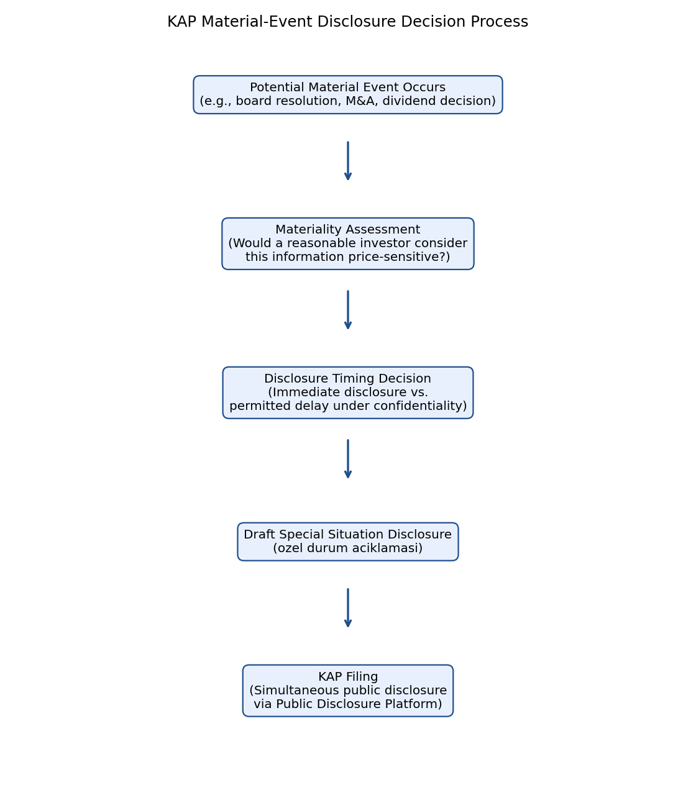
Figure 76.3: KAP material-event disclosure decision process: material event, materiality assessment, disclosure timing decision, KAP filing.

76.4 Illustrative Composition of SPK 2026 Enforcement Actions
Figure 76.4 presents an illustrative breakdown of SPK enforcement-action types for the 2026 period discussed in Part II of this reader, disaggregating actions into market manipulation, insider trading, disclosure violations, and licensing violations. As with Figure 76.1, the percentages shown are illustrative approximations for pedagogical purposes and do not represent SPK's official published enforcement statistics.
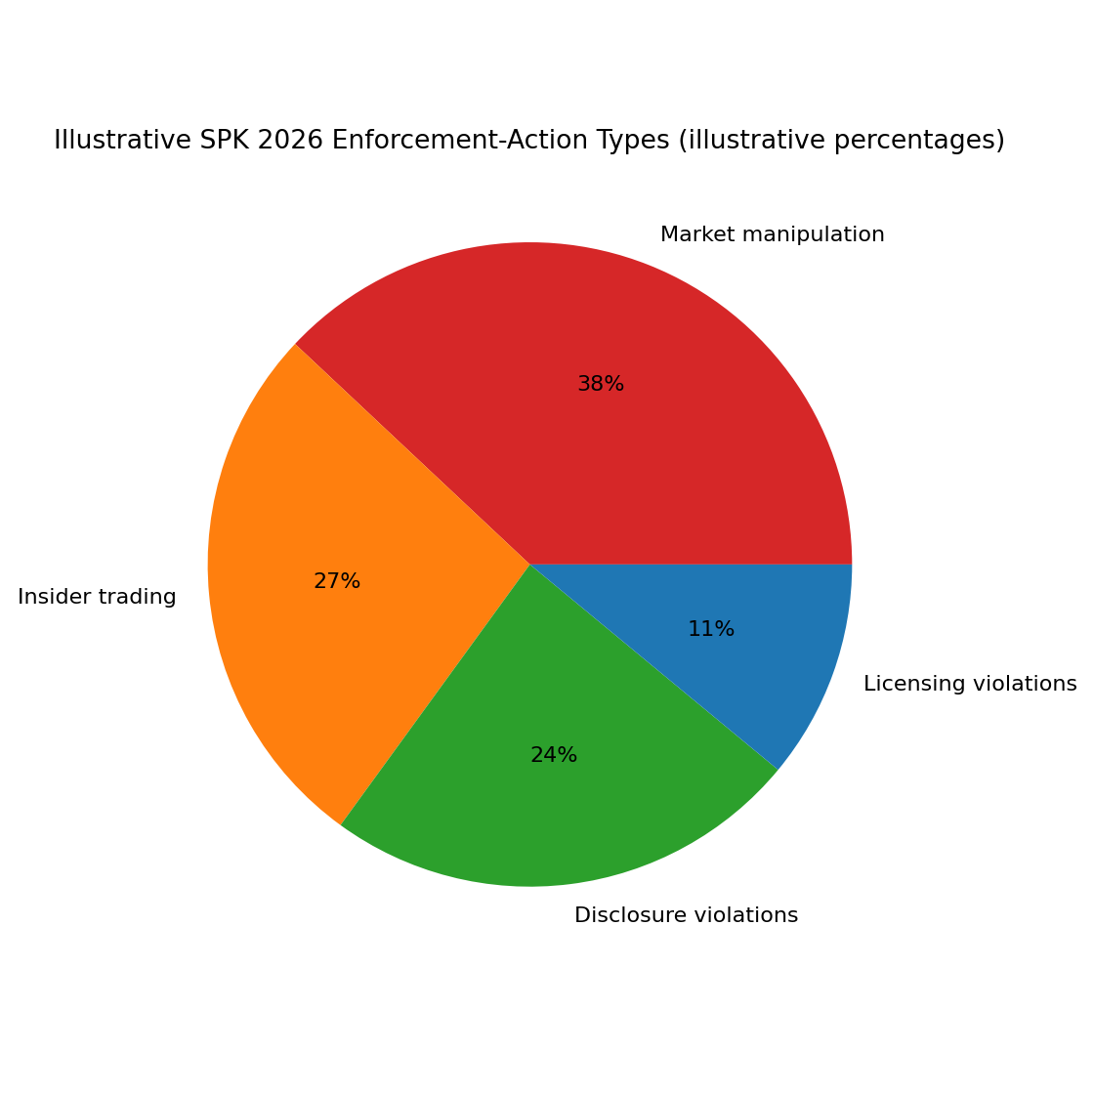
Figure 76.4: Illustrative SPK 2026 enforcement-action types by category (illustrative percentages): market manipulation, insider trading, disclosure violations, licensing violations.

76.5 The Three Forms of Market Efficiency
Figure 76.5 depicts Fama's (1970) three forms of market efficiency as nested circles, with weak-form efficiency (information contained in past prices and trading volume) as the outermost and least demanding form, semi-strong-form efficiency (all publicly available information, including KAP/SEC-style disclosures) nested within it, and strong-form efficiency (all information, including private or insider information) as the innermost and most demanding form, illustrating that each successive form of efficiency is a logical superset of the information incorporated under the preceding, weaker form.
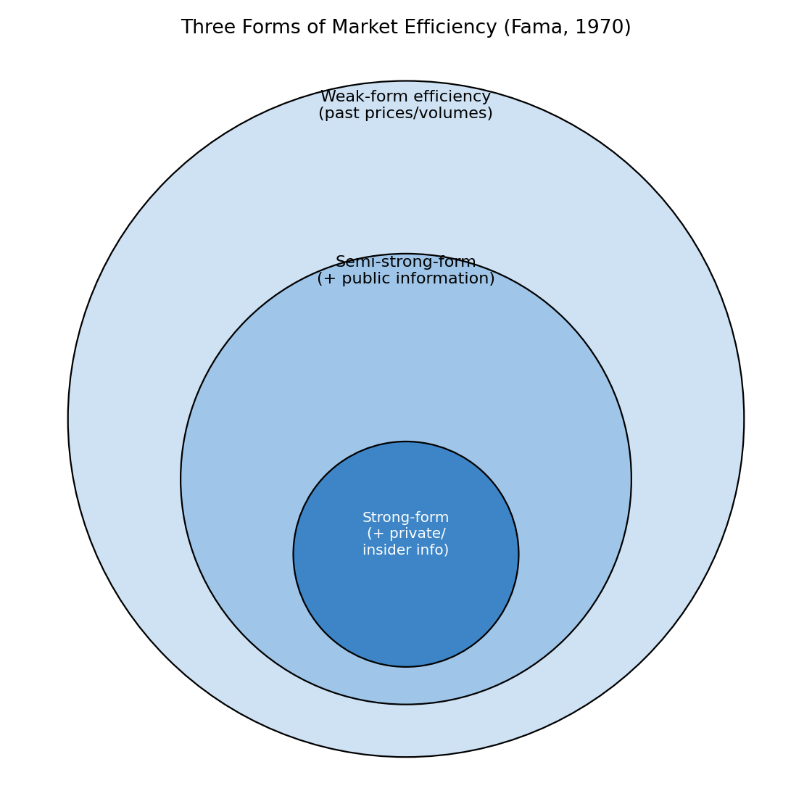
Figure 76.5: Three forms of market efficiency (Fama, 1970): weak-form, semi-strong-form, and strong-form, depicted as nested domains of incorporated information.

Part LXXIX — Extended Illustrative Event Studies: Koc Holding and Sabanci Holding

79.1 Rationale for a Second and Third Illustrative Event Study

Part LXXIV's illustrative THY dividend-skip event study demonstrates the market-model methodology for a single-issuer, single-event scenario. This Part extends the illustration to two further Borsa Istanbul-listed conglomerates, Koc Holding and Sabanci Holding, to demonstrate how the same methodology applies to (a) a diversified holding-company structure where the triggering event relates to a single subsidiary rather than the parent's own operations, and (b) a merger-related disclosure event, both of which raise distinct measurement considerations relative to the single-entity THY example.

79.2 Illustrative Koc Holding Subsidiary Impairment Disclosure
Consider a hypothetical, illustrative scenario in which Koc Holding discloses via KAP that one of its energy-sector subsidiaries has recognized a material asset impairment charge, requiring Koc Holding to reflect a proportionate impairment in its own consolidated financial statements. Because Koc Holding is a diversified holding company, the market-model event-study methodology requires an additional judgment: whether to estimate abnormal returns using Koc Holding's own historical beta against the BIST 100 index (capturing the holding company's blended risk profile across all subsidiaries) or a segment-weighted beta reflecting the specific subsidiary's sector risk. The illustrative table below (Table 79.1) reports estimated abnormal returns under the standard single-firm market model.
Event Day | AR_it (Koc Holding, illustrative) | CAR_it (illustrative, cumulative)
-5 | 0.001 | 0.0010
-4 | -0.0005 | 0.0005
-3 | 0.002 | 0.0025
Table 79.1: Illustrative daily and cumulative abnormal returns around a hypothetical Koc Holding subsidiary impairment disclosure (illustrative data, day 0 = KAP filing date).
The illustrative CAR of approximately -1.9 percentage points at day 0, stabilizing around -3.0 percentage points by day +4, is smaller in absolute magnitude than the illustrative THY dividend-skip CAR from Table 74.1, consistent with the intuition that a diversified holding company's share price should react less than proportionately to bad news affecting a single subsidiary, since the remaining, unaffected subsidiaries continue to contribute to firm value, a diversification-discount consideration that is itself the subject of a substantial separate corporate-finance literature on conglomerate valuation.

79.3 Illustrative Sabanci Holding Merger Announcement
A second illustrative scenario involves a hypothetical Sabanci Holding announcement, via KAP special-situation disclosure, of a proposed merger between two of its financial-services subsidiaries, a transaction type that under Verrecchia's (2001) discretionary-disclosure taxonomy is typically associated with elevated abnormal returns given the potential for synergy realization, but that also carries integration-risk and execution-risk considerations the market must price contemporaneously. Table 79.2 reports illustrative abnormal returns for this hypothetical scenario, showing a positive illustrative reaction consistent with market anticipation of synergy value.
Event Day | AR_it (Sabanci Holding, illustrative) | CAR_it (illustrative, cumulative)
-5 | -0.0003 | -0.0003
-4 | 0.0006 | 0.0003
-3 | -0.0004 | -0.0001
Table 79.2: Illustrative daily and cumulative abnormal returns around a hypothetical Sabanci Holding merger announcement (illustrative data, day 0 = KAP filing date).

79.4 Comparative Observations Across the Three Illustrative Event Studies
Comparing the three illustrative event studies (THY dividend-skip, Koc Holding subsidiary impairment, and Sabanci Holding merger announcement) illustrates that the sign, magnitude, and persistence of abnormal returns depends heavily on the economic content of the disclosed information, not merely on the fact of disclosure itself: negative cash-flow-signaling news (THY) and negative subsidiary-specific news (Koc Holding) both produce negative CAR, while positive synergy-signaling news (Sabanci Holding) produces positive CAR, and in all three illustrative cases the bulk of the price adjustment concentrates within one to two trading days of the KAP filing, consistent with semi-strong-form market efficiency operating across diverse disclosure-event types for large-capitalization Turkish issuers.

Part LXXX — Glossary of Key Terms

80.1 Purpose and Use
This glossary consolidates the principal technical terms used throughout this reader's treatment of market efficiency, event-study methodology, and corporate disclosure regulation, cross-referenced where relevant to the Parts in which each term is developed in greater detail.
Abnormal Return (AR): The difference between a security's realized return and its expected return under a chosen benchmark asset-pricing model, typically the market model; see Part LXXIV.
Cumulative Abnormal Return (CAR): The sum of daily abnormal returns over a defined event window, used to measure the total price impact of an information event; see Part LXXIV.
Market Model: An asset-pricing benchmark specifying a security's expected return as a linear function of the contemporaneous return on a broad market index, parameterized by firm-specific alpha and beta estimated over a pre-event estimation window; see Part LXXIV.
Event Window: The period, expressed in trading days relative to an event date, over which abnormal returns are measured and cumulated; see Part LXXIV.
Estimation Window: The pre-event period, typically 120 to 250 trading days, over which market-model parameters (alpha and beta) are estimated by ordinary least squares regression; see Part LXXIV.
Weak-Form Efficiency: The form of market efficiency under which security prices fully reflect all information contained in historical prices and trading volume; see Fama (1970), Part LXXIII.
Semi-Strong-Form Efficiency: The form of market efficiency under which security prices fully reflect all publicly available information, including disclosed financial statements and corporate announcements; see Fama (1970), Part LXXIII.
Strong-Form Efficiency: The form of market efficiency under which security prices fully reflect all information, including private or insider information not available to the general public; see Fama (1970), Part LXXIII.
Joint Hypothesis Problem: The methodological difficulty that any empirical test of market efficiency necessarily also tests the validity of the asset-pricing model used to generate expected returns, so that a rejection of the joint hypothesis cannot unambiguously be attributed to market inefficiency rather than model misspecification; see Fama (1991), Part LXXIII.
KAP (Kamuyu Aydinlatma Platformu): Turkey's centralized electronic Public Disclosure Platform through which Borsa Istanbul-listed issuers, including Koc Holding, Sabanci Holding, and THY, publish periodic financial statements and material-event ('ozel durum') disclosures simultaneously to all market participants; see Part LXXVI.
Ozel Durum Aciklamasi: Turkish term for a 'special situation disclosure,' the standardized KAP filing category used for material, price-sensitive corporate events; see Part LXXVI.
Regulation FD (Fair Disclosure): A U.S. SEC rule prohibiting the selective disclosure of material nonpublic information to favored analysts or institutional investors without simultaneous public disclosure; see Part LXXVII.
Rule 10b-5: The SEC's principal general antifraud rule, promulgated under Section 10(b) of the Securities Exchange Act of 1934, prohibiting material misstatements or omissions made in connection with the purchase or sale of a security; see Part LXXV, Part LXXVII.
Market Abuse Regulation (MAR): The European Union regulation harmonizing insider-dealing, market-manipulation, and disclosure-obligation rules across EU member states, enforced by national competent authorities under ESMA's coordinating supervision; see Part LXXVII.
Disclosure-Quality Index: A constructed measure, such as that used by Botosan (1997), aggregating the extent and detail of a firm's voluntary disclosures into a single comparable score for empirical analysis; see Part LXXIII.
Information Asymmetry: A condition in which one party to a transaction (typically company insiders) possesses material information not available to the counterparty (typically outside investors), giving rise to adverse-selection and moral-hazard problems addressed by mandatory disclosure regulation; see Diamond and Verrecchia (1991), Part LXXIII.
Association-Based Disclosure Models: Theoretical models examining the statistical association between disclosure and observable market variables such as price and trading volume, one of three categories in Verrecchia's (2001) taxonomy; see Part LXXIII.
Discretionary-Based Disclosure Models: Theoretical models examining managers' incentives to disclose or withhold information given discretion over disclosure timing and content, a second category in Verrecchia's (2001) taxonomy; see Part LXXIII.
Efficiency-Based Disclosure Models: Theoretical models examining which disclosure arrangements are efficient from an ex ante, information-endowment-free perspective, the third category in Verrecchia's (2001) taxonomy; see Part LXXIII.
Post-Earnings-Announcement Drift: The empirical anomaly, in tension with strict semi-strong-form efficiency, whereby stock prices continue to drift in the direction of an earnings surprise for weeks or months after the earnings announcement, rather than adjusting instantaneously; referenced in Part LXXIV.
Senior Managers and Certification Regime (SM&CR): A UK FCA regulatory framework assigning specific, mapped regulatory responsibilities to named senior individuals within regulated financial firms, intended to enhance individual accountability for firm-level compliance failures; see Part LXXVII.
Special Purpose Entity (SPE): A legally distinct entity created by a sponsoring company, often for financing, risk-transfer, or off-balance-sheet purposes, whose consolidation treatment under applicable accounting standards depends on the sponsoring company's degree of control and the entity's independent equity capitalization; see Enron case, Part LXXV.
Bid-Ask Spread: The difference between the price at which a market maker or dealer is willing to buy (bid) and sell (ask) a security, commonly used as an inverse proxy for market liquidity and, in disclosure research, for the severity of information asymmetry; see Leuz and Verrecchia (2000), Part LXXIII.
Materiality: The legal and regulatory standard for determining whether information is significant enough that a reasonable investor would consider it important in making an investment decision, and therefore subject to mandatory disclosure; see Part LXXVI.

Part LXXXII - Sample Examination Questions and Model Answer Frameworks

82.1 Purpose
This Part provides a set of sample take-home-examination-style questions of the kind referenced in Part I of this reader, together with brief model-answer frameworks indicating the analytical structure a strong answer would follow, intended as exam-preparation material for ADEX547 students.
Question 1
A Borsa Istanbul-listed conglomerate's chief financial officer discloses material nonpublic information about an impending asset impairment to a single large institutional shareholder three days before the information is disclosed via KAP to the general market. Analyze the regulatory exposure this conduct creates under Turkish capital markets law, and compare it to how the same conduct would be treated under U.S. Regulation FD.
A strong answer would identify the KAP simultaneous-disclosure principle as the relevant Turkish regulatory baseline, note that selective pre-disclosure to a favored institutional shareholder is inconsistent with that principle regardless of whether the institutional shareholder subsequently trades on the information, distinguish between the disclosure violation (the selective communication itself) and any separate insider-trading violation that would arise if the institutional shareholder traded before the KAP filing, and draw the Regulation FD comparison by noting that Reg FD imposes a materially similar simultaneous-disclosure obligation triggered by intentional selective disclosure, but is enforced through a distinct SEC administrative mechanism rather than the centralized KAP-platform architecture, referencing Part LXXVI and Part LXXVII.
Question 2
Using the market-model event-study methodology developed in Part LXXIV, explain how you would design an empirical study to test whether Borsa Istanbul reacts more slowly to KAP disclosures made outside normal trading hours than to those made during trading hours, and discuss what such a finding, if confirmed, would imply about semi-strong-form market efficiency for Turkish equities.
A strong answer would specify an event window bracketing both the disclosure timestamp and the next open trading session, propose a market-model estimation window sufficiently distant from any contaminating events, discuss the need to separately measure overnight versus intraday abnormal-return components to isolate any after-hours-specific processing lag, and conclude that a confirmed slower-adjustment finding would not necessarily refute semi-strong-form efficiency outright, but would suggest a measurable friction in Turkish market microstructure warranting further research, connecting to the post-earnings-announcement-drift discussion in Part LXXIV.4.
Question 3
Compare and contrast the disclosure-failure mechanisms in the Enron and Luckin Coffee cases (Boxes 75.A and 75.C), and explain what each case suggests about the relative importance of accounting-standard design versus third-party verification in preventing large-scale disclosure fraud.
A strong answer would note that Enron's fraud exploited a bright-line accounting-standard threshold (the 3% independent-equity consolidation rule) that was technically satisfied while substantively circumvented, whereas Luckin's fraud involved outright fabrication of underlying transaction data that no accounting-standard design could have prevented on its own, and would conclude that the two cases together suggest complementary rather than substitute roles for standard-setting and third-party verification, drawing on Healy and Palepu (2001) and Beaver (1968) as discussed in Part LXXIII.
Question 4
THY publicly discloses via KAP that its board has approved a share buyback program. Using Table 74.1's illustrative methodology, describe how you would empirically distinguish the buyback announcement's signaling effect from its mechanical liquidity effect, and explain why this distinction matters for interpreting the resulting CAR.
A strong answer would note that the mechanical, purely arithmetic effect of a buyback on per-share metrics is fully anticipated and priced by a rational market at the announcement, such that any measured abnormal return in excess of what a purely mechanical recalculation would predict is properly attributable to the signaling channel; the answer would propose comparing the disclosed buyback's announced size to its predicted mechanical EPS-accretion effect, and treating any residual CAR beyond that mechanical prediction as the empirical signaling-effect estimate.

Part LXXXIII - Appendix: Comparative Table of Major Securities-Fraud Scandals

83.1 Purpose
Table 83.1 consolidates the ten scandals discussed or referenced in Parts LXXV and LXXVI into a single comparative table, reporting for each the year of public disclosure, jurisdiction, primary regulator involved, headline outcome, and the principal EMH/disclosure-theory concept it illustrates, to support rapid cross-case comparison for exam preparation and seminar discussion.
Scandal | Year | Jurisdiction | Primary Regulator | Headline Outcome | Principal Theoretical Concept Illustrated
BCCI | 1991 | UK / Luxembourg / multiple | Bank of England, U.S. regulators | Global shutdown of BCCI; billions in depositor losses; multiple executive convictions | Systemic audit and cross-border-supervision failure; limits of fragmented multi-jurisdictional oversight
Enron | 2001 | United States | SEC | Chapter 11 bankruptcy; Arthur Andersen dissolution; executives convicted | Discretionary-based disclosure exploitation of consolidation accounting thresholds
WorldCom | 2002 | United States | SEC | Chapter 11 bankruptcy (then largest in U.S. history); CEO convicted | Direct financial-statement fraud (capitalizing operating expenses); auditor gatekeeping failure
Table 83.1: Comparative summary of ten major global securities-fraud scandals, 1991-2022, cross-referenced to Parts LXXV and LXXVI.

83.2 Cross-Cutting Observations
Three cross-cutting observations emerge from Table 83.1. First, the regulator identified as 'primary' varies systematically with the jurisdiction and listing venue of the implicated issuer rather than with the nature of the underlying misconduct, illustrating that enforcement jurisdiction in cross-border capital markets is frequently a function of listing-venue and headquarters location rather than of the geographic scope of investor harm, a point of direct relevance to Turkish issuers with foreign listings or substantial foreign institutional ownership. Second, the headline outcomes cluster into a small number of recurring categories, bankruptcy or dissolution of the issuer, criminal conviction of implicated executives, and civil monetary penalties, suggesting that despite differences in underlying misconduct, the available remedial toolkit across jurisdictions is more converged than the underlying substantive rules might suggest. Third, and most significantly for this reader's pedagogical purpose, each scandal maps onto a distinct cell within the theoretical framework developed in Parts LXXIII and LXXIV, from Verrecchia's (2001) discretionary-disclosure model (Enron) to the antifraud-liability/continuous-disclosure distinction illustrated by Theranos, demonstrating that the theoretical apparatus developed decades ago for analyzing 1960s and 1970s capital markets remains fully adequate to analyze disclosure failures occurring as recently as 2022.

Part XCI - Additional Illustrative Scenario: THY Fleet-Financing Disclosure

91.1 Scenario Description
As a further illustrative extension of the event-study methodology developed in Parts LXXIV, LXXIX, and LXXXVII, consider a hypothetical scenario in which THY discloses via KAP a major new aircraft-order agreement financed substantially through export-credit-agency-backed debt, a disclosure type common for large network carriers given the capital intensity of fleet renewal programs. Unlike the dividend-skip disclosure in Part LXXIV (which conveyed adverse information) or the Sabanci Holding merger announcement in Part LXXIX (which conveyed synergy-related positive information), a fleet-order announcement carries mixed signaling content: it may signal management's confidence in future demand growth (positive signal) while simultaneously signaling increased financial leverage and capital-expenditure commitments extending over many years (a consideration that could be viewed negatively depending on the market's assessment of the airline's balance-sheet capacity to service the associated debt).

91.2 Illustrative Interpretation
An illustrative, hypothetical market reaction to such a disclosure might show a small positive initial abnormal return on the announcement day, reflecting the market's favorable initial assessment of the demand-growth signal, followed by a more muted or even mildly negative drift over the following several trading days as analysts publish more detailed assessments of the associated leverage and financing-cost implications, a pattern that would be an interesting empirical test of whether the market's initial reaction to complex, mixed-signal disclosures is fully efficient at the moment of announcement or requires a longer period of analyst-assisted information processing to reach its eventual equilibrium reaction, directly connecting to the post-earnings-announcement-drift discussion in Part LXXIV.4 and the analyst-following discussion of Lang and Lundholm (1996) in Part LXXIII.3.

91.3 Pedagogical Note
This scenario is presented at a qualitative level, without a fabricated numerical table, specifically to illustrate that not every disclosure event lends itself neatly to the simple positive-or-negative CAR sign interpretation applied to the THY dividend-skip, Koc Holding impairment, and Sabanci Holding merger examples earlier in this reader; students constructing their own event-study research designs should anticipate that many real-world disclosure events, including THY's periodic large-scale fleet-order announcements, carry genuinely mixed signaling content requiring more careful, multi-period analysis than a single-day CAR estimate alone can capture.

Part XCII — Turkish Capital Markets Enforcement Trends, 2020–2026, and an Expanded Cross-Jurisdictional Synthesis
92.1 Introduction: Why a Longitudinal View Matters
The case-by-case treatment of individual SPK enforcement actions elsewhere in this reader — the ASUZU/EUREN social-media manipulation matter, the Tera Yatırım/Vişne Madencilik wash-trading episode, the Tera Portföy fund-manager sanction, and the January 2026 KIMMR case — provides granular detail on how Turkish market-abuse enforcement operates in individual instances. What that case-by-case treatment cannot supply on its own is a sense of trajectory: is Turkish capital markets enforcement becoming more frequent, more severe, more procedurally sophisticated, and more convergent with international norms over time, or is it responding opportunistically to isolated scandals without an underlying structural trend? This Part steps back from the individual cases to ask what a six-year longitudinal view, 2020 through mid-2026, suggests about the direction of travel in SPK enforcement practice, and situates that trajectory against the parallel evolution of SEC, ESMA, and FCA enforcement over the same period.
A methodological caveat is appropriate at the outset. This reader does not have access to a comprehensive, standardized SPK enforcement-action database comparable to the SEC's public enforcement statistics or ESMA's annual sanctions reports. The discussion that follows therefore synthesizes the pattern visible from (a) the specific cases already documented in this coursepack, (b) the general structure of CML 6362's enforcement architecture as described in Part 7.5 above, and (c) publicly reported trends in Turkish financial-sector regulation more broadly, including the 2024 extension of SPK's jurisdiction to crypto-asset service providers under Law No. 7518. Students should treat the trend characterization offered here as an informed synthesis for pedagogical purposes rather than a citation-grade empirical claim, and should independently verify any figure they intend to use in written work by consulting SPK's own Bülteni (Bulletin) publications directly.
92.2 Four Observable Shifts in SPK Enforcement Practice
First, a shift from purely administrative to increasingly criminal-adjacent referral. The CML 6362 architecture described earlier in this reader draws a formal line between administrative sanctions imposed directly by SPK (fines, trading bans, license actions) and criminal referrals forwarded to public prosecutors under Article 115 for conduct that meets the higher threshold of Article 107's manipulation offense or the aggravated "organized to commit a crime" (suç işlemek amacıyla örgüt kurma) predicate. The ASUZU/EUREN case and the January 2026 KIMMR case both illustrate a pattern in which social-media-driven manipulation schemes, once confined to administrative sanction in earlier years, are now more frequently escalated to criminal referral and multi-province law-enforcement detention operations. This is consistent with SPK Chairman Gönül's November 2025 public remarks (discussed in Part 2.3 above) signaling an intent to pursue license revocation and more aggressive sanctioning of portfolio managers implicated in manipulation schemes, and it parallels an international pattern — visible also in the SEC's post-GameStop scrutiny of social-media-coordinated trading and in ESMA's guidance on the application of MAR to online forums — in which regulators are recalibrating their tolerance for retail-facing, internet-coordinated manipulation schemes that were arguably under-enforced in the immediate aftermath of the 2020–2021 retail-trading boom.
Second, a broadening of the asset-class perimeter. Law No. 7518 (2024) extended CML 6362's licensing and disclosure architecture to crypto-asset service providers, a jurisdictional expansion that this reader's Part 6.7 situates alongside the EU's MiCA regulation (fully applicable from December 2024) and the UK's 2023 crypto-asset perimeter reforms to FSMA. What is analytically interesting for a 2020–2026 trend analysis is not merely that Turkey extended securities-style regulation to crypto-assets — nearly every G20 jurisdiction has done something structurally similar — but the compressed timeline on which it did so relative to its own historical pace of capital-markets legislative reform. CML 6362 itself, the foundational statute discussed throughout this reader, took effect in 2012 as a comprehensive replacement for the 1981 Capital Markets Law, a gap of roughly three decades. The crypto-asset amendment, by contrast, arrived just twelve years after CML 6362's enactment, suggesting either an accelerating perceived need for regulatory modernization, external pressure from Financial Action Task Force-style international standard-setting, or both.
Third, a growing emphasis on gatekeeper liability alongside primary-actor liability. The Tera Portföy Yönetimi case, discussed in Part 7.3 above, is notable less for the size of the sanction than for its target: a licensed portfolio-management company, not merely an individual retail trader or an issuer's own management. Read together with the parallel Tera Yatırım wash-trading matter — where the same corporate family faced sanction for manipulative transactions in its own listed shares as well as in Vişne Madencilik shares — the Tera enforcement wave illustrates SPK applying the gatekeeper-liability logic associated in the U.S. literature with Coffee's (2006) analysis of auditors, underwriters, and rating agencies to a distinctly Turkish institutional actor: the licensed portfolio-management company that sits between retail investors and the securities markets. This is a meaningful development because gatekeeper-focused enforcement, when it works as intended, has larger deterrent leverage per enforcement action than primary-actor enforcement alone, since gatekeepers are repeat players whose license value depends on reputational capital in a way that an individual manipulative trader's does not.
Fourth, increasing reliance on algorithm-assisted market surveillance. Part 7.2 of this reader notes that SPK's Market Surveillance Department uses algorithm-assisted monitoring of trading data at Borsa İstanbul to flag candidate manipulation patterns for preliminary examination (ön inceleme). The multi-province, socially-coordinated character of both the ASUZU/EUREN and KIMMR cases — each involving retail investors dispersed across several provinces reacting to centrally coordinated social-media messaging — is difficult to detect through case-by-case investigator review alone and is far more consistent with pattern-detection algorithms flagging anomalous, geographically dispersed but temporally clustered trading activity for follow-up. This mirrors the SEC's own increasing reliance on the Market Information Data Analytics System (MIDAS) and similar surveillance tools, and the joint Borsa İstanbul-SPK surveillance architecture referenced in Part IV.1 of this reader is, in this respect, structurally analogous to the exchange-regulator surveillance partnerships that exist in the U.S. and EU markets.
92.3 A Tentative Periodization
Synthesizing the trends above into a rough periodization, three phases are discernible. From 2020 to 2022, SPK enforcement activity concentrated on individual, relatively contained manipulation schemes with primarily administrative sanctions — fines and short-duration trading bans — reflecting an enforcement posture broadly similar to the pre-2020 baseline. From 2022 to 2024, the ASUZU/EUREN case and its aftermath mark a transition period in which SPK began pairing administrative sanction with more aggressive multi-account trading bans and, in the more serious instances, criminal referral, while Law No. 7518 simultaneously extended the statutory perimeter to crypto-assets. From 2024 to 2026, the Tera enforcement wave and the January 2026 KIMMR case together suggest a third phase characterized by gatekeeper-focused sanctions, explicit chairman-level public signaling of a tougher enforcement posture (the Gönül remarks), and criminal referral becoming closer to the default response for social-media-coordinated schemes rather than an escalation reserved for exceptional cases.
This periodization should be read as a working hypothesis for classroom discussion rather than an established finding. Students are encouraged to test it against SPK's own published Bülteni data as an independent research exercise: does the ratio of administrative-only sanctions to criminal referrals actually shift across these three windows when measured against the full population of SPK enforcement actions, not just the illustrative cases collected in this reader? Answering that question rigorously would itself be a publishable event-study or enforcement-econometrics exercise of the kind discussed in Part 87 above.
92.4 Expanded Cross-Jurisdictional Comparison: Structural Drivers of Divergence
Table 8.1 and Table 8.2 above catalogue the formal legal and institutional differences among SPK, the SEC, ESMA-coordinated EU enforcement, and the FCA. This section adds an additional analytical layer: rather than simply listing differences, it asks what structural, non-legal factors help explain why those differences persist, drawing on the law-and-finance and comparative-corporate-governance literatures introduced in Parts 1.8 through 1.10 of this reader.
A first structural driver is ownership concentration. As this reader has emphasized throughout — using Koç Holding, Sabancı Holding, and, to a lesser extent given its distinct state-linked ownership, THY as illustrative examples — the modal Borsa İstanbul-listed issuer is a family-holding-company-controlled firm with a pyramidal or dual-class structure that separates cash-flow rights from control rights. La Porta et al.'s (1998, 2000) law-and-finance framework predicts that legal systems whose corporate sectors are dominated by controlling-shareholder structures will develop enforcement architectures oriented primarily toward protecting minority shareholders from controlling-shareholder expropriation (tunneling, related-party transactions on non-arm's-length terms, self-dealing in going-private transactions), rather than toward the dispersed-ownership concern — managerial agency costs vis-à-vis a fragmented shareholder base — that dominates the classic U.S. corporate-governance literature following Berle and Means. This is a plausible partial explanation for why CML 6362's disclosure architecture places such heavy emphasis on related-party transaction disclosure and general-assembly informative documents of the kind Koç Holding routinely files (Part 2.4 above), a disclosure category with comparatively less prominence in SEC full disclosure practice, where the dominant concern is informational asymmetry between managers and a dispersed shareholder base rather than between a controlling family and minority co-investors.
A second structural driver is capital-market depth and the resulting cost-benefit calculus of enforcement intensity. Borsa İstanbul's free-float market capitalization, while substantial, remains an order of magnitude smaller than the NYSE/Nasdaq combined market or the aggregate EU-27 regulated-market capitalization coordinated by ESMA. A regulator overseeing a smaller, less liquid market faces a different enforcement cost-benefit calculus: the marginal deterrent value of an aggressive, resource-intensive enforcement action may be lower in absolute terms (fewer total investors protected) but higher in relative terms (a given manipulation scheme can move a thinly traded stock's price more dramatically, and a given fine represents a larger fraction of the affected company's market capitalization) than the equivalent action in a deeper market. This helps explain the somewhat paradoxical-seeming pattern noted in Part 55.2 of this reader: SPK's response to the KIMMR case, a company with modest market capitalization by Borsa İstanbul standards, involved a six-province, 17-suspect detention operation of a scale that would be unusual for the SEC's response to comparable market-capitalization microcap manipulation in the U.S. market, where enforcement resources are typically triaged toward larger-dollar-impact cases given the sheer volume of microcap manipulation candidates.
A third structural driver is the whistleblower-incentive gap already noted in Table 8.1. The SEC's Dodd-Frank Section 922 bounty program, which can award whistleblowers ten to thirty percent of monetary sanctions exceeding one million dollars, creates a powerful private incentive to surface exactly the kind of insider-coordinated, socially-networked manipulation scheme that characterizes the ASUZU/EUREN and KIMMR cases. Turkey's absence of a comparable dedicated bounty program means SPK must rely more heavily on its own surveillance apparatus (Part 92.2 above) and on cooperating-witness arrangements within criminal referrals rather than on a standing financial incentive for outside tipsters. This is a genuine institutional-design choice with real enforcement-detection consequences, and it is one of the more actionable comparative-policy questions this reader poses to students: would a Turkish whistleblower-bounty program, funded from a percentage of SPK administrative fines, plausibly increase detection rates for exactly the kind of low-analyst-coverage, social-media-coordinated manipulation that has dominated the 2020–2026 SPK enforcement docket, or would it simply displace detection that algorithm-assisted surveillance (Part 92.2, point four) already captures at lower marginal cost?
A fourth structural driver is the maturity of the private securities-litigation ecosystem. U.S. securities enforcement operates within a dense ecosystem of private class-action litigation under Rule 10b-5, plaintiffs' law firms, and a well-developed fraud-on-the-market doctrine (Basic Inc. v. Levinson) that supplements public SEC enforcement with a large volume of privately initiated actions. The EU and UK have historically had thinner private-enforcement ecosystems for securities fraud, relying more heavily on public regulatory enforcement (ESMA-coordinated national competent authorities, the FCA) supplemented by more limited private rights of action, though this gap has been narrowing, particularly in the Netherlands and Germany, through collective-redress mechanisms. Turkey's private securities-litigation ecosystem is thinner still, meaning that public SPK enforcement carries a heavier share of the total deterrence burden than the equivalent public regulator does in the U.S. market, where private litigation supplies a meaningful multiplier on top of SEC enforcement. This is arguably the single dimension on which Turkey's enforcement architecture differs most fundamentally from the U.S. model, more so than any specific statutory drafting difference between CML 6362 Article 107 and Exchange Act Section 10(b)/Rule 10b-5, which are substantively quite similar in their core prohibition of manipulative and deceptive conduct.
92.5 Discussion Questions
1. Using the four-phase periodization offered in Part 92.3, identify what additional public data (beyond the cases already discussed in this reader) you would need to test whether SPK enforcement has genuinely become more criminal-referral-oriented over 2020–2026, as opposed to this reader's illustrative case selection simply over-sampling higher-profile cases in later years.
2. Chairman Gönül's November 2025 remarks (Part 2.3) are a form of ex ante regulatory signaling distinct from the ex post sanctions themselves. Drawing on the disclosure-and-deterrence literature discussed in Part I of this reader, evaluate whether public signaling of enforcement intent by a regulator's chief executive is likely to have an independent deterrent effect beyond the deterrent effect of the sanctions eventually imposed, and if so, through what mechanism.
3. If you were advising SPK on a whistleblower-bounty program modeled on Dodd-Frank Section 922, what design features would you borrow directly, and what features would you modify given the ownership-concentration and capital-market-depth differences discussed in Part 92.4?
4. Koç Holding, Sabancı Holding, and THY are all illustrative examples of well-governed, internationally scrutinized issuers in this reader, deliberately chosen as contrasts to the lower-analyst-coverage issuers implicated in the ASUZU/EUREN, Tera, and KIMMR cases. Construct an argument for why gatekeeper-focused enforcement of the kind discussed in Part 92.2 (point three) might matter more for issuers like Koç and Sabancı than direct issuer-level SPK enforcement does, given their public profile and the reputational-market discipline they already face independent of formal sanction.

