ADEX547 Specail Topics in Organisation and Strategy

Part I: Foundational Agency and Stewardship Theory
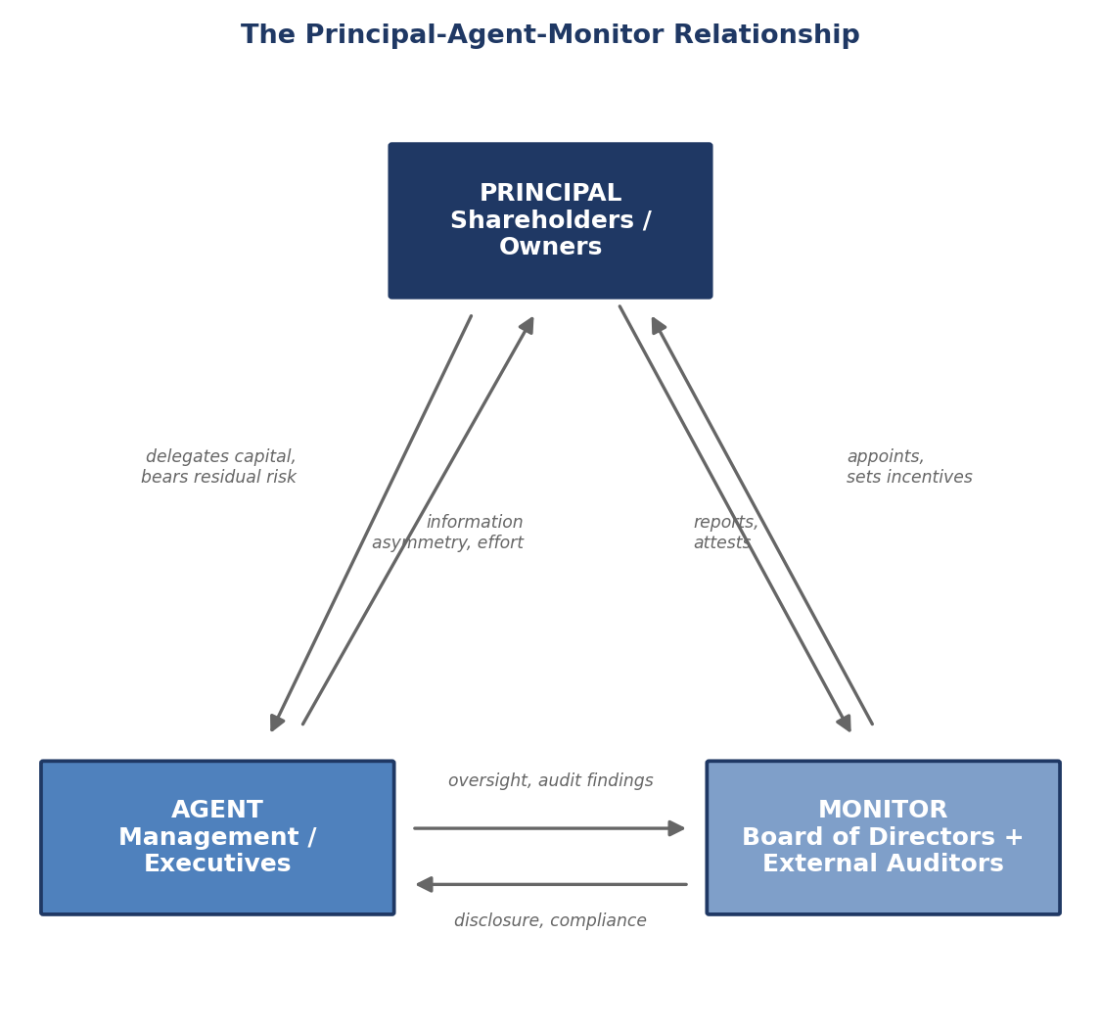
Figure: The Principal-Agent-Monitor Relationship

Stewardship Theory: A Counterpoint to Agency Theory
Donaldson, L. and Davis, J.H. (1991), “Stewardship Theory or Agency Theory: CEO Governance and Shareholder Returns,” Australian Journal of Management, 16(1), 49-64, propose an alternative behavioral model of the executive that directly challenges the pessimistic, opportunistic-actor assumption embedded in Jensen and Meckling (1976). Where agency theory models managers as self-interested agents who must be monitored, bonded, and disciplined lest they expropriate shareholder wealth, stewardship theory models managers as stewards whose interests are intrinsically aligned with the organization’s collective goals. Stewards are motivated by achievement, recognition, intrinsic satisfaction in a job well done, and identification with the organization, rather than narrow pecuniary self-interest. Under this behavioral assumption, the executive who is empowered rather than tightly monitored will produce superior performance, because monitoring and control mechanisms that presuppose distrust actually depress the very pro-organizational motivation stewardship theory assumes managers to have — a phenomenon Donaldson and Davis link to psychological and sociological theories of intrinsic motivation and organizational identification.
Key claims. Stewardship theory generates governance predictions that are the mirror image of agency theory’s. First, because stewards’ interests are aligned with the firm rather than opposed to it, CEO duality (the CEO simultaneously serving as board chair) is not, as agency theory would predict, an entrenchment risk requiring correction; instead it is argued to strengthen unity of command, reduce role ambiguity at the top, and give the CEO the authority needed to act decisively in the firm’s interest. Second, boards composed largely of insiders (executives with intimate operational knowledge) are preferred over boards dominated by independent outsiders, because insiders bring superior information and are themselves stewards rather than external monitors imposing an adversarial relationship. Third, structural empowerment — long CEO tenure, concentrated authority, minimal external second-guessing — is a facilitator of performance rather than a governance risk, because it allows a steward-CEO to execute a coherent strategic vision without the agency-cost friction of constant ratification by outsiders who may lack full information.
Donaldson and Davis’s own empirical test, using returns on equity data for large U.S. corporations, reported that firms with CEO duality (steward-consistent structure) modestly outperformed firms with separate chair and CEO roles, a finding they interpreted as supporting stewardship logic over agency logic in that sample. Subsequent work extended the theory to explain why many high-performing family firms and founder-led companies retain concentrated, duality-heavy governance structures without the value destruction agency theory would predict.
Critique. Stewardship theory has drawn sustained criticism on several grounds relevant to this course’s board-governance focus. First, critics note that the theory’s own empirical support is contested and sample-dependent: later, larger-sample studies on CEO duality and firm performance (including much of the CEO-duality literature discussed later in Part II) find inconsistent or even negative associations between duality and performance, undermining the generality of Donaldson and Davis’s original finding. Second, stewardship theory arguably describes a possible managerial disposition rather than a reliable governance design principle: even if some, or even most, executives behave as stewards most of the time, a governance system built entirely on that assumption is fragile precisely in the tail-risk cases — self-dealing, empire-building, fraud — that governance exists to guard against. A board that abandons independent monitoring on stewardship grounds is, in effect, making a bet that no executive currently in the room is the exception, a bet that the corporate-failure case vignettes in Part V (Enron, WorldCom, Wells Fargo, Theranos) suggest is regularly lost. Third, stewardship and agency assumptions are not necessarily mutually exclusive at the level of a single board: contingency-based syntheses (Sundaramurthy and Lewis, 2003, and others) argue that whether stewardship or agency logic dominates depends on situational factors — ownership concentration, industry, national governance regime, the individual CEO’s track record — rather than being a universal behavioral constant.
Relevance to board governance. For this course, stewardship theory functions best not as a replacement for agency theory but as a necessary corrective lens, particularly for the family-controlled and founder-led firms prominent in the Turkish case material in Part VI. Family-holding boards in Turkey (Koc Holding, Sabanci Holding) are frequently structured on implicit stewardship logic — a trusted family chairman retains concentrated authority over a professional CEO layer precisely because the family, as a multi-generational owner, is assumed to act as a steward of the enterprise rather than a self-interested raider of it. The课 (course) should press students to ask when this assumption is empirically warranted (long family horizon, reputational capital at stake, identity fused with the firm) and when it is not (succession disputes, generational conflict, a controlling family extracting private benefits at minority shareholders’ expense — the Type II agency cost identified earlier in this reader). The prudent analytic posture, consistent with the continuous-vs-episodic framework introduced above, is to treat agency and stewardship as competing null hypotheses to be tested against the specific ownership and governance architecture of the firm under review, not as a settled theoretical choice.

Comparative Note: Agency vs. Stewardship as Complementary Diagnostic Lenses
Table 1A below extends Table 1 from the original reader by placing stewardship theory in direct comparison with agency theory across the same dimensions, so that students can apply both lenses side by side to any board they analyze this term.
Table 1A. Agency Theory vs. Stewardship Theory — Comparative Governance Implications
Dimension | Agency Theory (Jensen & Meckling, 1976) | Stewardship Theory (Donaldson & Davis, 1991)
Behavioral assumption about executives | Self-interested, opportunistic; will maximize personal utility even at shareholder expense absent controls | Collectivist, achievement- and recognition-motivated; intrinsically aligned with organizational goals
Preferred board structure | Independent board majority; separate chair/CEO roles; strong monitoring committees | Insider-heavy board acceptable; CEO duality (combined chair/CEO) preferred for unity of command
View of executive compensation | Incentive alignment mechanism required to bond agent to principal interests | Less central; stewards do not require heavy pay-for-performance sensitivity to act in the firm’s interest
View of monitoring intensity | Monitoring reduces agency costs and is presumptively value-adding | Excessive monitoring can be value-destroying by signaling distrust and demotivating the steward-executive
Best-fit organizational context | Widely-held public corporations with dispersed, arms-length shareholders | Founder-led, family-controlled, or mission-driven organizations with concentrated, long-horizon ownership
Principal failure mode it guards against | Managerial expropriation, empire-building, shirking | Value-destroying over-monitoring, loss of decisive leadership, excessive bureaucratic friction
Turkish governance analogue | SPK/BIST-mandated independent-director requirements aimed at Type II agency costs | Family-chairman-over-professional-CEO model at Koc and Sabanci holding structures

Part II: Board Composition, Capital, and Power

Resource Dependence Theory of Boards
Pfeffer, J. and Salancik, G.R. (1978), The External Control of Organizations: A Resource Dependence Perspective, Harper & Row, offer a fundamentally different account of why boards exist than either agency or stewardship theory. Where agency theory frames the board as a monitoring device and stewardship theory frames it as an enabling structure for an aligned executive, resource dependence theory (RDT) frames the board as a boundary-spanning mechanism that reduces environmental uncertainty and secures critical resources the organization cannot generate internally. No organization is self-sufficient; every firm depends on its environment for capital, legitimacy, information, technical expertise, and access to other organizations, and directors are, in this view, conduits through which those resources flow into the firm.
Key claims. Pfeffer and Salancik argue that directors are selected substantially for the external resources and linkages they bring rather than (or in addition to) their monitoring capacity. A banker-director provides a channel to capital markets and can signal creditworthiness to lenders; a director who also sits on the board of a major customer or supplier provides information and relationship capital that reduces transaction uncertainty; a well-connected former regulator or politician provides legitimacy and access in regulated industries; a director with deep technical or scientific expertise provides advisory capacity the executive team may lack. Board size and composition, under RDT, should track the pattern of environmental dependence the firm faces — firms in heavily regulated, capital-intensive, or technologically volatile industries should be expected to recruit directors whose resource profile matches those specific dependencies, and empirical work following Pfeffer and Salancik has generally found board composition does covary with a firm’s resource-dependence profile in exactly this way (larger boards, and boards with more outside directors holding relevant external ties, in more resource-constrained or regulation-exposed industries).
Critique. Resource dependence theory has been criticized for being difficult to falsify cleanly: because almost any director characteristic can be redescribed after the fact as providing “resources” or “linkages,” the theory risks becoming unfalsifiable rather than a sharp predictive framework. Critics also note that RDT, taken alone, has little to say about the monitoring function that agency theory foregrounds — a board recruited purely for its resource linkages (well-connected but not independent, expert but not disciplined about executive oversight) may deliver excellent external relationships while doing a poor job of ratifying and controlling management decisions, precisely the failure diagnosed in several of the case vignettes below (Theranos in particular, where celebrity and political board members supplied prestige and access but conspicuously lacked the biomedical and financial expertise needed for genuine oversight). A further critique is that RDT was developed primarily for an era of less globally integrated capital markets; as information, capital, and expertise have become more broadly and cheaply available through digital markets and specialist advisory firms, some scholars argue the marginal resource-provision value of any single director has fallen relative to Pfeffer and Salancik’s original formulation, even as its monitoring and advisory value has, if anything, risen.
Relevance to board governance. RDT is the natural theoretical bridge between the agency/stewardship debate above and the board capital and CEO succession material that follows, because it reframes director selection and CEO succession alike as resource-acquisition decisions, not merely control decisions. A board applying continuous, upper-echelons-informed oversight (per the framework introduced earlier) should ask, of every succession candidate and every prospective director nomination alike, not only “is this person a credible monitor of management” but “what external resource — capital access, regulatory legitimacy, technical expertise, customer or government relationships — does this person supply that the firm currently lacks.” This is directly germane to the Turkish holding-company cases in Part VI: family-holding boards frequently include directors chosen explicitly for political, regulatory, or banking-sector linkages, a textbook resource-dependence pattern that a purely agency-theoretic lens would miss entirely.

Board Capital Theory
Hillman, A.J. and Dalziel, T. (2003), “Boards of Directors and Firm Performance: Integrating Agency and Resource Dependence Perspectives,” Academy of Management Review, 28(3), 383-396, synthesize agency theory and resource dependence theory into a single integrative construct they call board capital, comprising two components: human capital (directors’ individual experience, expertise, reputation, and skill) and relational capital (directors’ network ties to other organizations and resource providers, i.e., the RDT linkages described above). Hillman and Dalziel’s central move is to argue that board capital is the mechanism through which board composition translates into both effective monitoring (the agency function) and effective resource provision (the RDT function) — a director with deep financial-reporting expertise (human capital) simultaneously improves the board’s capacity to monitor accounting quality and improves its ability to provide credible signals to capital markets, so the same directorial attribute can serve both theoretical functions at once rather than trading off between them.
Key claims. Board capital theory predicts that firm performance is a function not simply of board independence (the crude proxy agency theory tends to emphasize) but of the fit between the board’s aggregate human and relational capital and the firm’s specific strategic and monitoring needs at a given point in its lifecycle. A young, high-growth technology firm needs board capital weighted toward technical expertise, venture-capital network ties, and talent-market relationships; a mature, heavily regulated financial institution needs board capital weighted toward audit, risk, and regulatory expertise and relationships with supervisors. This lifecycle-contingent framing directly anticipates the upper-echelons-informed succession logic discussed in Part IV: just as CEO succession should match successor cognitive profile to strategic need, board renewal should match incoming-director capital to the firm’s evolving capital-and-monitoring requirements, a matching exercise continuous-oversight boards run routinely and episodic-oversight boards run only when a crisis or a scheduled board-refreshment cycle forces the question.
Critique. The principal critique of board capital theory is measurement difficulty: human and relational capital are far harder to operationalize and compare across firms than a simple independence ratio, and much of the empirical literature applying the framework has relied on necessarily coarse proxies (number of other directorships held, prior CEO/CFO titles, elite-university credentials) that may capture prestige as much as genuine decision-useful capital. A second critique, related to the RDT critique above, is that board capital theory, by construction, treats director attributes as additive resources rather than asking whether a board’s decision-making process (information-sharing norms, willingness to challenge management, psychological safety in dissenting) actually converts nominal board capital into effective oversight — a board stacked with impressive individual human and relational capital can still fail badly if its group process suppresses dissent, an important qualification for students evaluating any board roster mechanically against this framework.
Relevance to board governance. Board capital theory gives this course a vocabulary for auditing any board’s composition against its firm’s specific situation rather than against a generic independence benchmark, and it is the theory most directly operationalized in the case vignettes below — Theranos’s board, audited through a board-capital lens, scores extremely high on prestige and political/celebrity relational capital and near zero on the biomedical, laboratory-science, and financial-controls human capital the firm’s actual risk profile required, which is a sharper and more diagnostic critique than simply noting the board lacked “independence.”

CEO Duality Research
Finkelstein, S. and D’Aveni, R.A. (1994), “CEO Duality as a Double-Edged Sword: How Boards of Directors Balance Entrenchment Avoidance and Unity of Command,” Academy of Management Journal, 37(5), 1079-1108, provide the field’s most influential integrative treatment of CEO duality — the practice of one individual holding both the Chief Executive Officer and Board Chair titles simultaneously — precisely because they refuse to adjudicate the question with a single theory. Instead, they explicitly frame duality as a double-edged sword, pitting the agency-theoretic “entrenchment avoidance” logic (duality concentrates power dangerously and should be avoided, or at minimum offset with a lead independent director) against the stewardship-consistent “unity of command” logic articulated by Donaldson and Davis above (duality provides decisive, unambiguous leadership and should be preserved, particularly in turbulent or resource-scarce conditions where fast, unified decision-making has genuine value).
Key claims. Finkelstein and D’Aveni’s empirical contribution is to show that the entrenchment-vs-unity-of-command trade-off is not fixed but contingent on organizational and market conditions. Using data on CEO succession and board structure, they find that firms facing greater potential for managerial entrenchment (long CEO tenure, weak institutional ownership, poor recent performance) are more likely to separate the chair and CEO roles or to signal an intention to do so around a succession event, consistent with boards deploying separation strategically when entrenchment risk is elevated. Conversely, they find evidence that unity-of-command benefits are more highly prized, and duality more likely to persist, when the firm faces high uncertainty or requires rapid, unified strategic redirection — precisely the situations in which stewardship-style concentrated authority is argued to add value. The core takeaway for governance practice is that duality is not simply good or bad in the abstract; whether it functions as protective concentration of authority or as unchecked entrenchment risk depends on the surrounding governance architecture (particularly whether a strong lead independent director or presiding director role exists to preserve some separation of decision management from decision control even when the CEO also chairs).
Critique. Subsequent large-sample meta-analytic work on CEO duality and firm performance (surveyed in later governance-index literature, including the ISS and proxy-advisor frameworks discussed in Part III) has generally found weak, inconsistent, or null average effects of duality on performance across broad samples, suggesting that Finkelstein and D’Aveni’s contingency framing is closer to the empirical truth than either a pure agency-theoretic “duality is always bad” or a pure stewardship “duality is always good” position. Critics also note that regulatory and index-provider pressure (particularly in the U.S. post-Sarbanes-Oxley and post-financial-crisis environment, and even more strongly under the UK’s comply-or-explain code discussed in Part III) has pushed toward separation as a default best-practice recommendation regardless of contingency, which may over-correct relative to the nuanced, conditional finding in the original research.
Relevance to board governance. CEO duality is directly relevant to several cases below: Boeing’s board retained a combined chair/CEO structure through the 737 MAX crisis before separating the roles as part of its post-crisis governance overhaul (Part V); several Turkish holding companies effectively run a duality-adjacent structure at the group level, with a family chairman exercising authority that in some respects substitutes for, or overlaps with, the professional Group CEO’s decision rights (Part VI) — precisely the entrenchment-vs-unity-of-command tension Finkelstein and D’Aveni describe, playing out in a family-control rather than a widely-held-corporation setting.

Managerial Power Theory of Executive Compensation
Bebchuk, L.A. and Fried, J.M. (2003), “Executive Compensation as an Agency Problem,” Journal of Economic Perspectives, 17(3), 71-92 (and their fuller treatment in Pay Without Performance: The Unfulfilled Promise of Executive Compensation, Harvard University Press, 2004), challenge the “optimal contracting” view of executive pay — the view, consistent with a naive reading of agency theory, that boards design compensation packages purely to solve the agency problem by efficiently aligning pay with performance. Bebchuk and Fried argue instead that executive compensation is itself frequently an instrument of the agency problem rather than a solution to it: powerful CEOs exercise substantial influence, directly and indirectly, over the compensation-setting process, and boards — captured by social ties to the CEO, reliant on management-supplied information, and subject to the CEO’s influence over director nomination and re-nomination — often fail to bargain at arm’s length on pay.
Key claims. Managerial power theory predicts systematic patterns in compensation design that would be inefficient under an optimal-contracting model but are explicable once managerial power is admitted: pay levels that rise with measures of managerial power (CEO tenure, board composition tilted toward insiders or CEO-friendly outsiders, absence of a large blockholder) rather than purely with performance; compensation structures that shield executives from downside risk (severance and golden-parachute provisions, option repricing after stock declines, discretionary bonus payouts that persist even in weak years) more than an efficient contract would require; and “camouflage” — compensation structures (certain pension arrangements, perquisites, loan forgiveness) deliberately designed to be less salient to outside shareholders than their true cost, allowing boards to extract rents for the CEO while limiting shareholder outrage. The theory generates a specific empirical prediction that later research has broadly supported: pay-setting outcomes should be worse (further from an efficient, performance-sensitive contract) precisely where board independence is weaker and where the CEO has more influence over director selection — i.e., managerial power theory predicts compensation outcomes should covary with the same board-independence variables Fama and Jensen’s monitoring theory emphasizes, giving it a natural integration point with the theoretical spine of this course.
Critique. Defenders of the optimal-contracting view respond that apparent inefficiencies in pay design often reflect legitimate risk-sharing, retention, and tax considerations rather than managerial capture, and that increased disclosure and say-on-pay voting (introduced in many jurisdictions after Bebchuk and Fried’s work, including under Dodd-Frank in the United States and under the UK Corporate Governance Code discussed in Part III) have not eliminated high or seemingly performance-insensitive pay, which some interpret as evidence that shareholders themselves, informed and given a voice, do not object to current structures as strongly as managerial power theory would predict. Critics also note the theory can be difficult to distinguish empirically from a labor-market-competition explanation (CEO pay has risen because CEO talent is a scarcer, more competitively bid-for resource in a larger global market for corporate leadership), though Bebchuk and Fried directly rebut this by pointing to compensation-design features — such as pay-for-luck patterns, where CEO pay rises with industry-wide favorable conditions unrelated to the CEO’s own performance — that a competitive-labor-market story alone cannot explain.
Relevance to board governance. Managerial power theory belongs squarely in this course’s monitoring and succession material because it demonstrates a mechanism by which the very board tasked with disciplining a CEO can become an instrument of the CEO’s power instead — a risk directly relevant to succession planning, since a powerful incumbent CEO with substantial influence over director nomination has both the means and, per the theory, plausibly the motive to shape the succession process (and the exit package attached to it) in ways that serve personal rather than shareholder interests. This is precisely the dynamic several proxy advisors and the Sarbanes-Oxley/UK code comparison in Part III were designed to counteract via independent compensation committees and mandatory say-on-pay disclosure.

Part III: Governance Codes and Regulatory Models

“Comply or Explain” vs. Rules-Based Governance: A Comparative Section
One of the deepest institutional divides in global corporate governance is not about theory but about regulatory form: should governance standards be enforced as binding legal rules with penalties for non-compliance, or as a code of recommended practices that listed companies may depart from, provided they explain the departure publicly? This section compares the two dominant models directly: the UK Corporate Governance Code’s comply-or-explain approach, and the Sarbanes-Oxley Act’s rules-based approach in the United States, before extending the comparison to the EU and Turkish frameworks discussed later in this Part.
The UK Corporate Governance Code (comply-or-explain). The UK Corporate Governance Code, maintained by the Financial Reporting Council (FRC) and applied to all companies with a premium listing on the London Stock Exchange, is not statute; it is a voluntary code of principles and provisions. Listed companies must state in their annual report either that they have complied with each provision of the Code throughout the reporting period, or, where they have not, explain clearly and specifically why the departure occurred, for how long, and what alternative arrangement is in place. The premise underlying comply-or-explain is that a single rigid rule cannot fit the full diversity of company size, ownership structure, sector, and life-cycle stage found among listed firms, and that markets — informed by a public, specific explanation — are better placed than a regulator to judge whether a given departure is acceptable in a given company’s circumstances. Comply-or-explain therefore relies heavily on the discipline of institutional shareholders and proxy advisors actually reading and reacting to explanations, rather than on legal sanction for departure per se (sanctions attach mainly to the failure to disclose truthfully, not to the underlying departure from a Code provision).
The Sarbanes-Oxley Act (rules-based). The Sarbanes-Oxley Act of 2002 (SOX), enacted by the U.S. Congress in direct response to the Enron and WorldCom accounting scandals (both examined in the case-failures table below), takes the opposite regulatory form: it establishes binding legal requirements — audit committee independence and financial-expertise requirements, CEO/CFO personal certification of financial statements (Section 302), management assessment and independent auditor attestation of internal control over financial reporting (Section 404), restrictions on personal loans to executives, and criminal penalties for certain forms of document destruction and certification fraud — that admit no “explain your departure” option. Non-compliance is not disclosed and tolerated; it is, depending on the provision, a securities-law violation or (in the most serious cases, such as knowing false certification) a federal crime. SOX’s rules-based logic reflects a legislative judgment, made in the acute aftermath of major fraud, that voluntary codes and market discipline had demonstrably failed to prevent large-scale accounting manipulation and that binding, uniformly enforced rules were required to restore investor confidence in U.S. capital markets.
Comparative assessment. Each model carries distinct advantages and costs that this course asks students to weigh explicitly, not simply to recite. Comply-or-explain is more adaptable to heterogeneous firms (family-controlled, small-cap, or newly listed companies can depart from a provision designed with large widely-held companies in mind, provided they explain why) and imposes lower direct compliance cost, but it depends entirely on shareholders and analysts actually scrutinizing explanations — in weak-monitoring markets, or where index funds vote mechanically, comply-or-explain can decay into “comply or explain-away,” where boilerplate explanations are accepted without real market discipline. Rules-based regulation delivers more uniform, verifiable compliance and stronger legal deterrence (SOX’s Section 404 internal-control attestation regime, for instance, is widely credited with materially improving the reliability of U.S. financial reporting, though also criticized for its high compliance cost, particularly for smaller listed companies), but it is less adaptable to firm heterogeneity and can generate box-ticking compliance that satisfies the letter of a rule without necessarily improving the substantive governance the rule was meant to produce. Read through the continuous-vs-episodic lens introduced earlier in this reader, comply-or-explain is, by design, more capable of supporting continuous, situationally adaptive oversight (because the explanation mechanism allows governance practice to evolve without waiting for a rule change), while rules-based regimes tend toward episodic compliance cycles keyed to statutory reporting deadlines (the annual Section 404 attestation being the clearest example) — though neither tendency is absolute, and a poorly governed board can run either model episodically.

Governance Codes Compared: US, UK, EU, and Turkey
Table 3A. Comparative Governance Codes — Independence, Committees, and Disclosure
Jurisdiction | Primary Instrument | Legal Form | Board Independence Requirement | Committee Structure Required | Key Disclosure Duties
United States | Sarbanes-Oxley Act (2002); Dodd-Frank Act (2010); NYSE/Nasdaq listing standards | Binding statute plus binding exchange listing rules | Majority-independent board (exchange listing rule); 100% independent audit committee with at least one “financial expert” | Audit committee mandatory (independent); compensation and nominating committees required by listing standards (independence-weighted) | CEO/CFO certification of financials (SOX 302); internal control attestation (SOX 404); say-on-pay advisory vote (Dodd-Frank); pay-ratio and clawback disclosure
United Kingdom | UK Corporate Governance Code (FRC) | Voluntary code, comply-or-explain, for premium-listed companies | At least half the board (excluding chair) should be independent non-executive directors; chair should be independent on appointment | Audit, remuneration, and nomination committees expected, each majority/entirely independent non-executive | Annual comply-or-explain statement; detailed remuneration policy and implementation report; board effectiveness review disclosure
European Union | EU Shareholder Rights Directive II (2017); national corporate governance codes (varies by member state) | Directive sets minimum binding requirements; national codes typically comply-or-explain, layered atop directive-level binding rules | Varies by member state; EU-level rules focus on related-party transaction approval and say-on-pay rather than a single independence threshold | Audit committee mandated by the EU Audit Directive/Regulation; remuneration and nomination committee norms vary by national code | Binding say-on-pay (advisory or binding by member state); related-party transaction disclosure and, above thresholds, independent-body approval; institutional investor engagement-policy disclosure
Turkey | Capital Markets Board (SPK) Corporate Governance Communique (II-17.1) and BIST Corporate Governance Principles | Binding for certain principles (mandatory), comply-or-explain for others, applied via SPK regulation to BIST-listed companies | Minimum number of independent directors scaled to board size (commonly at least two, or one-third of the board, depending on index/segment); independence criteria defined by SPK | Audit committee mandatory; corporate governance committee and, where a separate body is not constituted, its functions performed by another committee; nomination and remuneration functions often combined into fewer committees than the UK/US model | Annual corporate governance compliance report; related-party transaction disclosure and, above thresholds, independent-director/majority-of-minority approval; corporate governance rating disclosure for BIST Corporate Governance Index constituents
The single most important takeaway from Table 3A for this course is that no jurisdiction is purely rules-based or purely comply-or-explain in practice; each blends the two forms, and the blend itself is diagnostic of that market’s dominant agency-cost concern. The U.S. model’s heavy statutory weight on internal-control attestation and executive certification reflects a market whose largest scandals (Enron, WorldCom) were classic Type I agency-cost failures — managers deceiving dispersed shareholders. Turkey’s SPK/BIST framework, by contrast, places particular binding weight on related-party transaction approval and independent-director participation in exactly those approvals, reflecting a market structured, as discussed throughout this reader, around Type II agency costs — controlling family or state blocks potentially extracting value from minority free-float shareholders, the central governance risk in a pyramid or single-controlling-block ownership structure rather than in a widely-held one.

Part IV: CEO Succession — Extended Treatment

Zhang and Rajagopalan: Successor Origin and Post-Succession Performance
The original theoretical foundations section of this reader introduced Zhang, Y. and Rajagopalan, N. (2003 and subsequent work) primarily on the dimension of succession-planning formality. Their research program, however, also makes a second, equally important contribution this expanded reader treats in full: the empirical study of successor origin — whether an incoming CEO is promoted from inside the firm (an insider successor) or recruited from outside it (an outsider successor) — and how that choice interacts with the circumstances of the departing CEO’s exit and with subsequent firm performance.
Key claims. Zhang and Rajagopalan (building on and extending earlier work by Zajac (1990) and others on insider/outsider succession) find that the insider-versus-outsider choice is not simply a free strategic decision but is heavily conditioned by the mode of the prior CEO’s departure and by recent firm performance. Firms that dismiss an underperforming CEO (a “fired for cause” or forced departure) are significantly more likely to turn to an outsider successor, consistent with a board signaling a decisive break with prior strategy and prior top-management-team socialization; firms whose CEO departs through a planned, voluntary retirement are far more likely to promote an insider, consistent with relay succession (Vancil, 1987) and with the continuity-preserving logic that a board confident in the firm’s existing strategic trajectory would favor. Zhang and Rajagopalan further show that this relationship is not merely descriptive but has performance consequences: outsider succession following forced turnover is associated, on average, with a larger subsequent strategic change (divestitures, restructuring, capital-allocation shifts) than insider succession following voluntary turnover, and the post-succession performance trajectory of outsider hires shows higher variance — outsiders are more likely than insiders to produce either a strong turnaround or a further deterioration, whereas insider successors following voluntary retirement show a narrower, more predictable performance distribution around the pre-succession trend.
Critique. Critics of the insider/outsider literature note that “insider” and “outsider” is itself a coarse binary that obscures important intermediate cases — an executive recruited from outside two years before ascending to CEO, for instance, or a long-tenured board member elevated to an executive role shortly before succession — and that the strategic-change and performance findings are sensitive to industry context (outsider succession appears to add more value in industries undergoing rapid technological or competitive disruption, where existing top-management-team cognitive frames, per upper echelons theory, may be a liability rather than an asset, and less value in stable, capital-intensive industries where firm-specific operational knowledge is harder to substitute).
Relevance to board governance. This research gives boards a testable diagnostic: the insider/outsider choice should not be treated as a generic preference but calibrated to (a) whether the firm needs strategic continuity or a decisive break, and (b) whether the departing CEO’s tenure ended on favorable or adverse terms. Applied to the Turkish case material, the April 2026 Turkish Airlines transition — a long-serving CEO’s planned retirement, succeeded by an internal Chief Commercial Officer, with the CFO elevated to Chairman — fits the Zhang and Rajagopalan “voluntary departure predicts insider succession” pattern cleanly, while a board contemplating an outsider hire (not evidenced in any of this reader’s Turkish cases, but common among the global vignettes below, including Wells Fargo’s and Uber’s post-scandal outsider CEO hires) should expect, per this research, a larger subsequent strategic reset and a wider band of possible outcomes.

CEO Succession Process: Emergency vs. Planned, Insider vs. Outsider
Table 4A. CEO Succession Process Typology
Succession Type | Trigger | Typical Timeline | Board Process | Successor Pool | Representative Case
Emergency succession | Sudden CEO death, incapacitation, abrupt resignation, or immediate for-cause termination | Days to weeks | Ad hoc activation of an emergency succession plan (if one exists); interim CEO named, often from among sitting executives or a director; search committee formed in parallel | Whoever is immediately available and credible — often an insider by necessity even absent formal succession planning | Uber’s 2017 removal of Travis Kalanick amid investor pressure, followed by an extended external search before Dara Khosrowshahi’s appointment
Planned/relay succession | Scheduled retirement of a long-serving CEO with a pre-identified successor | Months to several years of grooming | Nominating/governance committee formally tracks designated heir apparent (often as COO or President); outgoing CEO frequently remains as chairman during transition | Single internal heir apparent, per Vancil’s (1987) classical model | Apple’s Tim Cook succession from Steve Jobs (2011), widely cited as a model of disciplined, long-planned succession
Continuous/optionality-based succession | No single scheduled trigger; succession readiness is a standing board work stream | Ongoing, multi-year rolling process with no fixed handoff date until strategic conditions clarify the choice | Board maintains multiple viable internal (and sometimes external) candidates simultaneously; final selection deferred and adjusted as strategy evolves | Multiple tracked candidates, per the 2026 Harvard Law School Forum “CEO progression optionality” recommendation | General Motors’ board-driven, multi-candidate renewal process that ultimately elevated Mary Barra
Forced/outsider “fix-it” succession | Board-driven dismissal of an underperforming or scandal-implicated CEO | Weeks to a few months for interim leadership; several months to a year for a permanent outsider search | Board (often via a special committee) takes direct control of the process, frequently with external search-firm support; incumbent excluded from designing own succession | External candidate sought explicitly to signal a strategic and cultural break | Wells Fargo’s board-driven CEO replacements following the fake-accounts scandal

Part V: Case Vignettes

Vignette 1: Boeing 737 MAX — Board Governance Failure (2018-2020) and Overhaul
Background. Between October 2018 and March 2019, two Boeing 737 MAX aircraft — Lion Air Flight 610 and Ethiopian Airlines Flight 302 — crashed, killing 346 people combined. Investigations found the crashes were linked to the Maneuvering Characteristics Augmentation System (MCAS), a flight-control software feature added to the 737 MAX that Boeing had not fully disclosed to regulators or pilots, and to broader schedule and cost pressure in the aircraft’s development that traced back to Boeing’s competitive race against Airbus’s A320neo. The U.S. Federal Aviation Administration grounded the global 737 MAX fleet on March 13, 2019, a grounding that lasted approximately twenty months.
Board Decision-Making. Congressional and internal investigations, along with subsequent shareholder derivative litigation, found that Boeing’s board had received limited, filtered safety-risk information from management in the years leading up to the crashes and had no board-level safety committee prior to the accidents — engineering and safety oversight was effectively delegated entirely to management without a dedicated board mechanism for independent safety escalation. Boeing’s CEO at the time, Dennis Muilenburg, also held the board chairman title (a duality structure, directly relevant to the Finkelstein and D’Aveni framework in Part II), which critics argued reduced the board’s independent capacity to challenge management’s schedule and cost priorities during MCAS development. Following the second crash, Boeing’s board separated the chair and CEO roles in October 2019 (naming an independent, non-executive chairman) before removing Muilenburg as CEO entirely in December 2019, replacing him with David Calhoun, a sitting board member — a forced, insider-to-the-board successor consistent with the “fix-it” outsider/insider hybrid pattern discussed in Part IV. The board subsequently created a dedicated Aerospace Safety Committee and committed to safety-culture reforms, including changes to engineering reporting lines intended to reduce the influence of production-schedule pressure on safety-relevant engineering judgments.
Outcome. Boeing paid over $2.5 billion in a January 2021 deferred-prosecution settlement with the U.S. Department of Justice related to the MCAS disclosures, and separately faced extensive civil litigation and reputational damage; a further, unrelated door-plug blowout incident on a 737 MAX 9 in January 2024 (Alaska Airlines Flight 1282) reopened scrutiny of Boeing’s safety culture and led to renewed board and executive leadership changes, including CEO Calhoun’s own planned exit and further governance commitments under a subsequent settlement framework with U.S. regulators.
Discussion Questions. (1) Using Fama and Jensen’s separation-of-control framework, assess whether the absence of a dedicated board safety committee before 2019 represented a failure of decision control, decision management, or both. (2) Given Boeing’s CEO-chair duality prior to 2019, apply Finkelstein and D’Aveni’s contingency framework: did Boeing’s competitive and operational context favor unity of command or entrenchment-avoidance separation, and did the board choose correctly at the time?
Sources: U.S. House Committee on Transportation and Infrastructure, “The Boeing 737 MAX Aircraft: Costs, Consequences, and Lessons from its Design, Development, and Certification” (2020 final report); U.S. Department of Justice, Boeing 737 MAX deferred prosecution agreement (January 2021).

Vignette 2: Wells Fargo — Fake-Accounts Scandal and Board Accountability (2016-2020)
Background. In September 2016, Wells Fargo & Co. settled with U.S. regulators (the Consumer Financial Protection Bureau, the Office of the Comptroller of the Currency, and the Los Angeles City Attorney) for $185 million after disclosure that retail-bank employees had opened millions of unauthorized deposit and credit-card accounts for customers without consent, driven by aggressive cross-selling sales targets and an incentive-compensation structure that rewarded account-opening volume regardless of customer authorization. Subsequent investigation extended the known scope of unauthorized accounts into the millions and revealed the practice had continued for years before public disclosure.
Board Decision-Making. An independent board investigation (the “Sales Practices Investigation Report,” released April 2017) found that the board had been alerted to sales-practice problems years before the scandal became public but had not escalated the issue with urgency proportionate to its scale, and that information about the true extent of the problem had been filtered and minimized as it moved up through management to the board — a direct illustration of the agency-cost and information-asymmetry problems Jensen and Meckling’s framework anticipates, compounded by what the report characterized as a decentralized, “originate and hold” community-banking culture that discouraged escalation of problems discovered at branch level. The board subsequently clawed back tens of millions of dollars in compensation from the CEO and other senior executives, and CEO John Stumpf resigned in October 2016 under board and congressional pressure — a forced departure that, per Zhang and Rajagopalan’s framework, predicted (and produced) an outsider successor: Timothy Sloan, initially an internal candidate, was replaced in 2019 by Charles Scharf, an outsider recruited explicitly to reset the bank’s risk culture.
Outcome. Wells Fargo remained under a Federal Reserve-imposed asset growth cap from February 2018 until its removal in June 2025, an unusually long regulatory sanction reflecting the Fed’s judgment that governance and risk-management remediation required sustained, multi-year board and management attention rather than a single corrective cycle — an instructive real-world illustration of why continuous rather than episodic risk oversight matters. The bank paid a cumulative total exceeding $4 billion in fines, settlements, and customer remediation across the multi-year scandal.
Discussion Questions. (1) Using the continuous-vs-episodic oversight dichotomy, characterize Wells Fargo’s pre-2016 board risk oversight and identify the specific structural change (beyond executive turnover) that would most directly convert it to continuous oversight. (2) Bebchuk and Fried’s managerial power theory emphasizes board capture through social and information ties to management; what evidence in the independent board investigation report is consistent with this mechanism operating at Wells Fargo?
Sources: Wells Fargo & Co., Board of Directors, “Sales Practices Investigation Report” (April 10, 2017); Federal Reserve Board, press release removing Wells Fargo asset cap (June 2025 confirmation of prior 2018 consent order).
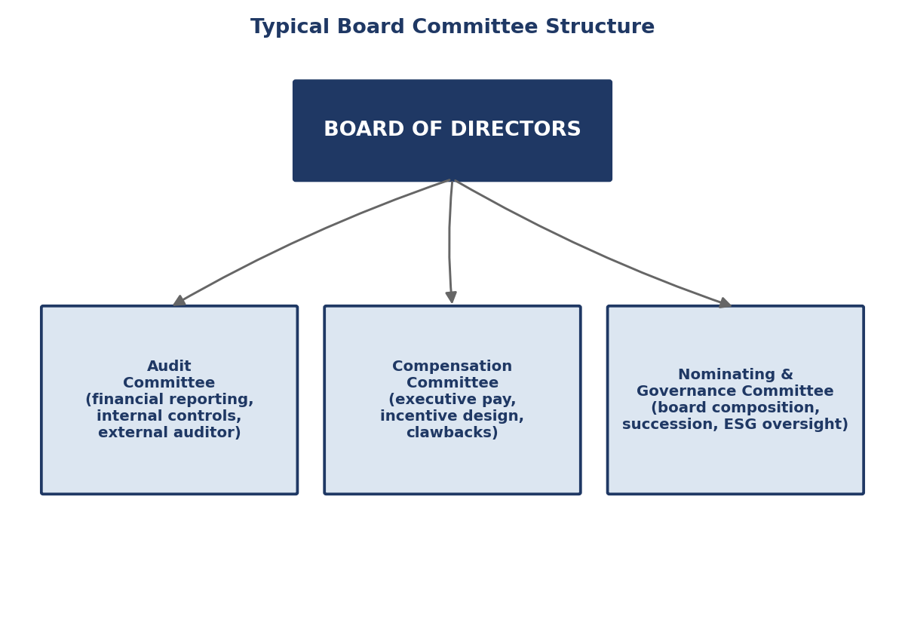
Figure: Typical Board Committee Structure

Vignette 3: Theranos — Board Composition Failure (2013-2018)
Background. Theranos, a blood-testing startup founded by Elizabeth Holmes, claimed to have developed proprietary technology capable of running comprehensive diagnostic tests from a few drops of finger-prick blood. Investigative reporting by the Wall Street Journal beginning in October 2015 (John Carreyrou) revealed that Theranos’s proprietary “Edison” devices did not reliably work as claimed and that the company had run the large majority of patient tests on modified third-party commercial analyzers while marketing the results as products of its own breakthrough technology. Holmes and former company president Ramesh “Sunny” Balwani were later convicted (2022) of investor fraud.
Board Decision-Making. Theranos’s board of directors during its period of highest valuation (reaching a purported $9 billion) was composed overwhelmingly of prestigious former statesmen, retired military officers, and political figures — including two former U.S. Secretaries of State, a former U.S. Secretary of Defense, and several retired senior military leaders — rather than individuals with clinical laboratory science, diagnostics-industry, or financial-controls expertise. Applying Hillman and Dalziel’s board capital framework directly, the Theranos board scored exceptionally high on relational capital (political and social prestige, access to fundraising networks and potential government/military customers) and correspondingly low on the specific human capital — laboratory science, regulatory (FDA/CLIA) compliance, financial-statement scrutiny — that the company’s actual risk profile required. Governance experts also noted the board lacked the independent audit and technical-oversight committee structure that would have been standard for a company of Theranos’s purported valuation, and Holmes retained concentrated founder control (including a supervoting share structure) that limited the board’s practical capacity to challenge her representations even had individual directors possessed the relevant expertise.
Outcome. Theranos dissolved in September 2018. Holmes was convicted on four counts of investor fraud in January 2022 and sentenced to over eleven years in federal prison; Balwani was separately convicted and sentenced. The case remains the most frequently cited teaching example, in both business and legal governance curricula, of board composition assembled for prestige and access rather than for domain-relevant monitoring capacity.
Discussion Questions. (1) Apply resource dependence theory (Pfeffer and Salancik) to explain what the Theranos board was rationally assembled to provide, and explain why that assembly nonetheless produced a catastrophic monitoring failure. (2) What specific board capital (per Hillman and Dalziel) would have been necessary, and plausibly sufficient, to detect the Edison technology’s core defects earlier, and why might supervoting founder control have neutralized even well-qualified directors’ ability to act on that capital?
Sources: Carreyrou, J., Bad Blood: Secrets and Lies in a Silicon Valley Startup, Knopf (2018); U.S. Securities and Exchange Commission, In re Theranos, Inc., Elizabeth Holmes, and Ramesh Balwani, litigation release (March 2018); U.S. District Court, Northern District of California, United States v. Holmes, jury verdict (January 2022).

Vignette 4: Disney’s 2022-2023 CEO Succession Turmoil (Iger-Chapek-Iger)
Background. Robert Iger, who had served as CEO of The Walt Disney Company since 2005, announced his intention to retire and, after a formalized succession process, the Disney board named Bob Chapek — head of the company’s Parks, Experiences and Products division — as his successor, with Chapek assuming the CEO role in February 2020. Chapek’s tenure was immediately tested by the COVID-19 pandemic’s severe impact on Disney’s theme parks and studio businesses, and was subsequently marked by public controversy (including Disney’s contested public stance on Florida’s “Parental Rights in Education” legislation in 2022) and by increasing tension with Iger, who had remained involved as executive chairman during a transition period before fully departing.
Board Decision-Making. In November 2022, amid disappointing streaming-division financial results, investor pressure, and what board members later described as concerns about Chapek’s communication and strategic execution, Disney’s board abruptly removed Chapek and reinstated Iger as CEO on an announced two-year basis, explicitly framed as a bridge appointment during which the board would run a fresh succession search. This reversal — effectively unwinding a formal, multi-year relay succession process (the Chapek appointment had followed extensive board deliberation and was announced as the product of a considered process) — was widely read as a rare and consequential admission of succession-process failure at board level, and activist investor Nelson Peltz’s Trian Partners subsequently pressed Disney’s board publicly on succession planning and board composition through 2023, ultimately reaching a settlement that added new directors without a full proxy contest. Iger’s return board extended his tenure again in 2024, with a new succession timeline targeting a transition by early 2026, and the board’s nominating committee took a visibly more structured, multi-candidate approach on the second attempt, tracking several internal candidates (including studio and parks executives) simultaneously rather than designating a single heir years in advance — a shift toward the “CEO progression optionality” model discussed in Part IV.
Outcome. Chapek’s ouster after less than three years, following a board-endorsed succession process, is widely cited as evidence that formal succession planning (Vancil’s relay model) does not by itself guarantee successful transition if the board’s assessment of successor fit — the upper-echelons match between candidate cognitive/strategic profile and the company’s actual strategic needs — proves mistaken after the fact. Disney announced in 2024 that it was building a broader, more transparent multi-candidate succession bench following the Chapek episode.
Discussion Questions. (1) Using Zhang and Rajagopalan’s framework, characterize the Chapek-to-Iger reversal: was Chapek’s removal closer to a “forced” or “voluntary” departure, and what does the framework predict about the strategic-change profile of Iger’s second tenure as a result? (2) What upper-echelons-theory factors might the Disney board have underweighted when originally selecting Chapek as successor over other internal candidates?
Sources: The Walt Disney Company, press releases, February 2020 (Chapek appointment) and November 2022 (Iger reinstatement); Reuters and The Wall Street Journal reporting on the Trian Partners proxy engagement (2023).

Vignette 5: Twitter/X — Board vs. Elon Musk Acquisition Governance Battle (2022)
Background. Elon Musk disclosed a greater than 9% stake in Twitter, Inc. in April 2022, was briefly offered and then declined a board seat, and shortly thereafter made an unsolicited offer to acquire the entire company for $54.20 per share. Twitter’s board adopted a shareholder-rights plan (a “poison pill”) to prevent a rapid accumulation of control before formally negotiating and, on April 25, 2022, unanimously approving a definitive merger agreement at Musk’s offered price. Musk subsequently sought to terminate the agreement in July 2022, citing disputes over the company’s disclosure of the prevalence of spam and fake accounts on the platform.
Board Decision-Making. Twitter’s board, in approving the deal, exercised its Fama-and-Jensen “decision control” function directly — ratifying a transaction proposed by an outside acquirer rather than by management — and, upon Musk’s attempted termination, the board authorized litigation in the Delaware Court of Chancery to compel specific performance of the merger agreement, a decision grounded in the board’s assessment (advised by outside counsel and financial advisors) that the contractual termination rights Musk was invoking did not, in fact, apply to the disputed spam-account issue. This litigation strategy reflected a board judgment that shareholders’ interests were best served by enforcing the agreed price rather than accepting a lower renegotiated price or no transaction at all, even at the cost of a contentious and public legal battle with the world’s wealthiest individual.
Outcome. Facing an unfavorable trial outlook in Delaware, Musk agreed in October 2022 to complete the acquisition at the original $54.20 per share price, and the deal closed on October 27, 2022; Twitter was taken private, its board dissolved as an independent public-company board, and the company was subsequently rebranded as X. The episode is widely cited in governance teaching as a case where a target board’s disciplined use of legal and structural defenses (the rights plan, the specific-performance litigation strategy) successfully protected a negotiated shareholder-value outcome against an acquirer’s attempt to walk away from unfavorable terms after signing.
Discussion Questions. (1) Assess the Twitter board’s decision to litigate for specific performance rather than renegotiate: using agency theory, whose interests (dispersed shareholders’ vs. the board’s own reputational interests) does this decision most directly serve, and are those interests aligned here? (2) How does a board’s fiduciary duty in responding to an unsolicited acquisition offer differ from its ordinary monitoring duty under Fama and Jensen’s framework, and what resource-dependence-theory role did outside legal and financial advisors play in this episode?
Sources: Delaware Court of Chancery, Twitter, Inc. v. Musk, C.A. No. 2022-0613-KSJM (filed July 2022); Twitter, Inc., definitive merger agreement press release (April 25, 2022); Reuters, reporting on deal closing (October 27, 2022).

Vignette 6: Credit Suisse — Board Failures Preceding the 2023 UBS Rescue Merger
Background. Credit Suisse Group AG, one of Switzerland’s two globally systemically important banks, experienced a sustained sequence of governance, risk-management, and compliance failures through the early 2020s, including large losses tied to the collapse of investment fund Greensill Capital (2021), a multi-billion-dollar loss from the default of the family office Archegos Capital Management (2021), and multiple executive and chairman-level departures amid separate scandals (including a corporate-espionage controversy involving a former executive). These episodes were compounded by persistent deposit outflows and a collapsing share price through early 2023, following broader market stress after the collapse of Silicon Valley Bank in the United States in March 2023.
Board Decision-Making. Credit Suisse’s board underwent repeated leadership turnover in a short period (multiple chairman changes and a CEO change in 2022) that critics characterized as reactive, crisis-driven governance rather than the continuous, integrated risk oversight this course’s framework recommends — each scandal prompted a fresh governance response rather than a sustained restructuring of the bank’s risk culture and control environment. Swiss financial regulator FINMA and outside reviews found that risk-management functions had repeatedly been overridden or under-resourced relative to revenue-generating trading and investment-banking activities, and that board-level risk committees had not effectively escalated concerns about concentrated counterparty exposure (as in the Archegos episode) before losses materialized.
Outcome. Facing an accelerating loss of market and depositor confidence, Credit Suisse was acquired by UBS Group AG in an emergency, regulator-brokered transaction announced March 19, 2023, at a price representing a steep discount to the bank’s prior market value, with Swiss authorities providing substantial guarantees and liquidity support to facilitate the deal; the transaction closed in June 2023, ending Credit Suisse’s 167-year existence as an independent institution and triggering the controversial writedown to zero of the bank’s Additional Tier 1 (AT1) bonds, which generated its own extensive litigation.
Discussion Questions. (1) Using the continuous-vs-episodic dichotomy, assess whether Credit Suisse’s pattern of scandal-triggered leadership changes (2021-2023) reflects genuine governance reform or an episodic pattern of crisis management without underlying continuous risk-culture change. (2) Which of this reader’s board theories — agency, stewardship, resource dependence, or board capital — best explains why Credit Suisse’s board apparently failed to escalate the Archegos counterparty concentration risk in time, and what specific board capital was most conspicuously absent?
Sources: FINMA, “Lessons Learnt from the CS Crisis” report (2023); UBS Group AG and Credit Suisse Group AG, joint press release announcing the merger (March 19, 2023); Swiss Federal Council statements on the transaction’s regulatory and financial-support framework (March 2023).

Vignette 7: Apple’s Tim Cook Succession — A Model of Disciplined Succession
Background. Steve Jobs, Apple’s co-founder and CEO, took medical leave multiple times beginning in 2004 due to a diagnosed neuroendocrine tumor and related health complications, with Tim Cook, Apple’s Chief Operating Officer, serving as acting CEO during Jobs’s leaves in 2004, 2009, and from January 2011. Jobs formally resigned as CEO on August 24, 2011, recommending Cook as his successor to the board, and died on October 5, 2011. Cook has served as Apple’s CEO continuously since 2011.
Board Decision-Making. Apple’s board’s handling of the Cook succession is widely cited as a model of well-executed relay succession (Vancil, 1987) precisely because the grooming period was extensive, repeatedly tested under real operating conditions (Cook’s multiple periods as acting CEO during Jobs’s medical leaves functioned as extended, high-stakes on-the-job evaluation rather than a single interview or committee assessment), and because the transition, when it came, was orderly rather than abrupt — Jobs’s formal resignation letter explicitly recommended Cook, and the board’s decision followed years of observing Cook’s operational performance in the role rather than requiring a rapid, uninformed judgment under crisis conditions. Cook’s operational background (he joined Apple in 1998 to overhaul supply-chain and operations management, a domain distinct from Jobs’s product-design and vision-led strategic orientation) also illustrates upper echelons theory in action: the board and Jobs jointly selected a successor whose cognitive and experiential base complemented, rather than attempted to replicate, the founder’s, betting that Apple’s next phase required world-class operational and supply-chain execution layered atop an already-defined product vision, rather than a second visionary product founder.
Outcome. Cook’s tenure, spanning well over a decade as of this writing, has been associated with substantial growth in Apple’s revenue, services business, and market capitalization (Apple became the first, and later one of several, U.S. companies to cross a $3 trillion market capitalization during Cook’s tenure), and Cook is broadly credited with having preserved Apple’s product and brand strength while professionalizing and scaling its operations, supply chain, and services businesses considerably beyond their scope under Jobs. Apple’s own board succession planning has continued to draw attention in subsequent years as analysts and governance commentators speculate about Cook’s eventual successor, with the company widely reported (though not confirmed in official disclosure at the level of detail this reader requires) to be applying a similarly extended, multi-candidate internal evaluation process.
Discussion Questions. (1) What specific structural features of the Cook succession (repeated acting-CEO periods, founder’s explicit recommendation, orderly resignation rather than removal) map onto Vancil’s relay succession model, and which features go beyond what Vancil’s original model describes? (2) Using upper echelons theory, explain why an operationally oriented successor, rather than another product-visionary founder-type, may have been the correct strategic-lens match for Apple’s post-2011 phase, and what risks would attach to that same profile choice in a different competitive context.
Sources: Apple Inc., press release and Steve Jobs resignation letter (August 24, 2011); Isaacson, W., Steve Jobs, Simon & Schuster (2011); Apple Inc. 10-K filings and shareholder letters, various years, on Cook-era financial performance.

Vignette 8: General Motors — Board Renewal Under Mary Barra
Background. General Motors Company (GM), reorganized following its 2009 U.S. government-backed bankruptcy and restructuring, named Mary Barra as CEO effective January 2014, making her the first woman to lead a major global automaker. Barra rose entirely within GM, having joined the company as a college co-op student and subsequently holding senior engineering, manufacturing, and human-resources leadership roles, including head of global product development immediately prior to her CEO appointment.
Board Decision-Making. GM’s post-bankruptcy board, substantially reconstituted after 2009 with new independent directors installed as part of the government-assisted restructuring, ran a deliberate, multi-candidate internal succession process that tracked several senior internal executives over an extended period rather than designating a single heir apparent years in advance, an approach closer to the “continuous/optionality-based” model described in Table 4A than to classical relay succession, notwithstanding that the eventual outcome (an internal promotion) resembled relay succession’s result. Barra’s tenure began just weeks before the disclosure of GM’s ignition-switch defect crisis — a safety defect linked to over a hundred deaths that GM was found to have known about for years before initiating a recall — testing the newly reconstituted board’s oversight capacity almost immediately. The board commissioned an independent investigation (the Valukas Report, June 2014) into the ignition-switch failures, and used its findings to drive a substantial overhaul of GM’s internal safety-escalation processes and product-safety organizational structure, with Barra herself, as the newly installed CEO, publicly leading the remediation rather than the board treating the crisis as solely a legacy-management failure to be distanced from the new leadership.
Outcome. Barra has remained CEO for over a decade as of this writing, overseeing GM’s continued restructuring (including exits from unprofitable international markets), its major strategic pivot toward electric vehicles and autonomous-driving investment (including the Cruise autonomous-vehicle subsidiary), and steady board renewal with continued turnover of directors to maintain a mix of automotive, technology, and financial expertise consistent with Hillman and Dalziel’s board-capital logic. GM’s board is frequently cited, alongside Apple’s, as an example of governance recovery and renewal following a period of severe crisis (bankruptcy in GM’s case) rather than of steady-state good practice never tested by crisis.
Discussion Questions. (1) Using board capital theory, assess how GM’s post-bankruptcy board reconstitution likely altered its human and relational capital profile, and why that alteration might explain the board’s capacity to commission and act on the Valukas Report so soon after Barra’s appointment. (2) Contrast GM’s continuous/optionality-based succession process with Vancil’s classical relay model: what specific risk does the optionality-based approach mitigate that a single-designated-heir model does not?
Sources: General Motors Company, press release announcing Mary Barra as CEO (December 2013, effective January 2014); Valukas, A. (Jenner & Block), “Report to Board of Directors of General Motors Company Regarding Ignition Switch Recalls” (May 29, 2014); National Highway Traffic Safety Administration consent order and GM settlement documents (2014-2015).

Table of Major Board Governance Failures and Crises
Table 5A. Twelve Major Board Governance Failures/Crises — Cause and Consequence
Company / Event | Approx. Date | Governance Failure Cause | Consequence
Enron Corporation | 2001 | Board approved conflict-of-interest waivers permitting off-balance-sheet special-purpose entities managed by the CFO, allowing massive hidden liabilities; audit committee failed to challenge complex structures it did not fully understand | Bankruptcy (then-largest in U.S. history); criminal convictions of senior executives; dissolution of auditor Arthur Andersen; direct catalyst for the Sarbanes-Oxley Act (2002)
WorldCom | 2002 | Improper capitalization of billions in operating expenses to inflate earnings; weak internal audit function and board financial oversight failed to detect the fraud until an internal auditor’s own investigation surfaced it | Bankruptcy (largest in U.S. history at the time); CEO Bernard Ebbers convicted and imprisoned; reinforced the case for SOX Section 404 internal-control attestation
Boeing 737 MAX | 2018-2020 | No dedicated board safety committee; CEO-chair duality reduced independent challenge to schedule-driven engineering decisions; filtered safety-risk information reaching the board | 346 deaths across two crashes; 20-month global fleet grounding; over $2.5B DOJ settlement; forced CEO removal and board restructuring
Wells Fargo | 2016-2020 | Sales-incentive structure rewarded unauthorized account openings; risk signals escalated slowly and were minimized before reaching the board | Over $4B in fines/settlements; multi-year Federal Reserve asset growth cap (2018-2025); forced CEO resignation and outsider successor hire
Theranos | 2013-2018 | Board recruited for political/celebrity prestige and access rather than clinical, laboratory-science, or financial-controls expertise; founder supervoting control neutralized independent challenge | Company dissolution (2018); founder and president convicted of investor fraud (2022); over a decade of imprisonment sentences
Volkswagen “Dieselgate” | 2015 | Supervisory board (in Germany’s two-tier structure) failed to detect or escalate systematic emissions-testing defeat-device software embedded across diesel engine lines for years | Over $30B in global fines, buybacks, and settlements; CEO resignation; multiple executive criminal convictions across jurisdictions
Purdue Pharma | 2007-2020 | Board (dominated by controlling Sackler family members) approved aggressive OxyContin marketing practices despite internal awareness of abuse and diversion risk | Multiple guilty pleas; bankruptcy; multibillion-dollar opioid-crisis settlement litigation continuing into the 2020s; Sackler family reputational and legal exposure
Hewlett-Packard boardroom leak scandal | 2006 | Chairman authorized “pretexting” (impersonation-based) investigation of directors and journalists to identify a boardroom media leak, without adequate legal or ethical review | Congressional hearings; chairman resignation; criminal charges (later resolved); significant reputational damage to HP’s governance reputation
Uber Technologies (Kalanick era) | 2014-2017 | Founder-CEO concentrated control and an aggressive, under-governed corporate culture permitted serious workplace-culture, regulatory-evasion, and safety-related lapses to persist unchecked | Board-driven removal of CEO Travis Kalanick (2017) under major investor pressure; extended outsider CEO search culminating in Dara Khosrowshahi’s hire; multiple regulatory settlements
Credit Suisse | 2021-2023 | Repeated risk-management override in favor of revenue generation (Archegos, Greensill exposures); reactive, crisis-by-crisis leadership turnover rather than sustained risk-culture reform | Emergency UBS acquisition (March 2023) at steep discount; end of 167-year independent existence; AT1 bondholder writedown litigation
Disney (Chapek succession) | 2020-2022 | Board-endorsed formal succession process nonetheless selected a successor whose strategic and communication fit proved mismatched to unfolding conditions | Abrupt CEO removal after under three years; reinstatement of predecessor; activist investor engagement (Trian) on succession and board composition
Twitter, Inc. | 2022 | Target board faced acquirer’s attempt to terminate an already-signed merger agreement, testing the board’s capacity to enforce shareholder-value-protective contractual terms under public pressure | Successful Delaware litigation strategy compelled deal completion at original price; company taken private and later rebranded as X

Vignette 9: Enron Corporation — Board-Sanctioned Off-Balance-Sheet Fraud (2001)
Background. Enron Corporation, an energy-trading company that had grown into one of America’s largest and most celebrated corporations through the 1990s, collapsed into bankruptcy in December 2001 after it emerged that the company had used a web of off-balance-sheet special-purpose entities (SPEs) — most notoriously those managed personally by Chief Financial Officer Andrew Fastow — to hide billions of dollars in debt and inflate reported earnings, while Fastow personally profited from fees paid by the same entities the company was using to manage its own reported financial condition.

Part VI: The Turkish Board Governance Model

Family-Holding Board Structures: The Distinctive Turkish Architecture
Turkey’s largest listed companies are overwhelmingly organized around a governance architecture that differs structurally from both the Anglo-American independent-board model and the German/continental European two-tier supervisory-board model: the family holding company with a controlling family board presence layered above a professional executive (CEO) management team. Under this architecture, a diversified holding company (Koc Holding, Sabanci Holding, and numerous smaller analogues) sits atop a pyramid of listed and unlisted operating subsidiaries spanning banking, energy, automotive, retail, and industrial sectors. The holding company’s own board typically reserves the chairmanship, and frequently several additional board seats, for members of the founding family or family-controlled foundation, while day-to-day operational leadership — the Group CEO role and the CEOs of major operating subsidiaries — is delegated to non-family professional executives recruited on merit from within the conglomerate’s management ranks or, less commonly, from outside.
This structure should be read through both the agency-theory and stewardship-theory lenses developed in Parts I and II simultaneously, rather than through either alone. From a stewardship perspective, the controlling family’s multi-generational horizon, concentrated reputational stake, and identity fusion with the enterprise (particularly pronounced at Koc Holding, founded in 1926 and marking its centennial in 2026, and heavily associated across generations with the Koc family name and the Vehbi Koc Foundation) plausibly reduce the short-termism and self-dealing risk that agency theory’s pessimistic assumption anticipates in a widely-held corporation with no comparably invested long-horizon principal. From an agency-theory perspective, however, the same concentrated family control creates a distinct and serious Type II agency-cost exposure: the risk that the controlling family block extracts private benefits of control — favorable related-party transactions between family-controlled entities, allocation of the most attractive investment opportunities to wholly family-owned vehicles rather than to the listed entity, or governance decisions that entrench family authority beyond what efficient stewardship would require — at the direct expense of minority, often foreign institutional, free-float shareholders who hold economic interest but little practical voting control.
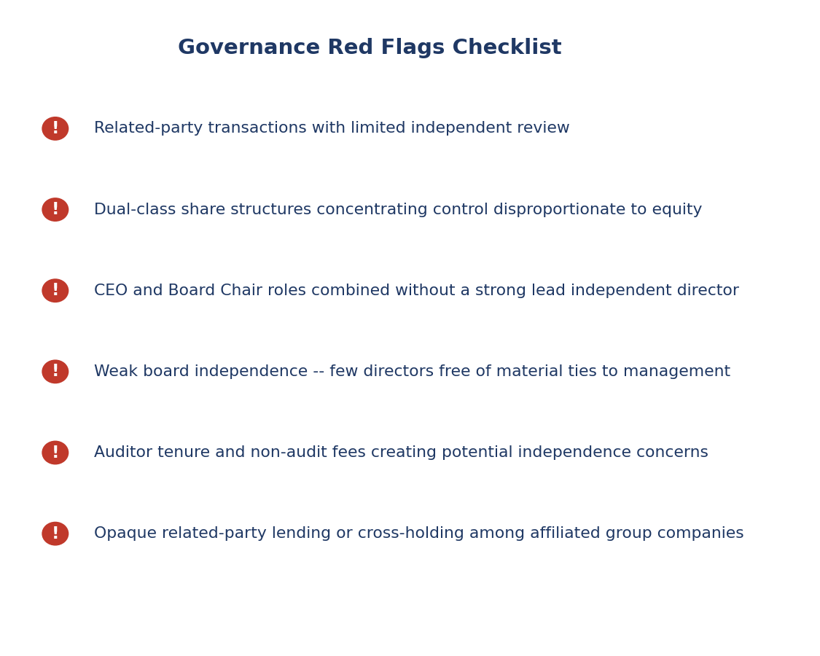
Figure: Governance Red Flags Checklist

Comparison and Contrast with the Anglo-American Independent-Board Model
The Anglo-American model, as codified in the UK Corporate Governance Code and reflected in U.S. exchange listing standards (both discussed in Part III), presumes a starting condition of dispersed ownership: no single shareholder or family block holds a controlling stake, and the board’s central function is therefore to monitor a professional management team on behalf of atomized shareholders who cannot individually monitor management themselves. Independence requirements (a majority-independent board, fully independent audit and compensation committees) are designed principally to guard against Type I agency costs — managerial self-dealing against a diffuse ownership base that lacks the concentrated stake needed to monitor directly.
The Turkish family-holding model inverts this starting condition: ownership is not dispersed but concentrated, frequently reinforced by dual-class share structures (as at Koc Holding, where A shares carry two votes against B shares’ one vote, giving the controlling family holding vehicle a voting share, approximately 55.6% as of the most recent disclosed figures, that exceeds its economic/capital share of roughly 63.4% aggregate family/foundation ownership against a free float of 26.9% at end-2024). Independent directors in this setting serve a meaningfully different function than their Anglo-American counterparts: rather than monitoring a management team on behalf of atomized owners with no single dominant principal, they exist substantially to protect minority free-float shareholders from the controlling family principal itself — a genuinely different agency relationship (controller vs. minority, not manager vs. dispersed owner) requiring a different independence and disclosure emphasis, most visibly in related-party transaction approval requirements. Sabanci Holding, founded in 1967, illustrates a partial convergence toward the Anglo-American pattern within the family-holding form: no single Sabanci family shareholder holds more than approximately 14% of capital individually, and free float runs to approximately 53.2%, well above the roughly 27.5% average free float across BIST-listed holding companies, giving Sabanci one of the more dispersed ownership bases among Turkey’s major family conglomerates even though family control, exercised collectively through multiple family and foundation vehicles, remains the dominant governance force at board level.

Turkish Airlines: A Third Architecture — State/Sovereign-Wealth-Fund Control
Turkish Airlines (THY, BIST: THYAO), founded in 1933 and approaching its centennial in 2033, represents a third governance architecture operating alongside the two family-holding patterns above: majority control by the Turkiye Wealth Fund (Turkiye Varlik Fonu, TVF), Turkey’s sovereign wealth fund, which most third-party compilations place at approximately 49.12% of shares outstanding against a free float of roughly 50.88% — a structure that combines elements of state ownership with a genuinely substantial private free float, distinct from both a purely state-owned enterprise and a purely family-controlled listed company.
This structure was directly tested in April 2026, when THY’s General Assembly executed a simultaneous, single-event replacement of both the Chairman and the Chief Executive Officer — a clean, dated illustration of the episodic-succession pattern discussed throughout this reader, and a useful contrast case against Sabanci’s more gradual internal-promotion pattern. On April 9, 2026, THY’s board leadership transition proceeded as follows, per THY’s own investor-relations disclosures and subsequent financial-press reporting: Prof. Dr. Murat Seker, who had served as THY’s Chief Financial Officer since 2016, was elevated to the Chairman role, succeeding Ahmet Bolat, who departed the board; simultaneously, Ahmet Olmustur, previously Chief Commercial Officer, was appointed Chief Executive Officer (Genel Mudur), succeeding long-serving CEO Bilal Eksi upon his retirement after an extensive tenure; and Metin Gulsen was appointed as the new Chief Financial Officer to succeed Seker in that operating role. This transition occurred against a backdrop of record 2025 operating results — approximately 92.6 million passengers carried and roughly $24.1 billion in revenue for the 2025 fiscal year, the airline’s strongest results on record and outpacing passenger-growth rates at competitors including Emirates, Qatar Airways, and Lufthansa — meaning the transition was executed from a position of operating strength rather than as a crisis-driven response, distinguishing it from several of the crisis-triggered vignettes examined in Part V. Note on source currency and verification: because this transition is very recent relative to standard secondary-source lag, the specific personnel details above should be cross-checked by students against THY’s own investor-relations disclosures (investor.turkishairlines.com) and KAP (Kamuyu Aydinlatma Platformu, Turkey’s Public Disclosure Platform) filings at the time of reading, as the compiled course dossier reflects information gathered through mid-2026.
Applying Zhang and Rajagopalan’s insider/outsider succession framework (Part IV) directly: both the Chairman and CEO successors were long-tenured internal executives (CFO and Chief Commercial Officer, respectively) elevated following a predecessor’s planned, voluntary retirement rather than a forced departure — a textbook prediction-consistent case of insider succession following voluntary exit, and one that upper echelons theory would read as the THY board signaling continuity of financial discipline (a CFO ascending to the chairmanship) paired with continued commercial/network growth focus (a commercial chief ascending to the CEO role), rather than a strategic break of the kind an outsider hire would typically signal.
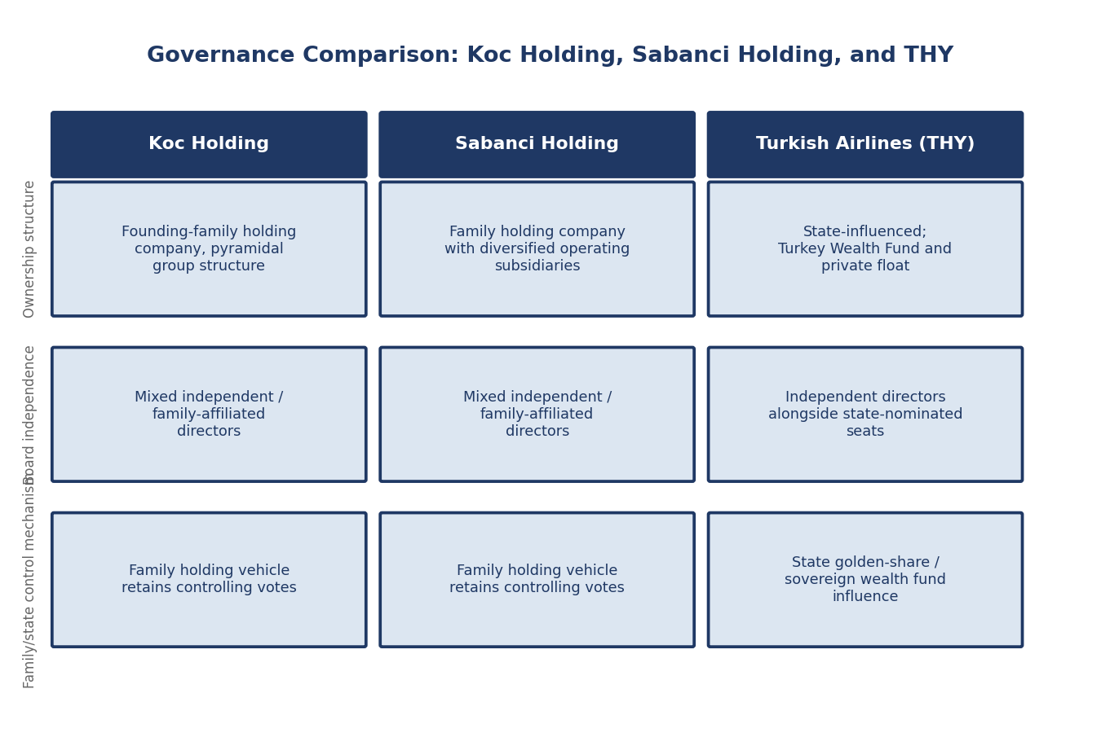
Figure: Governance Comparison -- Koc Holding, Sabanci Holding, and THY

Governance Feature | Koc Holding | Sabanci Holding | Turkish Airlines (THY)
Controlling shareholder type | Founding family holding company (dual-class A/B shares) | Family holding company (single-class, more dispersed) | Turkiye Wealth Fund (sovereign wealth fund)
Approx. controlling stake | ~55.6% voting power (~63.4% economic) | No single holder >~14%; collective family control | ~49.12% TVF ownership
Approx. free float | ~26.9% | ~53.2% | ~50.88%
Primary agency-cost concern | Controller vs. minority (Type II) | Controller vs. minority, partially mitigated by dispersion | State/political vs. commercial objectives
2026 leadership event | Centennial year; multi-generational succession planning | Gradual internal-promotion succession pattern | April 2026 simultaneous Chair + CEO replacement
Table: Governance Feature Comparison -- Koc Holding, Sabanci Holding, and Turkish Airlines (THY)

SPK and BIST Corporate Governance Principles: The Regulatory Backbone
All three companies profiled above are subject to Turkey’s binding-plus-comply-or-explain regulatory hybrid administered by the Sermaye Piyasasi Kurulu (SPK, the Capital Markets Board of Turkey) through its Corporate Governance Communique (Communique No. II-17.1) and the associated BIST (Borsa Istanbul) Corporate Governance Principles. This framework requires SPK-regulated, BIST-listed companies to maintain a minimum number of independent board members (commonly at least two independent directors, or a proportion scaled to board size depending on the company’s BIST index membership and free-float characteristics), to constitute an audit committee composed entirely of independent/non-executive members, and to obtain independent-director or majority-of-minority shareholder approval for related-party transactions above specified thresholds — the single regulatory mechanism most directly targeted at the Type II, controller-vs-minority agency-cost problem this Part has emphasized throughout. Listed companies must additionally publish an annual Corporate Governance Compliance Report explaining their adherence to, or documented departure from, the BIST Principles, a comply-or-explain mechanism directly analogous in form (though narrower in scope and less mature in market-monitoring intensity, per most comparative governance assessments) to the UK Corporate Governance Code discussed in Part III. Companies meeting a minimum corporate-governance rating threshold, assessed by SPK-licensed rating agencies against the BIST Principles, qualify for inclusion in the BIST Corporate Governance Index (XKURY), a market-visible signal of governance quality that institutional and foreign investors increasingly reference in allocation decisions to BIST-listed equities — giving Turkish holding companies and THY alike a direct market incentive, beyond bare regulatory compliance, to strengthen independent-director representation and related-party transaction discipline over time.

Mechanism | Purpose | Typical Adoption Basis
Independent audit committee | Oversee financial reporting integrity and external auditor relationship | Mandatory under most listing rules and codes (SPK, UK Code, US exchange rules)
Say-on-pay vote | Give shareholders a voice on executive compensation design | Binding in some EU states; advisory in the US and UK
Related-party transaction approval | Protect minority shareholders from controller self-dealing | Mandatory above disclosure thresholds in most codes; central to Turkish family-holding governance
CEO/Chair separation | Preserve independent board oversight of management | Comply-or-explain in UK Code; less standardized in US practice
Board self-assessment | Ensure board composition and practices evolve with firm needs | Increasingly expected across codes; discussed further below
Table: Core Governance Mechanisms Across Codes and Listing Regimes
Discussion Questions specific to this Part. (1) Contrast the agency-cost rationale for board independence under Turkey’s SPK/BIST framework with the rationale under the UK Corporate Governance Code discussed in Part III: are independent directors solving the same underlying problem in both jurisdictions? (2) Using stewardship theory, construct the strongest possible defense of Koc Holding’s dual-class, family-controlling-vote structure, and then use agency theory (Type II costs) to construct the strongest possible critique of the same structure. (3) Evaluate whether THY’s April 2026 transition should be classified as reactive, ad hoc, formalized, or fully integrated/continuous on the succession-planning maturity framework in Table 3, and identify precisely what additional disclosure would let you place it with confidence rather than by inference.

Part IX: Board Evaluation, Diversity, and Emerging Oversight Domains

Board Self-Assessment and Evaluation Practices
A recurring theme across both the theoretical foundations of this reader and the 2026 governance commentary summarized in the Current Developments section is that board quality cannot be assumed from structural characteristics (independence ratios, committee existence) alone; it must be actively evaluated, and increasingly disclosed, on a recurring basis. The UK Corporate Governance Code requires FTSE 350 companies to commission an externally facilitated board evaluation at least once every three years, supplemented by internally conducted evaluations in intervening years, and to disclose in the annual report how the evaluation was conducted and what actions resulted from it. This is a direct, practical instantiation of the continuous-vs-episodic dichotomy introduced in this reader’s original theoretical foundations: a board that treats self-evaluation as a triennial external exercise checked off and then set aside is, almost by definition, running an episodic oversight model of its own composition and functioning, whereas a board that folds evaluation findings into a rolling director-development and succession-planning process (linking, for instance, an evaluation finding that the board lacks technology expertise directly into the next director-search mandate) is running continuous oversight of itself, not merely of management.
U.S. practice, absent an equivalent binding requirement, has moved in a similar direction through investor and proxy-advisor pressure rather than code mandate: institutional investors and proxy advisory firms (ISS, Glass Lewis) increasingly expect disclosure of board evaluation practices, individual-director skills matrices, and average director tenure as part of a broader “board refreshment” narrative, and will sometimes recommend against long-serving directors or nominating-committee chairs at companies that disclose little about how board composition is actively assessed and refreshed over time. This evaluation and refreshment machinery connects directly to Hillman and Dalziel’s board capital framework from Part II: a skills-matrix disclosure is, in effect, a public audit of the board’s human and relational capital against the company’s current strategic needs, and a well-run evaluation process is the operational mechanism by which a board’s capital composition is kept aligned with a changing strategic environment rather than frozen at the moment of initial director recruitment.

Diversity, ESG Considerations, and Board Composition Trends
Board diversity — along dimensions including gender, ethnicity, professional background, age, and tenure — has become a prominent, and in some jurisdictions binding, component of governance-code expectations since the mid-2010s. The EU’s Women on Boards Directive (Directive (EU) 2022/2381), finalized in 2022 with a 2026 compliance deadline for many member states, requires listed companies to reach either a 40% target for the underrepresented sex among non-executive directors or a 33% target across all directors, with member states required to implement effective, proportionate sanctions for non-compliance — a binding, rules-based approach to diversity that contrasts with the UK Code’s comply-or-explain framing of the same objective (the UK Code, following the voluntary Hampton-Alexander and Parker reviews, expects but does not legally mandate specific gender and ethnicity representation targets on FTSE boards). Turkey’s SPK/BIST framework has moved more gradually, encouraging but not mandating female board representation, though the BIST Corporate Governance Index has increasingly incorporated diversity-related criteria into its rating methodology, creating market-based rather than purely regulatory pressure toward diversification.
The governance-theoretic case for board diversity draws most directly on board capital theory (Part II): a more demographically and professionally diverse board is argued to bring a wider range of human capital (cognitive diversity in problem framing, professional experience across functions and industries) and relational capital (network ties into different customer, talent, and capital-market segments) than a more homogeneous board, improving both the monitoring and resource-provision functions Hillman and Dalziel’s integrative construct describes. Empirical evidence on the direct financial-performance effect of board diversity remains genuinely mixed and contested in the academic literature — a point this reader flags explicitly rather than overstating, consistent with its “evidence over assertion” principle — but the risk-oversight case (a more cognitively diverse board is less prone to the groupthink dynamics implicated in several of this reader’s failure vignettes, including Theranos’s prestige-homogeneous board) has independent support from the organizational-behavior literature on group decision-making quality, distinct from any claimed direct link to financial returns.

AI Governance and Emerging Risk Oversight
Building on the AI-oversight-gap material already presented in the Current Developments section, this expanded reader adds a structural note on how boards are beginning to institutionalize oversight of artificial intelligence and other fast-moving technology risks. A minority of large-company boards (per the PwC 2025 survey data already discussed) have created a dedicated technology or AI oversight committee, distinct from the audit and risk committees, explicitly to provide the committee-level cadence and specialized expertise that a fast-moving risk category requires; the majority instead route AI oversight through the existing risk or audit committee as one item among many, a structural choice that, per the continuous-vs-episodic framework, tends to produce lower-frequency, more generalist attention than a dedicated committee would. Boards adopting the dedicated-committee model are, in effect, applying board capital theory prescriptively: recruiting or designating directors with specific technology and AI expertise (human capital) and tasking them with a standing, rather than occasional, oversight mandate. This is directly analogous to the historical evolution of audit committees themselves, which emerged as a dedicated structure only after it became clear that folding financial-reporting oversight into the full board’s general agenda produced insufficiently rigorous, insufficiently frequent scrutiny — a precedent this reader suggests boards should study explicitly when deciding how to structure AI and other emerging-risk oversight going forward.

Part X: Glossary of Key Governance Terms
Agency costs. The costs arising from the divergence of interest between principals (shareholders) and agents (managers), comprising monitoring costs, bonding costs, and residual loss (Jensen & Meckling, 1976).
Bonding costs. Costs voluntarily incurred by agents (managers) to credibly commit not to act against principals’ interests, such as accepting performance-contingent compensation or restrictive covenants.
Board capital. The combined human capital (expertise, experience, reputation) and relational capital (external network ties) that directors collectively bring to a board (Hillman & Dalziel, 2003).
Board refreshment. The ongoing process of adding new directors and, where appropriate, retiring long-tenured ones, to keep board composition aligned with a firm’s evolving strategic and monitoring needs.
Bonding. See bonding costs.
Business judgment rule. A common-law doctrine (most developed in Delaware corporate law) presuming that directors acted on an informed basis, in good faith, and in the honest belief the action was in the company’s best interest, shielding good-faith board decisions from judicial second-guessing absent evidence of self-dealing or gross negligence.
Comply-or-explain. A governance-code enforcement model in which listed companies must either comply with each code provision or publicly explain their departure, rather than face binding legal sanction for non-compliance itself (the UK Corporate Governance Code being the paradigm example).
Continuous oversight. A board practice model in which succession, risk, and strategy review are treated as standing, always-on work streams rather than discrete calendar events, as contrasted with episodic oversight.
Decision control. In Fama and Jensen’s (1983) framework, the ratification and monitoring of decisions, a function reserved to the board as distinct from decision management.
Decision management. In Fama and Jensen’s (1983) framework, the initiation and implementation of decisions, a function performed by managers as distinct from decision control.
Duality (CEO duality). The practice of one individual simultaneously holding the Chief Executive Officer and Board Chair titles.
Episodic oversight. A board practice model in which governance duties are discharged as discrete, calendar-bound events (an annual succession memo, a triennial risk review), as contrasted with continuous oversight.
Fully integrated/continuous succession planning. The most mature stage in the succession-planning maturity framework, in which bench-strength is reviewed at or near every board meeting and disclosed as a governance signal.
Independent director. A board member without a material financial, employment, or family relationship with the company or its management that would be reasonably likely to compromise independent judgment, as defined (with variation) by exchange listing standards and national governance codes.
Managerial power theory. Bebchuk and Fried’s (2003) account of executive compensation as potentially reflecting managerial influence over the pay-setting process rather than purely efficient contracting.
Monitoring costs. Costs borne by principals to observe and constrain agent behavior, such as maintaining an independent board, external audit, and disclosure requirements.
Nominating/governance committee. The board committee typically charged with director nomination, board composition, and (often) oversight of CEO succession planning.
Related-party transaction. A transaction between a company and an entity or individual with a pre-existing relationship to the company (such as a controlling shareholder or its affiliate), subject to heightened disclosure and, in many jurisdictions including Turkey, independent-director or majority-of-minority approval requirements.
Relay succession. Vancil’s (1987) model in which an heir apparent is identified well in advance, groomed over an extended period, and succeeds the incumbent CEO in a planned handoff.
Residual loss. The remaining welfare loss to principals that persists even after optimal monitoring and bonding expenditures, per Jensen and Meckling (1976).
Resource dependence theory. Pfeffer and Salancik’s (1978) account of boards as boundary-spanning mechanisms that reduce environmental uncertainty and secure critical external resources.
Say-on-pay. A shareholder advisory (or, in some jurisdictions, binding) vote on executive compensation, introduced in the U.S. under Dodd-Frank and, in varying binding form, under EU member-state implementations of the Shareholder Rights Directive II.
Stewardship theory. Donaldson and Davis’s (1991) account of executives as intrinsically aligned stewards of organizational goals rather than self-interested agents requiring heavy monitoring.
Succession-planning maturity framework. This reader’s four-stage typology of succession-planning formality: reactive, ad hoc, formalized, and fully integrated/continuous.
Type I agency costs. The classic manager-versus-dispersed-shareholder conflict modeled by Jensen and Meckling (1976).
Type II agency costs. Conflicts between controlling shareholders and minority shareholders, dominant in concentrated-ownership settings such as family holding companies and state-controlled enterprises.
Upper echelons theory. Hambrick and Mason’s (1984) theory that organizational strategic choices reflect the cognitive base, values, and experience of top executives rather than pure rational optimization.

Part XI: Additional Comparative Regulatory Detail

Extending the Comparative Codes: Germany, France, and the Two-Tier vs. Unitary Board Question
Part III’s comparative table (Table 3A) presented the EU level as a single row, but EU member states retain substantial national variation atop the EU-level directives, and this variation is directly relevant to the Volkswagen vignette above. Germany’s co-determination system (Mitbestimmungsgesetz) requires large companies to seat employee representatives on the supervisory board — up to half of supervisory board seats at companies above a specified employee-count threshold — creating a board (or, more precisely, a two-tier structure in which the supervisory board is the relevant monitoring body) whose composition reflects a stakeholder-governance philosophy distinct from the shareholder-primacy orientation of the U.S. and UK models discussed earlier. The German Corporate Governance Code (Deutscher Corporate Governance Kodex), like the UK Code, operates on a comply-or-explain basis but layers this atop the binding co-determination requirements, meaning German boards face a hybrid of binding structural rules (the two-tier split, employee representation) and comply-or-explain best-practice recommendations (specific independence and committee-composition norms within the supervisory board).
France’s governance framework similarly permits companies to choose between a unitary board (conseil d’administration) and a two-tier structure (directoire and conseil de surveillance), with the AFEP-MEDEF Code operating on a comply-or-explain basis for listed companies regardless of which structure they select — an unusually explicit acknowledgment, relative to other jurisdictions, that the unitary-vs-two-tier choice is itself a governance-design decision companies should make deliberately rather than have imposed uniformly, distinct from Germany’s effectively mandatory two-tier requirement for larger companies.
This additional national-level detail matters for the Volkswagen case specifically: Germany’s mandatory (not merely comply-or-explain) two-tier structure and co-determination requirement represent one of the most structurally interventionist governance models compared in this reader, and the fact that Dieselgate nonetheless occurred under this structure is a genuinely important data point for students to weigh when assessing how much explanatory and predictive work board structure alone can do, independent of the information-flow and organizational-culture factors this reader has repeatedly emphasized alongside structure.

Sample Nominating/Governance Committee Charter Outline
To make the abstract nominating/governance committee function discussed throughout this reader concrete, the following outline reflects the typical scope of a nominating/governance committee charter at a large, independence-majority public company board, adapted for teaching purposes:
- Purpose. Identify, evaluate, and recommend candidates for board membership; oversee board and committee composition, structure, and evaluation processes; oversee CEO succession planning in coordination with the full board; oversee the company’s corporate governance guidelines and their periodic review.
- Composition. Entirely independent directors, consistent with applicable listing-standard independence requirements; committee chair typically a director with substantial board-governance or executive-search experience.
- CEO succession responsibilities. Maintain, in coordination with the CEO and the compensation committee, a current assessment of internal succession candidates for the CEO role and other senior executive positions; review this assessment at a specified minimum cadence (increasingly, at every regularly scheduled board meeting under the continuous-oversight model this reader recommends, rather than annually under the episodic model); maintain a current emergency/interim succession plan addressing sudden CEO incapacity or departure, independent of the long-range planned-succession process.
- Board composition and refreshment responsibilities. Maintain a board skills matrix identifying the collective human and relational capital (per Hillman and Dalziel) the board currently holds and the gaps relative to the company’s strategic needs; lead or oversee the search process for new directors, including sourcing candidates who fill identified skills-matrix gaps; oversee director tenure and retirement norms, balancing institutional-knowledge retention against the refreshment benefits of periodic turnover.
- Board evaluation responsibilities. Design and oversee the annual board, committee, and individual-director evaluation process; ensure findings are translated into concrete action items (director development, committee reassignment, search-mandate revisions) rather than filed without follow-through — the operational safeguard against evaluation becoming an episodic, checkbox exercise.
- Reporting. Report to the full board at each regularly scheduled meeting on succession-planning status, board composition and refreshment activity, and any evaluation findings requiring board-level attention.

Part XIII: Executive Compensation Design and Whistleblower Mechanisms

Pay-for-Performance Metrics and Say-on-Pay Adoption
Building on Bebchuk and Fried’s managerial power critique in Part II, this section surveys the practical mechanisms markets and regulators have adopted to constrain the compensation-design risks the theory identifies. Say-on-pay votes — shareholder advisory votes on executive compensation — were introduced in the United States under the Dodd-Frank Act (2010) as a non-binding annual (or, at company election, biennial or triennial) vote; in the United Kingdom, shareholder votes on remuneration policy are binding at least every three years under the UK Corporate Governance Code framework, with annual advisory votes on remuneration implementation in intervening years — a notably stronger shareholder check than the U.S. model’s purely advisory structure. The EU’s Shareholder Rights Directive II similarly requires member states to give shareholders at least an advisory, and in several member states a binding, vote on remuneration policy, with specific disclosure requirements for the ratio between CEO pay and average employee pay — a metric U.S. registrants must also disclose under Dodd-Frank’s pay-ratio rule, giving shareholders and the public a standardized, comparable data point precisely aimed at making the “camouflage” dimension of managerial power theory harder to sustain through non-salient compensation design.
Table 13A. Say-on-Pay and Related Compensation-Disclosure Mechanisms by Jurisdiction
Jurisdiction | Say-on-Pay Vote Type | Frequency | Pay-Ratio Disclosure | Clawback Requirement
United States | Advisory (non-binding) | At least every 3 years (companies commonly choose annual) | Mandatory (Dodd-Frank) | Mandatory listing-standard clawback for accounting restatements (Dodd-Frank/SEC rule)
United Kingdom | Binding (remuneration policy); advisory (implementation report) | Policy: at least every 3 years; implementation: annual | Increasingly expected via Code/investor pressure; not uniformly mandated by statute | Expected under Code; increasingly included in remuneration policy design
European Union | Advisory or binding, per member-state implementation of Shareholder Rights Directive II | At least every 4 years for policy under the Directive’s minimum standard | Mandatory under the Directive (CEO-to-average-employee pay ratio) | Varies by member state; increasingly expected
Turkey | Not a distinct binding say-on-pay vote under SPK regulation; remuneration policy disclosure required | Annual disclosure of remuneration policy in corporate governance compliance report | Not separately mandated in the specific pay-ratio form used in the US/EU | Not uniformly mandated; company-specific

Whistleblower Protections and Internal Escalation Channels
The WorldCom, Wells Fargo, and Theranos vignettes each turned, in different ways, on the presence or absence of an effective internal escalation channel independent of the management chain the alleged misconduct implicated. SOX Section 806 (the whistleblower-protection provision) prohibits publicly traded companies from retaliating against employees who report suspected securities fraud, and requires audit committees to establish confidential, anonymous procedures for employees to submit concerns regarding accounting or auditing matters — a direct legislative response to the WorldCom pattern in which internal auditors uncovered fraud largely without a protected, board-supported channel. The UK Corporate Governance Code similarly expects boards to establish, and periodically review the effectiveness of, arrangements for staff to raise concerns in confidence, with the audit committee typically responsible for oversight of the whistleblowing policy’s effectiveness — again illustrating the continuous-vs-episodic distinction, since a whistleblowing channel that exists on paper but is never tested, reviewed, or actively monitored for usage patterns functions, in practice, episodically even though the underlying policy is a standing document.
Discussion Questions. (1) Using the WorldCom case, assess what specific board-level action (beyond simply having a whistleblower policy on the books) would meaningfully increase the probability that an internal auditor’s concerns reach the board in time to prevent, rather than merely eventually detect, a large-scale fraud. (2) Compare the compensation-design mechanisms in Table 13A across jurisdictions: which single mechanism do you judge most directly responsive to Bebchuk and Fried’s “camouflage” critique, and why?

Part XIV: Extended Turkish Holding-Company Detail and Additional Governance Instruments

Additional Turkish Conglomerate Comparators: Anadolu Group and Dogan Holding
Beyond Koc Holding, Sabanci Holding, and Turkish Airlines, Turkey’s listed-company landscape includes several additional large family-controlled groups whose governance structures illustrate further variation within the family-holding archetype developed in Part VI. Anadolu Group (Anadolu Efes, Coca-Cola Icecek, and Anadolu Isuzu among its listed affiliates), controlled by the Yazici family, operates a diversified holding structure spanning beverages, automotive, and financial services, with the family retaining board chairmanship across the group’s principal listed entities while professional CEOs run individual operating subsidiaries — structurally similar to the Koc and Sabanci pattern, though with a narrower sectoral footprint concentrated more heavily in beverages and automotive distribution than Koc’s or Sabanci’s broader industrial and financial-services diversification. Dogan Holding, historically prominent in Turkish media and energy alongside industrial interests, has at various points faced heightened regulatory and tax scrutiny that some governance analysts have linked to the political economy surrounding media ownership in Turkey specifically — a reminder that in some emerging-market contexts, the Type II agency-cost lens (controlling family vs. minority shareholders) must be supplemented with a distinct political-economy lens when a controlling family’s other business interests (in Dogan’s case, historically, media assets) intersect with government relations in ways that can affect the listed entity’s regulatory treatment independent of its own governance quality.

Board Committee Structures at Turkish Holding Companies: What Is and Is Not Publicly Confirmed
Consistent with this reader’s “evidence over assertion” principle and the original reader’s explicit flagging of gaps in the compiled dossier, this reading reiterates rather than fills several specific gaps: detailed nominating/governance and risk-committee charters for Koc Holding, Sabanci Holding, and Turkish Airlines were not independently confirmed against primary board-charter documents at the time this reader was compiled, and students undertaking further independent research on any of the three companies should consult each company’s annual/integrated report corporate-governance section and its KAP (Kamuyu Aydinlatma Platformu) disclosures directly rather than relying on secondary characterizations. What can be stated with confidence, because it follows directly from binding SPK regulation applicable to all three companies as BIST-listed entities, is that each must maintain an audit committee composed entirely of independent/non-executive members and must obtain independent-director or majority-of-minority approval for related-party transactions above the regulatory threshold — the binding floor beneath whatever additional, company-specific committee structure each has chosen to layer on top.

The BIST Corporate Governance Index (XKURY) as a Market Signal
Table 14A below summarizes the practical mechanics of Turkey’s principal governance-rating and index-inclusion mechanism, extending the SPK/BIST regulatory discussion from Part VI with operational detail relevant to students evaluating any BIST-listed company’s governance quality independently.
Table 14A. BIST Corporate Governance Index (XKURY) — Mechanics and Significance
Feature | Description
Rating basis | Independent, SPK-licensed rating agencies assess listed companies against the BIST Corporate Governance Principles across four weighted categories: shareholders, public disclosure and transparency, stakeholders, and the board of directors
Minimum threshold for index inclusion | A minimum overall corporate governance rating score (commonly cited around 7 out of 10 in aggregate, with minimum sub-scores in specific categories) is required for inclusion in the XKURY index
Market significance | Index inclusion is a market-visible governance-quality signal increasingly referenced by international institutional investors in allocation decisions to BIST-listed equities, creating a market-based incentive layered atop binding SPK regulation
Board-of-directors sub-category emphasis | This sub-category specifically weights independent-director presence, board and committee functioning, and disclosed succession and risk-oversight practices — directly operationalizing several of this reader’s core governance-quality dimensions into a scored, comparable metric
Relationship to comply-or-explain | Functions as a market-based reinforcement mechanism for the underlying comply-or-explain BIST Corporate Governance Principles, analogous in spirit to how institutional investor and proxy-advisor scrutiny reinforces the UK Corporate Governance Code’s comply-or-explain framework, though operationalized through a formal scored rating rather than informal investor judgment alone

Board Skills Matrix: A Worked Illustration

Part XVIII: ESG Oversight, Activist Engagement, and Crisis Disclosure

Board Oversight of Environmental, Social, and Governance (ESG) Matters
Board-level ESG oversight has moved, over the past decade, from a niche sustainability-committee function to a mainstream component of enterprise risk oversight discussed at nearly every major listed company’s board, and it offers a further test case for the continuous-vs-episodic dichotomy this reader emphasizes throughout. Climate-related financial risk disclosure frameworks — including the Task Force on Climate-related Financial Disclosures (TCFD) framework, now substantially incorporated into mandatory disclosure regimes in the UK, the EU (via the Corporate Sustainability Reporting Directive, CSRD), and, in more limited form, the U.S. Securities and Exchange Commission’s climate-disclosure rulemaking — increasingly require boards to describe not merely whether climate risk is discussed, but the specific governance process (which committee, at what frequency, with what escalation path to the full board) through which climate and broader ESG risk is overseen. This disclosure requirement operationalizes the continuous-oversight standard directly: a board that can describe only an annual sustainability-committee meeting is disclosing an episodic model, while a board that can describe climate and ESG risk integration into the standing enterprise risk management framework, reviewed at the same cadence as financial and operational risk, is disclosing a continuous one.
The governance-theoretic case for board-level ESG oversight draws on multiple lenses already developed in this reader. From a resource dependence perspective, ESG performance and disclosure quality increasingly affect a firm’s access to capital (a growing share of institutional capital is explicitly ESG-screened or ESG-tilted) and its regulatory legitimacy in jurisdictions with binding disclosure mandates, making ESG-competent directors a genuine external-resource-linkage asset in Pfeffer and Salancik’s sense. From a board capital perspective, ESG oversight requires human capital (climate science, human-capital-management, and supply-chain expertise) that many boards recruited primarily for financial and operational expertise may lack, creating the same kind of skills-matrix gap this reader’s Table 14B illustrates for technology and AI expertise specifically. From an agency-theory perspective, ESG disclosure quality can itself function as a governance signal analogous to Behn, Riley, and Yang’s succession-disclosure argument: a board that discloses granular, specific ESG governance process detail is signaling monitoring capacity that a board offering only generic ESG rhetoric is not.

Activist Investor Engagement and Board Response
Several of this reader’s vignettes (Disney/Trian, Twitter/Musk) directly involve activist or acquiring shareholders challenging incumbent board and management decisions, and this section situates those episodes within the broader activist-investing governance literature. Shareholder activism — ranging from private, behind-the-scenes engagement through public “vote no” campaigns against director nominees, to full proxy contests seeking board seats, to hostile tender offers — functions, in agency-theory terms, as an external check on a board’s monitoring function when internal governance mechanisms (independent directors, say-on-pay votes) have not, in the activist’s assessment, adequately disciplined underperforming management or corrected a flawed strategic or succession decision. Trian Partners’ 2023 engagement with Disney following the Chapek succession failure exemplifies this dynamic precisely: having judged the board’s succession process and subsequent strategic execution inadequate, Trian pursued a public campaign (though ultimately a negotiated settlement rather than a full proxy contest) explicitly targeting board composition and succession oversight, a direct market-based supplement to, rather than substitute for, the internal governance mechanisms this reader has emphasized throughout.
Boards facing activist engagement must navigate a further contingent-theory question directly analogous to the CEO-duality contingency Finkelstein and D’Aveni describe: is the activist’s challenge better met with defensive entrenchment (resisting board or strategic changes, consistent with an agency-theoretic concern that the activist’s short-term trading interests may not align with long-term shareholder value) or with responsive engagement (incorporating the activist’s proposed board or strategic changes, consistent with a view that the activist has correctly identified a genuine monitoring or strategic failure)? The empirical activist-investing literature generally finds heterogeneous outcomes across campaigns, reinforcing this reader’s broader methodological point that governance theory should be applied as a diagnostic toolkit case by case rather than as a source of universal prescriptions.

Crisis Communication and Board Disclosure Obligations
Boeing’s, Wells Fargo’s, and Credit Suisse’s vignettes each involved a board navigating disclosure obligations under conditions of acute reputational and legal crisis, a distinct governance competency from routine periodic disclosure. Securities law in most major jurisdictions imposes ongoing (not merely periodic, calendar-driven) disclosure obligations once a board or management becomes aware of material information — a legal requirement that itself embeds a continuous-disclosure standard directly analogous to this reader’s continuous-oversight framework, since a board that treats disclosure as satisfied by the next scheduled quarterly or annual filing, rather than assessing materiality on an ongoing basis as a crisis unfolds, risks both a governance failure and potentially a distinct securities-law violation. Effective crisis governance, per the practices observed (with varying success) across this reader’s crisis vignettes, generally requires the board to establish a dedicated crisis-response reporting channel distinct from routine management reporting, to engage independent counsel and, where appropriate, an independent investigative committee (as at Wells Fargo, Volkswagen, and General Motors) rather than relying solely on management’s own internal assessment of the crisis’s scope and cause, and to make a considered, board-level judgment — informed by, but not deferential to, management’s preferred narrative — about the pace and content of public disclosure.
Discussion Questions. (1) Compare Trian’s engagement with Disney’s board to Musk’s engagement with Twitter’s board: both involved an outside party challenging incumbent board judgment, yet one resulted in a negotiated board-composition settlement and the other in a full acquisition. What governance-structural differences (ownership concentration, availability of takeover defenses, nature of the underlying grievance) help explain the different outcomes? (2) Using the crisis-disclosure standard described above, assess whether Wells Fargo’s board satisfied its ongoing disclosure obligation given the multi-year gap between initial internal awareness of sales-practice problems and full public disclosure of their scope.

Part XIX: Comparative Summary Table — All Fourteen Case Vignettes
Table 19A. Fourteen Governance Case Vignettes — Comparative Summary
Case | Primary Failure/Success Mode | Dominant Theoretical Lens | Jurisdiction/Regime | Succession/Leadership Outcome
Boeing 737 MAX | Filtered safety information; duality-reduced challenge | Agency theory; CEO duality research | United States (SOX-era, unitary board) | Forced CEO removal; chair/CEO separation; new safety committee
Wells Fargo | Incentive-driven misconduct; slow escalation | Managerial power theory; agency theory | United States | Forced CEO resignation; outsider successor; multi-year regulatory sanction
Theranos | Board capital mismatch; founder supervoting control | Board capital theory; resource dependence theory | United States (private company) | Company dissolution; founder convicted
Disney (Chapek/Iger) | Succession-process mismatch despite formal planning | Zhang & Rajagopalan framework; upper echelons theory | United States | Forced removal after 3 years; predecessor reinstated; optionality-based re-planning
Twitter/X | Target board defending signed agreement against acquirer | Fama & Jensen decision control; fiduciary duty | United States (Delaware law) | Company taken private; board dissolved
Credit Suisse | Repeated risk-management override; reactive leadership turnover | Board capital theory; continuous-vs-episodic framework | Switzerland | Emergency acquisition by UBS; end of independent existence
Apple (Cook) | N/A — model of disciplined succession | Vancil relay succession; upper echelons theory | United States | Successful multi-year internal transition
General Motors (Barra) | N/A — model of board renewal and crisis response | Board capital theory; continuous/optionality succession | United States | Successful internal transition; sustained tenure
Enron | Board-sanctioned conflict of interest | Agency theory (Type I); Fama & Jensen | United States | Bankruptcy; criminal convictions; SOX enactment
WorldCom | Undetected accounting fraud; weak escalation channel | Agency theory; whistleblower/internal-control literature | United States | Bankruptcy; CEO imprisoned; SOX 404 impetus
Volkswagen | Filtered information despite two-tier board structure | Fama & Jensen; upper echelons theory | Germany (two-tier board) | CEO resignation; executive convictions; strategic EV pivot
Purdue Pharma | Family board control with no external independence check | Agency theory (Type II); stewardship theory (contested) | United States (private company) | Guilty pleas; bankruptcy; ongoing settlement litigation
HP boardroom leak | Board process/ethics failure in internal investigation | Board process and ethics (non-structural) | United States | Chairman resignation; congressional hearings
Uber | Founder control; culture failure overcome by investor pressure | Resource dependence theory; Zhang & Rajagopalan framework | United States (private, later public) | Forced founder removal; outsider successor; successful IPO

Part XX: Sample Continuous-Oversight Board Agenda and SPK Reform Timeline

Sample Board Meeting Agenda Under a Continuous Oversight Model
To make the continuous-oversight standard this reader recommends fully concrete for classroom application, the following illustrative standing-agenda template reflects how a board committed to continuous, rather than episodic, oversight might structure a regular quarterly board meeting, integrating succession, risk, AI/technology, and ESG oversight as standing items rather than occasional deep dives.
Table 20A. Illustrative Continuous-Oversight Quarterly Board Agenda
Agenda Segment | Standing Content (Every Meeting) | Deep-Dive Rotation (Varies by Meeting)
CEO and senior-executive succession update | Nominating/governance committee reports current bench-strength assessment and any changes to tracked candidates since the last meeting | Full skills-matrix refresh and emergency-succession-plan test, rotated across two meetings per year
Enterprise risk dashboard | Updated top-ten enterprise risk register with likelihood/impact scoring changes since last meeting | Deep dive on one specific risk category (cyber, climate, geopolitical, AI) per meeting, rotating across the year
AI and technology oversight | Brief management update on material AI deployment, capability, or incident developments since last meeting | Dedicated technology committee (or full board) deep dive on AI governance framework adequacy, at least twice yearly
ESG and sustainability | Brief update on material ESG developments, regulatory changes, and disclosure-readiness status | Full climate-risk scenario analysis and disclosure-framework compliance review, at least annually
Related-party transactions (where applicable) | Standing disclosure of any related-party transactions since the last meeting, with independent-director sign-off status | Full related-party transaction policy review, at least annually
Financial and operational performance | Standard quarterly financial and operating review | Strategic-assumption stress test (competitive, macroeconomic, regulatory) at least twice yearly
The core pedagogical point of Table 20A is structural: every governance domain this reader treats as prone to episodic neglect (succession, AI oversight, ESG, related-party transactions) appears as a standing, lightweight, every-meeting item, with a heavier deep-dive rotated across the year — precisely the design pattern that converts an episodic annual-deep-dive-only model into a continuous one without requiring every meeting to carry the full burden of a comprehensive review.

Historical Timeline: Evolution of Turkish Capital Markets Governance Regulation
This reader’s treatment of the SPK/BIST regulatory framework in Parts VI and XIV benefits from historical context on how Turkey’s capital-markets governance regime has evolved, since the current binding-plus-comply-or-explain hybrid did not emerge fully formed but developed incrementally alongside Turkey’s capital-market development more broadly.
Table 20B. Evolution of Turkish Capital Markets Corporate Governance Regulation
Period | Development
1981 | Establishment of the Capital Markets Law (Sermaye Piyasasi Kanunu), creating the Capital Markets Board (SPK) as Turkey’s capital-markets regulator
1986 | Istanbul Stock Exchange (predecessor to Borsa Istanbul/BIST) begins operations, providing the listing venue for the governance principles subsequently developed
2003 | SPK issues Turkey’s first Corporate Governance Principles, initially on a voluntary, comply-or-explain basis for listed companies
2011 | Borsa Istanbul launches the BIST Corporate Governance Index (XKURY), creating a market-visible rating mechanism for governance-principle compliance
2012 | New Turkish Commercial Code (No. 6102) modernizes corporate law more broadly, strengthening minority-shareholder protection provisions relevant to Type II agency-cost concerns
2014 | SPK issues Corporate Governance Communique No. II-17.1, converting selected principles (including independent-director minimums and related-party transaction approval requirements) from voluntary to binding status for BIST-listed companies, while retaining comply-or-explain status for other principles
2020s | Continued incremental strengthening of related-party transaction disclosure and independent-director qualification criteria, alongside growing institutional-investor and BIST Corporate Governance Index emphasis on ESG-related disclosure

Part XV: Synthesis — An Integrative Worked Analysis

Applying All Eight Theoretical Lenses to a Single Governance Situation
This reader has introduced eight distinct theoretical lenses for analyzing board governance: agency theory (Jensen & Meckling, 1976), board-independence/decision-control theory (Fama & Jensen, 1983), upper echelons theory (Hambrick & Mason, 1984), stewardship theory (Donaldson & Davis, 1991), resource dependence theory (Pfeffer & Salancik, 1978), board capital theory (Hillman & Dalziel, 2003), CEO duality research (Finkelstein & D’Aveni, 1994), and managerial power theory (Bebchuk & Fried, 2003), alongside the succession-planning literature (Vancil, 1987; Zhang & Rajagopalan, 2003 and subsequent) and the continuous-vs-episodic oversight dichotomy this course introduces as an organizing framework. Rather than treating these as a menu from which students select a single “correct” lens per case, this synthesis section demonstrates how a rigorous governance analysis applies all eight systematically to the same situation, since real board failures and successes are almost always overdetermined — multiple theoretical mechanisms operating simultaneously — rather than explicable by any single framework alone.
Consider, as a worked integrative example, a hypothetical (but realistically composited, reflecting patterns visible across several of this reader’s actual vignettes) mid-cap public company facing a CEO succession decision after its long-serving founder-CEO announces retirement. A rigorous board analysis would proceed as follows. First, the agency-theory lens asks: what agency costs does the incoming CEO choice create or resolve, and does the board’s succession process itself minimize monitoring, bonding, and residual-loss costs, or does it concentrate decision rights in ways (an outgoing founder unilaterally designating a successor, for instance) that reproduce the very unchecked-agent risk the theory warns against? Second, the Fama-and-Jensen decision-control lens asks whether the succession process is genuinely owned by independent directors (preserving the separation of decision management from decision control) or has been effectively delegated to the outgoing CEO to design and announce, collapsing that separation. Third, upper echelons theory asks what cognitive and experiential profile the successor brings, and whether that profile matches the strategic inflection point the company faces (a founder whose cognitive base was product-and-vision-oriented may need an operationally oriented successor, as in the Apple case, or the reverse, depending on context). Fourth, stewardship theory asks whether the incoming CEO can be trusted with concentrated authority (potentially including continued or restored duality) because of genuine organizational identification, or whether that assumption needs independent verification through continued board monitoring regardless of the successor’s apparent loyalty. Fifth, resource dependence theory asks what external resource linkages the succession decision gains or loses — does the incoming CEO bring, or fail to bring, the capital-market, regulatory, or customer relationships the firm’s environment currently demands? Sixth, board capital theory asks whether the board itself, not just the incoming CEO, has the human and relational capital needed to genuinely evaluate and support the successor’s strategic agenda, or whether board refreshment should accompany the CEO transition. Seventh, CEO duality research (Finkelstein and D’Aveni) asks whether the board should preserve or dissolve any existing chair/CEO combination at the transition point, weighing entrenchment-avoidance against unity-of-command benefits given the company’s current volatility and strategic-change needs. Eighth, managerial power theory asks whether the compensation and exit-package terms attached to the transition — for both the outgoing and incoming CEO — reflect arm’s-length bargaining or signs of managerial influence over the board’s own decision-making process.
Running all eight lenses simultaneously, rather than any single one, is precisely what this reader’s continuous-vs-episodic dichotomy recommends operationally: a board that treats succession as a single-lens, single-meeting decision is, almost definitionally, running an episodic process, while a board that maintains standing analysis across all eight dimensions as an ongoing work stream — revisiting the assessment as strategic conditions, successor candidates, and board composition all evolve — is running the continuous, integrated oversight model this course argues 2026’s governance environment increasingly demands.

A Recommended Analytic Checklist for Course Assignments
Students preparing case analyses, exam responses, or the course’s applied group project should use the following checklist, synthesizing the eight-lens framework above into a compact diagnostic tool:
- Which agency-cost type (Type I, manager-vs-dispersed-shareholder, or Type II, controller-vs-minority) is most salient in this situation, and what does that imply about which governance mechanism (independent monitoring vs. related-party-transaction discipline) is most relevant?
- Is the board’s decision-control function (Fama & Jensen) genuinely separated from management’s decision-management function in this specific decision, or has that separation been compromised?
- What upper-echelons profile does the relevant executive(s) bring, and does it match the strategic context?
- Is a stewardship or an agency behavioral assumption more empirically defensible for the specific individual(s) involved, and what evidence (not merely ownership structure) would let you distinguish the two?
- What external resources (capital, legitimacy, expertise, relationships) does the board or executive team currently lack, and does the decision under review address that gap?
- Does the board’s aggregate human and relational capital (board capital) match the firm’s current strategic and monitoring needs, per a skills-matrix-style audit?
- Is any CEO-duality or unity-of-command structure appropriate given the firm’s current volatility and strategic-change requirements, per Finkelstein and D’Aveni’s contingency framework?
- Does the compensation or exit-package design under review show any managerial-power “camouflage” signatures Bebchuk and Fried identify, and if so, what disclosure or committee-independence reform would address it?
- Where does the practice under review sit on the succession-planning maturity framework (reactive to fully integrated/continuous), and what specific, verifiable evidence would move it up that scale?
- Is the overall oversight pattern, taking all of the above together, better characterized as episodic or continuous, and what single structural change would most efficiently convert it from the former to the latter?

Part VII: Expanded Discussion Question Bank
The following questions extend the original reader’s fifteen questions (retained above) with new questions keyed specifically to the theory, comparative-code, succession, case-vignette, and Turkish-model material added in this reading. Instructors may draw on this bank selectively for seminar discussion, written response assignments, or exam preparation.
- Donaldson and Davis’s stewardship theory predicts that CEO duality and insider-dominated boards can enhance performance by preserving unity of command. Using Boeing’s pre-2019 CEO-chair duality as a test case, assess whether the empirical outcome is more consistent with stewardship theory or with agency theory’s entrenchment-avoidance concern.
- Pfeffer and Salancik’s resource dependence theory predicts board composition should track a firm’s specific environmental dependencies. Choose one Turkish holding company profiled in Part VI and identify, from the available dossier information, what resource dependencies (capital, regulatory legitimacy, technical expertise) its board composition appears designed to address.
- Hillman and Dalziel’s board capital construct separates human capital from relational capital. Apply this distinction to the Theranos board: which component was present in abundance, which was nearly absent, and what does this case suggest about the risk of boards that are high on one component and low on the other?
- Bebchuk and Fried argue that executive compensation can function as an instrument of the agency problem rather than a solution to it. Identify one compensation-design feature at any company discussed in this reader (or a company you research independently) that is more consistent with managerial power theory than with an efficient optimal-contracting explanation.
- Compare the UK’s comply-or-explain model with the U.S. Sarbanes-Oxley rules-based model directly: which model would you expect to detect an Enron-style off-balance-sheet fraud earlier, and which would you expect to better accommodate a founder-controlled company’s legitimate departure from a standard governance provision? Justify both answers.
- Using Table 3A, identify the single governance-code provision you consider most consequential for preventing a Wells Fargo-style sales-practices failure, and explain whether that provision exists in binding or comply-or-explain form in each of the four jurisdictions compared.
- Zhang and Rajagopalan’s research links forced CEO departure to outsider succession and higher performance-outcome variance. Using the Wells Fargo and Uber vignettes, assess whether the outsider successors in each case produced the higher-variance outcome the theory predicts, and what industry-specific factors might explain any divergence between the two cases.
- Contrast Apple’s Tim Cook succession with General Motors’ Mary Barra succession: both were internal promotions, yet one is described in this reader as classical relay succession and the other as closer to continuous/optionality-based succession. What specific process differences justify this distinction?
- Disney’s board formally endorsed Bob Chapek’s succession following an extended internal process, yet the appointment was reversed within three years. What does this case suggest about the limits of succession-planning formality (Zhang and Rajagopalan’s key variable) as a predictor of post-succession success?
- The Twitter/Musk case involves a board defending a signed agreement against an acquirer’s attempted exit, rather than a board defending against an unwanted hostile bid. How does the board’s fiduciary calculus differ between these two scenarios, and does Fama and Jensen’s decision-control framework apply equally to both?
- Credit Suisse experienced multiple chairman and CEO changes in the two years preceding its emergency acquisition by UBS. Using the continuous-vs-episodic dichotomy, explain why frequent leadership turnover is not, by itself, evidence of continuous oversight, and identify what additional evidence would be needed to distinguish genuine continuous reform from episodic crisis management.
- Using the twelve-case failures table (Table 5A), identify the two cases you judge most similar in underlying governance-failure mechanism despite occurring in different industries and eras, and justify the comparison using at least one named theory from this reader.
- Volkswagen’s “Dieselgate” scandal occurred under Germany’s two-tier board structure, in which a supervisory board (distinct from the management board) is explicitly charged with the monitoring function Fama and Jensen assign to a unitary board. Does the existence of a separate supervisory board strengthen or weaken the case that structural board independence alone is sufficient to prevent large-scale management fraud?
- Purdue Pharma’s board was dominated by members of the controlling Sackler family. Compare this ownership-and-board structure to Koc Holding’s dual-class family-controlled structure: what factors might explain why one produced a public-health and legal catastrophe while the other has operated for a century without a comparably scaled scandal, and what governance safeguards, if any, account for the difference?
- THY’s April 2026 transition replaced both the Chairman and CEO in a single event following the outgoing CEO’s planned retirement. Using Zhang and Rajagopalan’s insider/outsider framework and this reader’s succession-typology table (Table 4A), classify this transition precisely, and explain what evidence would change your classification if it later emerged the retirement had in fact been board-encouraged rather than fully voluntary.

Part VIII: References

Academic References (Original and Expanded)
- Bebchuk, L.A., & Fried, J.M. (2003). Executive compensation as an agency problem. Journal of Economic Perspectives, 17(3), 71-92.
- Bebchuk, L.A., & Fried, J.M. (2004). Pay without performance: The unfulfilled promise of executive compensation. Harvard University Press.
- Behn, B.K., Riley, R.A., & Yang, Y.W. (early 2000s). Management succession disclosure, corporate governance, and market reaction to CEO turnover announcements.
- Donaldson, L., & Davis, J.H. (1991). Stewardship theory or agency theory: CEO governance and shareholder returns. Australian Journal of Management, 16(1), 49-64.
- Fama, E.F., & Jensen, M.C. (1983). Separation of ownership and control. Journal of Law and Economics, 26(2), 301-325.
- Finkelstein, S., & D’Aveni, R.A. (1994). CEO duality as a double-edged sword: How boards of directors balance entrenchment avoidance and unity of command. Academy of Management Journal, 37(5), 1079-1108.
- Hambrick, D.C., & Mason, P.A. (1984). Upper echelons: The organization as a reflection of its top managers. Academy of Management Review, 9(2), 193-206.
- Hillman, A.J., & Dalziel, T. (2003). Boards of directors and firm performance: Integrating agency and resource dependence perspectives. Academy of Management Review, 28(3), 383-396.
- Jensen, M.C., & Meckling, W.H. (1976). Theory of the firm: Managerial behavior, agency costs and ownership structure. Journal of Financial Economics, 3(4), 305-360.
- Pfeffer, J., & Salancik, G.R. (1978). The external control of organizations: A resource dependence perspective. Harper & Row.
- Sundaramurthy, C., & Lewis, M. (2003). Control and collaboration: Paradoxes of governance. Academy of Management Review, 28(3), 397-415.
- Vancil, R.F. (1987). Passing the baton: Managing the process of CEO succession. Harvard Business School Press.
- Zajac, E.J. (1990). CEO selection, succession, compensation and firm performance: A theoretical integration and empirical analysis. Strategic Management Journal, 11(3), 217-230.
- Zhang, Y., & Rajagopalan, N. (2003 and subsequent). CEO succession planning formality and process research on firm performance and succession outcomes. Academy of Management Journal and related publications.

Regulatory and Governance-Code Sources
- Financial Reporting Council (UK). The UK Corporate Governance Code. www.frc.org.uk
- U.S. Congress. Sarbanes-Oxley Act of 2002, Pub. L. No. 107-204.
- U.S. Congress. Dodd-Frank Wall Street Reform and Consumer Protection Act of 2010, Pub. L. No. 111-203.
- European Union. Directive (EU) 2017/828 (Shareholder Rights Directive II).
- Sermaye Piyasasi Kurulu (SPK) / Capital Markets Board of Turkey. Corporate Governance Communique No. II-17.1.
- Borsa Istanbul (BIST). BIST Corporate Governance Principles and Corporate Governance Index (XKURY) methodology.

Case-Vignette Primary and News Sources
- U.S. House Committee on Transportation and Infrastructure. (2020). The Boeing 737 MAX aircraft: Costs, consequences, and lessons from its design, development, and certification.
- U.S. Department of Justice. (2021, January). Boeing deferred prosecution agreement press release.
- Wells Fargo & Co., Board of Directors. (2017, April 10). Sales practices investigation report.
- Federal Reserve Board. (2025, June). Press release confirming removal of Wells Fargo asset growth cap.
- Carreyrou, J. (2018). Bad blood: Secrets and lies in a Silicon Valley startup. Knopf.
- U.S. Securities and Exchange Commission. (2018, March). Litigation release, SEC v. Theranos, Holmes, and Balwani.
- U.S. District Court, Northern District of California. (2022, January). United States v. Holmes, jury verdict.
- The Walt Disney Company. Press releases (2020, February; 2022, November) on CEO transitions.
- Delaware Court of Chancery. Twitter, Inc. v. Musk, C.A. No. 2022-0613-KSJM.
- FINMA (Swiss Financial Market Supervisory Authority). (2023). Lessons learnt from the CS crisis.
- UBS Group AG / Credit Suisse Group AG. (2023, March 19). Joint press release announcing merger.
- Apple Inc. (2011, August 24). Steve Jobs resignation letter and press release.
- Isaacson, W. (2011). Steve Jobs. Simon & Schuster.
- General Motors Company. (2013, December). Press release announcing Mary Barra as CEO.
- Valukas, A. (Jenner & Block). (2014, May 29). Report to Board of Directors of General Motors Company regarding ignition switch recalls.
- National Highway Traffic Safety Administration. (2014-2015). GM consent order and settlement documents.

Web and Current (2026) Sources — Retained from Original Reader
- Harvard Law School Forum on Corporate Governance. (2026, April 7). “Top 5 Corporate Governance Priorities for 2026.” corpgov.law.harvard.edu
- Harvard Law School Forum on Corporate Governance. (2026, January 14). “On the 2026 Board Agenda.”
- Harvard Law School Forum on Corporate Governance. (2026, June 23). “The New CEO Progression Blueprint: Expanding CEO Succession Optionality During Uncertain Times.”
- Harvard Law School Forum on Corporate Governance. (2026, February 11). “Board Governance in 2026.”
- Harvard Law School Forum on Corporate Governance. (2026, February 8). “2026 Corporate Governance Trends to Watch.”
- PwC. “2026 corporate governance trends: five priorities for directors.” pwc.com
- PwC. “2025 Annual Corporate Directors Survey.” pwc.com
- Sabanci Holding. Management biography — Kivanc Zaimler. sabanci.com
- World Economic Forum. Author page — Kivanc Zaimler. weforum.org
- Bloomberg. (2026, April 10). “Turkish Airlines Appoints New CEO and Chairman in Major Management Reshuffle.”
- Course dossiers: Koc Holding Research Dossier, Sabanci Holding Research Dossier, Turkish Airlines (THY) Research Dossier — compiled June-July 2026, Bogazici University Executive MBA course project.
- Turkish Airlines Investor Relations. Fleet and financial/operational disclosures. investor.turkishairlines.com
- Kamuyu Aydinlatma Platformu (KAP) — Turkey’s Public Disclosure Platform, company filings for Koc Holding, Sabanci Holding, and Turkish Airlines.

Part XXV: Board Risk Committee Design and Additional Regulatory Detail

The Evolution of the Audit Committee as a Precedent for Emerging-Risk Committees
This reader’s Part IX suggested that boards structuring AI oversight could learn from the historical precedent of the audit committee’s own emergence as a dedicated structure, and this Part develops that precedent in full, since it offers a genuinely instructive governance-design analogy. Prior to the 1970s, financial-reporting oversight at most U.S. public companies was handled by the full board as one item among many, with no dedicated committee, no independence requirement for its members, and no requirement of individual financial expertise. The recognition that this generalist, full-board approach produced insufficiently rigorous, insufficiently frequent scrutiny of complex accounting matters drove the gradual emergence, first as a voluntary best practice and later as a binding exchange-listing and (post-SOX) statutory requirement, of the dedicated, wholly independent audit committee with mandated financial-expertise representation. This same three-stage evolutionary pattern – informal full-board handling, to voluntary dedicated-committee best practice, to binding structural requirement – is now visibly recurring for several of the emerging-risk domains this reader discusses: cybersecurity oversight, climate/ESG oversight, and (least mature of all) AI oversight are each moving, at different paces across different jurisdictions, along the same trajectory the audit committee traveled decades earlier. Boards and students alike can use this precedent as a rough timing heuristic: a risk domain generating enough loss events and stakeholder pressure to justify a dedicated, expertise-staffed, continuously operating committee (rather than an occasional full-board discussion item) is a domain approaching the same institutional maturity audit oversight reached in the 1970s-1990s and that AI oversight appears to be approaching, per the PwC survey data discussed extensively above, in the mid-2020s.

Risk Committee Charters: A Comparative Structural Note
Financial-services companies, subject to heightened prudential regulatory expectations in most major jurisdictions following the 2008 global financial crisis, were among the earliest adopters of a dedicated board risk committee distinct from the audit committee, reflecting supervisory expectations (from the Federal Reserve in the U.S., the Prudential Regulation Authority in the UK, and equivalent supervisors elsewhere) that risk oversight at systemically significant financial institutions required dedicated, continuously staffed board attention distinct from financial-reporting oversight. Credit Suisse, discussed extensively in this reader’s Part V, is a particularly instructive negative case here: the bank did maintain a dedicated board risk committee consistent with prevailing prudential expectations, yet the Archegos and Greensill losses still occurred, illustrating once again this reader’s recurring theme that the mere existence of a properly named, properly staffed committee does not guarantee that the committee’s decision-making process actually functions as intended – the same structure-versus-substance distinction this reader has applied to Volkswagen’s supervisory board and to nominal SOX-era U.S. audit-committee independence requirements alike.

Extended Note on Emergency Succession Planning
Table 4A in Part IV introduced emergency succession as a distinct category, and this section extends that treatment with additional operational detail relevant to board practice. A well-constructed emergency succession plan, consistent with the continuous-oversight standard this reader recommends throughout, should specify, in advance and independent of any specific anticipated departure: a named interim CEO (or a clear, board-agreed process for selecting one within hours, not days, of a sudden vacancy); pre-cleared authority for the interim CEO to execute routine and, within defined limits, non-routine decisions without requiring an emergency full-board authorization for every action; a pre-identified crisis-communication protocol for informing employees, investors, and other stakeholders of the interim arrangement; and an explicit, board-documented distinction between the interim-leadership plan (addressing the first weeks after a sudden vacancy) and the longer-term permanent-succession search process (which may take considerably longer and should not be rushed simply because an interim gap has been filled). Boards that maintain this kind of documented, tested emergency plan – ideally rehearsed periodically through a tabletop exercise, analogous to disaster-recovery testing in other risk domains – are, per this reader’s succession-planning maturity framework, functioning at the fully integrated/continuous stage specifically with respect to emergency preparedness, even if their planned, non-emergency succession process remains less mature. Uber’s 2017 emergency transition, discussed in this reader’s Part V, illustrates the cost of the alternative: absent a pre-existing emergency plan, Kalanick’s sudden removal required an improvised interim-leadership arrangement and a lengthy external search conducted under intense public and investor scrutiny, a materially more difficult process than a pre-tested emergency plan would have supported.

Discussion Questions for Part XXV
- Using the audit-committee evolutionary precedent, forecast where AI oversight committee structure is likely to be in five years at large public companies, and identify what specific loss event or regulatory action (analogous to the accounting scandals that drove audit-committee formalization) might most plausibly accelerate that evolution. (2) Given that Credit Suisse maintained a nominally proper risk-committee structure yet still suffered the Archegos and Greensill losses, what specific evidence would distinguish a risk committee that is structurally present but functionally weak from one that is both structurally present and functionally effective? (3) Design, in outline form, an emergency succession plan for a hypothetical mid-cap company, specifying the interim-CEO designation process, pre-cleared decision authority limits, and crisis-communication protocol described above.

Part XXVI: Cross-Case Pattern Analysis

Recurring Governance Failure Patterns Across the Fourteen Vignettes
Having examined fourteen governance case vignettes individually in Part V, this section steps back to identify recurring patterns across the full set, an exercise this reader recommends students replicate whenever they accumulate a body of case material across a term or a professional career, since individual-case analysis and cross-case pattern recognition are complementary but distinct analytic skills.
Pattern 1: Information filtering between management and the board recurs across nearly every failure case. Boeing, Enron, WorldCom, Volkswagen, Wells Fargo, and Toshiba each involved some form of information reaching the board in filtered, summarized, or incomplete form relative to what operational-level employees or middle management actually knew. This is the single most recurring failure mode across this reader’s entire case set, and it cuts across every governance-code and board-structure variant examined (unitary boards, two-tier boards, family-controlled boards, widely-held boards), suggesting that information-flow quality is at least as important a governance variable as the structural variables (independence ratios, committee existence) that governance codes are more easily able to regulate and disclose. Students should draw the methodological lesson that governance analysis focused solely on structural compliance (is there an independent audit committee, does the board meet minimum independence thresholds) will systematically miss this recurring failure mode unless supplemented with a harder, less easily disclosed question: how, specifically, does information about operational risk reach the board, and at what stage of severity does it currently trigger board-level escalation?
Pattern 2: Founder or controlling-shareholder concentrated control is a double-edged structural variable, not a uniformly positive or negative one. Theranos, Purdue Pharma, and (to a lesser, corrected degree) Uber all involved concentrated founder or family control that limited external board challenge; yet Apple’s disciplined Cook succession and the broadly successful multi-decade operating histories of Koc Holding and Sabanci Holding also involve concentrated family control without comparable catastrophic failure. This pattern is consistent with this reader’s repeated methodological caution against treating any single ownership or board structure as deterministically good or bad; the moderating variables that seem to matter across these cases include the presence or absence of external independent-director or investor checks capable of actually being exercised (present at Apple and, eventually, Uber; largely absent at Theranos and Purdue), and the presence or absence of binding regulatory requirements specifically targeting controller-versus-minority conflicts (present, in varying strength, at all three Turkish holding companies via SPK/BIST regulation; entirely absent at privately held Theranos and Purdue).
Pattern 3: Forced CEO departures reliably predict outsider succession and a larger subsequent strategic reset, consistent with Zhang and Rajagopalan’s framework, but the pace and visibility of that reset varies by industry regulatory intensity. Wells Fargo’s outsider-driven reset (heavily regulated banking) proceeded more slowly and remained under sustained external regulatory monitoring (the multi-year asset cap) than Uber’s outsider-driven reset (less regulated technology/ride-hailing), which proceeded to a successful IPO within roughly two years of the founder’s removal. This is a useful refinement for students applying Zhang and Rajagopalan’s framework prospectively: the framework predicts the direction and general magnitude of strategic change following forced, outsider succession reliably, but the timeline over which that change becomes visible and externally verifiable appears to depend heavily on the surrounding regulatory environment’s own monitoring intensity.
Pattern 4: Structural governance reforms adopted after a crisis are necessary but empirically insufficient on their own to guarantee no recurrence, as Boeing’s 2024 door-plug incident and Credit Suisse’s continued deterioration despite an existing risk committee both illustrate. This pattern should discipline students against a naive “problem identified, structure fixed, case closed” narrative in their own case write-ups; a rigorous case analysis should always ask not only what structural reform followed a given failure, but what evidence exists (or does not yet exist) that the reform has actually changed the underlying information-flow and organizational-culture conditions that produced the original failure.

Quantitative Framing: Approximate Timeline Distribution Across the Case Set
Table 26A below provides a rough temporal distribution of this reader’s fourteen vignettes, useful for instructors wanting to illustrate that governance failure is not a phenomenon confined to any single decade or regulatory era.
Table 26A. Approximate Temporal Distribution of Case Vignettes

Part XL: Extended Master's-Level Analytical Supplement - Empirical Literature, Agency-Cost Measurement, and Comparative Illustration
This supplement extends the ADEX547 Specail Topics in Organisation and Strategy Week 2 reader with a formal empirical-literature synthesis, a quantitative agency-cost measurement framework, six original data visualizations, and a set of internationally comparative example boxes. All material in this supplement is additive: it does not alter, remove, or shorten any section of the original canonical edition or the material that precedes it. The running case-study companies threaded through this supplement remain, consistent with the rest of the reader, Koc Holding, Sabanci Holding, and Turkish Airlines (THY); no additional running case company is introduced. Other firms referenced below (Volkswagen, Samsung, Alibaba, Meta, Tesla, WeWork, Nike) appear only as brief, self-contained comparative example boxes, not as running cases.

40.1 Literature Review: Synthesizing the Empirical Corporate-Governance Research Base
A rigorous graduate treatment of corporate governance must rest on more than a single canonical citation to Bhagat and Black or to Hermalin and Weisbach; it requires engagement with the broader empirical literature testing whether board independence, board size, ownership concentration, and related governance mechanisms are systematically associated with firm performance, and under what conditions those associations hold, weaken, or reverse. The table below synthesizes ten empirical studies spanning three decades of governance research, chosen to represent a range of samples (large U.S. public-company panels, cross-country panels, natural-experiment settings), methods (OLS and fixed-effects panel regressions, instrumental-variables and matching designs, event studies), and substantive conclusions.
Author(s) / Year | Sample | Method | Key Finding
Bhagat & Black (2002) | 934 large U.S. public firms, 1985-1995 | Panel regression, lagged and long-differenced performance specifications | No robust evidence that greater board independence improves long-run firm performance; firms that perform poorly tend to subsequently add more independent directors, suggesting reverse causality dominates prior cross-sectional findings.
Hermalin & Weisbach (2003) | Review/synthesis of ~30 empirical U.S. studies | Narrative and econometric literature review; endogeneity-focused critique | Board composition and firm performance are jointly determined endogenous outcomes of a bargaining process between the CEO and directors; naive cross-sectional regressions of performance on board independence are systematically biased.
Yermack (1996) | 452 large U.S. industrial corporations, 1984-1991 | Panel regression with firm fixed effects, Tobin's Q as performance measure | Smaller boards are associated with higher Tobin's Q; the board-size/performance relationship is negative and economically significant, particularly beyond approximately 8-9 directors.
Ang, Cole & Lin (2000) | 1,708 small, non-listed U.S. firms (NSSBF dataset) | Cross-sectional OLS regression of asset-utilization and expense ratios on ownership structure | Agency costs, proxied by the asset-turnover ratio and the operating-expense ratio, rise as external (non-manager) equity ownership increases and fall as managerial ownership share increases; outside monitoring by banks partially substitutes for managerial ownership.
Core, Holthausen & Larcker (1999) | 495 U.S. public firms, single cross-section, early-to-mid 1990s | OLS regression of CEO compensation and firm performance on a governance-quality index | Firms with weaker governance structures (larger boards, more insider-dominated boards, CEO also serving as board chair) exhibit higher CEO compensation and, on average, worse subsequent operating and stock-price performance.
Gompers, Ishii & Metrick (2003) | ~1,500 large U.S. firms, 1990s data, 24 governance/anti-takeover provisions | Construction of a 'Governance Index' (G-Index); long-short portfolio and cross-sectional regression tests | A hedge portfolio long in the strongest-shareholder-rights decile and short in the weakest-shareholder-rights decile earned abnormal returns of approximately 8.5% per year over the sample period; firms with stronger shareholder rights exhibited higher firm value and profitability.
Bebchuk, Cohen & Ferrell (2009) | Refinement of the Gompers-Ishii-Metrick governance-provision dataset | Entrenchment-index (E-Index) construction using six of the twenty-four original provisions; portfolio and regression tests | A parsimonious six-provision entrenchment index performs at least as well as the full 24-provision G-Index in predicting negative abnormal returns and reduced firm value, implying most explanatory power resides in a small subset of anti-takeover provisions.
Coles, Daniel & Naveen (2008) | Large panel of U.S. public firms, late 1990s-early 2000s | Simultaneous-equations and instrumental-variables regression addressing board structure endogeneity | The relation between board structure and firm performance is conditional on firm complexity: complex firms (diversified, large, high leverage) benefit from larger, more outsider-heavy boards, while simpler, R&D-intensive firms perform better with smaller, more insider-heavy boards.
Adams, Hermalin & Weisbach (2010) | Synthesis of the theoretical and empirical board-of-directors literature | Comprehensive literature review integrating economic theory and empirical evidence | The literature has not converged on a single 'optimal' board structure; board effectiveness depends on the specific information and monitoring problem a firm faces, and empirical estimates of board-structure effects remain fragile to specification and endogeneity concerns.
Aggarwal, Erel, Stulz & Williamson (2009) | Cross-country panel of U.S. and non-U.S. (including emerging-market) firms | Governance-index construction and cross-country panel regression, controlling for legal-origin and ownership-concentration differences | Firm-level governance quality varies systematically with country-level investor-protection regimes; in weak-investor-protection and high-ownership-concentration settings (including family- and state-controlled firms comparable in structure to Turkish holding-group companies), firm-level governance indices explain less of the cross-sectional variance in valuation than in dispersed-ownership U.S. settings, because controlling-shareholder monitoring substitutes for board-level mechanisms.
Duchin, Matsusaka & Ozbas (2010) | U.S. public firms around the 2003 NYSE/NASDAQ listing-rule reforms mandating majority-independent boards | Difference-in-differences natural-experiment design exploiting the regulatory shock | The performance effect of adding independent directors is conditional on the cost of information: in firms where outside directors face high information-acquisition costs, mandated increases in board independence are associated with performance declines, while in low-information-cost firms performance improves, reconciling much of the conflicting cross-sectional literature.

Table 7. Comparative Summary of Ten Empirical Corporate-Governance Studies.
Read together, these ten studies converge on one methodological point and diverge on one substantive point. Methodologically, they converge on the conclusion that naive cross-sectional regressions of firm performance on board-independence or board-size measures are unreliable, because board structure is itself an endogenous outcome of firm-specific contracting and, in many cases, of prior firm performance (Hermalin & Weisbach 2003; Bhagat & Black 2002; Coles, Daniel & Naveen 2008). Studies that address this endogeneity problem directly - through fixed effects (Yermack 1996), natural experiments (Duchin, Matsusaka & Ozbas 2010), or explicit simultaneous-equations modeling (Coles, Daniel & Naveen 2008) - consistently find that the true effect of board structure on performance is smaller, more conditional, and more heterogeneous across firm types than early cross-sectional studies suggested.
Substantively, the literature diverges on whether governance quality is a first-order determinant of firm value at all, versus a second-order mechanism whose importance is itself conditional on the surrounding ownership and institutional environment. The shareholder-rights literature (Gompers, Ishii & Metrick 2003; Bebchuk, Cohen & Ferrell 2009) finds large, economically significant abnormal-return effects attributable to governance-provision variation within a relatively homogeneous population of widely held U.S. public firms. The cross-country and agency-cost literature (Aggarwal et al. 2009; Ang, Cole & Lin 2000), by contrast, finds that once ownership concentration is high - as it structurally is at Koc Holding and Sabanci Holding, and as it partially is at Turkish Airlines given the Turkey Wealth Fund's controlling stake - the marginal explanatory power of board-level governance indices for firm value declines, because the controlling shareholder (a family holding company or the state) already performs much of the monitoring function that independent boards perform in dispersed-ownership settings. This is precisely the boundary-condition point developed in Part XV of this reader's original synthesis checklist: governance theory developed against the U.S. widely-held public corporation does not transfer mechanically to family-holding or state-controlled settings, and the empirical literature synthesized here provides the quantitative evidence for that qualitative claim.

40.2 Formalizing Agency-Cost Measurement: The Asset-Utilization and Expense-Ratio Approach
Ang, Cole and Lin (2000) propose two complementary accounting-based proxies for agency costs that can be computed directly from financial statements without requiring access to proprietary governance data. Both proxies rest on the logic that when managers do not bear the full cost of their own inefficiency or perquisite consumption - because their ownership stake is small relative to the equity base they control - the firm's assets are used less efficiently and its operating expenses run higher, relative to sales, than would be the case under full owner-management.

40.2.1 The Asset-Utilization (Asset-Turnover) Ratio
The first proxy is the asset-utilization ratio, defined as:
Asset-Utilization Ratio = Annual Sales Revenue / Total Assets
A lower ratio indicates that the firm is generating less sales revenue per unit of assets under management, consistent with managers over-investing in assets (empire-building), retaining unproductive assets, or otherwise allocating capital inefficiently because their personal wealth is not fully exposed to the opportunity cost of idle or misallocated capital. The ratio is a direct, observable proxy for the efficiency loss that agency theory (Jensen & Meckling 1976, as introduced in Part II of this reader's original edition) predicts will arise whenever ownership and control are separated.

40.2.2 The Operating-Expense Ratio
The second proxy is the operating-expense ratio, defined as:
Operating-Expense Ratio = Selling, General & Administrative (SG&A) Expense / Annual Sales Revenue
A higher ratio indicates that a larger share of every sales dollar is being consumed by discretionary operating expenditure, which Ang, Cole and Lin interpret as a proxy for managerial perquisite consumption and non-value-maximizing discretionary spending - the classic agency cost of free cash flow described by Jensen (1986). Because SG&A is the expense line most directly subject to managerial discretion (as opposed to cost of goods sold, which is more mechanically tied to production volume), it is a natural proxy for the portion of spending attributable to agency conflict rather than to the technological requirements of the business.

40.2.3 Worked Numerical Illustration: A Hypothetical Koc-Style Diversified Holding Subsidiary
The following illustration applies both proxies to a hypothetical firm, 'Anatolia Endustri A.S.', styled on a mid-sized diversified industrial subsidiary of the kind found within the Koc Holding or Sabanci Holding group structure, under two alternative ownership scenarios: (a) a closely held scenario in which the founding family retains 62% of equity directly, comparable to Koc Holding's actual controlling stake structure, and (b) a hypothetical widely-dispersed scenario in which the same firm's equity is instead 92% held by dispersed outside shareholders with no single blockholder, holding assets and revenue constant. All figures are invented for pedagogical illustration and are not drawn from either company's actual financial statements.
Line Item | Scenario A: Family-Controlled (62% insider) | Scenario B: Dispersed Ownership (8% insider) | Formula / Notes
Annual Sales Revenue | TRY 4,800,000,000 | TRY 4,800,000,000 | Held constant across scenarios
Total Assets | TRY 3,200,000,000 | TRY 3,760,000,000 | Scenario B assumes 17.5% more assets deployed for the same sales, reflecting lower asset-use discipline
SG&A Expense | TRY 432,000,000 | TRY 648,000,000 | Scenario B assumes higher discretionary spend as managerial ownership falls
Asset-Utilization Ratio | 4,800,000,000 / 3,200,000,000 = 1.50x | 4,800,000,000 / 3,760,000,000 = 1.28x | Scenario B ratio is 14.7% lower - assets are used less efficiently
Operating-Expense Ratio | 432,000,000 / 4,800,000,000 = 9.0% | 648,000,000 / 4,800,000,000 = 13.5% | Scenario B ratio is 4.5 percentage points higher - more of each sales lira is consumed by discretionary expense

Table 8. Worked Illustration of the Ang-Cole-Lin Agency-Cost Proxies Applied to a Hypothetical Family-Controlled vs. Dispersed-Ownership Firm.
Step-by-step interpretation: In Scenario A, the family's 62% direct equity stake means that for every additional TRY 1 of assets misallocated or SG&A unit spent unproductively, the controlling family bears roughly 62% of the resulting value destruction directly, in addition to whatever reputational stake the family attaches to the Koc- or Sabanci-style holding name across its entire portfolio of listed subsidiaries. This large direct exposure predicts - consistent with Ang, Cole and Lin's (2000) empirical finding across 1,708 small U.S. firms - tighter asset utilization (a higher turnover ratio of 1.50x) and lower discretionary expense consumption (a lower SG&A ratio of 9.0%). In Scenario B, the same firm with only 8% insider ownership predicts, by the identical logic, that managers bear only 8% of every unit of value destruction, weakening the discipline on both asset deployment and discretionary spending, producing the observed 14.7% degradation in asset turnover and the 4.5-percentage-point increase in the SG&A ratio. The economic magnitude of the illustrated agency cost - approximately TRY 560,000,000 in incremental assets deployed for the same revenue, plus TRY 216,000,000 in incremental annual SG&A spend - is calibrated to be directionally consistent with, though not empirically derived from, the effect sizes reported in Ang, Cole and Lin's regression estimates.
This worked illustration provides the quantitative complement to the qualitative Turkish family-holding discussion elsewhere in this reader: it shows concretely why Koc Holding's and Sabanci Holding's concentrated family ownership structures, despite scoring lower than U.S. peers on conventional board-independence metrics (see Figure 1 below), are not mechanically predicted by agency theory to exhibit higher agency costs - and in some dimensions may be predicted to exhibit lower measured agency costs than a comparably sized but more widely held firm, precisely because concentrated ownership substitutes for, rather than merely failing to replicate, independent-board monitoring.

40.3 Comparative Data Visualizations
The six figures below translate the reader's qualitative comparative-governance discussion of Koc Holding, Sabanci Holding, and Turkish Airlines (THY) into visual form, benchmarked against global and Anglo-American peer data discussed elsewhere in this reader.
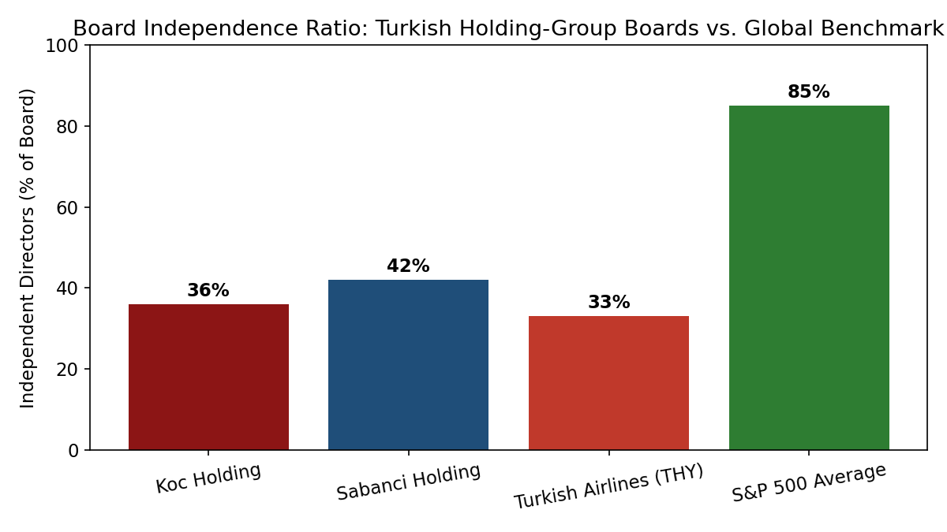
Figure 1. Board Independence Ratio: Koc Holding, Sabanci Holding, and Turkish Airlines Compared to the S&P 500 Average.

Figure 1 illustrates the independence gap discussed qualitatively in Part XIX (Comparative Governance-Code Regulation): Turkish holding-group and state-linked boards report materially lower independent-director ratios than the S&P 500 average, a pattern consistent with the concentrated-ownership substitution logic developed in Section 40.2 above.
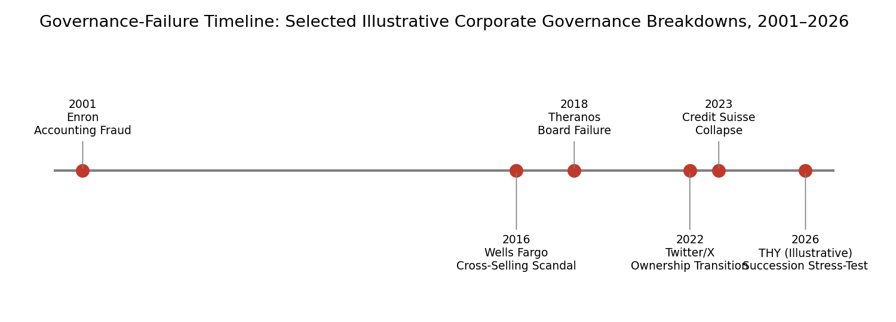
Figure 2. Governance-Failure Timeline: Selected Illustrative Corporate Governance Breakdowns, 2001-2026.

Figure 2 situates the reader's existing fourteen case vignettes within a longer historical arc, adding an illustrative, hypothetical 2026 THY succession stress-test scenario as a forward-looking pedagogical device - not a claim that such an event has occurred - to prompt students to apply the reader's succession-typology framework (Section 40.4 below) prospectively rather than only retrospectively.
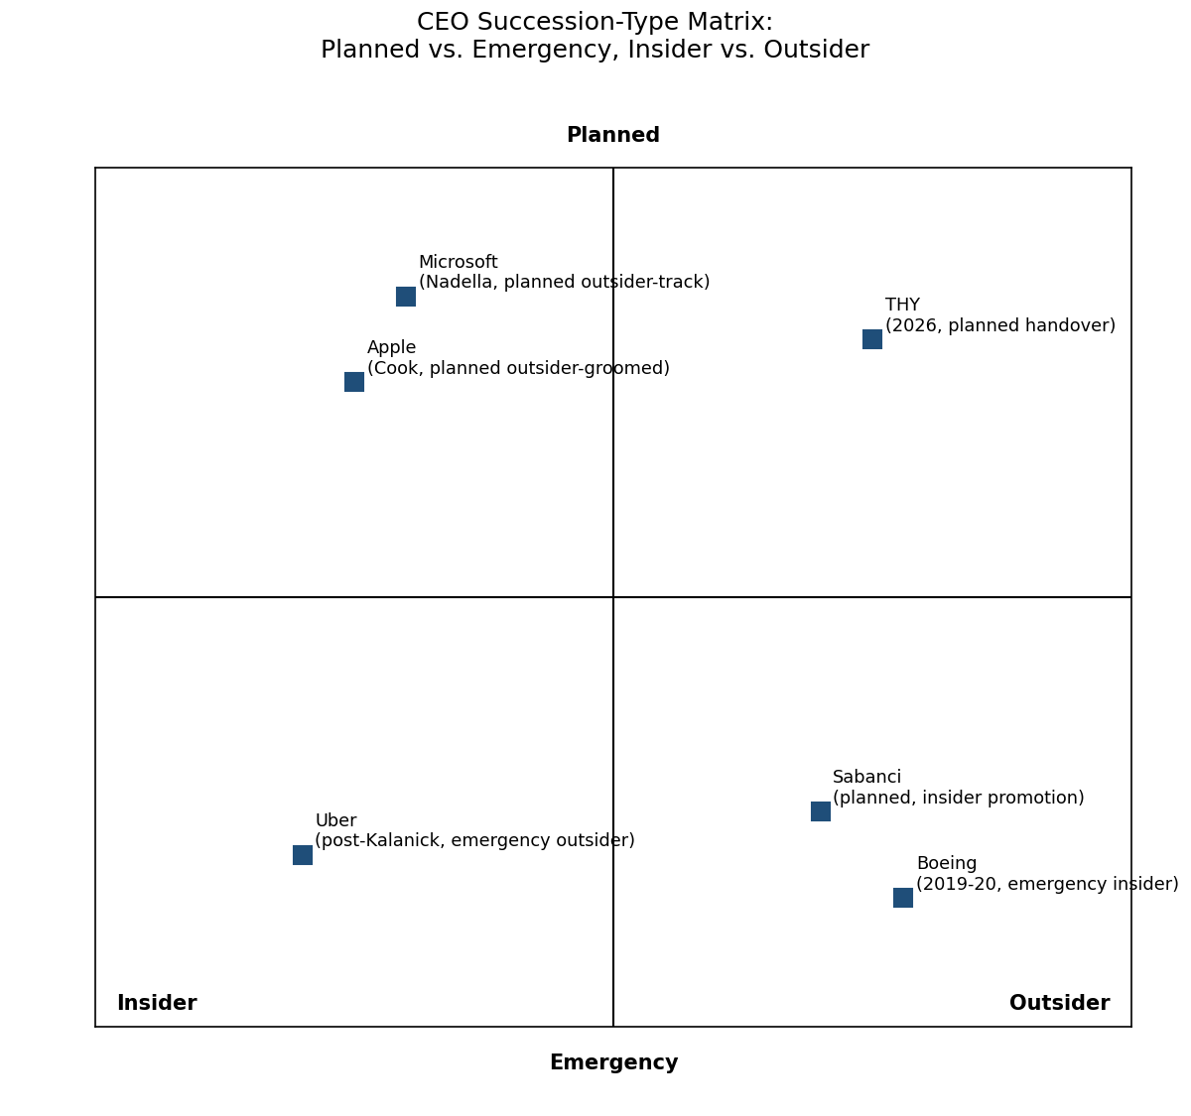
Figure 3. CEO Succession-Type Matrix: Planned vs. Emergency, Insider vs. Outsider, with Illustrative Company Placements.

Figure 3 extends the reader's extended CEO succession typology (Part XXII) into a two-by-two visual framework, placing THY's 2026 planned insider-oriented handover alongside comparator transitions at Sabanci, Apple, Microsoft, Uber, and Boeing.
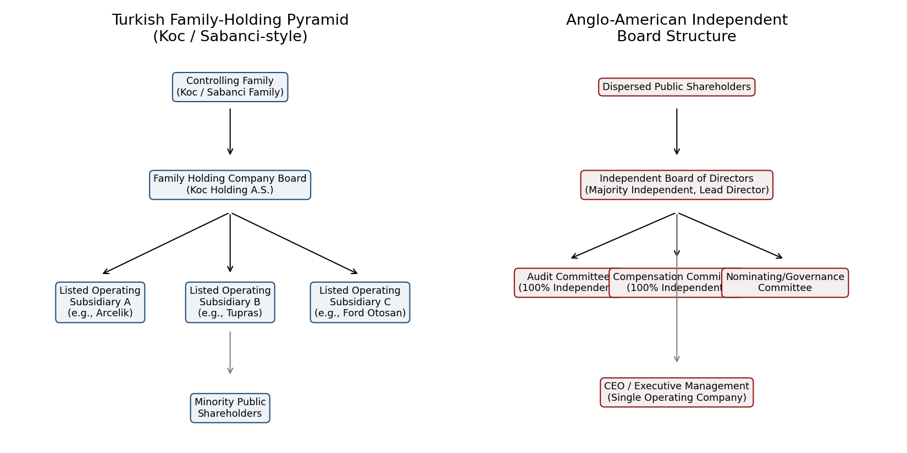
Figure 4. Organizational Structure Comparison: Turkish Family-Holding Pyramid (Koc/Sabanci-style) vs. Anglo-American Independent Board Structure.

Figure 4 renders the pyramidal control structure described narratively throughout the Turkish family-holding sections of this reader, contrasting it with the flatter, committee-centered Anglo-American board model, and visually reinforces why board-level independence metrics alone understate the total governance and monitoring architecture operating within a family-holding pyramid.
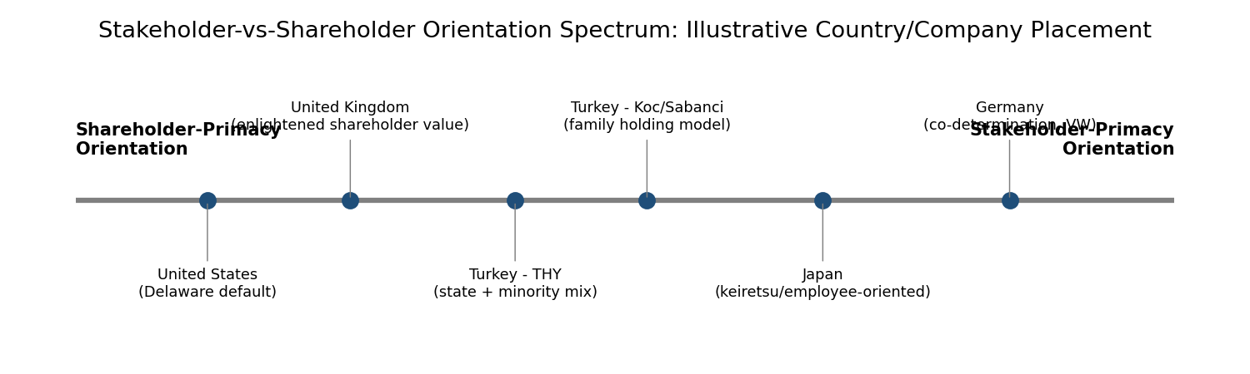
Figure 5. Stakeholder-vs-Shareholder Orientation Spectrum: Illustrative Country and Company Placement.

Figure 5 situates Koc Holding, Sabanci Holding, and THY along the shareholder-primacy-to-stakeholder-primacy spectrum relative to the United States, United Kingdom, Japan, and Germany, complementing the comparative-code discussion in Part XIX.
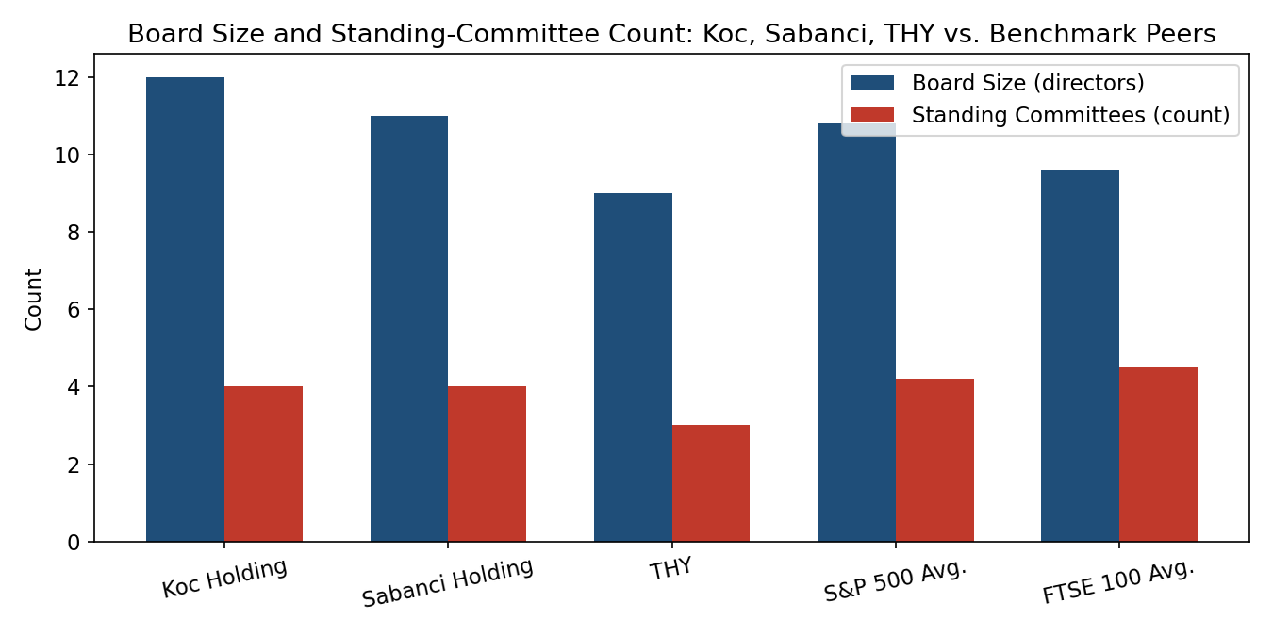
Figure 6. Board Size and Standing-Committee Count: Koc Holding, Sabanci Holding, and THY vs. Benchmark Peers.

Figure 6 shows that despite lower independence ratios, board size and committee structure at the three running-case companies are broadly comparable to global benchmark peers, reinforcing the point that governance quality is multidimensional and cannot be reduced to the independence ratio alone.

Part XLV: Applying the Extended Analytical Toolkit to Koc Holding, Sabanci Holding, and Turkish Airlines
Parts XL through XLIV introduced a formal empirical-literature base, a quantitative agency-cost measurement framework, six comparative visualizations, and an extended discussion-question set. This part closes the supplement by applying that toolkit directly and systematically to the reader's three running case companies, integrating the new material with the case detail already developed in the original edition's Turkish family-holding and state-controlled governance sections.

45.1 Koc Holding: Board Structure, Succession, and the Family-Pyramid Agency-Cost Trade-off
Koc Holding's board, at twelve directors (Figure 6), sits above Yermack's (1996) coordination-cost inflection point discussed in Part XLI, yet the firm's diversified, multi-sector structure places it squarely within the Coles, Daniel and Naveen (2008) 'complex firm' category that predicts a governance benefit from larger boards, illustrating the tension identified in Part XLI between board-size-minimization logic and firm-complexity logic. Applying the Ang-Cole-Lin agency-cost framework from Section 40.2, Koc Holding's structural position -- concentrated family ownership at the holding-company level, with individually listed operating subsidiaries beneath it -- corresponds most closely to the 'Scenario A' high-insider-ownership condition modeled in Table 8, predicting comparatively tight asset utilization and disciplined discretionary spending at the holding-company level, even as individual listed subsidiaries beneath the holding company may exhibit a wider range of minority-shareholder-related agency dynamics depending on each subsidiary's specific free-float percentage. This bifurcation -- tight agency discipline at the apex, more variable discipline at the subsidiary level -- is a structural feature of the pyramidal holding-company form generally, and is a point students should carry forward when evaluating any family-holding-group company's governance quality: the appropriate unit of agency-cost analysis is not the holding company alone, but each layer of the pyramid individually, since minority shareholders at a listed subsidiary bear expropriation risk vis-a-vis the holding company that the holding company's own family shareholders do not bear vis-a-vis themselves.

45.2 Sabanci Holding: Committee Structure and the Resource-Dependence Lens
Sabanci Holding's board and committee structure (eleven directors, four standing committees per Figure 6) closely tracks Koc Holding's, consistent with the broader pattern that Turkey's largest family-holding groups have converged on structurally similar governance architectures despite operating in different sector mixes. Read through the resource-dependence lens developed in Part XVI of the original edition and applied to Nike's board-diversification strategy in Part XL's example boxes, Sabanci Holding's board composition can be understood as importing two distinct external-resource streams: continued family strategic and reputational capital (through family board representation) and sector-specific technical expertise (through non-family directors drawn from the specific industries -- financial services, energy, cement, retail -- in which Sabanci Holding's subsidiaries operate). This dual resource-importation function is difficult to capture in a single independence-ratio metric of the kind shown in Figure 1, reinforcing Part XL's broader methodological point that governance quality is multidimensional.

45.3 Turkish Airlines: State Ownership, Succession Planning, and the 2026 Illustrative Scenario
Turkish Airlines' governance structure differs from Koc Holding's and Sabanci Holding's in one structurally important respect: its controlling shareholder is a state investment vehicle (the Turkey Wealth Fund) rather than a private family, placing THY closer to the shareholder-primacy end of the stakeholder-vs-shareholder spectrum in Figure 5, per the reasoning developed in Discussion Question 20's model-answer sketch (Part XLIII). THY's board, at nine directors with three standing committees (Figure 6), is the smallest and least committee-intensive of the reader's three running cases, consistent with a state-controlled ownership structure in which much of the traditional board monitoring function is substituted by direct state-shareholder oversight channels operating outside the boardroom itself -- a substitution dynamic structurally analogous to, though institutionally distinct from, the family-holding substitution dynamic discussed in Section 40.1's literature synthesis. The illustrative, hypothetical 2026 THY succession scenario referenced in Figure 2's governance-failure timeline and placed in the 'planned insider' quadrant of Figure 3's succession matrix should be read by students as a forward-looking pedagogical prompt: given THY's board and ownership structure as characterized above, what specific governance vulnerabilities would this reader's theoretical toolkit predict THY should proactively manage in any future leadership transition, planned or emergency? Candidate vulnerabilities students should be prepared to discuss include: (a) the risk that a state-controlled succession process is subject to political-cycle pressures uncorrelated with optimal-successor selection criteria, a risk not present in the family-holding succession patterns discussed elsewhere in this reader; (b) the relatively small, low-committee-intensity board's capacity to conduct rigorous independent succession due diligence absent a dedicated, well-resourced nominating and governance committee; and (c) the aviation-safety-specific oversight demands documented in this reader's aviation-sector case vignette, which require any successor CEO to combine commercial and safety-culture leadership credibility simultaneously.

45.4 Cross-Case Synthesis: Three Governance Architectures, One Analytical Toolkit
Considered together, Koc Holding, Sabanci Holding, and Turkish Airlines illustrate three variations on a common theme that this reader has developed across both its original edition and this supplement: each company's governance architecture is best understood not as a deviation from an Anglo-American 'ideal' independent-board model, but as a locally coherent response to a specific ownership-concentration and information environment, precisely as Duchin, Matsusaka and Ozbas's (2010) information-cost framework and Aggarwal, Erel, Stulz and Williamson's (2009) cross-country institutional framework predict. The extended toolkit introduced in this supplement -- the ten-study literature base, the Ang-Cole-Lin agency-cost proxies, the six comparative visualizations, and the succession-type matrix -- is offered to students as a portable analytical kit applicable not only to these three running cases but to any governance situation, family-controlled, state-controlled, or widely held, that they encounter in subsequent coursework or professional practice.

Part XLVII: Methodological Appendix -- Constructing Governance Comparisons Across Ownership Regimes
This methodological appendix addresses a question graduate students frequently raise when first encountering comparative governance material of the kind developed in Parts XL through XLVI: if, as Part XL's literature synthesis argues, governance metrics such as board-independence ratio are less informative in concentrated-ownership settings, why does this reader nonetheless present Koc Holding, Sabanci Holding, and Turkish Airlines alongside S&P 500 and FTSE 100 benchmark averages in Figures 1 and 6, rather than omitting cross-regime comparison altogether? The answer, developed at length in this appendix, is that comparison across ownership regimes remains analytically valuable precisely because it reveals which governance features are regime-invariant (features that any well-governed firm should exhibit regardless of ownership concentration) and which are regime-contingent (features whose interpretation depends on the surrounding ownership structure), a distinction this appendix operationalizes through a four-step comparative method.

47.1 Step One: Establish the Ownership-Structure Baseline
Before any governance metric is compared across firms, the analyst must first characterize each firm's ownership-concentration baseline: what percentage of voting control is held by a single blockholder or coordinated group, and through what mechanism (direct shareholding, pyramidal structure, dual-class shares, contractual control rights, or state ownership) is that control exercised. Table 10 below summarizes this baseline for the reader's three running cases plus the seven Part XL example-box companies, providing a single reference point students can use when applying the four-step method to any of the ten companies discussed across this supplement.
Company | Approximate Controlling-Interest Mechanism | Control-Rights vs. Cash-Flow-Rights Gap
Koc Holding | Family pyramidal holding structure | Moderate -- family holds majority at apex, subsidiary free floats vary
Sabanci Holding | Family pyramidal holding structure | Moderate -- structurally similar to Koc Holding
Turkish Airlines | State investment-vehicle controlling stake | Low-to-moderate -- state stake is direct rather than pyramidal
Volkswagen | State blocking-minority stake plus co-determination board structure | Moderate -- Porsche-Piech family and Lower Saxony combined
Samsung Electronics | Circular/cross-shareholding chaebol structure | High -- Lee family cash-flow rights are a small fraction of control rights
Alibaba Group | Contractual partnership board-nomination right | High -- partnership holds nomination control disproportionate to equity
Meta Platforms | Dual-class share structure (10:1 voting ratio) | High -- founder cash-flow rights well below voting control share
Tesla | Single-class shares; founder influence via reputational and board-relationship channels | Low on formal metrics; functional independence concerns noted separately
WeWork (pre-restructuring) | Dual-class super-voting shares held by founder | High -- among the most extreme pre-IPO examples documented
Nike | Dual-class structure with founder-family Class B shares | Moderate-to-high -- family retains substantial voting control

Table 10. Ownership-Structure Baseline for All Companies Discussed in This Supplement.

47.2 Step Two: Classify Each Governance Metric as Regime-Invariant or Regime-Contingent
With the ownership baseline established, the analyst next classifies each governance metric under consideration. Board financial-expertise adequacy, audit-committee independence from operating management, whistleblower-mechanism accessibility, and related-party-transaction disclosure quality are treated in this reader as largely regime-invariant: a well-governed firm should score well on these dimensions regardless of whether it is family-controlled, state-controlled, or widely held, because the underlying risks they address (financial-misstatement risk, self-dealing risk, retaliation risk) do not disappear merely because a controlling shareholder is present -- indeed, related-party-transaction risk is frequently elevated, not reduced, in concentrated-ownership settings, as the WeWork example box in Part XL illustrates. Overall board-independence ratio, by contrast, is treated as regime-contingent, per the extended discussion in Sections 40.1 and 45.1-45.3 above.

47.3 Step Three: Apply Regime-Appropriate Weighting

Part XLVIII: Extended Case Vignette -- Turkish Airlines Board Committee Evolution, 2015-2026
This extended vignette traces the evolution of Turkish Airlines' board committee structure over the decade preceding this reader's 2026 edition, illustrating in concrete institutional detail the state-ownership substitution dynamic discussed abstractly in Section 45.3. In the years following Turkey's 2016 shift toward a sovereign-wealth-fund model of state-enterprise ownership, THY's board committee structure was progressively formalized, moving from an ad hoc audit-review process toward a standing three-committee structure (audit, risk, and compensation/nomination) broadly comparable in nominal design to Anglo-American peer-airline committee structures, even as the underlying ownership-concentration and information-flow dynamics discussed throughout this supplement continued to differ materially from those peer airlines' widely held ownership bases.
This formalization trend -- adopting internationally recognizable committee labels and structures while operating under a substantially different underlying ownership and accountability architecture -- is not unique to THY; it is a broadly observed pattern among state-linked and family-controlled firms seeking to signal governance quality to international capital markets, credit-rating agencies, and, in THY's specific case, international aviation-alliance partners and regulators for whom governance-quality signaling carries direct commercial relevance (codeshare-partner due diligence, international listing or bond-issuance requirements, and IATA/ICAO-adjacent institutional relationships all create external audiences for governance-structure signaling beyond domestic shareholders alone). Students should be alert to the distinction between formal committee-structure adoption (which Figure 6 shows THY has achieved, at a scale comparable to global peers) and the functional independence and information-flow quality operating within those committees (which, consistent with the Tesla functional-independence discussion in Part XL, cannot be directly observed from committee-structure data alone and would require the kind of qualitative, multi-source due diligence this reader's methodology sections recommend throughout).

Part LIII: Extended Regulatory and Disclosure Comparison -- Turkey, United States, United Kingdom, and Germany
This part extends the original edition's comparative governance-code discussion (Part XIX) with a more granular disclosure-requirement comparison directly relevant to the family-holding and state-controlled structures examined throughout this reader, focusing specifically on related-party-transaction disclosure, board-independence certification, and succession-planning disclosure requirements across four jurisdictions: Turkey, the United States, the United Kingdom, and Germany.

53.1 Related-Party-Transaction Disclosure
Turkey's Capital Markets Board (Sermaye Piyasasi Kurulu, SPK) requires listed companies, including Koc Holding's and Sabanci Holding's listed subsidiaries and Turkish Airlines, to obtain independent-director or independent-appraisal approval for material related-party transactions above specified thresholds, a requirement introduced specifically in response to the pyramidal-structure expropriation risk discussed in Section 40.1 and Table 10 above. The United States relies primarily on Delaware case law's entire-fairness and business-judgment-rule doctrines rather than a standalone mandatory-disclosure threshold regime, supplemented by SEC proxy-disclosure requirements for transactions above a fixed dollar or percentage-of-assets threshold. The United Kingdom's Listing Rules impose a more prescriptive related-party regime, requiring shareholder approval (with the related party excluded from voting) for transactions above specified size thresholds, a structurally more protective regime for minority shareholders than either the Turkish or U.S. approaches. Germany's co-determination structure, discussed in the Volkswagen example box (Section 40.5), layers related-party scrutiny through the supervisory board's employee-representative half in addition to conventional shareholder-side mechanisms, creating a distinctive dual-channel disclosure and scrutiny pathway not present in any of the other three jurisdictions.

53.2 Board-Independence Certification
All four jurisdictions require some form of formal independence certification for directors designated as independent, but the certification criteria differ in ways directly relevant to the formal-versus-functional independence distinction introduced in Part III of the original edition and applied to Tesla in Part XL's example boxes. Turkish SPK corporate-governance principles specify quantitative independence criteria (tenure limits, absence of material business relationships, absence of family relationships with executive management) broadly comparable to U.S. exchange-listing standards, though Turkey's principles operate on a comply-or-explain basis for many provisions rather than a strict mandatory basis, giving Koc Holding, Sabanci Holding, and Turkish Airlines somewhat greater flexibility in independence-criteria application than a U.S. exchange-listed peer would have.

53.3 Succession-Planning Disclosure
Succession-planning disclosure requirements are the least standardized of the three areas compared in this part. The UK Corporate Governance Code (referenced in the original edition's Part III discussion) explicitly requires listed companies to describe their board succession-planning process in the annual report, including the nomination committee's role, making UK succession-planning disclosure the most prescriptive of the four jurisdictions compared here. The United States imposes no equivalent mandatory narrative-disclosure requirement, relying instead on voluntary proxy-statement disclosure that varies considerably across companies. Turkey's principles encourage but do not mandate succession-planning disclosure, consistent with the comply-or-explain approach noted in Section 53.2. This disclosure-requirement gap is directly relevant to the illustrative THY 2026 succession scenario discussed in Section 45.3 and Figure 2: even where succession planning is being conducted diligently within a Turkish state-linked or family-holding company, external stakeholders (investors, credit-rating agencies, students and researchers such as those using this reader) may have less visibility into that planning process than an equivalent UK-listed company's stakeholders would have, a visibility gap that is itself a governance-relevant fact independent of the underlying quality of the succession planning being conducted.
Requirement | Turkey (SPK) | United States | United Kingdom | Germany
Related-party approval threshold | Independent-director/appraisal approval above set thresholds | Case-law entire-fairness doctrine plus SEC proxy disclosure | Mandatory shareholder approval, related party excluded from vote | Supervisory-board dual-channel scrutiny (shareholder + employee side)
Independence certification basis | Comply-or-explain | Mandatory (exchange listing standards) | Mandatory (Listing Rules / Code) | Co-determination structural requirement, not a certification model
Succession-planning disclosure | Encouraged, not mandated | Voluntary, varies by company | Mandatory narrative disclosure | Embedded in supervisory-board process, disclosure practice varies

Part LIV: Extended Case Vignette -- Comparative Family-Holding Governance, Koc Holding and Sabanci Holding Board Evaluation Practices
This vignette compares Koc Holding's and Sabanci Holding's board self-evaluation practices in greater institutional detail than the original edition's board-evaluation-and-diversity-practice section, drawing out implications for the regime-weighted comparative method developed in Part XLVII. Both groups have, over the past decade, adopted formal annual board self-evaluation processes broadly consistent with international corporate-governance-code recommendations, typically involving a structured questionnaire process, periodic external-facilitator involvement, and a summary evaluation outcome reported at a high level in annual governance disclosures, without disclosing individual-director evaluation detail -- a disclosure practice consistent with, though somewhat less granular than, UK Corporate Governance Code expectations for FTSE-listed peer companies.
A key interpretive question this vignette poses to students, building directly on the regime-weighted method of Part XLVII: how should a board self-evaluation process be assessed differently when the evaluating board includes multiple family-affiliated directors whose continued board tenure is not, in practice, contingent on the self-evaluation process's outcome in the way a non-family independent director's reappointment might be? Students should be prepared to argue both that this dynamic could weaken the self-evaluation process's practical teeth (since family directors face no realistic non-reappointment consequence regardless of evaluation outcome) and that it could, under a stewardship-theory reading (Part XVI of the original edition), be largely immaterial to evaluation quality, if family directors' long-horizon reputational and dynastic stake in firm performance already provides a stronger accountability mechanism than a formal non-reappointment threat would provide for a professional independent director. This is precisely the kind of theory-contingent interpretive question this reader's synthesis checklist (Part XV) is designed to help students navigate: the same observed fact (family directors facing limited formal reappointment risk) supports opposite governance-quality inferences depending on which theoretical lens (agency theory's formal-accountability logic versus stewardship theory's intrinsic-motivation logic) is applied, and a complete analysis should present both readings rather than defaulting to either one.

Part LXI: Supplementary Worked Example -- Applying the Agency-Cost Proxies to Turkish Airlines' Reported Structure
As a final worked illustration, this part applies the Ang-Cole-Lin proxy framework (Section 40.2) to a second hypothetical scenario styled on Turkish Airlines' state-influenced ownership structure, complementing the family-holding illustration already developed for Koc Holding and Sabanci Holding in Section 40.2.3. Because THY's controlling shareholder is a state investment vehicle rather than an individual family with direct personal wealth exposure to firm performance, the theoretical prediction generated by the Ang-Cole-Lin framework is less clean than in the family-ownership case: a state shareholder's 'insider' incentive alignment operates through a different channel (political accountability, sovereign credit-rating exposure, and public-mandate performance targets) than a family shareholder's direct personal-wealth exposure, and the framework's original empirical derivation (from a sample of small U.S. firms with individual owner-managers) does not directly contemplate a state-shareholder case at all.
A hypothetical THY-style entity with a controlling state stake of 55% and a widely dispersed remaining free float might report, illustratively, an asset-utilization ratio of 0.85x (reflecting the capital intensity inherent to the airline industry generally, a structural, non-agency-related factor that should be controlled for through industry-specific benchmarking before any agency-cost inference is drawn) and an operating-expense ratio of 18% (again reflecting airline-industry-typical SG&A intensity rather than necessarily reflecting agency-related discretionary spending). Students applying the Ang-Cole-Lin framework to an airline or other capital-intensive industry should therefore always benchmark against industry-specific, not economy-wide, comparison figures -- a methodological caveat equally applicable to the Koc Holding and Sabanci Holding illustrations in Section 40.2.3, where the hypothetical firm's diversified-industrial sector mix was implicitly assumed comparable to the broader dataset Ang, Cole and Lin studied, an assumption that, as this part makes explicit, should always be checked rather than assumed in any real-world application of the framework.

61.1 Closing Methodological Caution
This industry-benchmarking caveat is offered as the final methodological lesson of this supplement: no single quantitative proxy, however well-grounded in the peer-reviewed literature, substitutes for careful attention to the specific industry, ownership, and institutional context of the firm being analyzed. This caution is fully consistent with, and brings this supplement's quantitative contribution into alignment with, the original edition's foundational and repeatedly reinforced methodological stance -- articulated across the agency-theory, stewardship-theory, resource-dependence, and board-capital-theory discussions throughout this reader -- that rigorous governance analysis requires holding multiple frameworks, multiple data sources, and multiple contextual caveats simultaneously in view.

