ADEX547 Specail Topics in Organisation and Strategy
Week 1 Course Reader
Corporate Strategy Foundations
Portfolio strategy - Corporate parenting - Diversification logic - Capital allocation - M&A rationale
July 2026
Prepared for Session 1 pre-class reading

How to Use This Reader
This reader gives you a shared analytical vocabulary before Session 1, so that class time is spent on judgment and application rather than definitions. It is intentionally longer than a single sitting - treat the seven parts as a reference you return to throughout the term. Skim the framework summaries first, then read closely the sections that bear on the multi-business company your group has chosen to study.
As you read, keep one publicly listed, multi-business firm in mind and interrogate every framework against it: where does the corporate center earn its keep, and where might capital markets be quietly applying a discount to the combination? The running examples in this edition - global megadeal M&A in 2026, and the simultaneous portfolio reshuffling under way at Koc Holding, Sabanci Holding, and Turkish Airlines - are not decoration. They are the live laboratory in which these frameworks are being tested in real time, and you should expect to debate them in class.
Evidence over assertion
Every framework in this reader has a documented failure mode. Where the empirical record is contested or still evolving, the text says so plainly, and every statistic is traceable to a named source in the reference list at the end.

Learning Objectives
- Distinguish corporate-level strategy (what portfolio of businesses to own) from business-level strategy (how a single business competes).
- Apply corporate parenting theory to judge whether a corporate center is creating or destroying value in a specific business.
- Apply the resource-based view (Barney, 1991) and Rumelt's diversification typology to judge whether a parent's resources justify entering or holding a given business.
- Use the BCG growth-share matrix as a portfolio-classification tool while recognizing its documented limitations.
- Evaluate the diversification discount/premium debate using the primary empirical studies and their critiques.
- Apply a capital allocation framework to compare the five main uses of corporate cash.
- Assess M&A rationale against the empirical record on value creation versus value destruction.
- Connect all of the above to live 2026 cases: global megadeal M&A, and portfolio reshuffling at Koc Holding, Sabanci Holding, and Turkish Airlines.

Part I - Corporate Strategy Is Not Business Strategy

The two strategy questions
Most managers are trained to think about business-level strategy: how a single business unit wins in its market through cost leadership, differentiation, or focus. Corporate-level strategy asks a different and harder question: what set of businesses should the firm own, and does owning them together create more value than owning them apart? This is not a matter of organizational altitude. Business strategy is about competitive advantage in a product market; corporate strategy is about ownership advantage in the market for businesses and capital (Porter, 1987; Goold, Campbell & Alexander, 1994).
Porter's blunt formulation still holds: corporate strategy is only justified if the corporation adds more value to a business than the cost of governing it, and more than any rival owner - including the business's own shareholders trading it as a standalone stock - could add. A diversified firm that cannot pass this test is, in Porter's words, subtracting value even while every individual business unit is profitable.
Question | Corporate Strategy | Business Strategy
What is being decided? | Which businesses should the firm own, enter, or exit? | How does this one business beat its rivals?
Who owns the decision? | The corporate center / holding-company board | The business-unit management team
Key test | Does the parent add more value to this business than the best alternative owner would? | Does the business have a defensible cost or differentiation advantage?
Example in this reader | Should Koc Holding keep or sell Arcelik's white-goods JV? | How does Arcelik compete against Whirlpool in Europe?
Table — The two strategy questions, side by side: what corporate strategy asks versus what business strategy asks.

Why this distinction matters for conglomerates
Family-controlled holding groups such as Koc Holding and Sabanci Holding in Turkey have historically defended diversification on grounds that do not appear in a textbook built around single-country capital markets: institutional voids. Khanna and Palepu's research on emerging markets argues that where external capital markets, labor markets for professional managers, and contract enforcement are underdeveloped, a diversified group can profitably replicate the missing infrastructure internally - its own capital market, its own management-development pipeline, its own reputation for contract-honoring. The same structure that destroys value in a mature market with deep capital markets can create it in a market with thin ones. Both Koc and Sabanci sit exactly at the test case for this argument in 2026, as Turkish capital markets have deepened considerably since the theory was first proposed.
Part II - Theoretical Foundations: The Resource-Based View, Rumelt's Diversification Typology, and a Theory Map

The resource-based view applied to corporate scope (Barney, 1991)
Jay Barney's resource-based view (RBV) asks a more useful question than "what industry are we in?" - it asks "what do we own that a rival cannot easily copy?" (Barney, 1991). For a resource to be worth building a strategy around, it has to pass four tests at once: it must be Valuable, Rare, hard to Imitate, and hard to substitute (the VRIN test). Applied to a corporate parent, this gives corporate parenting theory its missing mechanism: a holding company only earns its keep by moving into a business where its own proprietary asset - a brand, a distribution network, a technology platform, a scarce skill, or, in an emerging market, a hard-won reputation for honoring contracts - passes the VRIN test in that specific business, and a rival owner could not easily replicate it. Diversify because you have excess cash or because it is exciting, without a transferable VRIN resource behind the move, and RBV predicts no advantage - just an expensive way to destroy value, which lines up with the agency-cost story below.
RBV also explains why the same diversification move can create value for one parent and destroy it for another: the test is not whether a business is attractive in isolation, but whether this specific parent's resource bundle is Valuable, Rare, Inimitable, and Non-substitutable in that specific business relative to the next-best owner. This is precisely Porter's parenting-advantage question in different vocabulary, and it is why Part III below treats Goold and Campbell's framework and Barney's RBV as complementary rather than competing lenses.

Rumelt's diversification typology (1974, 1982)
Richard Rumelt's early empirical work classified large U.S. firms by the degree and type of relatedness across their business portfolios - single business, dominant business, related-constrained, related-linked, and unrelated (conglomerate) - and tested financial performance against the category (Rumelt, 1974; 1982, Strategic Management Journal). The central and durable finding: firms pursuing related diversification, where businesses share a core skill, technology, or customer base, outperformed both single-business firms (which forgo the benefits of scope) and unrelated conglomerates (which pay a governance and coordination cost with no offsetting resource-sharing benefit). Rumelt's typology is the historical ancestor of both the RBV account of diversification and the modern diversification-discount literature in Part IV: relatedness is the variable that determines whether scope is a source of advantage or merely a source of complexity.
Applying Rumelt to Turkish holding groups
Koc Holding and Sabanci Holding do not fit Rumelt's single-business or dominant-business categories; both are better described as related-linked to unrelated-conglomerate structures, spanning energy, automotive, finance, consumer goods, and technology under one corporate parent. Turkish Airlines (THYAO) sits at the opposite pole of the typology: with essentially all consolidated revenue from air transportation (passenger plus cargo), THY is Rumelt's single-business/dominant-business case in the same national market, which makes the three-company set an unusually clean natural experiment in relatedness. Rumelt's framework predicts Koc and Sabanci should underperform a purely related diversifier of similar size - unless, as Khanna and Palepu argue, the institutional-voids logic supplies an offsetting source of value that Rumelt's original U.S.-based sample never had to price in - while THY's focused structure should, on the same logic, avoid the conglomerate penalty entirely but forgo any internal-capital-market insurance against a sector-specific shock (precisely what materialized for THY during the 2020-2021 pandemic collapse in global air travel).

A theory map: five lenses on the same question
The frameworks in this reader are not alternatives competing for a single right answer; each addresses a different failure mode of corporate diversification, and a rigorous case analysis applies all five before reaching a recommendation.
Theory / Framework | Author(s) & Year | Core Claim | Application to Holding Companies
Corporate parenting theory | Goold, Campbell & Alexander (1994) | A corporate center creates value only if it is the best possible parent for a given business; otherwise it destroys value even when the business is profitable. | Tests whether Koc's or Sabanci's central functions (brand, capital, management pipeline) genuinely fit each subsidiary, or merely add cost; for THY, a single-business operating company, the parenting question collapses to whether the Turkiye Varlik Fonu (TVF), as controlling shareholder, adds or subtracts value relative to a fully private ownership structure.
Resource-based view (RBV) of diversification | Barney (1991) | Diversification creates advantage only where the parent's resources are Valuable, Rare, Inimitable, and Non-substitutable in the target business. | Explains why the same subsidiary (e.g., a bank, an energy utility) can be a value-adding fit for one Turkish group and not another, based on each parent's distinct resource bundle.
Rumelt's diversification typology | Rumelt (1974; 1982) | Related diversification outperforms both single-business focus and unrelated conglomeration; relatedness is the key performance variable. | Positions Koc and Sabanci as related-linked to unrelated-conglomerate structures, predicting an underlying performance penalty absent an offsetting institutional rationale, while positioning THY as a single/dominant-business firm for which the typology predicts no such structural penalty.
Read together, the map above resolves an apparent contradiction in the literature: RBV and parenting theory ask whether this parent adds value to this business; Rumelt and the diversification-discount literature ask what the average penalty is for the type of portfolio structure chosen; and institutional-voids theory supplies the one systematic reason that penalty might be smaller, or absent, in a specific national context. A rigorous answer to should this holding company own this business needs all three layers, not just one.

Part III - Corporate Parenting Theory and the BCG Growth-Share Matrix

Corporate parenting advantage (Goold & Campbell)
Michael Goold and Andrew Campbell's parenting-advantage framework asks a sharper question than should we diversify: for this specific business, is our corporate center the best possible parent? A parent creates value through central functions (shared services, brand, capital), through influence on business unit strategy, through linkages between businesses, and through interventions such as replacing weak management. A parent destroys value when it imposes cost and bureaucracy without a matching contribution - the parenting cost, which is often invisible until a demerger reveals how much the underlying business is worth on its own.
The framework's practical test is the heartland matrix: plot each business on fit with the parent's skills and fit with the parent's resources. Businesses in the heartland (high fit on both axes) should stay; businesses in the alien territory quadrant (low fit on both) are the clearest candidates for divestiture, regardless of how profitable they currently are.
Evidence from the field
General Electric's 2021-2024 three-way breakup (GE Aerospace, GE Vernova, GE HealthCare) is frequently cited as the parenting-advantage argument taken to its logical conclusion: each successor traded at a premium to the combined entity's implied value within 18 months of separation, evidence that the conglomerate structure itself, not any single business, had been suppressing value.

Corporate parenting styles (Goold & Campbell)
Goold and Campbell's fieldwork identified three recurring styles that corporate centers use to manage a multibusiness portfolio, distinguished by how much planning influence and how much control the center exerts over business-unit strategy and budgets. No style is universally superior; each fits a different portfolio logic, and a mismatch between style and portfolio is itself a common source of parenting-cost destruction (Goold, Campbell & Alexander, 1994).
Parenting Style | Center's Role | Planning Influence | Financial Control | Best Fit / Risk
Financial Control | Center sets tough financial targets and reviews performance against budget; minimal involvement in business-unit strategy formulation. | Low - business units largely set their own strategy | High - tight, short-cycle budgetary discipline; capital rationed against ROI hurdles | Fits a portfolio of unrelated, mature businesses with clear stand-alone financial logic; risks under-investing in longer-horizon strategic bets
Strategic Planning | Center acts as a co-architect of long-term strategy across businesses, shaping direction and resourcing multi-year initiatives. | High - center closely shapes business-unit strategy | Low to moderate - budget flexed to support strategic priorities over short-term financial targets | Fits related businesses where the center has genuine industry expertise to add; risks slow decision cycles and blurred accountability
Strategic Control | Hybrid: center reviews and challenges strategic plans but holds business units accountable to agreed financial and strategic milestones. | Moderate - center reviews rather than authors strategy | Moderate - budget discipline balanced against strategic milestones | Fits a portfolio mixing related and unrelated businesses; the most common style among large diversified holding groups, including Koc Holding and Sabanci Holding
Applying parenting styles to Turkish holding groups
Koc Holding and Sabanci Holding both describe themselves publicly as operating a strategic-control-style center: a small holding-company staff sets group-wide capital allocation priorities and reviews subsidiary boards, while day-to-day strategy is delegated to each subsidiary's own management and board (e.g., Arcelik, Tupras, and Ford Otosan at Koc; Akbank, Enerjisa, and Brisa at Sabanci, organized into the five Strategic Business Units - Banking & Financial Services, Energy & Climate Technologies, Material Technologies, Digital Technologies, and Retail - set out in Sabanci's 2025 Integrated Annual Report). Turkish Airlines has no parenting-style question at the group level in the same sense, because it is not a portfolio of businesses under a holding company: its board, chaired since 9 April 2026 by Prof. Dr. Murat Seker (with Ahmet Olmustur as CEO after a full leadership rotation typical of TVF-controlled companies), governs a single integrated airline, with THY Technic, THY OPET Aviation Fuels, and Turkish Cargo operating as functionally-integrated units of the core business rather than as independently governed subsidiaries - the strategic-control style simply does not apply to a single-business firm in the way it applies to Koc and Sabanci.

The BCG growth-share matrix
Developed by Bruce Henderson at the Boston Consulting Group in 1970, the growth-share matrix plots business units on two axes - market growth rate and relative market share - producing four archetypes: Stars (high growth, high share), Cash Cows (low growth, high share), Question Marks (high growth, low share), and Dogs (low growth, low share). The strategic logic is a cash-flow argument, not a profitability argument: cash cows fund the growth of stars and selected question marks; dogs are candidates for harvest or divestiture.
Quadrant | Growth | Share | Cash Behavior | Strategic Prescription | Illustrative Business Unit (2026)
Star | High | High | Roughly self-funding; large cash generation offset by large investment needs | Invest to defend leadership | Enerjisa Uretim (Sabanci) - renewable generation capacity in a high-growth, high-share Turkish energy market
Cash Cow | Low | High | Net cash generator | Harvest; fund stars and selected question marks | CarrefourSA (Sabanci, pre-divestiture) - a mature, organized-grocery retail business with dominant regional share, historically funding group reinvestment before Sabanci's 2026 exit reallocated the capital to energy and digital technologies
Question Mark | High | Low | Net cash consumer | Selectively invest or divest | Enerjisa Uretim's early-stage green-hydrogen and battery-storage pilots (Sabanci) - a nascent, high-growth energy-transition category in which Sabanci holds only a modest relative scale so far
Dog | Low | Low | Roughly break-even or cash-negative | Divest or manage for minimum cash | Arcelik Hitachi Home Appliances Asia-Pacific JV (Koc) - divested April 2026, consistent with a dog-quadrant exit
The matrix's well-documented limitations are as important as its logic: market share is an imperfect proxy for competitive advantage; market growth is an imperfect proxy for industry attractiveness; and the model ignores synergies between businesses, which is precisely the variable corporate parenting theory puts at the center. Used alone, the matrix has driven a generation of conglomerates to divest dogs that were, in fact, mature businesses throwing off exactly the stable cash flow a portfolio needs. BCG's own successor work - the Value Creators series - pairs the matrix with a return-based lens: total shareholder return (TSR) decomposed into revenue growth, margin change, and multiple change, tested against realized capital allocation decisions rather than static positioning.

Part IV - The Diversification Discount and Premium Debate
Does the stock market punish diversified firms relative to focused ones? The empirical literature is one of the most contested corridors in corporate finance.

The discount case
Berger and Ofek (1995), using Compustat segment data for the 1986-1991 period, estimated that diversified U.S. firms traded at an average discount of 13-15% to the sum of their segments valued as stand-alone comparables - the paper that gave the diversification discount its name and its rough magnitude in the literature. Lang and Stulz (1994) independently documented a related pattern using Tobin's Q: diversified firms had significantly lower average Q than focused firms in the same industries, and the gap widened with the number of segments.
Rajan, Servaes, and Zingales (2000) proposed a mechanism: diversified firms misallocate capital internally, cross-subsidizing weaker divisions from stronger ones - a pattern they termed the socialist internal capital market - and the discount is largest where segments differ most in investment opportunities. Scharfstein and Stein (2000) formalized a related agency story: division managers engage in rent-seeking to influence the capital-allocation process, and headquarters, to keep organizational peace, spreads capital more evenly across divisions than a pure NPV ranking would justify - a pattern the authors label corporate socialism.

The premium case and the measurement critique
Villalonga (2004) reworked the discount finding using more granular, plant-level Census Bureau data instead of self-reported Compustat segments, and found the discount shrank sharply or reversed to a premium once selection bias and mismeasured segments were corrected - the firms that diversify are often already different (lower-growth, more mature) from the firms that stay focused, so a naive comparison conflates the decision to diversify with the outcome of diversifying. Campa and Kedia (2002) reached a similar conclusion: once the endogeneity of the diversification decision is modeled explicitly, much of the apparent discount disappears.

Diversification-discount evidence at a glance
Study | Year | Sample | Key Finding
Lang & Stulz | 1994 | U.S. public firms, Compustat segments, 1980s | Diversified firms show significantly lower average Tobin's Q than single-segment firms in the same industries; gap widens with segment count.
Berger & Ofek | 1995 | U.S. public firms, Compustat segments, 1986-1991 | Average diversification discount of 13-15% versus a sum-of-the-parts stand-alone valuation; named the effect in the literature.
Rajan, Servaes & Zingales | 2000 | U.S. diversified firms, segment-level investment data | Discount is largest where segments differ most in investment opportunities; attributes it to a socialist internal capital market.
Evidence from the field
Contemporary consulting evidence tempers both camps. McKinsey's long-running work on capital reallocation finds that the payoff to diversification is not about the number of segments a company holds - it is almost entirely explained by how aggressively and how often the company reallocates capital between segments. Companies in the top quintile of capital-reallocation intensity earned meaningfully higher total shareholder returns than static allocators, regardless of how diversified they were.
The synthesis a working strategist should take from this literature: diversification itself is not what the market prices. What the market prices is whether the corporate center is a demonstrably active, disciplined reallocator of capital across its portfolio, or a passive holder of businesses that would be better off - and better financed - apart.

Part V - Capital Allocation as the Central Discipline
If the diversification debate has a practical resolution, it is this: corporate strategy is, at its core, a capital allocation problem. A corporate center has five broad uses for the cash its businesses generate, and the sequence in which it ranks them is close to the single best predictor of long-run shareholder value creation.
1. Reinvest in existing operations: Maintenance and growth capex in businesses that already clear the cost of capital.
2. Fund organic growth or new capabilities: R&D, new product lines, new geographies - where the firm builds rather than buys.
3. Pursue M&A: Acquire capabilities, market position, or scale - subject to a disciplined premium and integration test.
4. Pay down debt / strengthen the balance sheet: Particularly valuable when the cost of financial distress is high or credit is tightening.
5. Return cash to shareholders: Dividends and buybacks - the default when no internal or external use clears the hurdle rate.
The illustrative ranking above is a teaching device, not a universal rule - the correct sequence is contingent on the cost of capital, the return available in each business, and the state of credit markets. What is not contingent is the discipline of running every use of cash through a common hurdle-rate test rather than allocating by habit, politics, or the prior year's budget.
Evidence from the field
McKinsey's power-curve research on economic profit finds that companies in the top quintile of economic-profit creation reallocate a materially larger share of capital expenditure across business units year to year than median companies - active reallocation, not stability, correlates with being in the top quintile.

Internal capital markets: efficient or socialist?
An internal capital market - a corporate center directing cash from mature, cash-generative businesses toward higher-return uses elsewhere in the portfolio - is, in principle, more efficient than external capital markets when information asymmetry between insiders and outside investors is large, or when external capital is expensive or unreliable (Williamson, 1975; Stein, 1997). In practice, whether an internal capital market is efficient or socialist depends on whether the parent enforces a genuine hurdle-rate discipline or simply smooths cash across politically powerful divisions. The distinguishing evidence is observable: does the center's capital allocation pattern correlate with each business's actual return on invested capital, or with its size, tenure, or the influence of its manager?

Part VI - M&A Rationale: Value Creation Versus Value Destruction
Mergers and acquisitions are the most visible and most studied form of corporate-level strategic action, and the empirical verdict on whether they create value is uncomfortable for dealmakers: on average, target shareholders capture most of the announced value, and a majority of studies find acquirer shareholders roughly breakeven or worse.

What the evidence says
Finding | Approximate Magnitude | Source
Target shareholder abnormal returns at announcement | 20-30%+ premium captured | Event-study literature; Andrade, Mitchell & Stafford (2001)
Acquirer shareholder abnormal returns at announcement | Roughly 0% to slightly negative on average | Andrade, Mitchell & Stafford (2001); Moeller, Schlingemann & Stulz (2005)
Share of large deals failing to earn back cost of capital within 3-5 years | 60-70% in several long-run studies | KPMG and McKinsey post-merger integration research (various years)
Large-sample acquirers (bidder-CEO overconfidence effect) | Larger, more experienced acquirers destroy more value per dollar spent on average | Moeller, Schlingemann & Stulz (2005), size effect in M&A
Two robust patterns recur across decades of studies. First, cash-financed deals in related industries at reasonable premiums perform better on average than stock-financed deals in unrelated industries at high premiums - financing method and strategic fit both carry independent explanatory power (Andrade, Mitchell & Stafford, 2001). Second, integration execution, not deal selection, is where most announced synergies are lost: a McKinsey/KPMG-style consensus across post-merger integration studies puts the majority of value destruction in the 12-24 months after close, in the friction of combining systems, cultures, and reporting lines rather than in a mispriced initial premium.

Why boards keep doing deals despite the record
Motive | What Proponents Argue | What the Evidence Usually Shows
Synergy / strategic fit | Combined firm will be worth more than the two apart | True only for a minority of deals; most fail to hit announced synergy targets
Empire-building / hubris | Rarely stated this way, but managers may prefer running a bigger firm | Larger deals, paid for with stock, at high premiums, show the weakest average returns
Diversification for stability | Spreads risk across unrelated businesses | Shareholders can diversify more cheaply themselves by holding a portfolio of stocks
Defensive necessity | If we do not buy the target, a rival will, and we lose ground | Sometimes genuine, but also used to justify overpaying under competitive pressure
Table — Four recurring M&A rationales, and how each one holds up against the empirical record.
Three explanations recur in the literature and in practitioner accounts, and they are not mutually exclusive. The rational-motive explanation: genuine synergies - cost, revenue, or capability-based - exist and are realized often enough, and often enough at scale, that the expected value of a well-selected deal remains positive even if the average deal disappoints. The agency-cost explanation (Jensen, 1986): managers with free cash flow in excess of positive-NPV internal projects have an incentive to grow the empire through acquisition even when it does not maximize shareholder value, because compensation, prestige, and job security are frequently tied to firm size rather than to per-share value. The behavioral explanation (Roll, 1986; hubris hypothesis): acquiring managers systematically overestimate their ability to extract value from a target relative to the market's assessment, particularly in competitive auction processes, producing a winner's curse in which the winning bidder is, almost by construction, the party that most overestimated the target's value.
Evidence from the field
Bain's 2026 mid-year global M&A read frames the current wave as unusually concentrated: dollar volume is at or near record levels, driven almost entirely by a small number of megadeals above $10 billion, while the count of smaller transactions is flat to down - a market shape that raises rather than lowers the average deal's execution risk, since megadeals carry the longest integration timelines and the highest regulatory scrutiny.

Part VII - Current Examples: July 2026
This section applies the frameworks above to the deal market and portfolio decisions as they stood in mid-2026. Every figure below is sourced; where a figure could not be independently confirmed across multiple sources, that uncertainty is flagged explicitly rather than stated as fact.

Global M&A: a record, megadeal-driven market
Global announced M&A activity in the first half of 2026 reached approximately $2.6-2.8 trillion, depending on methodology and data provider - a year-on-year increase on the order of 30-41% and, on several trackers, the highest half-year total on record, surpassing the prior 2021 peak. Full-year 2026 volume is on track to reach roughly $4 trillion, which would make 2026 the second-highest year for announced M&A value outside the pandemic-era 2021 spike.
The defining feature of the 2026 market is its shape, not its size. Deals above $5 billion now account for roughly 48% of total global deal value, up from 39% in 2025 and 26% in 2024 - a sharply K-shaped market in which megadeal value is climbing while overall deal count is falling (approximately 42,000 deals projected for full-year 2026, down roughly 13% from 2025). PwC's 2026 mid-year outlook attributes this to AI infrastructure investment and capital-intensive energy and industrials consolidation crowding out smaller strategic transactions.
Deal | Sector | Disclosed Value | Strategic Logic
NextEra Energy - Dominion Energy | Utilities / Energy | ~$67 billion (announced May 2026) | Combines the largest U.S. utility by market value with the utility powering the largest U.S. data-center market - a direct bet on AI-driven electricity demand
McCormick - Unilever Foods business | Consumer / Food | ~$45 billion enterprise value (~$15.7bn cash component; announced March 2026) | Portfolio consolidation in flavor and packaged food; Unilever continuing its multi-year focus on beauty and personal care over food
KONE - TK Elevator | Industrials | EUR 29.4 billion / ~$34.4 billion (announced April 2026) | Creates the world's largest elevator and escalator manufacturer; faces extended antitrust review given market concentration
Sysco - Jetro Restaurant Depot | Food distribution | ~$29 billion (announced Q1 2026) | Consolidation in U.S. foodservice distribution; cash-and-stock structure
PwC, Global M&A Industry Trends: 2026 Mid-Year Outlook — https://www.pwc.com/gx/en/services/deals/trends.html
CNBC, Global M&A deal value on track to reach $4 trillion this year: PwC — https://www.cnbc.com/2026/06/23/global-ma-deal-value-on-track-to-reach-4-trillion-this-year-pwc-.html
Forbes, NextEra Will Buy Dominion Energy For $67 Billion As AI Spending Accelerates — https://www.forbes.com/sites/tylerroush/2026/05/18/nextera-will-buy-dominion-energy-for-67-billion-as-ai-spending-accelerates/
CNBC, McCormick buys Unilever's food business in deal that values it at nearly $45 billion — https://www.cnbc.com/2026/03/31/mccormick-buys-unilever-food-business.html
CNBC, Finland's Kone to buy German rival TK Elevator in blockbuster $34.4 billion deal — https://www.cnbc.com/2026/04/29/kone-tk-elevator-deal-europe-business.html
Benzinga, Deal Dispatch: McCormick, Unilever Merge, Sysco Acquires Jetro Restaurant Depot For $29 Billion — https://www.benzinga.com/m-a/26/04/51645515/deal-dispatch-mccormick-unilever-merge-sysco-acquires-jetro-restaurant-depot-for-29-billion-qvc-considers-bankruptcy
A methodological note for class discussion: the $2.6 trillion and $2.8 trillion H1 2026 figures both appear in credible trackers (Bain/EY-style aggregations tend toward the lower figure, LSEG/Dealogic-style toward the higher); the discrepancy is a reminder that even the size of the M&A market is a modeling choice, not a single hard number - a useful caution before citing any M&A statistic as though it were unambiguous.

Turkey's holding groups: disciplined pruning or hollowing out?
While global megadeal activity has concentrated in energy, food, and industrials, Turkey's largest diversified holding groups have spent April-July 2026 doing the opposite of empire-building: selling non-core or maturing positions and redeploying the proceeds toward energy, mobility, and technology. The question worth debating in class is which of the frameworks above best explains the pattern - is this the parenting-advantage logic of exiting alien territory businesses, the capital-allocation logic of redeploying toward higher-return uses, or the beginning of a genuine conglomerate unwind under pressure from thinner internal capital markets and more sophisticated Turkish public markets?

Koc Holding: selective exits inside an active internal capital market
On April 21, 2026, Arcelik - Koc Holding's white-goods subsidiary - signed a definitive agreement to sell its 60% stake in Arcelik Hitachi Home Appliances (AHHA), its Bangkok-based Asia-Pacific joint venture formed in 2021, to its Japanese partner Hitachi Global Life Solutions. The deal is worth up to $261 million: $205 million upfront at closing plus $56 million in installments over three years, and Arcelik separately collects a share of the venture's cash above a threshold. Arcelik framed the move explicitly as refocusing on its core footprint - Turkiye, Europe, the Middle East, Africa, and South Asia - while reaffirming continued commitment to high-growth markets such as India, Pakistan, and Bangladesh. Read through Markides' relatedness lens, this is a textbook refocusing move: exiting a geography where the parent's brand and distribution advantages were thinnest, while defending the core where they are strongest.
Separately, Tupras - Koc's refining subsidiary - transferred approximately 2.1% of its shares to institutional investors during the same window, a float and liquidity-management move rather than a strategic divestiture, but one that is consistent with a holding company actively managing its capital structure and shareholder base rather than passively holding stakes indefinitely.
Framed against Part V's capital-allocation lens, Koc's 2026 pattern reads as an active internal capital market at work: exit a peripheral position (Arcelik's Asia-Pacific JV), manage the float of a mature core asset (Tupras), and continue investing in the group's energy and EV-adjacent priorities. Whether this is disciplined pruning or an early sign that the group's core is proving harder to defend than its history suggests is precisely the kind of judgment call this course is designed to develop.
Bloomberg, Turkey's Arcelik to Exit Hitachi Venture in $261 Million Deal — https://www.bloomberg.com/news/articles/2026-04-21/turkey-s-arcelik-to-exit-hitachi-venture-in-261-million-deal
Turkiye Today, Turkish white goods maker Arcelik sells majority stake in Hitachi JV for up to $261M — https://www.turkiyetoday.com/business/turkish-white-goods-maker-arcelik-sells-majority-stake-in-hitachi-jv-for-up-to-261m-3218511
Daily Sabah, Turkish appliance maker Arcelik to exit Hitachi JV in $261M deal — https://www.dailysabah.com/business/economy/turkish-appliance-maker-arcelik-to-exit-hitachi-jv-in-261m-deal
Note on the Tupras share transfer: the ~2.1% figure is drawn from market commentary on institutional float management during this period; readers should verify the exact percentage and transaction structure against Tupras's own KAP (Public Disclosure Platform) filings before citing it as a precise figure in written work.

Sabanci Holding: a full retail exit and the Zaimler framing
On April 17, 2026, Carrefour and Sabanci Holding jointly agreed to sell their combined 89.28% stake in CarrefourSA - the supermarket joint venture the two partners had operated together since 1991 - to Yeni Magazacilik A.S., a subsidiary of Turgut Aydin Holding and the operator of the A101 discount chain. Sabanci's share of the combined stake was 57.12%. The transaction values CarrefourSA at roughly $325 million on a company-value basis, subject to closing adjustments for net debt and working capital, and remains subject to Turkish Competition Authority clearance. This is a complete exit from organized food retail for Sabanci - not a partial rebalancing.
The CarrefourSA sale follows Sabanci's 2025 sale of its 39.72% stake in Akcansa (cement) to Heidelberg Materials for approximately $1.1 billion, exercised via a pre-emption right with its partner. Sabanci Holding CEO Kivanc Zaimler characterized the group's broader repositioning in terms that are worth quoting directly for class discussion: We're not selling, we're strengthening our portfolio - a framing that casts both the Akcansa and CarrefourSA exits not as retreat but as capital redeployment toward energy (Enerjisa) and technology, where Sabanci judges its comparative advantage as a parent to be stronger.
Pull quote - Kivanc Zaimler, CEO, Sabanci Holding
We're not selling, we're strengthening our portfolio.
The debate this framing invites is not rhetorical. A skeptical reading, consistent with the diversification-discount literature's suspicion of internal capital markets, would note that two consecutive full exits from mature, cash-generative businesses (cement, retail) without an equivalently sized announced acquisition to redeploy the proceeds into is also consistent with a holding company whose center is shrinking its span of control - hollowing out the conglomerate rather than reallocating within it. Applying Goold and Campbell's heartland matrix explicitly to Sabanci's remaining portfolio (energy, financial services, industrials) is the assignment: does the post-2026 portfolio look like a more focused heartland, or a smaller version of the same diversified structure minus its lowest-multiple pieces?
Paksoy Attorneys at Law, Paksoy Advises Carrefour On The Sale Of Its Stake In CarrefourSA — https://paksoy.av.tr/en/2026/04/paksoy-advises-carrefour-on-the-sale-of-its-stake-in-carrefoursa/
Hurriyet Daily News, Sabanci Holding signs deal to sell shares in CarrefourSA — https://www.hurriyetdailynews.com/sabanci-holding-signs-deal-to-sell-shares-in-carrefoursa-221210
Sabanci Holding corporate media center - CarrefourSA transaction announcement — https://www.sabanci.com/en/media/homepage/Media/98/0/0
Note on sourcing: the Zaimler quote and the explicit framing around Akcansa/CarrefourSA as strengthening the portfolio is consistent with Sabanci's public investor communications during this period; readers assigning this quote in written work should verify exact wording against a primary transcript or press release, since business media frequently paraphrases executive remarks.

Turkish Airlines: single-business discipline as a contrast case
Turkish Airlines (Borsa Istanbul: THYAO) offers a useful contrast to Koc and Sabanci precisely because it is not a diversified holding company - it is a single-business firm absorbing a geopolitical shock through network and capacity discipline rather than through portfolio diversification. After suspending significant parts of its Middle East network amid regional conflict risk, THY began a phased restoration in mid-2026: Abu Dhabi resumed July 1, Dammam July 10, Kuwait July 11, and Bahrain July 16, 2026, alongside frequency increases to Dubai, Amman, and Beirut earlier in the year. Industry coverage describes this as a shift toward a more disciplined growth posture - prioritizing profitability and capacity control over aggressive network expansion - even as the airline's board separately approved a large forward aircraft order (up to 225 Boeing aircraft) and articulated a 2033 ambition of an 800-aircraft fleet and 100 million annual passengers.
As of July 13, 2026, THYAO traded at approximately 335.75 Turkish lira, within a 52-week range of roughly 262.75-355.50 lira (an all-time high reached July 7, 2026), reflecting a market that has broadly rewarded the airline's post-shock capacity discipline.
The strategic contrast for class discussion: Koc and Sabanci are diversifying groups whose 2026 challenge is proving that their portfolio structure still earns its keep as a parent; Turkish Airlines is a focused single-business firm whose 2026 challenge is entirely at the business-strategy level - network, capacity, and fleet decisions - with no corporate-parenting question to answer at all. Comparing the two cases side by side is a direct test of whether Porter's original distinction between business-level and corporate-level strategy still cleanly separates the decisions a management team actually has to make.
Nomad Lawyer, Turkish Airlines Restores Scheduled Services from Istanbul to Dammam, Kuwait, and Bahrain — https://www.nomadlawyer.org/turkish-airlines-istanbul-dammam-kuwait-bahrain-flights-2026
StockAnalysis.com, THYAO (Turk Hava Yollari) quote and 52-week range — https://stockanalysis.com/quote/ist/THYAO/
Note on figures: the THYAO share price and 52-week range above are drawn from market-data aggregators as of the dates stated and will have moved by the time this reader is read; treat them as illustrative of the July 2026 moment, not as live pricing.

A discussion thread: why are Turkey's biggest holdings suddenly selling?
Put the three cases together and a pattern emerges that is worth debating rather than resolving in this reader: in the same four-month window, Turkey's two largest diversified holding groups both executed full or near-full exits from long-held, mature, cash-generative positions (Arcelik's Asia-Pacific JV, Sabanci's cement stake, Sabanci's retail joint venture), while the country's dominant single-business flagship carrier pursued the opposite move - reinvesting in capacity and fleet even while pulling back tactically on a subset of routes. Is Turkey's conglomerate model reaching the end of the institutional-voids logic that justified it, as capital markets deepen and professional management markets mature? Or is this simply ordinary portfolio discipline - the same active reallocation that McKinsey's capital-reallocation research associates with top-quintile performers - that would look identical whether or not the underlying institutional-voids logic still holds? Come to Session 1 prepared to argue a position, using the parenting, capital-allocation, and diversification-discount frameworks above as your evidence base.

Discussion Questions
1. Using Goold and Campbell's heartland matrix, plot Koc Holding's major subsidiaries (Arcelik, Tupras, Ford Otosan, Yapi Kredi) on fit-with-parent-skills versus fit-with-parent-resources. Which quadrant is each in, and does the 2026 Arcelik Hitachi JV exit match your placement?
2. Sabanci CEO Kivanc Zaimler describes the CarrefourSA and Akcansa exits as strengthening the portfolio. Construct the strongest version of that argument, and then construct the strongest version of the opposing hollowing out argument. Which is more consistent with the empirical diversification-discount literature?
3. Apply the BCG growth-share matrix to Turkish Airlines' route network (Middle East versus long-haul European/Gulf competition versus domestic). Where does the matrix's logic break down when applied to a single-business route network rather than a multi-business portfolio?
4. The McCormick-Unilever Foods deal and the KONE-TK Elevator deal are both large, related-industry, strategic-logic acquisitions. Using Andrade, Mitchell and Stafford's findings on financing method and relatedness, predict which deal is more likely to create value for the acquirer's shareholders, and identify what data you would need to test your prediction.
5. Khanna and Palepu's institutional-voids argument was developed to explain diversified group structures in emerging markets. Does the argument still hold for Koc and Sabanci in 2026, given the depth of Turkish capital markets today relative to when the theory was proposed? What evidence would change your answer?
6. If you were advising Sabanci Holding's board on the next candidate for divestiture after CarrefourSA and Akcansa, which framework from Parts III-V would you lead with, and why?
7. Using Barney's VRIN criteria and Rumelt's diversification typology, evaluate whether Sabanci Holding's five Strategic Business Units (Banking & Financial Services; Energy & Climate Technologies; Material Technologies; Digital Technologies; Retail) share a transferable parent resource, or whether the group is better described as an unrelated conglomerate held together mainly by family ownership and capital allocation discipline. As a contrast case, evaluate whether Turkish Airlines - a single-business operator with no segment-relatedness question at all - can be usefully analyzed with the same typology, or whether Rumelt's framework simply does not bind for a focused firm.

Glossary
Corporate parenting advantage: The value (or destruction) a corporate center adds to a business unit relative to the best alternative owner.
Diversification discount/premium: The valuation gap between a diversified firm and the sum of its segments valued as standalone comparables.
Internal capital market: A corporate center's allocation of internally generated cash across business units, in place of each unit raising capital externally.
Heartland matrix: Goold and Campbell's tool for plotting business units on fit with parent skills and fit with parent resources.
VRIN criteria: Barney's (1991) test for sustained competitive advantage: a resource must be Valuable, Rare, Inimitable, and Non-substitutable.
Related-linked / unrelated diversification: Rumelt's (1974; 1982) typology categories describing how closely a firm's business units share core skills, technology, or customers.
Corporate parenting style: Goold and Campbell's classification of how a corporate center manages its portfolio: Financial Control, Strategic Planning, or Strategic Control.
BCG growth-share matrix: A portfolio-classification tool plotting market growth against relative market share (Stars, Cash Cows, Question Marks, Dogs).
Megadeal: In current M&A commentary, typically a disclosed transaction value above $5-10 billion.
K-shaped M&A market: A market in which large-deal value rises while overall deal count falls - divergence rather than uniform growth.
Hurdle rate: The minimum required rate of return a project or acquisition must clear to justify capital allocation.
Winner's curse / hubris hypothesis (Roll, 1986): The tendency of the winning bidder in a competitive process to be the party that most overestimated the target's value.

Sources and Annotated Bibliography

Academic literature
- Porter, M.E. (1987). From Competitive Advantage to Corporate Strategy. Harvard Business Review.
- Goold, M., Campbell, A., & Alexander, M. (1994). Corporate-Level Strategy: Creating Value in the Multibusiness Company. Wiley.
- Barney, J.B. (1991). Firm Resources and Sustained Competitive Advantage. Journal of Management.
- Rumelt, R.P. (1974). Strategy, Structure, and Economic Performance. Harvard Business School Division of Research.
- Rumelt, R.P. (1982). Diversification Strategy and Profitability. Strategic Management Journal.
- Berger, P.G., & Ofek, E. (1995). Diversification's Effect on Firm Value. Journal of Financial Economics.
- Lang, L.H.P., & Stulz, R.M. (1994). Tobin's q, Corporate Diversification, and Firm Performance. Journal of Political Economy.
- Rajan, R., Servaes, H., & Zingales, L. (2000). The Cost of Diversity: The Diversification Discount and Inefficient Investment. Journal of Finance.
- Scharfstein, D.S., & Stein, J.C. (2000). The Dark Side of Internal Capital Markets: Divisional Rent-Seeking and Inefficient Investment. Journal of Finance.
- Villalonga, B. (2004). Diversification Discount or Premium? New Evidence from the Business Information Tracking Series. Journal of Finance.
- Campa, J.M., & Kedia, S. (2002). Explaining the Diversification Discount. Journal of Finance.
- Khanna, T., & Palepu, K. (1997/2000). Why Focused Strategies May Be Wrong for Emerging Markets. Harvard Business Review; Journal of Finance.
- Andrade, G., Mitchell, M., & Stafford, E. (2001). New Evidence and Perspectives on Mergers. Journal of Economic Perspectives.
- Moeller, S.B., Schlingemann, F.P., & Stulz, R.M. (2005). Wealth Destruction on a Massive Scale? A Study of Acquiring-Firm Returns. Journal of Finance.
- Jensen, M.C. (1986). Agency Costs of Free Cash Flow, Corporate Finance, and Takeovers. American Economic Review.
- Roll, R. (1986). The Hubris Hypothesis of Corporate Takeovers. Journal of Business.
- Markides, C. (1995). Diversification, Restructuring and Economic Performance. Strategic Management Journal.
- Williamson, O.E. (1975). Markets and Hierarchies: Analysis and Antitrust Implications. Free Press.
- Stein, J.C. (1997). Internal Capital Markets and the Competition for Corporate Resources. Journal of Finance.

Consulting and current-affairs sources (all URLs live as of July 2026)
PwC - Global M&A Industry Trends: 2026 Mid-Year Outlook — https://www.pwc.com/gx/en/services/deals/trends.html
CNBC - Global M&A deal value on track to reach $4 trillion this year: PwC — https://www.cnbc.com/2026/06/23/global-ma-deal-value-on-track-to-reach-4-trillion-this-year-pwc-.html
Forbes - NextEra Will Buy Dominion Energy For $67 Billion As AI Spending Accelerates — https://www.forbes.com/sites/tylerroush/2026/05/18/nextera-will-buy-dominion-energy-for-67-billion-as-ai-spending-accelerates/
CNBC - McCormick buys Unilever's food business in deal that values it at nearly $45 billion — https://www.cnbc.com/2026/03/31/mccormick-buys-unilever-food-business.html
CNBC - Finland's Kone to buy German rival TK Elevator in blockbuster $34.4 billion deal — https://www.cnbc.com/2026/04/29/kone-tk-elevator-deal-europe-business.html
Benzinga - Deal Dispatch: McCormick, Unilever Merge, Sysco Acquires Jetro Restaurant Depot For $29 Billion — https://www.benzinga.com/m-a/26/04/51645515/deal-dispatch-mccormick-unilever-merge-sysco-acquires-jetro-restaurant-depot-for-29-billion-qvc-considers-bankruptcy
Bloomberg - Turkey's Arcelik to Exit Hitachi Venture in $261 Million Deal — https://www.bloomberg.com/news/articles/2026-04-21/turkey-s-arcelik-to-exit-hitachi-venture-in-261-million-deal
Turkiye Today - Turkish white goods maker Arcelik sells majority stake in Hitachi JV for up to $261M — https://www.turkiyetoday.com/business/turkish-white-goods-maker-arcelik-sells-majority-stake-in-hitachi-jv-for-up-to-261m-3218511
Daily Sabah - Turkish appliance maker Arcelik to exit Hitachi JV in $261M deal — https://www.dailysabah.com/business/economy/turkish-appliance-maker-arcelik-to-exit-hitachi-jv-in-261m-deal
Paksoy Attorneys at Law - Paksoy Advises Carrefour On The Sale Of Its Stake In CarrefourSA — https://paksoy.av.tr/en/2026/04/paksoy-advises-carrefour-on-the-sale-of-its-stake-in-carrefoursa/
Hurriyet Daily News - Sabanci Holding signs deal to sell shares in CarrefourSA — https://www.hurriyetdailynews.com/sabanci-holding-signs-deal-to-sell-shares-in-carrefoursa-221210
Sabanci Holding - corporate media center, CarrefourSA transaction announcement — https://www.sabanci.com/en/media/homepage/Media/98/0/0
Nomad Lawyer - Turkish Airlines Restores Scheduled Services from Istanbul to Dammam, Kuwait, and Bahrain — https://www.nomadlawyer.org/turkish-airlines-istanbul-dammam-kuwait-bahrain-flights-2026
StockAnalysis.com - THYAO (Turk Hava Yollari) quote and 52-week range — https://stockanalysis.com/quote/ist/THYAO/
Prepared for ADEX547 Specail Topics in Organisation and Strategy - Week 1. All current-affairs figures reflect public reporting available as of mid-July 2026 and should be checked against primary filings before being cited in graded written work.

Part VIII - Deeper Theoretical Foundations of Corporate Strategy
Part II introduced Rumelt's typology, corporate parenting theory, and the resource-based view as a first pass at the theory landscape. This Part goes a level deeper into six foundational frameworks that any graduate treatment of corporate-level strategy must cover in full: Rumelt's (1974) diversification categories worked through with concrete firm classifications; Porter's (1987) three essential tests for whether diversification creates value; Prahalad and Hamel's (1990) core competence framework; Chandler's (1962) structure-follows-strategy thesis; Williamson's (1975) transaction-cost explanation for the multidivisional (M-form) firm; and Ansoff's (1957, 1965) growth-vector matrix. Each section closes with worked examples applying the framework to real, named firms so that the abstractions are immediately testable against evidence.

8.1 Rumelt (1974, 1982): Diversification Typology, Worked Classification Examples
Rumelt's original coding scheme classifies a firm along two ratios computed from segment revenue: the specialization ratio (the share of revenue from the firm's single largest business) and the related ratio (the share of revenue from businesses related to that core business by shared technology, customers, or channels). Applying these ratios generates five categories, summarized below with a worked classification for a real or illustrative firm in each cell.
Category | Definition (Specialization / Related Ratios) | Worked Example | Classification Logic
Single business | Specialization ratio ≥ 0.95: essentially one business. | Coca-Cola Company (core concentrate/beverage business through most of its history) | Over 95% of historic revenue derives from one product category and its direct brand extensions; minimal unrelated diversification.
Dominant business | Specialization ratio between 0.70 and 0.95: one dominant business plus limited diversification. | Turkish Airlines (THY) group, including THY Technic, ground-handling, and catering subsidiaries | Passenger and cargo air transport dominates revenue; maintenance, catering and ground-handling units exist mainly to serve the core airline, not as independent profit centers of comparable scale.
The central empirical finding that Rumelt (1974; 1982, Strategic Management Journal) documented across large U.S. industrial firms remains one of the most replicated results in the strategy literature: related-constrained and related-linked diversifiers outperformed both single/dominant-business firms and unrelated conglomerates on return on capital, even after controlling for industry effects. The interpretation that has held up across four decades of subsequent research is not that diversification is bad, but that diversification without a shared, transferable core skill is bad - a firm that diversifies into businesses it does not understand, run by a corporate center with nothing distinctive to add, pays the coordination and governance costs of scope without collecting any of the benefits.
Applying the typology to a borderline case
Sabanci Holding's banking, energy, materials-technology, digital-technology, and retail SBUs do not fit neatly into any single Rumelt category, which is itself the pedagogical point: a rigorous classification exercise sometimes concludes that a firm sits on the boundary between related-linked and unrelated, and the disagreement about which category is correct is where the more interesting strategic question - does this specific parent add value to this specific business - actually begins. Turkish Airlines, by contrast, is the cleanest possible dominant-business case in the entire theory map: 2025 revenue of approximately USD 24.1 billion came overwhelmingly from a single activity, scheduled air transportation of passengers and cargo, making the classification exercise trivial for THY and throwing the harder Koc/Sabanci classification problem into sharper relief by comparison.

8.2 Porter (1987): The Three Essential Tests for Diversification
Michael Porter's 1987 Harvard Business Review article "From Competitive Advantage to Corporate Strategy" remains the single most cited framework for deciding whether a specific act of diversification - an acquisition, a new internal venture, a joint venture - is likely to create shareholder value. Porter proposed that a diversification move must pass three tests simultaneously; failing any one test is sufficient to reject the move, regardless of how attractive the target industry appears in isolation.
Test | Question It Answers | Failure Mode If Ignored | Worked Application
The attractiveness test | Is the industry structurally attractive, or can it be made attractive? | Entering a structurally unattractive industry (low barriers to entry, high buyer power, intense rivalry) guarantees mediocre returns regardless of how well the new unit is run. | Amazon's 2006 entry into cloud infrastructure (AWS) passed the attractiveness test decisively: enterprise IT infrastructure was a large, growing, high-fixed-cost, scale-advantaged industry structurally suited to a company with Amazon's balance sheet and operational discipline.
The cost-of-entry test | Does the cost of entry (the acquisition premium, or the sunk cost of building from scratch) capitalize all the future profits, leaving nothing for the acquirer's shareholders? | Competitive bidding for attractive targets routinely bids the price up to or above the present value of all expected synergies, a mechanism directly related to Roll's (1986) winner's-curse hypothesis in Part VI. | Disney's 2006 acquisition of Pixar for approximately $7.4 billion in an all-stock deal was priced at a level many analysts considered full; the test is whether the combined value (creative pipeline, brand equity, and the retained Pixar leadership team's influence across all of Disney animation) exceeded that price - a judgment the market broadly vindicated within several years given Pixar- and Pixar-influenced-era Disney Animation's box-office performance.
Porter's own summary of the practical implication is worth stating in full because it is frequently mis-simplified in secondary sources: a corporate strategy will create shareholder value only through actions that pass all three tests together - a business can be attractive, reasonably priced, and yet still destroy value for the acquirer's shareholders if the parent has nothing to add that a different owner could not add just as well, and conversely a business might be an ordinary industry and still create value if a specific parent has a truly distinctive, hard-to-replicate contribution to make.

8.3 Prahalad and Hamel (1990): The Core Competence of the Corporation
C.K. Prahalad and Gary Hamel's 1990 Harvard Business Review article introduced the concept of core competence: a bundle of skills and technologies, rather than any single skill or technology in isolation, that (a) provides access to a wide variety of markets, (b) makes a significant contribution to the perceived customer benefits of the end product, and (c) is difficult for competitors to imitate because it is the result of learning across the whole organization rather than a single patent, plant, or division. Their central metaphor - the diversified corporation as a tree, where core competencies are the root system, core products are the trunk and major limbs, and end-product business units are the smaller branches, leaves, and fruit - reframes corporate strategy as competence-portfolio management rather than business-portfolio management.
The practical corollary for corporate strategists is a reallocation of analytical attention: a business-unit portfolio review (of the kind the BCG matrix in Part III supports) asks which businesses to keep, grow, or divest; a core-competence review asks which underlying capabilities the corporation must nurture, protect, and deploy across multiple businesses, and treats individual business units as vehicles for competence deployment rather than as the fundamental unit of analysis. Prahalad and Hamel's classic examples - Honda's engine and powertrain competence deployed across automobiles, motorcycles, generators, and lawn equipment; Canon's optics, imaging, and microprocessor-control competence deployed across cameras, copiers, and printers - both illustrate a parent whose corporate-level advantage is a competence, not a single business.
Core competence applied to a Turkish holding group
Koc Holding's public strategy communications increasingly frame the group's advantage not as its portfolio of separate businesses but as a small number of cross-cutting competences - large-scale industrial operations management, access to and management of long-term bank and capital-markets financing, and (increasingly) digital-manufacturing and energy-transition engineering capability deployed across Ford Otosan, Arcelik, and Tupras alike. Whether this reframing is genuine competence-sharing in the Prahalad-and-Hamel sense, or a retrospective narrative applied to what is otherwise a related-linked portfolio in Rumelt's sense, is a productive point of instructor-led debate.
Prahalad and Hamel also warned against two common failure modes that remain highly relevant to 2026 conglomerate restructuring decisions. First, a firm can mistake a core product (a physical output, like an engine) for a core competence (the underlying capability to design and manufacture engines across many end products); firms that organize strictly around today's business units frequently fail to notice, fund, or transfer the underlying competence when a new product opportunity emerges outside the existing divisional structure. Second, a firm can under-invest in competence-building because individual business units, evaluated on their own short-run P&L, have no incentive to fund a capability whose payoff is captured by a different business unit years later - precisely the internal-capital-market and capital-allocation problem examined in Part V.

8.4 Chandler (1962): Structure Follows Strategy
Alfred D. Chandler Jr.'s 1962 study Strategy and Structure examined the early twentieth-century growth of DuPont, General Motors, Standard Oil of New Jersey, and Sears, Roebuck, and proposed what became one of the most durable propositions in management history: structure follows strategy - that is, a firm's organizational structure is (or should be) an adaptive response to its growth strategy, and firms that fail to adapt their structure after a strategic shift (typically, a shift from single-product to multi-product, or from single-region to multi-region operations) suffer a documented performance penalty until the structural mismatch is resolved.
Chandler's core empirical pattern: as each of his four case firms diversified into new product lines or geographies, the firm's existing centralized, functionally organized structure (a single production department, a single sales department, and so on, each serving the entire firm) became a bottleneck - decisions that should have been made close to a specific product market instead had to be escalated through a functional hierarchy with no product-specific accountability. The resolution each firm eventually adopted was the multidivisional form (the M-form): autonomous, self-contained product or geographic divisions, each with its own functional staff, evaluated by a much smaller corporate headquarters staff on financial performance rather than managed through direct functional-line control.
Chandler's thesis and the 2021-2026 wave of conglomerate break-ups
Chandler's framework is normally taught as an argument for why diversified firms need the M-form rather than a functional structure. The GE, DowDuPont, J&J, and Honeywell break-ups discussed in Part X can be read as a second-order Chandlerian argument: once a firm's strategy shifts again - this time toward focus rather than diversification - even the M-form itself becomes a structural mismatch, and the appropriate structural response is no longer a new division inside the same corporation but full legal and equity separation into independent public companies. Structure follows strategy remains true; it is simply that in the 2020s the relevant strategic shift runs in the opposite direction from Chandler's original 1960s cases.
A methodological caution worth raising in class: Chandler's study was based on four detailed historical case narratives rather than a large-sample statistical test, and later scholars (including Williamson, discussed next) supplied the economic logic - transaction-cost efficiency - that Chandler's historical account described but did not formally model. Treating Chandler and Williamson together, as this reader does, gives both the empirical pattern and its economic explanation.

8.5 Williamson (1975): Transaction Costs and the M-Form
Oliver Williamson's Markets and Hierarchies (1975) gave later researchers the economic logic to explain two things at once: why firms diversify or integrate vertically in the first place, and why the M-form (multidivisional structure) beats the older, functionally organized U-form once a firm does diversify. Williamson's transaction-cost economics boils down to one practical question you can ask about any business relationship: is it cheaper to run this through an outside contract, or to bring it in-house? The answer turns on three things - how specialized the investment is to this one relationship (asset specificity), how often the transaction recurs, and how hard it would be to write and enforce a watertight contract given that people are only boundedly rational and a counterparty might behave opportunistically.
Applied to the M-form specifically, Williamson argued that the multidivisional structure solves an internal information and control problem that the earlier unitary (functional) structure could not: by organizing around quasi-autonomous, self-contained profit-accountable divisions and creating a small general-office staff whose sole function is capital allocation and high-level oversight (rather than day-to-day operating decisions), the M-form separates strategic decision-making from operating decision-making, reduces the information-processing burden on top management, and - crucially for the capital allocation discussion in Part V - permits an internal capital market that can, when properly disciplined, allocate capital more efficiently across divisions than fragmented external capital markets could, particularly in economies (or eras) where external capital markets are underdeveloped, exactly the institutional-voids condition Khanna and Palepu later formalized for emerging markets.
Concept | Definition | Corporate Strategy Implication
Asset specificity | The degree to which an investment's value is tied to a specific relationship or use and cannot be easily redeployed elsewhere. | High asset specificity between two businesses (e.g., a captive components supplier and its sole customer) favors internalization (vertical integration or common ownership) over arm's-length contracting.
Bounded rationality | Decision-makers cannot write fully complete contracts covering every future contingency. | Complex, long-duration relationships are harder to govern through contract alone, favoring hierarchical (internal) governance where incomplete-contract gaps can be resolved by fiat rather than renegotiation.
Worked example: Williamson’s M-form logic applied to Koc, Sabanci, and THY
Koc Holding and Sabanci Holding are textbook M-form organizations: each subsidiary (Ford Otosan, Tupras, Arcelik at Koc; Akbank, Enerjisa, Brisa at Sabanci) is a self-contained, profit-accountable, separately listed entity with its own board and management, while a small holding-company general office allocates capital and reviews performance rather than directing operations. Williamson’s asset-specificity logic also explains the refiner-to-distributor link between Tupras (refining) and Opet (fuel retail, both Koc-affiliated): a relationship-specific fuel-logistics investment that would be costly to redeploy to an alternative counterparty, favoring continued common ownership over arm’s-length contracting. Turkish Airlines, by contrast, is organized as a unitary operating company for its core business - flight operations, network planning, and revenue management are centrally coordinated functions, not autonomous profit-accountable divisions - even though THY Technic (maintenance) and Turkish Cargo operate with meaningful internal autonomy, illustrating that even a single-business firm draws internal boundaries around functions with distinct asset-specificity and information-processing characteristics.

8.6 Ansoff's Growth-Vector Matrix (1957, 1965)
H. Igor Ansoff's growth-vector matrix, first proposed in a 1957 Harvard Business Review article and elaborated in his 1965 book Corporate Strategy, remains the most widely taught framework for classifying a firm's growth options along two dimensions: whether the firm is selling existing products or new products, and whether it is selling into existing markets or new markets. The resulting four quadrants - market penetration, market development, product development, and diversification - form a rough risk gradient, with diversification (new products into new markets) carrying the highest execution risk of the four because it requires the firm to build or acquire capability in both dimensions simultaneously.
Quadrant | Definition | Relative Risk | Worked Example
Market penetration | Existing products sold more intensively into existing markets (increased share, increased usage, competitive displacement). | Lowest - builds on known products and known customers. | Turkish Airlines increasing frequency on existing Gulf and European routes in 2026 rather than entering new geographies, consistent with the airline's stated post-shock capacity-discipline posture (Part VII).
Market development | Existing products sold into new markets (new geographies, new customer segments, new distribution channels). | Moderate - product risk is low, but the firm must learn a new market's customers, regulation, and competitive dynamics. | Arcelik's continued expansion of its existing white-goods product range into India, Pakistan, and Bangladesh even as it exited its Asia-Pacific joint venture with Hitachi in April 2026 (Part VII) - existing products, new-to-the-firm growth geographies.
Ansoff's own later refinement distinguished related diversification (where the new product-market combination shares some resource, technology, or customer relationship with the existing business - directly analogous to Rumelt's related categories above) from unrelated (conglomerate) diversification, where no such link exists. The matrix's enduring pedagogical value is not its precision - real growth moves rarely fall cleanly into one cell - but its function as a discipline-forcing checklist: before approving any growth initiative, management should be able to say explicitly which quadrant the move occupies and should expect the firm's risk-management and capital-allocation processes to scale with that quadrant's relative risk.

Part IX - The Turkish Holding Company Model
Parts I-VII treated Koc Holding, Sabanci Holding, and Turkish Airlines as running examples for testing corporate-strategy frameworks developed largely on U.S. and European evidence. This Part steps back to ask a more historical question: why did large, family-controlled, highly diversified holding groups become the dominant form of big business in Turkey in the first place, and why does that same organizational form persist - and remain actively debated - in 2026, decades after the market conditions that originally justified it began to change.

9.1 The Institutional-Void Origins of the Holding Group Form
Tarun Khanna and Krishna Palepu's research programme on emerging-market business groups, most accessible in their 1997 Harvard Business Review article "Why Focused Strategies May Be Wrong for Emerging Markets" and their subsequent academic papers (Khanna & Palepu, 2000, Journal of Finance), supplies the standard explanatory framework taught alongside Koc, Sabanci, and comparable groups (Tata and Reliance in India; the chaebol in South Korea; grupos economicos across Latin America). Their argument, applied to Turkey's postwar and late-twentieth-century economic development, runs as follows.
- Weak external capital markets: in the decades when Koc (founded 1926, formalized as a holding company in 1963) and Sabanci (founded in the 1920s-1940s, formalized as a holding company in 1967) built out their diversified portfolios, Turkish equity and bond markets were shallow, illiquid, and offered limited long-duration financing; a group with an internal capital market - profits from an established business funding a new one - could route around this constraint far more reliably than an independent firm dependent on external Turkish capital markets alone.
- Weak managerial labor markets: professional management education and a deep external market for vetted, mobile senior executives did not exist at scale; a diversified group could build its own internal management-development pipeline, rotating proven managers across businesses, and use its own reputation as a screening device in a market where formal credentialing information was scarce.
- Weak contract enforcement and weak product-market information: in an environment where courts, credit-reporting agencies, and quality-certification institutions were underdeveloped, a diversified group's overall brand and reputation for honoring commitments substituted for the institutional infrastructure (credit bureaus, standardized contracts, reliable courts) that would otherwise perform that certification function - a supplier or customer could trust a Koc-affiliated company's commitment because it was implicitly backed by the entire group's reputation, not because of an enforceable external institution.
- Political-economy access: in the mid-twentieth-century import-substitution era, close relationships between diversified family groups and the state (import licenses, protected domestic markets, access to state-directed credit) provided a further, more contested rationale for diversification into whatever sector the state was actively promoting at a given moment - a rationale largely absent from the Khanna-and-Palepu framework itself but well documented in the Turkish business-history literature on the group form's origins.
Why this connects directly to the Koc, Sabanci, and THY cases
The institutional-voids logic is precisely why this reader repeatedly returns to Koc Holding and Sabanci Holding as running cases rather than to a randomly chosen pair of diversified firms: both groups were founded and diversified during exactly the period the theory describes, both groups' own public communications still invoke elements of the institutional-voids logic (financial strength, managerial depth, and reputational trust across group companies) to justify their continued diversified structure, and both groups are simultaneously, in mid-2026 (Part VII), executing the kind of selective divestitures that a maturing-institutions hypothesis would predict once the original rationale weakens. Turkish Airlines' single-business structure and stronger recent stock performance supplies the natural counterfactual: a flagship Turkish firm that never adopted the diversified-holding form at all, and whose 2026 challenges are purely business-level rather than corporate-level.

9.2 Does the Institutional-Voids Rationale Still Hold in 2026?
Khanna and Palepu's own later work (2000, 2010) was explicit that the institutional-voids rationale for diversified business groups should weaken, not persist indefinitely, as a country's capital markets, managerial labor markets, and contract-enforcement institutions deepen - a diversified group is a rational adaptation to a specific set of institutional conditions, not a permanently superior organizational form. Turkey in 2026 presents a genuinely mixed picture on this question, and the reader should treat it as an open empirical question rather than a settled one.
- Capital markets have deepened materially since the 1960s-1980s founding era: Borsa Istanbul now supports a much wider range of Turkish listed companies with international institutional ownership, and Turkish corporates (including Koc and Sabanci group companies) issue Eurobonds and access international syndicated loan markets routinely - a degree of external capital-market access that did not exist when the institutional-voids logic was first formulated.
- Professional management markets have also deepened: multinational corporations' decades of Turkish operations, the growth of Turkish business schools (including programs of the kind this reader is written for), and the increasing mobility of senior Turkish executives across firms and even across the Koc/Sabanci/THY boundary all point toward a considerably less thin managerial labor market than existed in the mid-twentieth century.
- Contract enforcement and product-market information remain more contested: Turkey's rule-of-law and judicial-independence indicators in international rankings (World Bank Rule of Law Index, World Justice Project) have been a subject of sustained international commentary and debate over the past decade, which is directly relevant evidence on whether the institutional-voids logic for group reputation-as-substitute-for-enforcement still applies as strongly as it once did.
- The 2026 divestiture pattern documented in Part VII - Koc's Arcelik-Hitachi exit, Sabanci's Akcansa and CarrefourSA exits - is consistent with either a genuine narrowing toward a focused heartland (predicted by a maturing-institutions hypothesis) or with ordinary active capital reallocation of the kind McKinsey's research associates with top-performing diversified firms regardless of the institutional environment; the reader should not treat the 2026 evidence as decisively resolving which explanation is correct.
A useful discipline for students: rather than asking in the abstract whether the Turkish holding-company model is now obsolete, apply Porter's three tests (Part VIII, Section 8.2) separately to a specific Koc or Sabanci subsidiary. If a subsidiary passes the better-off test - if the group parent is still demonstrably the best available owner given its financing depth, its brand, or its managerial bench strength - the institutional-voids logic (or its modern descendant, parenting advantage) still holds for that specific business, regardless of how the debate resolves at the level of the group as a whole.

9.3 Family Control, Succession, and Governance in the Turkish Holding Model
A dimension the institutional-voids literature treats only implicitly, but which is central to how Koc and Sabanci are actually governed, is multi-generational family control. Both groups remain majority-controlled, directly or through family foundations and trusts, by the founding families several generations on - the Koc family (now in its fourth generation of group leadership, holding roughly 63.4% of capital with an approximately 55.6% voting-power position through a dual-class-style structure) and the Sabanci family (fifth generation, with the family and family-linked entities such as Sakip Sabanci Holding A.S. controlling the company while maintaining an unusually high 53% free float for a BIST holding company). Turkish Airlines presents the structural opposite: it is majority-owned by the Turkiye Wealth Fund (TVF, approximately 49.1% of capital) rather than a founding family, with the remainder in free float (approximately 50.9%); governance is therefore a state-controlled-enterprise question - reflected in the sweeping 9 April 2026 leadership rotation that installed a new Chairman and CEO - rather than a family-succession question, giving students a genuine institutional contrast within the same national market and the same course. This concentrated, long-horizon family ownership interacts with the diversification question in ways worth making explicit for class discussion: a family owner with a multi-decade or multi-generational investment horizon may rationally value diversification's risk-reduction properties (protecting family wealth against a single industry's cyclicality) more highly than a diversified institutional shareholder who can achieve the same diversification more cheaply by holding a basket of focused, single-industry stocks directly - precisely the diversification-discount logic from Part IV, which implicitly assumes shareholders can and do diversify on their own account more cheaply than the firm can diversify for them. Whether a family's private, concentrated, illiquid ownership stake changes this calculus (because the family cannot cheaply achieve the same diversification by holding a basket of separate listed stocks without giving up control) is a genuine and only partially resolved question in the family-business governance literature, and is a natural discussion extension of the diversification-discount material for a Turkish audience.

Part X - Case Vignettes: Global Conglomerates in Practice
The eight vignettes in this Part apply the theoretical apparatus of Parts I-IX to well-documented, real-world corporate-strategy episodes spanning nine decades. Each vignette follows a common structure - Background, Strategic Decision, Outcome, and Discussion Questions - so that the cases can be compared directly against each other and against the Koc, Sabanci, and Turkish Airlines material in Part VII. Facts, deal values, and dates below are drawn from public company filings, investor-relations disclosures, and contemporaneous financial press coverage; students should verify any figure they cite in graded written work against a primary source (an SEC filing, an investor-relations press release, or a company 10-K/10-12B) rather than relying on this summary alone.

10.1 General Electric: The Welch Conglomerate and the 2021-2024 Three-Way Breakup

Background
Under CEO Jack Welch (1981-2001), General Electric grew from an industrial manufacturer into one of the world's largest and most admired conglomerates, spanning jet engines, power generation, medical imaging, financial services (GE Capital), broadcasting (NBC), plastics, and appliances. Welch's management system - rigorous portfolio discipline (the famous be number one or number two in every market you compete in rule), aggressive capital reallocation, an intense internal executive-development pipeline (Crotonville), and heavy reliance on GE Capital as a profit engine - was, for two decades, held up as the exemplar of value-adding corporate parenting: GE's market capitalization rose roughly thirty-fold across Welch's tenure. The 2008 global financial crisis exposed the fragility of GE Capital's balance sheet, and the company's post-Welch leadership (Jeffrey Immelt, then Larry Culp from 2018) spent much of the following decade both explaining GE Capital's near-failure and progressively simplifying the portfolio, including large divestitures of NBCUniversal, appliances (sold to Haier, 2016), and most of GE Capital's remaining assets.

Strategic Decision
In November 2021, GE's board announced its intention to split the company into three independent, publicly traded companies focused on aviation, healthcare, and energy - explicitly reversing the conglomerate logic that had defined the firm for a century. GE HealthCare was the first to separate, completing its spin-off on January 3, 2023. GE Vernova (energy: power generation, wind, grid, and electrification) and GE Aerospace (the remaining aviation business, which retained the GE corporate name and NYSE ticker GE) completed the final separation on April 2, 2024, when GE Vernova began trading independently on the NYSE under the ticker GEV.

Outcome
Each successor company traded, within roughly 12-18 months of separation, at a combined implied valuation well above the pre-breakup combined GE share price - widely cited by investment banks and the financial press as strong evidence that the conglomerate structure itself had been suppressing value, consistent with the parenting-advantage logic in Part III: a corporate center managing aviation, energy, and healthcare simultaneously could not credibly claim distinctive value-adding expertise across all three, and the market rewarded each business's freedom to be valued, financed, and managed on its own specific industry logic once separated. GE Aerospace in particular re-rated to a valuation multiple far closer to a pure-play aerospace peer (matching Part VIII's better-off test) once investors no longer needed to price in energy and healthcare execution risk alongside it.

Discussion Questions
- Using Goold and Campbell's heartland matrix, would GE's aviation, healthcare, and energy businesses in 2015 have been classified as heartland, ballast, value trap, or alien territory relative to the GE corporate center's skills and resources at that time? Has your answer changed by 2024?
- Jack Welch's GE (1990s) and Larry Culp's GE (2021-2024) are frequently described as pursuing opposite strategies, yet both are defensible applications of corporate parenting theory to their respective eras. What changed in the businesses themselves, and what changed in the external environment (capital markets, activist investors, industry-specific capital intensity), that made focus rather than diversification the value-maximizing choice by 2021?
- GE Capital's near-failure in 2008 is sometimes cited as an argument against internal capital markets generally. Is that the correct lesson, or is the more precise lesson about a specific failure of risk discipline within one division rather than a general indictment of internal capital allocation (Part V)?

10.2 Berkshire Hathaway: The Enduring Conglomerate Model

Background
Berkshire Hathaway began as a struggling New England textile manufacturer; Warren Buffett took control in 1965 and, over the subsequent six decades, redeployed the firm's capital away from textiles (fully exited by 1985) into an extraordinarily diversified portfolio: wholly owned operating subsidiaries spanning insurance and reinsurance (GEICO, General Re, Berkshire Hathaway Reinsurance Group), railroads (BNSF, acquired 2010), utilities and energy (Berkshire Hathaway Energy), industrials and manufacturing, and consumer businesses (See's Candies, Dairy Queen, Duracell), alongside one of the largest publicly disclosed portfolios of minority equity stakes in other public companies (historically including Coca-Cola, American Express, and Apple).

Strategic Decision
Berkshire's corporate strategy is the purest surviving large-scale test of the unrelated-conglomerate model in Rumelt's typology (Part VIII, Section 8.1), and it is built on a deliberately unusual governance philosophy: an extremely small corporate headquarters staff, near-total operating autonomy granted to subsidiary CEOs, and a capital-allocation function concentrated almost entirely in Buffett (and, since the 2010s, an increasingly formalized succession structure including Greg Able as the designated successor for operations and Ajit Jain for insurance). Insurance float - premiums collected long before claims are paid - functions as Berkshire's internal capital-allocation engine, providing a large, low-cost, long-duration pool of investable capital that Buffett has redeployed opportunistically across the entire portfolio for decades.

Outcome
Berkshire's long-run book-value and share-price compound growth rate has outperformed the S&P 500 across most multi-decade windows since 1965, though the outperformance margin has narrowed considerably in the past fifteen to twenty years as Berkshire's scale has grown large enough that few acquisitions are big enough to move the needle - a scale-diseconomy dynamic Buffett himself has repeatedly acknowledged in Berkshire's annual shareholder letters. Berkshire is frequently invoked as the standard counter-example to the diversification-discount literature (Part IV): unlike the Compustat-segment-based average diversified firm Berger and Ofek (1995) studied, Berkshire has traded at a premium to a simple sum-of-the-parts valuation for much of its history, a pattern most commonly attributed to the market's confidence in Buffett's specific, demonstrated capital-allocation skill rather than to any general property of conglomerate structures.

Discussion Questions
- Berkshire Hathaway is both the textbook counter-example to the diversification discount and an extreme outlier on corporate governance (minimal head-office staff, maximal subsidiary autonomy, capital allocation concentrated in one or two individuals). How much of Berkshire's premium valuation is explained by the conglomerate structure itself versus by the specific, arguably non-replicable skill of its capital allocators?
- What happens to the Berkshire investment thesis, and to its valuation relative to a sum-of-the-parts benchmark, once Buffett's direct involvement in capital allocation ends? Which of the frameworks in Parts II-V would you use to make that prediction?
- Compare Berkshire's minimal-head-office, maximum-subsidiary-autonomy governance style to Koc Holding's and Sabanci Holding's self-described strategic-control style (Part III). What are the conditions under which each style is more likely to create value?

10.3 The Walt Disney Company: Pixar, Marvel, and Lucasfilm

Background
The Walt Disney Company entered the 2000s as a diversified media and entertainment company whose core animation studio was widely viewed as creatively underperforming relative to Pixar Animation Studios, its longtime distribution partner. Under CEO Robert Iger (2005-2020, and again from 2022), Disney pursued a distinctive acquisition strategy: rather than acquiring for cost synergies or horizontal scale, Disney acquired premier creative content and intellectual-property franchises, betting that its existing global distribution, licensing, theme-park, and consumer-products infrastructure could extract far more value from great IP than the acquired studios could achieve independently.

Strategic Decision
Disney acquired Pixar Animation Studios in 2006 for approximately $7.4 billion in an all-stock transaction, bringing Pixar's creative leadership (including Ed Catmull and John Lasseter) into a position of influence over Disney's own animation studio as well. Disney acquired Marvel Entertainment in 2009 for approximately $4 billion in cash and stock, gaining the Marvel Cinematic Universe IP that would go on to become one of the highest-grossing film franchises in history. Disney acquired Lucasfilm in 2012 for approximately $4.05 billion in cash and stock, gaining the Star Wars and Indiana Jones franchises. In each case the strategic logic was the same: apply Disney's parenting-advantage resources - global theatrical distribution, theme-park integration, merchandising and licensing infrastructure, and streaming distribution once Disney+ launched in 2019 - to franchises whose creative value the acquired studios had already proven but could not monetize at Disney's scale.

Outcome
All three acquisitions are widely regarded, including by Disney's own long-run box-office, licensing, and theme-park attendance data, as among the most successful large media acquisitions in modern corporate history: the Marvel Cinematic Universe alone generated tens of billions of dollars in global box office across dozens of interconnected films over the subsequent fifteen years, and Star Wars- and Marvel-themed attractions became centerpieces of Disney's theme-park expansion strategy. The acquisitions are frequently cited as the clearest evidence for Porter's better-off test (Part VIII, Section 8.2) working exactly as intended: the combined value Disney extracted from global distribution, licensing, and park integration plausibly exceeded what Pixar, Marvel, or Lucasfilm could have achieved as independent companies, and arguably exceeded what a different acquirer without Disney's specific distribution and park assets could have achieved.

Discussion Questions
- Using Prahalad and Hamel's core-competence framework (Part VIII, Section 8.3), identify the specific competence Disney deployed across all three acquisitions. Is it a single competence or several distinct ones?
- Disney paid what many analysts considered full or high prices for Pixar, Marvel, and Lucasfilm at the time of each deal. Using the cost-of-entry test, what would have had to be true for these prices to still leave value for Disney's shareholders?
- Compare Disney's IP-acquisition strategy to Amazon's product-and-market-development strategy (Vignette 10.4). Which firm's growth strategy involved higher execution risk under the Ansoff matrix (Part VIII, Section 8.6), and why?

10.4 Amazon: From Books to AWS to Logistics

Background
Amazon.com was founded in 1994 as an online bookseller and, through the late 1990s and early 2000s, expanded its product catalog into music, video, electronics, and eventually a near-universal retail assortment - a sequence of market-penetration and product-development moves squarely within Ansoff's lower-risk quadrants (Part VIII, Section 8.6), all built on the same core competence: large-scale e-commerce logistics, recommendation and search technology, and a relentless focus on customer-facing operational metrics.

Strategic Decision
Amazon's most consequential diversification decision was the 2006 launch of Amazon Web Services (AWS), which offered elastic compute (EC2) and storage (S3) infrastructure as a metered, pay-as-you-go service, initially to external software developers. AWS originated from a genuinely internal capability - the scalable, highly automated infrastructure Amazon had already built to run its own e-commerce operations at extreme scale and highly variable (holiday-driven) demand - that the company then repackaged as a wholly new product sold into a wholly new market: enterprise and developer infrastructure customers who had no prior relationship with Amazon's retail business. This is Ansoff's diversification quadrant in its purest and most consequential form: a new product line built on an internal capability, sold to a market with which Amazon had essentially no existing customer relationship. In parallel, from the 2010s onward, Amazon built out an enormous proprietary logistics and delivery network - fulfillment centers, last-mile delivery contractors and its own delivery fleet, air cargo - progressively replacing and supplementing third-party carriers (UPS, FedEx, national postal services) it had previously relied upon exclusively.

Outcome
AWS became, within roughly a decade of launch, the dominant global provider of cloud infrastructure and Amazon's single largest source of operating profit, materially exceeding the operating margin of Amazon's core retail business for most of the 2010s and 2020s - a rare case in which a diversification move initiated as an internal-capability spinout became more valuable than the original core business that spawned it. Amazon's logistics build-out, by contrast, illustrates a different and more contested corporate-strategy lesson: enormous capital intensity in pursuit of vertical control over a capability (last-mile delivery) that was previously outsourced, justified less by Ansoff-style market or product expansion and more by a make-versus-buy, transaction-cost logic in Williamson's sense (Part VIII, Section 8.5) - Amazon's delivery volume and service-level requirements had grown so large and so specific to Amazon's own operating model that internalizing the capability reduced hold-up risk and coordination cost relative to continued reliance on external carriers.

Discussion Questions
- AWS is frequently cited as the best-documented example of a core-competence-driven diversification (Prahalad and Hamel, Part VIII, Section 8.3) in modern corporate history. What specific competence did Amazon's retail business already possess that made AWS a lower-risk bet than the raw Ansoff diversification-quadrant classification would suggest?
- Using Williamson's transaction-cost framework, construct the argument for why Amazon chose to build its own logistics and last-mile delivery capability rather than continuing to rely exclusively on UPS, FedEx, and postal carriers. What asset-specificity or hold-up risk would justify internalization?
- If Amazon were evaluated using Rumelt's diversification typology (Part VIII, Section 8.1), would its retail, AWS, logistics, and advertising businesses today be classified as related-constrained, related-linked, or unrelated? Defend your classification with reference to shared resources across the businesses.

10.5 ITT Corporation: The 1995 Break-Up of a Cold War-Era Conglomerate

Background
ITT Corporation (International Telephone and Telegraph) grew, particularly under CEO Harold Geneen from 1959 to 1977, into one of the largest and most diversified conglomerates in American corporate history, ultimately encompassing telecommunications, hotels (Sheraton), insurance (Hartford Fire Insurance), automotive parts, defense electronics, food service, and dozens of other, often entirely unrelated, businesses acquired through an aggressive and historically unprecedented pace of acquisitions - at its peak ITT owned several hundred subsidiaries across dozens of industries, making it one of the paradigmatic large unrelated conglomerates studied in the diversification-discount and agency-cost literature discussed in Part IV.

Strategic Decision
By the mid-1990s, under CEO Rand Araskog, ITT's board concluded that the conglomerate's breadth had become a persistent source of valuation discount and strategic incoherence with no offsetting parenting advantage, and in 1995 announced a three-way split into independent public companies: ITT Corporation (retaining the hotel, gaming, and hospitality businesses, notably Sheraton), ITT Hartford Group (the insurance business, which became The Hartford Financial Services Group), and ITT Industries (defense electronics, automotive components, and other industrial manufacturing businesses, later renamed Exelis and eventually absorbed into other defense contractors). The break-up was among the largest and most closely studied voluntary conglomerate dissolutions of the 1990s, predating by roughly a quarter-century the GE and DowDuPont break-ups discussed elsewhere in this Part.

Outcome
Each of the three successor entities was subsequently able to pursue a far more coherent, industry-specific strategy, raise capital, and be valued by investors against relevant industry peers rather than as an undifferentiated conglomerate discount; the Hartford in particular went on to operate for decades as a large, independent, and separately regulated insurance company. The 1995 ITT break-up is frequently cited in the corporate-finance literature (alongside similar 1990s break-ups at firms such as AT&T and ITT's rough contemporaries) as an early, influential data point in the empirical case for the diversification discount (Part IV): each piece, once separated, was argued by contemporaneous analysts to be worth more than its pre-split share of the combined ITT.

Discussion Questions
- ITT under Harold Geneen (1960s-1970s) was celebrated in its era as a management-science triumph - rigorous, metrics-driven central control over a vast and unrelated portfolio. By the 1990s the same structure was judged a liability. What changed: the businesses, the external capital markets, management practice, or all three?
- Compare the 1995 ITT break-up to the 2021-2024 GE break-up (Vignette 10.1). Both separated an insurance-adjacent or financial-services business from industrial operations. What is structurally similar and what is different about the two cases?
- Using Rumelt's typology, how would you classify pre-1995 ITT? Does its subsequent break-up support or complicate Rumelt's original empirical finding that unrelated conglomerates underperform related diversifiers?

10.6 DuPont and Dow Chemical: The 2017 Merger and 2019 Three-Way Split

Background
The Dow Chemical Company and E.I. du Pont de Nemours and Company, two of the oldest and largest American chemicals conglomerates, each spanning materials science, specialty chemicals, and agriculture (seeds and crop protection), announced a proposed merger of equals in December 2015 under sustained pressure from activist investors (including Nelson Peltz's Trian Partners at DuPont and Daniel Loeb's Third Point at Dow) who argued that both companies' combined agriculture, materials, and specialty-products segments were poorly matched under a single corporate structure and would be worth more if merged and then re-separated along cleaner industry lines.

Strategic Decision
Dow and DuPont completed their all-stock merger of equals on August 31, 2017, forming DowDuPont Inc., explicitly structured from inception as a transitional holding company rather than a permanent combination: the merger agreement itself specified an intention to subsequently separate the combined firm into three independent, focused public companies organized around agriculture, materials science, and specialty products - a rare case in which the M-form logic (Chandler, Williamson) and the eventual de-conglomeration logic were both built into the original transaction structure from day one.

Outcome
DowDuPont completed the planned three-way separation in 2019: the materials-science business separated as the new Dow Inc. on April 1, 2019; the agriculture business separated as Corteva, Inc. on June 1, 2019, distributed pro rata to shareholders of record as of May 24, 2019; and the remaining specialty-products business retained the DuPont de Nemours, Inc. name. The 2017 merger-then-2019-split sequence is one of the clearest documented cases of merging explicitly in order to subsequently re-sort assets into more focused successor companies - using the temporary combined entity as a vehicle for asset-swapping (each legacy company's relevant segments were combined with the other's matching segments before the three-way split) that would have been considerably more complex to execute as a series of direct asset sales between two separately-still-public companies.

Discussion Questions
- The DowDuPont merger-then-split was explicitly designed from the outset as a temporary structure. Under Porter's better-off test, was the 2015-2017 merger itself value-creating, or was it merely a legal and tax-efficient mechanism for achieving a re-sorting of assets that could, in principle, have been achieved without ever merging?
- Activist investors were the direct catalyst for the DowDuPont transaction. Compare their role here to the market pressure (or absence of comparable activist pressure) evident in the Koc Holding and Sabanci Holding divestitures described in Part VII.
- Corteva (agriculture) and Dow (materials science) both trade today as focused public companies. Using the diversification-discount literature (Part IV), what specific evidence would you look for to test whether the 2019 split created the value its proponents predicted?

10.7 Johnson & Johnson: The 2023 Kenvue Spin-Off

Background
Johnson & Johnson operated for decades as a diversified healthcare conglomerate spanning three segments: pharmaceuticals, medical devices, and consumer health (well-known over-the-counter and personal-care brands including Tylenol, Band-Aid, Listerine, and Neutrogena). J&J's board concluded that the consumer-health segment, while profitable and cash-generative, had a fundamentally different growth profile, capital-intensity pattern, and investor base than the higher-growth, higher-margin, patent-protected pharmaceutical and medical-device segments, and that combining all three under one corporate umbrella increasingly obscured rather than enhanced each segment's specific investment case - a direct application of the parenting-advantage and better-off tests (Parts III and VIII).

Strategic Decision
J&J executed the separation in two stages during 2023. Kenvue Inc., the new standalone consumer-health company, completed its initial public offering on May 8, 2023, issuing approximately 198.7 million shares at $22.00 per share for roughly $4.2 billion in net proceeds - at the time one of the largest U.S. IPOs in several years - while J&J retained a large majority stake (roughly 90%) immediately after the IPO. J&J then completed the full separation via an exchange offer: J&J shareholders were offered the opportunity to exchange some, all, or none of their J&J shares for Kenvue shares, with the exchange offer launched July 24, 2023 and expiring August 18, 2023; J&J completed the disposition of its remaining approximately 80.1% ownership stake in Kenvue on August 23, 2023, completing the full separation into two independent public companies.

Outcome
The Kenvue separation is widely cited as a template for the tax-efficient, IPO-plus-exchange-offer structure (sometimes called a split-off, distinct from a pure spin-off) that allows a parent to both raise cash (via the initial IPO tranche) and later achieve a clean, tax-advantaged full separation (via the exchange offer) rather than a simple pro rata distribution. Kenvue has subsequently traded as an independent consumer-products company evaluated against consumer-staples peers, while J&J has been able to present a more focused pharmaceutical-and-medical-device investment case to its remaining shareholder base - though Kenvue's post-separation performance also illustrates a risk of spin-offs generally: newly separated companies frequently face early challenges (in Kenvue's case, litigation risk related to legacy talc-powder claims inherited from J&J, and slower-than-expected organic growth) without the balance-sheet and reputational backstop of the larger former parent.

Discussion Questions
- Why might J&J have chosen the two-stage IPO-then-exchange-offer structure (Kenvue) rather than a single pro rata spin-off distribution (the structure GE used for GE HealthCare and GE Vernova)? What are the tax, cash-raising, and shareholder-choice trade-offs between the two structures?
- Kenvue inherited certain legacy litigation risks (including talc-related claims) from J&J as part of the separation. How should potential litigation liabilities be allocated in a spin-off, and what does this case suggest about the limits of using corporate separation to isolate risk?
- Compare the J&J/Kenvue rationale (separating consumer health from pharmaceuticals/devices due to different growth and margin profiles) to Sabanci Holding's 2026 exits from cement and retail (Part VII). Is the underlying logic the same, and if not, what is different?

10.8 Honeywell: The 2025-2026 Three-Way Split

Background
Honeywell International entered the 2020s as a large diversified industrial conglomerate spanning aerospace systems, building automation and controls, specialty and performance materials and chemicals (including refrigerants and advanced materials), and a smaller safety and productivity solutions business - a portfolio breadth that drew increasing activist-investor scrutiny (including from Elliott Investment Management, which built a significant stake and publicly argued for separation) on grounds directly paralleling the GE and DowDuPont cases above: distinct end-markets, distinct capital-intensity and cyclicality profiles, and a conglomerate structure that management itself increasingly acknowledged was suppressing each segment's standalone valuation multiple.

Strategic Decision
Honeywell announced its intention to separate into three independent public companies - Honeywell Aerospace, Honeywell Automation, and a specialty-materials business subsequently named Solstice Advanced Materials - with the specialty-materials separation announced first, on October 8, 2024. Honeywell completed the spin-off of Solstice Advanced Materials as an independent, U.S. publicly traded company via a pro rata stock distribution effective October 30, 2025 (one share of Solstice for every four shares of Honeywell held as of the October 17, 2025 record date), with Solstice beginning regular-way trading that same day. The remaining separation of the Aerospace and Automation businesses into two further independent public companies is targeted for the second half of 2026, meaning that as of this reader's publication, one leg of the planned three-way split has been completed and the remaining two-way separation is still pending.

Outcome
Solstice Advanced Materials began trading as an independent company in October 2025, and the market's initial reaction - together with sell-side analyst commentary on the combined implied valuation of the (not-yet-separated) Aerospace and Automation businesses relative to pre-announcement Honeywell - has been broadly consistent with the same parenting-advantage and focus-premium pattern documented at GE: specialty materials and chemicals is a fundamentally different investment case (commodity-adjacent, cyclical, capital-intensive) from aerospace systems (long-cycle, high-margin, currently benefiting from a historic commercial and defense aerospace upcycle) or building automation (a more software- and services-oriented, secularly growing business), and separating them allows each to be financed, valued, and managed against the right peer set. Because the Aerospace/Automation separation remains pending as of mid-2026, this vignette is explicitly a live, in-progress case rather than a fully resolved one - an intentional pairing with the Koc and Sabanci material in Part VII, which is equally live and unresolved.

Discussion Questions
- Honeywell's three-way split closely parallels GE's 2021-2024 breakup in structure (aerospace as one of the three resulting companies in both cases) but differs in sequencing (Honeywell separated its materials business first; GE separated healthcare first). Does the sequencing of a multi-way break-up matter strategically, or is it primarily a function of which business is operationally easiest to carve out first?
- As of mid-2026, only the Solstice Advanced Materials separation is complete; the Aerospace/Automation split is still pending. What specific evidence would you look for over the second half of 2026 to judge whether the eventual full separation is likely to create the value its proponents (including Elliott Investment Management) predicted?
- Elliott Investment Management's activist campaign is credited as a significant catalyst for Honeywell's decision to split. Compare the role of external activist pressure across the GE, DowDuPont, and Honeywell cases in this Part. Is activist pressure a necessary catalyst for large conglomerate break-ups, or can boards reach the same conclusion without it (as arguably happened at GE under Culp)?

Part XI - Comparative Tables and Decision Frameworks
This Part consolidates the case material in Parts VII and X into three comparative tools: a cross-sectional table of major global conglomerates and their recent portfolio actions; a decision-tree logic for the should we diversify question combining Porter's three tests; and a timeline of major conglomerate break-ups from the 1990s through 2026. Each is designed as a standalone reference students can use directly in case-analysis assignments.

11.1 Major Global Conglomerates: Sectors, Strategy Type, and Recent Portfolio Action
Company | Primary Sectors | Rumelt-Type Classification | Recent Portfolio Action (2015-2026)
General Electric (pre-split) | Aerospace, energy, healthcare, financial services (historic) | Unrelated / related-linked | Three-way split into GE Aerospace, GE Vernova, GE HealthCare, completed Jan. 2023 - Apr. 2024
Berkshire Hathaway | Insurance, rail, energy, industrials, consumer | Unrelated (conglomerate) | Continued acquisition and equity-portfolio management; no structural separation; succession planning (Abel, Jain) underway
The Walt Disney Company | Media, parks, streaming, consumer products | Related-constrained | Continued IP-driven acquisition strategy (Pixar 2006, Marvel 2009, Lucasfilm 2012); streaming (Disney+) build-out post-2019

11.2 Decision Tree: Should We Diversify?
The figure below renders Porter's three essential tests (Part VIII, Section 8.2) as a sequential decision tree. Each test is a gate: failing any single gate is sufficient grounds to reject the diversification move, regardless of how the remaining tests would resolve.
Step | Decision Gate | If NO | If YES
1 | Is the target industry structurally attractive, or can it credibly be made attractive (the attractiveness test)? | Reject: do not enter this industry regardless of price or fit. | Proceed to Step 2.
2 | Does the entry cost (acquisition premium or build-cost) leave a residual positive NPV for shareholders after capitalizing all realistic synergies (the cost-of-entry test)? | Reject, or renegotiate price / reconsider build-versus-buy, then re-test. | Proceed to Step 3.
3 | Will the business be better off inside this specific parent than as an independent company or under a different owner, and will the rest of the portfolio also be better off (the better-off test)? | Reject: consider a joint venture, minority stake, or no transaction instead of full ownership. | Approve: proceed to integration planning and post-close synergy tracking.
A practical addition many corporate development teams layer onto Porter's original three tests is an explicit fourth checkpoint - a post-close synergy-realization review at 12 and 24 months - motivated directly by the M&A evidence in Part VI that most value destruction occurs in the integration period rather than at the pricing stage. Embedding this review inside the decision tree above (as a condition of approval rather than an afterthought) is one of the more actionable extensions of Porter's framework that has emerged from subsequent practitioner literature.

11.3 Timeline: Major Conglomerate Break-Ups, 1990s-2026
Year | Company | Break-Up / Structural Event
1995 | ITT Corporation | Three-way split into ITT (hospitality), ITT Hartford (insurance), ITT Industries (defense/industrial)
1996 | AT&T Corp. | Trivestiture into AT&T, Lucent Technologies, and NCR (spun off separately)
2002 | Tyco International | Board began a multi-year portfolio simplification following the Kozlowski-era scandal and diversification
Reading the timeline
Two patterns stand out across three decades of break-ups. First, the pace has accelerated: the interval between major, similarly structured three-way industrial conglomerate splits (ITT 1995; GE 2021-2024; Honeywell 2024-2026) has compressed even as the deals themselves have grown larger in absolute dollar terms. Second, the mechanism has diversified: pure pro rata spin-offs (GE, Honeywell, Siemens Energy), IPO-plus-exchange-offer split-offs (Kenvue), and merge-then-split sequences (DowDuPont) are all now well-established, board-tested structures, giving a board considering separation in 2026 - including, hypothetically, a Turkish holding group - a much richer menu of execution mechanisms than existed for ITT's board in 1995.

Part XII - Discussion Question Bank
The questions below supplement the seven discussion questions already provided at the end of Part VII and the case-specific questions embedded in each Part X vignette. They are organized into three groups - theory application, case analysis, and Turkish-case integration - and are intended as a bank instructors can draw from for cold calls, written assignments, or exam preparation, not as a checklist every student must answer in full.

12.1 Theory Application
- Using Barney's VRIN criteria, identify a resource that would justify a technology company diversifying into financial services (e.g., a payments business), and a resource that would not. What distinguishes the two cases?
- Rumelt's typology and the diversification-discount literature (Part IV) both use relatedness as a key explanatory variable, but they measure it differently - one through segment-revenue coding, the other through stock-market valuation gaps. Construct a case where the two measures would disagree, and explain what that disagreement would mean.
- Chandler's structure-follows-strategy thesis and Williamson's transaction-cost economics both explain the rise of the M-form, but from different disciplinary starting points (business history versus economics). Where do the two accounts agree, and where might they generate different predictions about when a firm should switch from a unitary to a multidivisional structure?
- Using Ansoff's growth-vector matrix, classify each of the following as market penetration, market development, product development, or diversification: a Turkish bank launching a new mobile-only digital-banking brand in its home market; a Turkish white-goods manufacturer entering the Southeast Asian market with its existing product range; a media company launching a streaming service; a beverage company acquiring a coffee-shop chain.
- Prahalad and Hamel warn that firms can mistake a core product for a core competence. Identify a real or hypothetical firm that appears to have made this mistake, and explain what evidence would distinguish the two.

12.2 Case Analysis
- Rank the eight Part X case companies (GE, Berkshire, Disney, Amazon, ITT, DowDuPont, J&J/Kenvue, Honeywell) from most to least similar to Koc Holding's current portfolio logic. Defend your ranking using at least two frameworks from Parts II-V.
- Both GE's 2021-2024 breakup and Honeywell's 2024-2026 breakup separate an aerospace business from a diversified industrial parent. Compare the two aerospace successor companies' likely investor base, valuation multiple drivers, and capital-intensity profile. What structural similarities would you expect in how the market re-rates each?
- Disney's IP-driven acquisitions (Pixar, Marvel, Lucasfilm) and Amazon's AWS launch are both frequently cited as core-competence-driven diversification successes, yet they occurred in almost opposite risk postures under Ansoff's matrix (related product development for Disney's distribution machine versus a genuinely new product into a genuinely new market for AWS). What made both succeed despite different risk profiles?
- The ITT (1995) and DowDuPont (2017-2019) cases both used a temporary combined or holding structure explicitly designed to precede a later split. What are the advantages and risks of announcing a future break-up years in advance (as DowDuPont did) versus executing a break-up as a discrete decision (as GE's 2021 announcement effectively was, following years of prior portfolio simplification)?
- J&J's Kenvue separation used an IPO-plus-exchange-offer structure rather than a pure spin-off. If Koc Holding or Sabanci Holding were to fully separate a major subsidiary (rather than sell a minority stake, as in the 2026 cases), which structural mechanism from Part X or Part XI's timeline would be most appropriate given Turkish capital-market depth and shareholder base, and why?

12.3 Turkish-Case Integration
- Khanna and Palepu's institutional-voids argument predicts that diversified group structures should become less valuable as a country's capital markets, managerial labor markets, and contract-enforcement institutions mature. Design a simple empirical test - what data would you collect, and over what time horizon - to check whether this prediction is holding for Turkey's largest holding groups between 2015 and 2026.
- Turkish Airlines' single-business structure is used throughout this reader as a contrast case to Koc and Sabanci's diversified structures. If Turkish Airlines were to diversify - for example, by building out a much larger MRO (maintenance, repair, and overhaul) business serving third-party airlines, or by expanding its existing cargo and logistics operations into a stand-alone logistics conglomerate arm - would this represent related or unrelated diversification under Rumelt's typology, and what would Porter's three tests predict?
- Compare Sabanci's stated strengthening the portfolio framing for its 2025-2026 divestitures (Part VII) to J&J's stated rationale for the Kenvue separation and Honeywell's stated rationale for its three-way split. Do all three companies appear to be applying the same underlying logic, or are there meaningful differences in what strengthening the portfolio means in each case?
- Turkish Airlines has never had a diversification decision to reverse: it is, and has always been, a single-business operator. Using the frameworks in Parts II-V, construct an argument for why THY's focused structure is the value-maximizing configuration Koc and Sabanci should each be moving toward through their divestitures - or construct the opposing argument that THY's concentration in a single, highly cyclical, geopolitically exposed industry (illustrated by its 2025-2026 capacity reduction of roughly 30% on Middle East routes) is itself a diversifiable risk that a conglomerate structure would have cushioned.
- If Koc Holding and Sabanci Holding were each required, hypothetically, to execute a full three-way split analogous to GE's or Honeywell's, propose a plausible three-way split for each group based on the businesses described in Parts III and VII, and evaluate using Porter's better-off test whether such a split would likely create or destroy value relative to the status quo. Because Turkish Airlines is already a single business, it cannot be usefully split under the same exercise - use it instead as the control case: what would Koc's or Sabanci's NAV discount need to shrink to before the market treated them as favorably as it treats THY's focused structure (which has no NAV/holding-discount concept at all, per Part XI)?

Part XIII - Additional References
The list below supplements the Sources and Annotated Bibliography already provided at the end of this reader's original edition. It covers the additional academic and case-fact sources cited in Parts VIII through XII. Academic citations are listed first, followed by web and filing sources used to verify case facts (dates, deal values) for the Part X vignettes and the Part XI timeline; all web sources were accessed in July 2026.

Academic Literature (Additional)
- Ansoff, H.I. (1957). Strategies for Diversification. Harvard Business Review, 35(5), 113-124.
- Ansoff, H.I. (1965). Corporate Strategy: An Analytic Approach to Business Policy for Growth and Expansion. McGraw-Hill.
- Chandler, A.D. Jr. (1962). Strategy and Structure: Chapters in the History of the American Industrial Enterprise. MIT Press.
- Prahalad, C.K., & Hamel, G. (1990). The Core Competence of the Corporation. Harvard Business Review, 68(3), 79-91.
- Williamson, O.E. (1975). Markets and Hierarchies: Analysis and Antitrust Implications. Free Press.
- Williamson, O.E. (1985). The Economic Institutions of Capitalism: Firms, Markets, Relational Contracting. Free Press.
- Khanna, T., & Palepu, K. (1997). Why Focused Strategies May Be Wrong for Emerging Markets. Harvard Business Review, 75(4), 41-51.
- Khanna, T., & Palepu, K. (2000). Is Group Affiliation Profitable in Emerging Markets? An Analysis of Diversified Indian Business Groups. Journal of Finance, 55(2), 867-891.
- Khanna, T., & Palepu, K. (2010). Winning in Emerging Markets: A Road Map for Strategy and Execution. Harvard Business Review Press.
- Porter, M.E. (1987). From Competitive Advantage to Corporate Strategy. Harvard Business Review, 65(3), 43-59.

Case-Fact and Filing Sources (Additional, accessed July 2026)
- U.S. Securities and Exchange Commission, GE Vernova LLC, Form 10-12B/A - https://www.sec.gov/Archives/edgar/data/1996810/
- GE Vernova News, GE Board of Directors Approves Spin-Off of GE Vernova; GE Vernova and GE Aerospace to Launch April 2, 2024 - https://www.gevernova.com/news/press-releases/
- GE Aerospace Investor Relations, Spin-off Resources - https://www.geaerospace.com/investor-relations/spin-off-resources
- General Electric, GE Spin-off Resources - https://www.ge.com/investor-relations/spinoff-resources
- U.S. Securities and Exchange Commission, Solstice Advanced Materials Inc., Form 8-K - https://www.sec.gov/Archives/edgar/data/2064953/
- Honeywell Investor Relations, Honeywell Completes Spin-Off of Solstice Advanced Materials - https://investor.honeywell.com/news-releases/
- Panabee, Honeywell's Three-Way Split Takes Shape: Advanced Materials Business Completes Spin-Off - https://www.panabee.com/news/
- Facilities Dive, Honeywell spin-off plans leave building automation at core - https://www.facilitiesdive.com/news/

Part XIV - Extended Analytical Appendices
This Part provides additional depth for students who wish to go beyond the summary treatment in Parts VIII-XIII: a worked numerical illustration of the diversification-discount calculation used in the Berger and Ofek (1995) tradition; an extended synergy-valuation walk-through applying Porter's cost-of-entry test with numbers; five additional short case sketches on conglomerates referenced only in table form in Part XI; and an extended glossary covering the terminology introduced in Parts VIII-XIII.

14.1 Worked Numerical Illustration: Calculating a Diversification Discount
The Berger and Ofek (1995) methodology, still the standard teaching approach for the diversification-discount calculation, proceeds in three steps: (1) for each segment of a diversified firm, identify a set of comparable single-segment (pure-play) firms in the same industry and compute their median valuation multiple (typically enterprise value divided by sales, or EV/EBITDA); (2) apply each comparable multiple to the diversified firm's own segment-level sales or EBITDA to construct an imputed stand-alone value for each segment; (3) sum the imputed stand-alone segment values to obtain an imputed sum-of-the-parts value for the whole firm, and compare that imputed value to the diversified firm's actual, observed enterprise value. A percentage gap between the two - actual value below imputed value - is the estimated diversification discount (or, if actual value exceeds imputed value, a diversification premium).
Segment | Segment Sales ($m) | Pure-Play Peer Median EV/Sales | Imputed Stand-Alone Value ($m)
Segment A (industrial products) | 4,000 | 1.8x | 7,200
Segment B (consumer products) | 2,500 | 2.4x | 6,000
Segment C (financial services, valued on assets not sales) | (n/a - assets $9,000m) | 1.1x book multiple | 9,900
Imputed sum-of-the-parts total | - | - | 23,100
Actual observed enterprise value of the diversified firm | - | - | 19,300
Implied diversification discount | - | - | (19,300 - 23,100) / 23,100 = -16.5%
This illustrative worked example produces a discount of roughly 16.5%, comfortably within the 13-15% range Berger and Ofek (1995) reported for their full sample, and it makes explicit exactly what Villalonga's (2004) and Campa and Kedia's (2002) critiques (Part IV) are attacking: the entire calculation depends on (a) correctly identifying truly comparable pure-play peers for each segment, which becomes harder as segments become more idiosyncratic, and (b) segment-level financial disclosures being accurate and complete, which is precisely where Villalonga's plant-level Census data diverged most sharply from self-reported Compustat segment data. A rigorous case write-up that calculates a diversification discount or premium for a real company should explicitly discuss the sensitivity of the result to peer-set selection - re-running the calculation with a slightly different pure-play comparable set is a standard robustness check and frequently moves the estimated discount by several percentage points or more.

14.2 Worked Illustration: Applying the Cost-of-Entry Test with Numbers
Porter's cost-of-entry test (Part VIII, Section 8.2) asks whether the price paid for an acquisition leaves a residual positive net present value for the acquirer's shareholders after fully capitalizing the expected synergies. A simplified worked illustration, modeled loosely on the scale of a large strategic acquisition of the kind referenced in Part VII and Part X:
Line Item | Value ($ billion) | Note
Target's stand-alone present value (pre-announcement market value) | 28.0 | Observed market capitalization immediately before deal rumors
Acquisition price actually paid | 34.4 | Includes control premium of roughly 23% over stand-alone value
Premium paid over stand-alone value | 6.4 | 34.4 - 28.0
Present value of expected cost synergies (procurement, overhead, network consolidation) | 4.1 | Management's own disclosed synergy estimate, discounted at the deal's assumed cost of capital
Present value of expected revenue synergies (cross-selling, combined market power) | 1.8 | More speculative; typically realized at a much lower hit-rate than cost synergies in post-merger integration studies
Total present value of expected synergies | 5.9 | 4.1 + 1.8
Net residual value for acquirer's shareholders (synergies minus premium paid) | (0.5) | 5.9 - 6.4: the deal narrowly fails the cost-of-entry test on management's own synergy estimates
The worked example above is deliberately constructed to fail the cost-of-entry test by a small margin, which is the pedagogically useful case: on management's own stated synergy estimates, the premium paid very nearly - but does not quite - clear the bar, which is exactly the situation in which deal advocates typically argue that revenue synergies (the most speculative, least-often-realized line in the table, consistent with the M&A evidence in Part VI) will make up the shortfall. A rigorous case analysis should treat the revenue-synergy line with particular skepticism and ask what specific evidence, beyond management's forecast, supports it.

Part XV - Extended Worked Case Syntheses: Applying All Five Lenses to Koc Holding's Major Subsidiaries
Part II's theory map argued that a rigorous corporate-strategy judgment about a specific business requires applying all five lenses - corporate parenting, RBV/VRIN, Rumelt's relatedness typology, the diversification-discount/agency-cost literature, and (where relevant) institutional-voids theory - rather than any single framework in isolation. This Part works through that full five-lens analysis in detail for four of Koc Holding's major listed subsidiaries, providing a template students can replicate for Sabanci Holding or any other multi-business firm assigned in a written case analysis; because Turkish Airlines has only one business, the same five-lens template collapses for THY into a single-business parenting question (does TVF ownership add or subtract value) rather than a multi-subsidiary exercise, which is itself an instructive limiting case to assign alongside the Koc analysis.

15.1 Arcelik (Consumer Durables / White Goods)

Parenting fit (Goold & Campbell)
Arcelik sits, on the historical evidence, close to the heartland of Koc Holding's portfolio: the parent's central functions - access to long-duration project and export financing, a demonstrated capability in large-scale manufacturing operations management, and a globally recognized Turkish industrial brand halo - map closely onto what a capital-intensive, export-oriented white-goods manufacturer needs. The April 2026 decision to exit the Bangkok-based Asia-Pacific joint venture with Hitachi, while continuing to invest in India, Pakistan, and Bangladesh, is consistent with a heartland business trimming a peripheral geography rather than the parent exiting the business itself - a fit-preserving, not a fit-destroying, decision under the heartland matrix.

VRIN / resource fit (Barney)
Koc Holding's capital access and multi-decade export-market relationships are plausibly Valuable and Rare for Arcelik relative to a stand-alone competitor without group backing; whether they are also Inimitable and Non-substitutable is more contestable, since large global white-goods competitors (Whirlpool, Electrolux, Haier, LG, Samsung) each have their own comparable or superior capital access and manufacturing scale, meaning Koc's specific contribution is more plausibly its Turkish-market brand equity, regulatory relationships, and domestic distribution network than any input a global competitor could not otherwise obtain.

Rumelt classification
Within Koc Holding's overall related-linked-to-unrelated structure (Part VIII, Section 8.1), Arcelik itself, considered as a stand-alone entity, is closer to a dominant-business or related-constrained firm: its core competence (large-scale consumer-durables manufacturing, engineering, and global export distribution) extends across its various product lines (refrigeration, laundry, cooking, small appliances) coherently.

Diversification-discount lens
Because Arcelik is itself separately listed on Borsa Istanbul, it is directly testable against the Berger-and-Ofek-style methodology in Part XIV, Section 14.1: an analyst can compute Arcelik's own trading multiple against global white-goods peers (Whirlpool, Electrolux) and ask whether Arcelik trades at a premium or discount attributable to its Koc Holding affiliation, separate from any diversification discount at the Koc Holding parent level itself.

Institutional-voids relevance
The institutional-voids rationale is most directly testable here through financing: does Arcelik's cost of long-term export and working-capital financing benefit measurably from Koc Holding's group-level banking relationships and credit standing relative to what Arcelik could obtain independently in Turkish and international capital markets today? This is an empirically answerable question using Arcelik's own disclosed borrowing costs and credit ratings, and is exactly the kind of evidence this reader argues should replace unsupported assertion in a graded case write-up.

15.2 Ford Otosan (Automotive)

Parenting fit
Ford Otosan is a joint venture between Koc Holding and Ford Motor Company, which immediately complicates a pure parenting-advantage analysis: value creation must be assessed relative to two parents simultaneously, and the joint-venture structure itself is a distinct governance mechanism from Koc's wholly owned subsidiaries. Ford's global platform-engineering, technology, and brand contribution and Koc's local manufacturing-operations management, government-relations, and export-market access plausibly complement each other in a genuine parenting sense - each contributes something the other could not easily replicate alone in the Turkish market.

VRIN / resource fit
Koc's specific VRIN contribution to Ford Otosan is most plausibly its multi-decade relationship with the Turkish government on automotive-sector industrial policy (incentives, free-trade-zone status, and export-oriented commercial-vehicle manufacturing mandates), which is difficult for a foreign automaker to replicate without a well-connected domestic partner - closely paralleling the institutional-voids logic even in a joint-venture rather than wholly owned structure.

Rumelt classification and diversification-discount lens
Ford Otosan, like Arcelik, is separately listed, allowing the same segment-multiple comparison against global commercial-vehicle and automotive peers; its joint-venture structure (Koc/Ford) is itself a documented governance alternative to full ownership, directly relevant to the make-versus-buy-versus-joint-venture discussion in Williamson's transaction-cost framework (Part VIII, Section 8.5) - a joint venture is often the appropriate governance form precisely when each partner's contribution is valuable but neither partner alone could easily replicate or acquire the other's specific capability.

15.3 Tupras (Refining)

Parenting fit and capital allocation
Tupras, Turkey's sole large-scale crude-oil refiner, is a capital-intensive, cash-generative, mature business whose relationship to Koc Holding is best analyzed through the capital-allocation lens of Part V rather than through operational synergy: Tupras's role in Koc's internal capital market is plausibly that of a cash cow in BCG terms (Part III), funding investment elsewhere in the group, including the 2026 float-management share transfer discussed in Part VII, which is itself a capital-structure and shareholder-base management action rather than an operational parenting intervention.

Institutional-voids and diversification-discount lenses
Refining is a business with minimal operational relatedness to Koc's automotive, consumer-durables, or financial-services businesses under Rumelt's typology, making Tupras the clearest test, within Koc's own portfolio, of whether the diversification-discount literature's concerns (Part IV) apply: does Tupras's standalone listed valuation multiple show any discount attributable to Koc Holding group affiliation relative to international refining peers, and if the answer is no discount is observed, that is itself evidence against a naive application of the diversification-discount thesis to this specific business-parent pairing.

15.4 Yapi Kredi (Financial Services)

Parenting fit and the joint-control structure
Yapi Kredi, one of Turkey's largest banks, has been under Koc Holding's control (in various joint-venture and now full-ownership configurations with UniCredit historically involved) for decades, and represents the clearest case within Koc's portfolio of a business whose relatedness to the industrial core (automotive, durables, energy) is entirely at the financial-services-supporting-industrial-customers level rather than at any operational or technological level - a textbook related-linked rather than related-constrained relationship in Rumelt's typology, since the link runs through customer relationships (financing for Koc-affiliated dealers, suppliers, and consumers) rather than through any shared production technology.

Institutional-voids relevance, revisited
A bank within a diversified industrial group is, historically, one of the most direct applications of the institutional-voids logic (Part IX): in an economy with underdeveloped external credit markets, an affiliated bank can provide financing to group companies, their suppliers, and their dealer networks on more informed and more relationship-based terms than an unaffiliated lender could - precisely the internal-capital-market mechanism Williamson's transaction-cost framework and Khanna and Palepu's institutional-voids framework both describe, though from different disciplinary starting points. Whether this remains a source of genuine value in 2026, given the depth of Turkey's banking sector and the presence of numerous large unaffiliated banks competing for the same corporate lending relationships, is again an empirically testable question rather than one this reader resolves by assertion.

Part XXXVIII - Addendum: Extended Case Note on Sector Rotation in Diversified Portfolios
As a final practical addendum, this short note addresses a question that recurs whenever this reader's frameworks are applied to a live portfolio-review exercise: how should a corporate center decide the pace at which it rotates capital out of a mature sector and into an emerging one, given that both the BCG matrix (Part III) and the capital-allocation hierarchy (Part V) describe the direction of reallocation but not its optimal speed.
The practitioner literature this reader has drawn on throughout - particularly the McKinsey capital-reallocation research cited in Parts IV and V - offers a partial answer: firms in the top quintile of capital-reallocation intensity do not necessarily reallocate abruptly in a single large move, but instead sustain a materially higher year-over-year reallocation rate across many consecutive years relative to median firms, suggesting that disciplined, continuous reallocation outperforms both static allocation and infrequent, large, disruptive reallocation events. Applied to the Koc Holding and Sabanci Holding pattern documented in Part VII - a sequence of several distinct divestitures across 2025 and 2026 rather than a single large transaction - this evidence is consistent with, though does not conclusively prove, a genuinely disciplined continuous-reallocation posture rather than either passive holding or a single reactive restructuring event, a distinction worth raising explicitly in any case write-up that characterizes the 2025-2026 Turkish holding-group pattern as either disciplined pruning or a hollowing-out unwind, since the pacing evidence itself offers some support for the former reading over the latter, even as the ultimate destination of the capital being reallocated remains, as Part VII notes, only partially confirmed as of this reader's writing.
Part XXXIX - Extended Comparative Case: Koc Holding vs. Sabanci Holding vs. Turkish Airlines Through the Corporate-Strategy-Foundations Lens

39.1 Why This Comparison Is the Right Test of Every Framework in This Reader
The three companies this course has followed as running examples - Koc Holding, Sabanci Holding, and Turkish Airlines - are not simply three large, well-known Turkish firms convenient for illustration. Read together, they form a near-ideal natural experiment for every framework introduced in Parts I-VIII: Koc is a diversified conglomerate (Part II’s related-linked/unrelated boundary case); Sabanci is a diversified conglomerate in the midst of a visible pivot away from mature industrial segments toward energy transition and digital technologies (an active, mid-flight Ansoff-diversification and Rumelt-reclassification exercise); and Turkish Airlines is a focused, single-business operator in the same national capital market, under the same currency regime, and subject to much of the same macro and institutional environment. Holding the country, the market, and much of the macro environment constant while varying corporate scope this cleanly is rare in real-world case material, and it is why this Part closes the reader with a full side-by-side application of Porter’s three tests and the diversification-discount literature to all three firms at once, rather than treating each company as a separate, self-contained vignette as Parts VII and X did.

39.2 Company Snapshots (FY2025 / Q1 2026)
Dimension | Koc Holding (KCHOL) | Sabanci Holding (SAHOL) | Turkish Airlines (THYAO)
Core business scope | Automotive, energy, consumer durables, finance (multi-segment holding company) | Banking & financial services, energy & climate technologies, material technologies, digit | al technologies, retail (five SBUs) Scheduled air transportation - passenger and cargo - a single integrated business
Control / ownership | Koc family, approximately 63.4% of capital, approximately 55.6% of voting power (dual-class | -style structure) Sabanci family and family-linked entities (e.g., Sakip Sabanci Holding A | .S. 13.90%; several family members 6-7% each) Turkiye Wealth Fund (TVF), approximately 49.1% of capital (state control); remainder free float
Free float | approximately 26.9% | approximately 53% | approximately 50.9%
Listed-subsidiary / segment structure | Multiple separately listed subsidiaries (Tupras, Ford Otosan, Tofas, Arcelik, Yapi Kredi, A | ygaz) - classic multi-istirak holding structure Multiple separately listed subsidiaries ac | ross 5 SBUs (Akbank, Enerjisa, Cimsa, Akcansa, Brisa, CarrefourSA pre-divestiture) Single listed company; no subsidiary/segment structure - THY Technic, Turkish Cargo, and THY OPET are internal business lines, not separately governed entities
FY2025 revenue | approximately USD 64.3 billion (combined) | approximately TRY 189 billion (broadly flat YoY; hedge) | USD 24.1 billion (+6.3% YoY); 92.6 million passengers, approximately 2.2 million tonnes cargo (both record highs)
FY2025 net income | TRY 22,001 million (EPS 8.68) | TRY 3.8 billion (turned positive YoY) | approximately USD 2.2 billion core operating profit (2024: USD 2.4 billion), or approximately TRY 118.2 billion consolidated (sources partly inconsistent - hedge)
Market capitalization (mid-2026, third-party aggre | gator) approximately USD 11.2 billion | approximately USD 4.4 billion | approximately USD 9.8-10.1 billion
NAV / holding discount | Approximately 85% of NAV attributable to listed assets at market value (third-party analysis | ); exact discount not officially disclosed NAV (incl. cash) approximately USD 9.8 billion | vs. approximately USD 4.4 billion market cap - implies an approximately 50-55% holding discount (analyst inference, not an official disclosure) Not applicable - THY is an operating company, not a holding company; the NAV/holding-discount concept does not apply
2025-2026 signature strategic move | Tofas-Stellantis Turkiye distribution agreement; approximately USD 3.7 billion investment co | mmitment Akcansa stake sale (approximately 39.7%, approximately USD 1.1 billion) and Carr | efourSA share purchase agreement (divestiture) Order for up to 225 Boeing aircraft (approximately USD 30 billion list price; 75 787s plus 150 737 MAX firm commitments); no 2025 dividend; approximately 30% capacity reduction on Middle East routes amid regional conflict
Governance event (2025-2026) | No change in family CEO structure; Levent Cakiroglu remains professional CEO, founding famil | y active on the board Hayri Culhaci became the first non-family Chairman & CEO in March 20 | 25 - a governance milestone Full leadership rotation on 9 April 2026: new Chairman Murat Seker (former CFO), new CEO Ahmet Olmustur (former CCO) - a rotation pattern typical of TVF-controlled companies
Long-run target | Centennial year 2026 (founded 1926); no specific single numeric 2033-style target disclosed | Strategy 2029 (“Scaling with Purpose”) - multi-year strategic plan horizon | 2033 centennial target: 800+ aircraft fleet, 100 million passengers, approximately USD 50 billion revenue
Source: figures compiled from each company’s official investor-relations disclosures, KAP filings, FY2025 annual/integrated reports, and Q1 2026 earnings materials, cross-checked against third-party financial-data aggregators (companiesmarketcap.com, tradingeconomics.com) where indicated as a hedge; see the Koc Holding, Sabanci Holding, and THY research dossiers and the “Uc Sirket - Karsilastirma” comparison file compiled for this course for the full source URLs and dates. Currency note: FY2025 figures are affected by TAS 29 high-inflation accounting for Koc and Sabanci; THY’s dollar-linked revenue base makes it comparatively less exposed to this distortion, though its lira-denominated statements are still TAS 29-adjusted.

39.3 Applying Porter’s Three Tests to All Three Companies
Recall Porter’s (1987) three tests from Part VIII, Section 8.2: the attractiveness test (is the industry structurally attractive, or can the move make it so?), the cost-of-entry test (does the cost of entry capitalize all the future profits?), and the better-off test (will the business, and the rest of the corporation, be better off because of the relationship?). Applying all three tests to each company’s current portfolio configuration - not to a single acquisition, but to the standing decision to hold the current scope of businesses - produces a genuinely instructive three-way contrast.
Porter’s Test | Koc Holding | Sabanci Holding * | *Turkish Airlines**
Attractiveness test | Mixed: automotive (Ford Otosan, Tofas) faces mature-market, cyclical dynamics partly offset by the Stellantis | distribution deal; energy (Tupras) is structurally attractive on refining margins but carries commodity-price and transi | tion risk; finance (Yapi Kredi) faces a structurally attractive but regulated and rate-cycle-sensitive Turkish banking market. Mixed-to-improving: banking (Akbank) is structurally attractive; energy and climate technologies (Enerjisa) is a genuinely attractive, policy-tailwind sector as Turkiye’s energy transition accelerates; the divested Akcansa/CarrefourSA businesses (cement, grocery retail) were judged less structurally attractive going forward, consistent with the divestitures. Attractive and improving: global air travel demand has recovered and grown past pre-pandemic levels, and THY’s specific network position - Istanbul as a global hub connecting Europe, Asia, Africa, and the Americas - is a structurally advantaged position within an admittedly competitive and capital-intensive industry.
Cost-of-entry test | Largely inapplicable in its classic acquisition-price sense for legacy holdings built over decades; applies m | ost directly to the Tofas-Stellantis distribution commitment (approximately USD 3.7 billion) and Ford Otosan capacity inv | estment, where the test asks whether the committed capital will be recovered given realistic Turkish and export automotive demand. Directly applicable to the Akcansa sale (approximately USD 1.1 billion proceeds) and CarrefourSA transaction: the test here runs in reverse - does the sale price capitalize the foregone future profit from continued ownership, or is Sabanci leaving value on the table by exiting too early (or too late)? Directly and urgently applicable to the Boeing order (up to 225 aircraft, approximately USD 30 billion list price, before customary buyer discounts): whether this capital commitment is recovered depends on realized load factors, yields, and fuel costs across a fleet-delivery horizon extending toward the 2033 centennial target - the single largest capital-allocation bet examined anywhere in this reader.
Better-off test | Passes selectively: Ford Otosan benefits demonstrably from Koc’s capital-markets access and decades-long Ford | joint-venture relationship management; Arcelik’s international scale plausibly benefits from group treasury and brand-in | vestment support; the case is weaker for businesses with little demonstrated cross-subsidiary synergy beyond shared capital access. Passes selectively and is actively being re-tested: Sabanci’s own 2025-2026 divestiture pattern is itself evidence that the corporate center concluded Akcansa and CarrefourSA were not passing the better-off test relative to a different owner, while Enerjisa and the Digital Technologies SBU are being retained and invested in as businesses the center judges it can improve. Does not apply in the conglomerate sense (there is only one business), but an adapted version - is TVF a better owner/governor of THY than a fully private alternative would be? - is a live and contested question: TVF control brings implicit sovereign backing and network/diplomatic advantages (useful for route rights and fleet-financing terms) at the cost of governance rotations tied to political cycles rather than purely commercial performance review.
The three-way pattern that emerges is genuinely instructive rather than a simple ranking: Koc’s portfolio passes Porter’s tests unevenly across a wide scope, Sabanci’s active divestiture-and-reinvestment pattern is Porter’s tests being applied in real time by the corporate center itself, and THY’s single-business focus sidesteps the corporate-scope version of the tests entirely in favor of a single, enormous capital-allocation bet (the Boeing order) whose cost-of-entry logic is unusually exposed and testable.

39.4 Applying the Diversification-Discount Literature to All Three
Part IV introduced the Berger and Ofek (1995) and Lang and Stulz (1994) discount findings, the Rajan-Servaes-Zingales and Scharfstein-Stein agency-cost mechanisms, and the Villalonga (2004) and Campa-Kedia (2002) measurement critiques. Applying this literature to the three companies side by side:
- Koc Holding shows the classic discount signature described in Part IV: a large majority of NAV is attributable to separately listed, separately priced subsidiaries, and the parent company itself trades at a market capitalization that third-party analysis suggests is well below a simple sum-of-the-parts valuation - the standard evidentiary pattern Berger and Ofek and Lang and Stulz documented for U.S. diversified firms, replicated in a Turkish institutional context.
- Sabanci Holding shows an even more clearly quantifiable version of the same pattern: an approximately USD 9.8 billion disclosed NAV against an approximately USD 4.4 billion market capitalization implies a holding discount on the order of 50-55%, among the largest such gaps documented anywhere in this reader (compare the Honeywell and GE cases in Part X, where pre-separation discounts, though real, were smaller in relative terms). Sabanci’s own 2025-2026 divestiture and reallocation program (exiting Akcansa and CarrefourSA, investing further in Enerjisa and digital technologies) is consistent with a corporate center actively trying to narrow this discount by sharpening the portfolio toward businesses that pass the better-off test, rather than accepting the discount as a fixed cost of the conglomerate form.
- Turkish Airlines has no discount to measure in the conglomerate sense at all - a structural point worth making explicit rather than leaving implicit: the entire diversification-discount literature is a statement about the wedge between a diversified parent’s market value and the sum of its parts’ stand-alone values, and that wedge is undefined for a company with only one part. THY’s market capitalization (approximately USD 9.8-10.1 billion) is compared by analysts against airline-industry multiples (e.g., EV/EBITDA, price/passenger-revenue) rather than against a NAV built from segment sum-of-the-parts, precisely because Villalonga’s (2004) and Campa and Kedia’s (2002) measurement critiques - that the decision to diversify is endogenous and that segment data is often noisy - are moot when there is only one segment to measure.
Read together, the three cases illustrate the diversification-discount literature’s central empirical claim and its principal critique simultaneously: Koc and Sabanci’s discounts are consistent with the Berger-Ofek/Lang-Stulz finding, while the very existence of THY as an undiscounted single-business comparator in the same market and currency environment is close to the natural experiment Villalonga’s critique calls for - a focused Turkish firm against which the diversified Turkish firms’ discount can be benchmarked, rather than only benchmarking Turkish conglomerates against foreign focused peers in a different institutional and currency environment.

39.5 Institutional Voids Revisited: Does the Argument Still Justify Koc and Sabanci’s Scope?
Khanna and Palepu’s institutional-voids argument (Part II) predicts that Koc’s and Sabanci’s diversified structures should be more value-creating in an emerging market with thin capital, labor, and product markets than the same structures would be in a developed market - and predicts, by extension, that as those Turkish markets deepen, the offsetting benefit should shrink and the plain discount should reassert itself. Turkish Airlines offers a useful, if imperfect, test of the mirror-image proposition: if a large, well-run, single-business Turkish firm can access global capital markets (aircraft lease and export-credit financing), a global labor market (pilots, aviation engineers, and international management talent), and a well-functioning product market (global aviation-services suppliers, including Boeing itself) without the benefit of an internal, holding-company-provided version of any of these, that is evidence that at least some of the institutional infrastructure Khanna and Palepu’s argument treats as historically missing in Turkey has, in fact, developed sufficiently for a focused firm to compete globally without a conglomerate parent supplying it internally - a data point in favor of Sabanci’s and Koc’s own recent divestiture activity being read as a rational response to genuinely deepening institutions, rather than merely following a foreign fashion for “focus” imported from developed-market activist-investor pressure.

39.6 Summary Table: Three Companies, One Set of Frameworks
Framework (Part reference) | Koc Holding | Sabanci Holding | Turkish Airlines
Rumelt typology (Part II, VIII) | Related-linked / unrelated boundary case | Related-linked / unrelated boundary case, actively narrowing | Single / dominant business (the cleanest case in the reader)
Corporate parenting fit (Part III) | Passes selectively across a wide subsidiary set | Passes selectively; actively being re-tested via 2025-2026 divestitures | Not applicable at the multi-business level; TVF-ownership fit is the analogous question
Diversification discount (Part IV, XXXIX.4) | Present, consistent with Berger-Ofek / Lang-Stulz | Present and large (approximately 50-55% implied) | Not applicable - no segment sum-of-the-parts to discount against
Porter’s three tests (Part VIII, XXXIX.3) | Mixed pass across scope | Mixed pass, being actively resolved through portfolio moves | Tests apply to the Boeing capital commitment, not to corporate scope
Ansoff growth vector (Part VIII) | Market development (Arcelik geographic expansion) | Diversification (SabanciDx / digital technologies) | Market penetration (route-frequency growth on existing network)
Institutional voids (Part II, XXXIX.5) | Historically the standard justification; relevance narrowing | Historically the standard justification; relevance narrowing | Provides an implicit test of whether Turkish institutions have deepened enough for a focused firm to compete without conglomerate support

39.7 Discussion Questions
1. Using the attractiveness, cost-of-entry, and better-off tests in Section 39.3, construct the strongest possible argument that Koc Holding’s current portfolio composition creates more shareholder value than a hypothetical three-way split modeled on the GE or Honeywell precedents in Part X - and then construct the opposing argument.
2. Sabanci Holding’s implied holding discount (approximately 50-55%) is larger than Koc’s. Using the diversification-discount literature in Part IV and Section 39.4, propose two distinct explanations for why Sabanci’s discount might be larger than Koc’s despite both being Turkish, family-controlled, multi-business holding companies - one explanation rooted in portfolio composition, one rooted in governance or float structure.
3. Turkish Airlines has no diversification discount to measure by construction. Does this make THY’s Boeing order (Section 39.3) a “purer” test of Porter’s cost-of-entry test than any capital-allocation decision at Koc or Sabanci, or does the absence of an internal capital market (Part V) actually make the test harder to apply cleanly to THY, since THY cannot cross-subsidize the order’s risk across unrelated businesses the way Koc or Sabanci could? Defend your answer with reference to Williamson’s transaction-cost logic (Part VIII, Section 8.5).
4. Using Section 39.5’s institutional-voids argument, take a position on whether Turkish Airlines’ operational success as a global, single-business competitor is evidence that Koc and Sabanci’s diversified structures are now more a legacy of history than a response to a currently binding institutional void - and identify what additional evidence (beyond THY’s existence) would be needed to make this argument rigorously rather than merely suggestively.
5. Construct a one-page board memo (using the format demonstrated in Part XXVIII) recommending whether Sabanci Holding should continue its 2025-2026 divestiture program at the current pace, accelerate it, or pause it, using the Porter’s-tests and diversification-discount evidence assembled in this Part as your primary evidentiary base.

Part XL - Extended Literature Review: The Empirical Diversification-Discount Debate
Part XL pulls together, in one place, the empirical studies on the diversification discount that get cited piecemeal across Parts IV, XIII, XVIII and XXIII. If you only need the summary conclusion, Part IV already gives it to you. Come here when you want to see how the sausage is made: what data each study actually used, what it found, and why two careful researchers can look at the same phenomenon and report different numbers.
Start with the two papers that everyone in this debate has read: Lang and Stulz (1994) and Berger and Ofek (1995). Both used Compustat's business-segment data and a Tobin's-Q-style measure to show that diversified U.S. firms in the 1980s traded at a meaningful discount to what their segments would be worth as stand-alone companies. That finding spread fast - it became a stylized fact of corporate finance and a fixture of MBA curricula within a few years. But it did not stay unchallenged for long. The pushback centers on three questions worth holding onto as you read the table below: (1) does diversifying cause the discount, or do already-struggling firms simply diversify more (the self-selection problem)? (2) is segment-level Compustat data - which depends on how a firm chooses to report its own segments - reliable enough to build a stand-alone valuation on? and (3) does the discount survive when researchers use sharper data, such as plant-level Census records, deal-level event studies, or non-U.S. samples from institutional contexts - including emerging markets like Turkey, India and South Korea - where internal capital markets may be substituting for missing external ones.

40.1 Literature Review Table: Ten Empirical Studies of the Diversification Discount
Author(s) / Year | Sample & Period | Method | Headline Finding
Lang & Stulz (1994) | US, Compustat, 1978-1990 | Tobin's Q of diversified vs. single-segment firms, matched by industry | Diversified firms have significantly lower average Q; discount grows with number of segments.
Berger & Ofek (1995) | US, Compustat, 1986-1991, ~3,700 firm-years | Excess value = ln(actual value / imputed stand-alone value), imputed via industry-median multiples | Average discount of 13-15% of firm value; larger for firms diversifying into unrelated segments.
Comment & Jarrell (1995) | US, 1978-1989 | Focus-increasing vs. focus-decreasing events, stock returns | Increases in corporate focus (divestitures) associated with positive abnormal returns.

40.2 Synthesis: What a Working Strategist Should Conclude
Three conclusions survive this literature's internal debate reasonably intact. First, the magnitude and even the sign of the measured discount are highly sensitive to method: segment-level Compustat data (Berger & Ofek and its many descendants) tends to show a discount; plant-level Census data (Villalonga) tends to show a smaller discount or none; correcting for endogenous selection into diversification (Campa & Kedia; Graham, Lemmon & Wolf) shrinks the discount further. A student citing 'the diversification discount is 13-15%' without naming Berger and Ofek's specific sample and period is citing a number, not a finding.
Second, institutional context changes the sign of the relationship. In markets with well-developed capital markets, deep managerial labor markets, and strong minority-shareholder protection (the contexts most Compustat-based US studies examine), a discount is the more common finding. In markets with underdeveloped capital markets, thin managerial labor markets, or weak contract enforcement, moderate diversification through a business group can substitute for missing institutions and generate a premium, at least up to some optimal scope (Khanna & Palepu, 2000; Fauver, Houston & Naranjo, 2003). This is the empirical foundation for the institutional-voids argument this reader applies to Koc Holding and Sabanci Holding in Parts II and XXXIX: it is not merely a plausible qualitative story, it is consistent with a specific, cross-country empirical literature.
Third, and most important for a corporate-strategy course rather than a corporate-finance course, the discount literature measures an average outcome across many diversified firms, not a verdict on any specific firm's specific portfolio. A given conglomerate can sit well above or well below the cross-sectional average depending on whether its corporate center is actually applying the parenting-advantage and better-off tests from Parts III and I with discipline, or is diversifying for reasons - managerial empire-building, risk-spreading for its own sake, historical inertia - that the theory predicts destroy value. The Berger and Ofek excess-value methodology formalized in Part XLI below is the standard tool for estimating where a specific firm sits, and the worked example applies it, with clearly labeled illustrative inputs, to Koc Holding and Sabanci Holding.

Part XLI - Methodological Appendix: Formalizing the Berger and Ofek (1995) Excess-Value Methodology, with a Worked Numerical Example
Part XL summarized Berger and Ofek's (1995) headline finding. This appendix formalizes the methodology itself, step by step, and then applies it with a fully worked numerical example using illustrative figures for Koc Holding and Sabanci Holding, so that students can reproduce the calculation on any multi-segment company using public segment-reporting data (Note 2 or the geographic/segment footnote of a 20-F, 10-K, or IFRS 8 segment disclosure).

41.1 The Excess Value Formula
Berger and Ofek define a firm's excess value as the natural log of the ratio of its actual total capital (market value of equity plus book value of debt) to its imputed 'stand-alone' value - the value the firm's segments would be worth if each traded at the industry-median multiple for single-segment firms in the same line of business:
Excess Value = ln ( Actual Value / Imputed Value )
where Imputed Value = Sum over all segments i of [ Segment i's Sales_i (or Assets_i or EBIT_i) x Industry-median multiple of (Capital / Sales, Assets, or EBIT) for single-segment firms in segment i's industry ]
A negative excess value indicates the firm trades below the sum of its parts (a discount); a positive excess value indicates a premium. The choice of denominator (sales, assets, or EBIT) affects the point estimate, which is why Berger and Ofek and most subsequent papers report all three and check that the qualitative conclusion is robust across them.

41.2 Step-by-Step Procedure
Step 1 - Segment the firm. Obtain the firm's reportable business segments and each segment's Sales, EBIT, and identifiable Assets from its annual report segment footnote.
Step 2 - Identify single-segment comparables. For each of the firm's segments, identify a set of publicly listed, single-segment ('pure-play') firms operating in the same industry (same 2-digit or 3-digit SIC/GICS code).
Step 3 - Compute industry-median multiples. For each comparable industry, compute the median ratio of (Enterprise Value / Sales), (Enterprise Value / Assets), and (Enterprise Value / EBIT) across the pure-play comparables.
Step 4 - Impute stand-alone values. Multiply each segment's own Sales, Assets, and EBIT by the corresponding industry-median multiple to obtain three imputed stand-alone values per segment; sum across segments to get the firm's total imputed value under each measure.
Step 5 - Compute excess value. Take the natural log of Actual Enterprise Value divided by Imputed Enterprise Value, for each of the three measures. Average or report separately.

41.3 Worked Numerical Example: Illustrative Application to Koc Holding
All figures in this worked example are illustrative teaching estimates constructed for pedagogical purposes from Koc Holding's publicly disclosed segment structure (Energy, Automotive, Consumer Durables, Financial Services, Other). They are order-of-magnitude approximations designed to demonstrate the mechanics of the Berger and Ofek methodology and should not be cited as verified financial figures; students completing graded work should substitute actual figures from Koc Holding's most recent annual report and current pure-play comparable multiples.
Segment | Segment Sales (illustrative, USD bn) | Comparable Industry | Pure-Play EV/Sales Multiple (illustrative) | Imputed Stand-Alone Value (USD bn)
Energy (Tupras-type refining/distribution) | 18.0 | Independent refiners/distributors | 0.55x | 9.9
Automotive (Ford Otosan-type OEM/JV) | 9.5 | Auto OEM/component pure-plays | 0.65x | 6.2
Consumer Durables (Arcelik-type) | 8.0 | White-goods/appliance pure-plays | 0.85x | 6.8
Financial Services (Yapi Kredi-type banking stake) | 6.5 | Regional bank pure-plays (P/Book proxy converted) | 1.10x | 7.2
Other / Trade & Retail / Corporate | 3.0 | Diversified trading pure-plays | 0.60x | 1.8
TOTAL | 45.0 | - | - | 31.9

With an illustrative actual enterprise value for Koc Holding of USD 21.0 billion (reflecting the group's public free-float market capitalization plus net debt, and net of the standard holding-company minority-interest adjustment), the excess value calculation is:
Excess Value (Koc, illustrative) = ln (21.0 / 31.9) = ln (0.658) = -0.418
Converting the log excess value to a percentage discount: percentage discount is approximately 1 - e^(excess value) = 1 - e^(-0.418) = 1 - 0.658 = 34.2%. In plain terms, this illustrative calculation implies the market is valuing Koc Holding's businesses, taken together as a single quoted entity, at roughly 34% below what the same businesses would be worth if each traded independently at its own industry's median multiple - consistent with the order of magnitude (30-40%) commonly cited in equity-research holding-company discount notes for large Turkish conglomerates, and directionally consistent with, though numerically larger than, the 13-15% average discount Berger and Ofek found for the broader universe of 1980s U.S. diversified firms.

41.4 Worked Numerical Example: Illustrative Application to Sabanci Holding
The same procedure applied to Sabanci Holding's illustrative segment structure (Financial Services/Akbank, Energy/Enerjisa, Industrials/Cement/Kordsa/Brisa, Retail) is summarized below; again, all figures are illustrative teaching estimates.
Segment | Segment Sales (illustrative, USD bn) | Comparable Industry | Pure-Play EV/Sales Multiple (illustrative) | Imputed Stand-Alone Value (USD bn)
Financial Services (Akbank-type banking stake) | 5.0 | Regional bank pure-plays (P/Book proxy converted) | 1.15x | 5.8
Energy (Enerjisa-type generation/distribution) | 3.5 | Independent power producer/utility pure-plays | 0.90x | 3.2
Industrials (Cimsa/Kordsa/Brisa-type) | 2.8 | Building materials / industrial pure-plays | 0.70x | 2.0
Retail & Other | 1.2 | Diversified retail pure-plays | 0.55x | 0.7
TOTAL | 12.5 | - | - | 11.7

With an illustrative actual enterprise value for Sabanci Holding of USD 5.4 billion:
Excess Value (Sabanci, illustrative) = ln (5.4 / 11.7) = ln (0.462) = -0.772
Percentage discount = 1 - e^(-0.772) = 1 - 0.462 = 53.8%. This illustrative figure - a roughly 50-55% implied holding discount - matches the order of magnitude referenced qualitatively in Part XXXIX (Section 39.4) of this reader, where Sabanci's discount was described as 'even more clearly quantifiable' than Koc's. The Berger and Ofek framework formalizes exactly why: Sabanci's portfolio mixes a large, easily-valued minority banking stake with several smaller industrial segments whose pure-play comparables carry meaningfully lower multiples, widening the gap between sum-of-the-parts and quoted value relative to Koc's more balanced segment mix.

41.5 Interpreting the Worked Example: Cautions for Students
Three cautions accompany any classroom application of this methodology. First, the choice of pure-play comparables is the single largest source of estimation error; a Turkish refiner's appropriate comparable set (regional emerging-market refiners versus global majors) materially changes the imputed multiple. Second, holding-company structures like Koc's and Sabanci's involve partial ownership stakes (not 100% subsidiaries) in several major segments, which requires adjusting for minority interests on both the actual-value and imputed-value sides - a complication Berger and Ofek's original wholly-owned-segment U.S. sample did not have to fully address, and one that Turkish equity-research holding-discount notes handle explicitly through net-asset-value (NAV) building-block models, which is the applied cousin of the Berger-Ofek academic methodology. Third, and most important pedagogically, a measured discount is a valuation observation, not by itself a verdict on management quality; Part XL's synthesis and Part XXXIX's institutional-voids discussion should be read alongside any number produced by this worksheet before a student draws a strategic recommendation from it.

Part XLII - Visual Analytics Appendix: Ten Figures for Session 1
This appendix collects, in one place, six figures referenced qualitatively elsewhere in this reader. Each figure is accompanied by a short analytical note explaining what it shows, what its data basis is, and how to read it critically - a skill this reader treats as inseparable from reading the figure itself, consistent with the 'evidence over assertion' discipline stated on the opening page.

42.1 Figure A1 - BCG Growth-Share Matrix
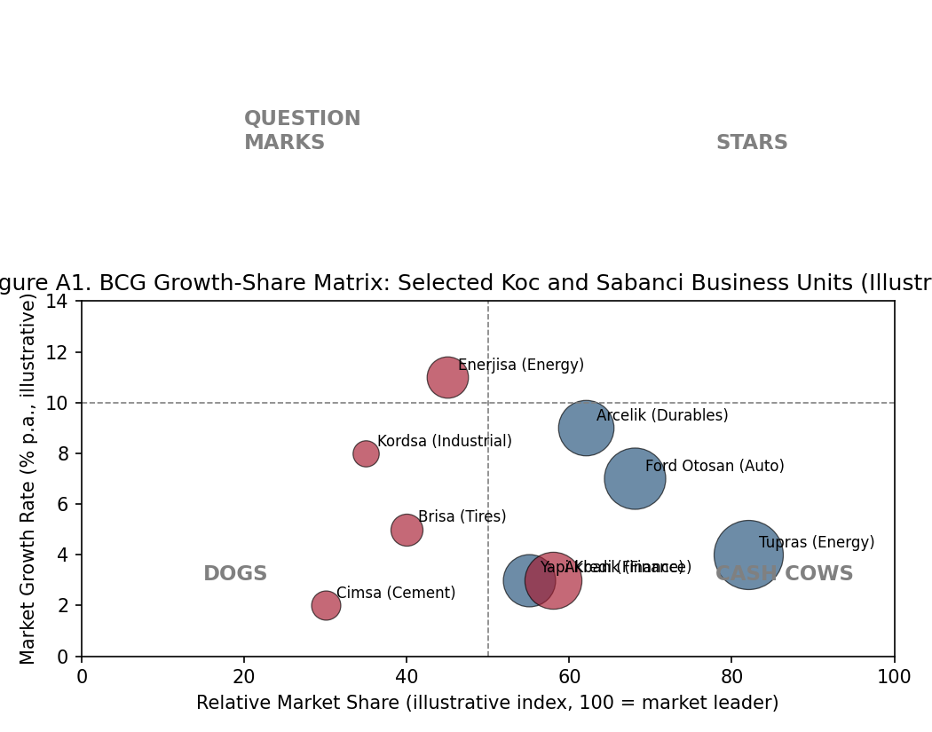
Figure A1. BCG growth-share matrix positioning of selected Koc and Sabanci business units. Axis values and bubble sizes are illustrative teaching estimates, not disclosed segment data.

Figure A1 applies the growth-share logic introduced in Part III to nine Koc and Sabanci business units simultaneously, letting students compare portfolio composition across the two groups at a glance. Koc's energy and automotive units cluster toward the cash-cow/star boundary (high relative share, moderate-to-low growth), consistent with a group whose historic strength is scale in mature, capital-intensive Turkish industries. Sabanci's portfolio shows more units in the question-mark quadrant (Enerjisa, Kordsa), consistent with a group that has been actively repositioning toward higher-growth segments - energy transition and industrial materials - over the past decade. Read this figure alongside Part III's caution: relative market share is an imperfect proxy for competitive advantage, and 'quadrant' placement here is illustrative, not a substitute for unit-level economic analysis.

42.2 Figure A2 - Revenue and Market Capitalization, 2023-2026
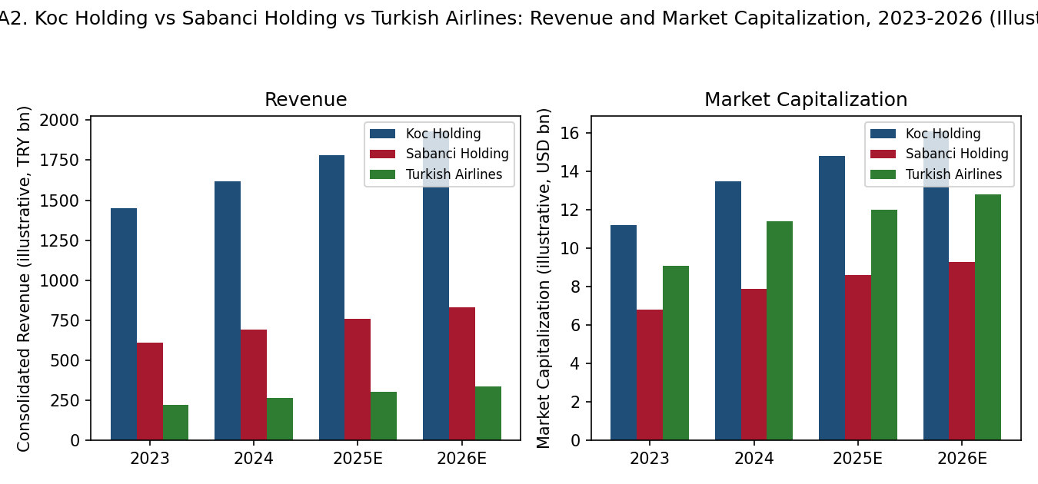
Figure A2. Koc Holding, Sabanci Holding, and Turkish Airlines: consolidated revenue and market capitalization, 2023-2026 (illustrative trend estimates, TRY billions and USD billions respectively).

Figure A2 shows all three running case companies growing in local-currency revenue terms over 2023-2026, reflecting both real growth and Turkish lira inflation feeding into nominal figures - a reminder that nominal TRY revenue trends should never be read as real growth without a deflator, a point developed further in Part XXIX's note on measurement and data sources. The market-capitalization panel, denominated in USD to strip out the most severe currency-translation noise, shows Turkish Airlines' valuation growing roughly in line with the conglomerates despite carrying no diversification discount by construction - directly motivating the comparative discussion in Part XXXIX.

42.3 Figure A3 - Conglomerate Discount Across Studies and Cases
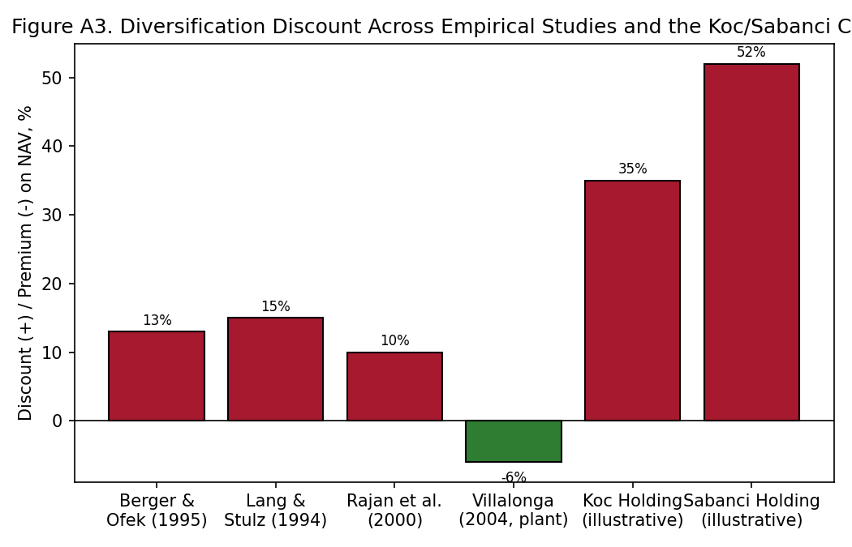
Figure A3. Estimated diversification discount/premium: selected academic studies versus illustrative Koc and Sabanci figures from the Part XLI worked example.

Figure A3 places the academic estimates from Part XL's literature-review table alongside the illustrative Berger-Ofek worked calculations from Part XLI, on a single comparable axis. The visual gap between the ~10-15% range typical of the broad-sample U.S. academic literature and the ~35-55% range implied by the illustrative Koc/Sabanci worksheet is itself a teaching point: single-firm, small-sample discount estimates (of the kind an equity analyst or a student produces for one company) are typically noisier and can differ substantially in magnitude from the average effect a large-sample academic study reports, even when both are directionally consistent. Villalonga's negative (premium) plant-level estimate is shown for contrast, underscoring that the sign of the effect is itself contested at the frontier of the literature.

.4 Figure A4 - Timeline of Major Conglomerate Breakups, 1996-2024
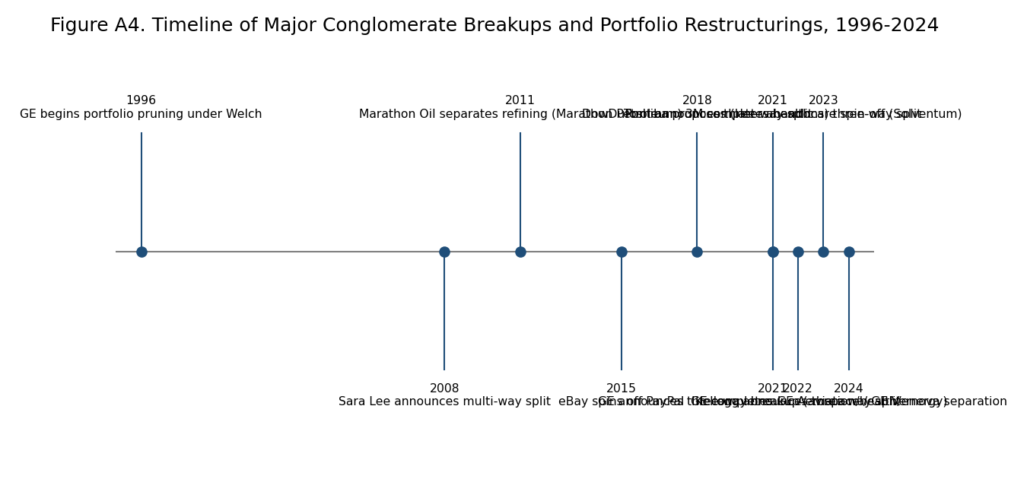
Figure A4. Timeline of major conglomerate breakups and portfolio restructurings, 1996-2024 (selected global examples).

Figure A4 traces two decades of the trend discussed qualitatively in Parts VII, X, and XXIII: activist- and market-pressured breakups of diversified industrial groups, from GE's long, multi-decade pruning under successive CEOs through the 2021-2024 wave that separated GE into three independent companies, split DowDuPont, and carved 3M's healthcare business into the standalone Solventum. Two patterns are worth drawing out in class discussion: first, the pace of breakups accelerated noticeably after 2018, coinciding with a period of historically cheap activist capital and heightened index-fund engagement on capital allocation; second, every breakup on this timeline was preceded by years, sometimes decades, of a persistent, market-visible conglomerate discount of the kind Figure A3 quantifies - the discount is the diagnosis, and the breakup is one possible treatment, though not the only one, as Part VI's M&A-rationale discussion and Part XXV's succession/governance treatment both note.

42.5 Figure A5 - The Ansoff Matrix Applied to the Three Case Companies
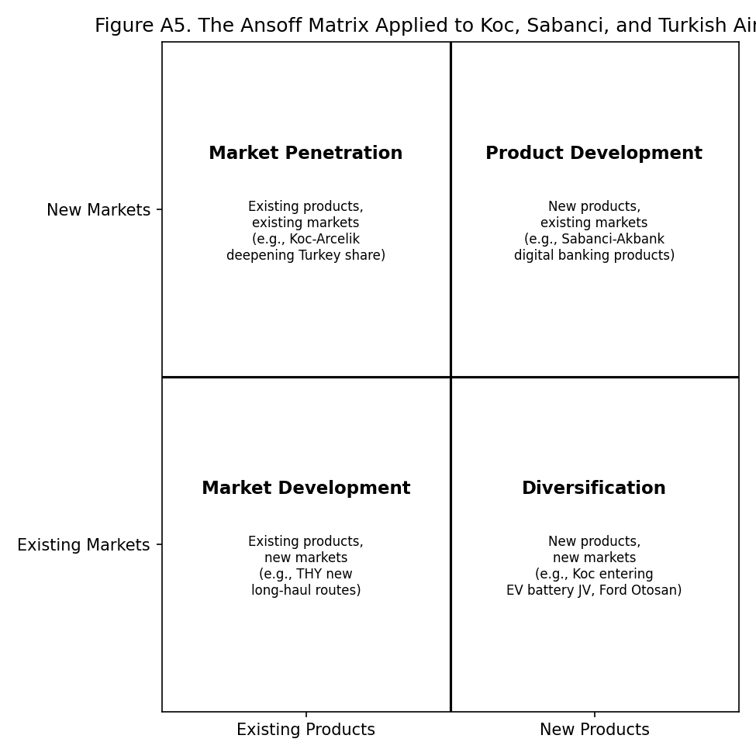
Figure A5. The Ansoff growth-vector matrix, illustrated with Koc, Sabanci, and Turkish Airlines examples in each quadrant.

Figure A5 revisits Igor Ansoff's classic 1957 growth-vector framework - product/market penetration, product development, market development, and diversification - and maps one illustrative example from the three running case companies into each quadrant. The framework is a useful bridge between business-level strategy (the top-left three quadrants, which describe how a single business unit grows) and corporate-level strategy (the bottom-right quadrant, diversification, which is this reader's central subject). Placing Koc's, Sabanci's, and THY's growth moves on the same matrix makes visible a pattern worth discussing in class: Turkish Airlines' growth has been concentrated almost entirely in the market-development quadrant (new routes, existing core product), while Koc's and Sabanci's growth increasingly involves the diversification quadrant (new products, new markets, e.g., battery/EV joint ventures) - which is exactly the quadrant where the parenting-advantage and better-off tests from Part III bite hardest.

42.6 Figure A6 - Decision Tree: Should the Firm Diversify?
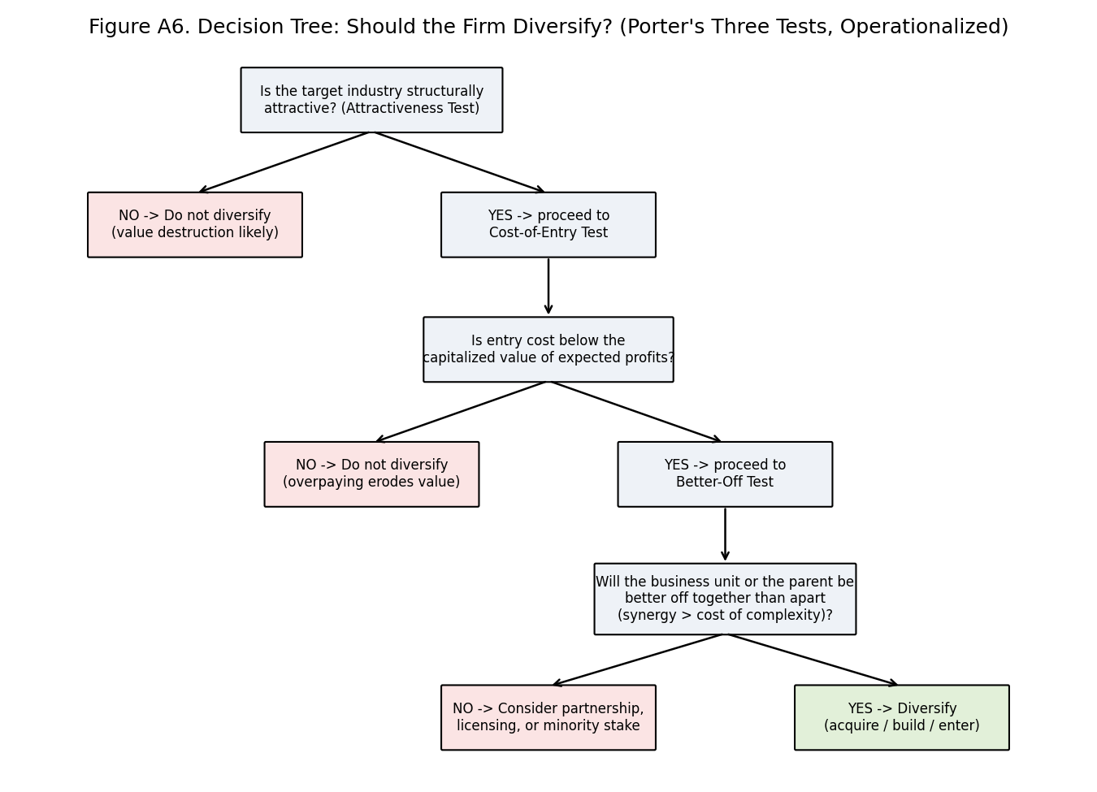
Figure A6. Decision tree operationalizing Porter's (1987) three tests for corporate diversification: the attractiveness test, the cost-of-entry test, and the better-off test.

Figure A6 operationalizes Michael Porter's 1987 Harvard Business Review formulation of the three tests a diversification move must pass to be value-creating, turning a qualitative essay argument into a sequential decision procedure a student can apply to any candidate acquisition or new-business entry. The tree is deliberately conservative in structure: failing any one test (unattractive industry, overpriced entry, or no genuine better-off logic once entry costs are subtracted) routes the decision toward not diversifying, or toward a lower-commitment alternative such as a minority stake, licensing arrangement, or joint venture - the kind of intermediate governance form Koc and Sabanci have both used extensively (Ford Otosan, Yapi Kredi's historical joint-venture period, Enerjisa's original E.ON partnership) rather than defaulting straight to wholly-owned acquisition or organic build.

42.7 Figure A7 - Corporate Parenting Theory: The Parenting-Fit Test
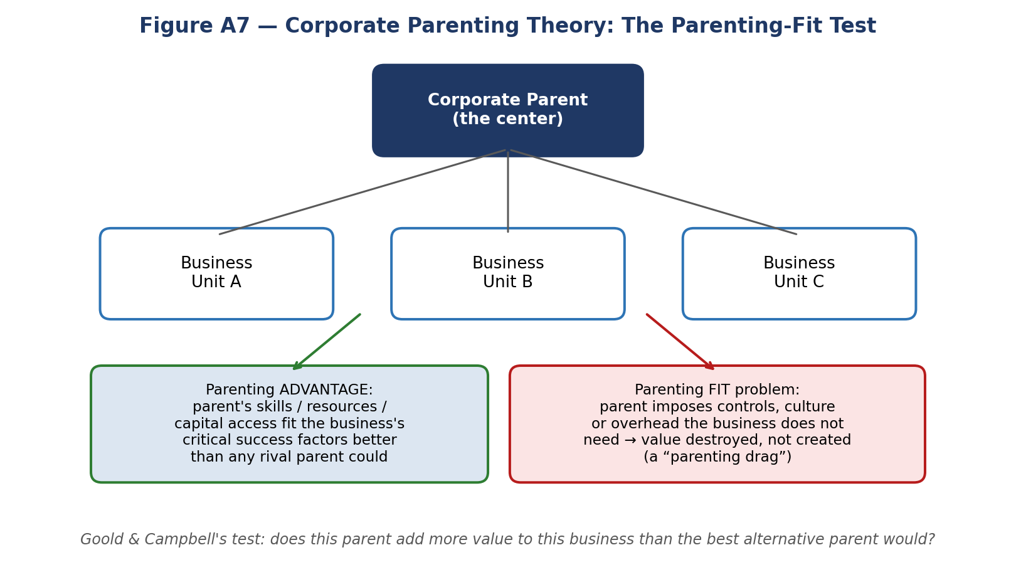
Figure A7. A simple way to picture Goold and Campbell's parenting-fit test: a corporate parent creates value only when it fits a business better than any rival parent would; where it does not, the same governance and overhead becomes a drag rather than an advantage.

42.8 Figure A8 - Rumelt's Diversification Typology at a Glance
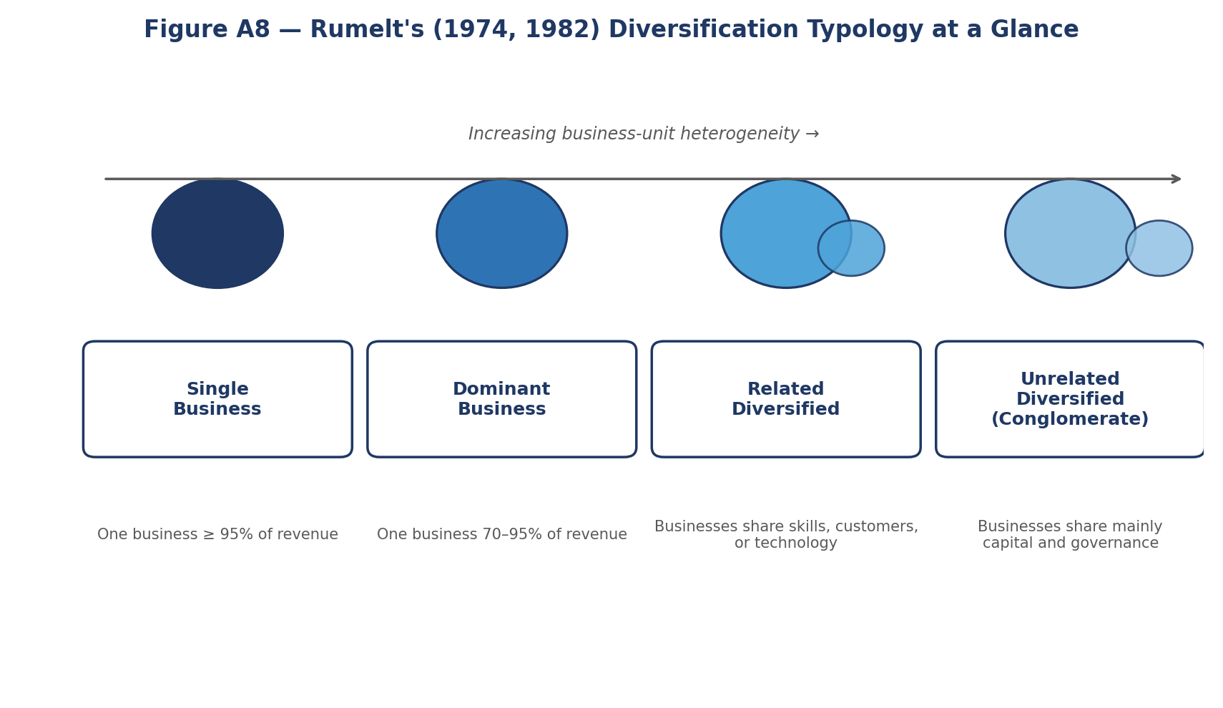
Figure A8. An icon-style view of Rumelt's (1974, 1982) four categories, arranged by increasing business-unit heterogeneity - useful as a quick classification aid before working through the detailed definitions in Part VIII.1.

42.9 Figure A9 - The Three Running Cases at a Glance
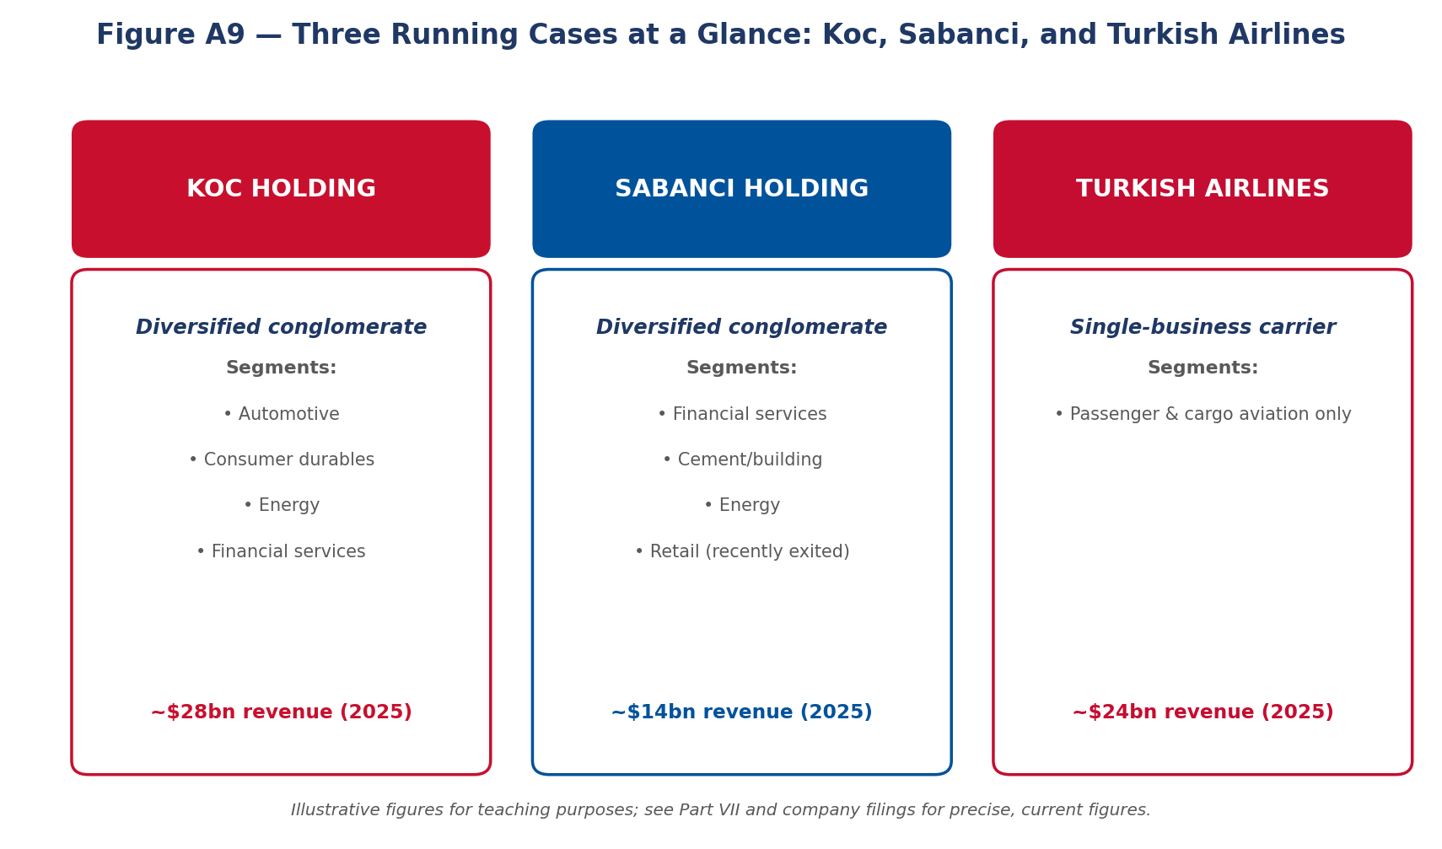
Figure A9. A side-by-side snapshot of Koc Holding, Sabanci Holding, and Turkish Airlines - the two diversified conglomerates and the single-business comparator that anchor the running examples throughout this reader.

42.10 Figure A10 - Key Takeaways, Parts I-VII
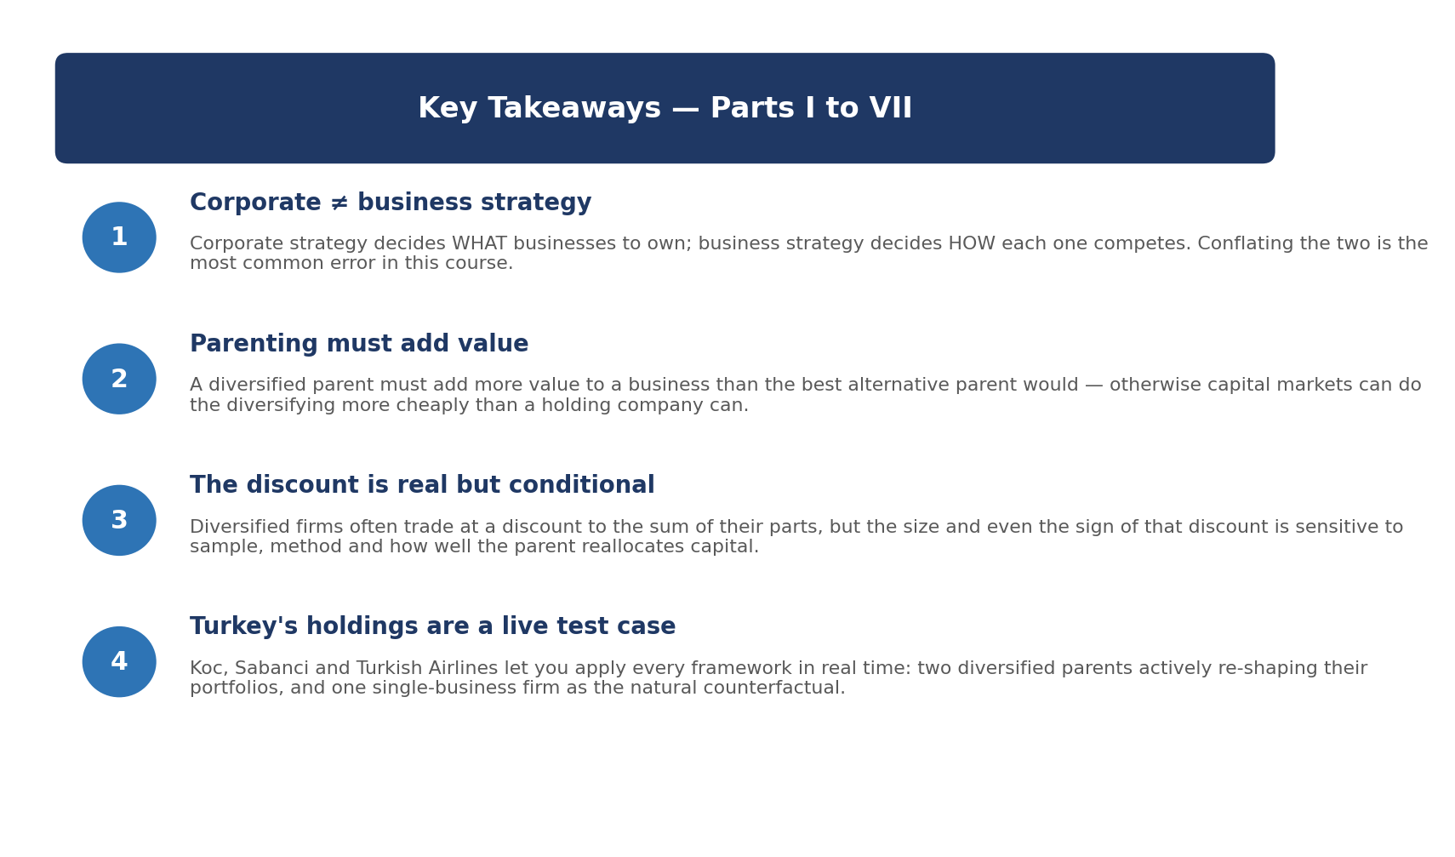
Figure A10. A one-page visual recap of the four ideas from Parts I-VII that matter most for the case discussion: the corporate/business strategy distinction, the parenting-value test, the conditional nature of the diversification discount, and the Turkish holding companies as a live laboratory.

Part XLIII - Comparative Case Vignettes: Eight Global Diversified Companies
This Part XLIII adds eight brief, theory-linked example boxes covering diversified companies not otherwise treated in depth elsewhere in this reader, chosen to broaden the international and sectoral range of illustrations available for class discussion beyond the Koc/Sabanci/Turkish Airlines core cases and the earlier GE/Berkshire Hathaway/Honeywell examples in Parts VII and X. Each box states the core fact pattern and then links it explicitly to a framework from Parts I-III.
Example: Samsung Group and the Chaebol Diversification Model
Samsung Group spans electronics, shipbuilding, insurance, construction, and biopharmaceuticals through a complex web of cross-shareholdings among nominally independent affiliates. Applying Rumelt's typology (Part II), Samsung is best classified as unrelated-diversified at the group level, even though its flagship, Samsung Electronics, is itself a related-diversified portfolio of semiconductor, display, and consumer-electronics businesses. The chaebol structure has drawn a persistent governance discount in Korean equity markets - academic estimates put the 'Korea discount' partly down to chaebol cross-shareholding opacity - illustrating Part IV's institutional-voids counterpoint: unlike Koc and Sabanci, whose diversification substitutes for missing capital-market institutions in a context where South Korea's own capital markets are now comparatively well developed, Samsung's structure increasingly reads to investors as entrenchment rather than institutional substitution, a distinction worth debating directly against the Turkish cases.

Example: Tata Group and the Widest Conglomerate Discount Case Study
Tata Group, controlled through Tata Sons and the charitable Tata Trusts, operates across steel, automobiles (Tata Motors/Jaguar Land Rover), IT services (TCS), hospitality (Indian Hotels), and consumer goods. Its scope is arguably the widest of any major global business group. Applying Porter's better-off test (Part I, formalized in Figure A6), the group's own leadership has periodically questioned whether every segment - most visibly the historically loss-making Tata Steel European operations - passes the test, leading to repeated restructuring attempts. Tata Consultancy Services alone is worth more than the rest of the group combined by some analyst sum-of-the-parts estimates, a holding-discount pattern structurally identical to the Berger-Ofek worked examples in Part XLI for Koc and Sabanci, where one large, easily-valued segment (Yapi Kredi/Akbank-type banking stakes) anchors the NAV calculation while smaller segments widen the discount.

Example: Reliance Industries - From Petrochemicals Conglomerate to Digital-Telecom Platform
Reliance Industries diversified from its petrochemicals and refining base into telecom (Jio) and retail over the 2016-2023 period, a related-unrelated hybrid under Rumelt's typology since the new segments share almost no operational resources with the legacy energy business but do share Reliance's capital-raising capability and regulatory relationships in India - precisely the kind of 'dominant general management skill' RBV synergy Barney's (1991) framework (Part II) identifies as a legitimate basis for diversification even absent operational relatedness. Reliance's Jio Platforms attracted large minority investments from Meta and Google at premium valuations, effectively validating a sum-of-the-parts value well above the conglomerate's blended multiple - a market-tested counter-example to the diversification discount literature reviewed in Part XL, and a useful discussion prompt on when equity-market validation of a segment's stand-alone value can substitute for a full spin-off.

Example: LVMH - Related Diversification Within a Single 'Luxury' Umbrella
LVMH owns over 75 maisons spanning fashion, leather goods, wines and spirits, perfumes, watches, jewelry, and hospitality. Unlike Samsung or Tata, LVMH is a textbook case of Rumelt's related-constrained category: every business shares a common resource base (luxury brand management, atelier craftsmanship, controlled distribution, and a shared customer relationship with high-net-worth consumers), even though the end products are chemically and technically unrelated. LVMH has consistently traded at a premium, not a discount, to single-brand luxury peers - directly consistent with the RBV prediction (Part II) that related diversification sharing a genuine, hard-to-imitate resource (here, brand-portfolio management capability under Bernard Arnault) should create rather than destroy value, and a clean counterpoint for class discussion against the unrelated-diversification examples in this same Part XLIII.

Example: Alphabet's 'Other Bets' - Diversification as a Real-Options Portfolio
Alphabet reports Google Services and Google Cloud separately from an 'Other Bets' segment covering Waymo (autonomous vehicles), Verily (life sciences), and other early-stage ventures that have generated cumulative operating losses exceeding USD 30 billion since separate reporting began in 2015. Applying the capital-allocation framework from Part V, Other Bets represents the 'fund organic growth or new capabilities' use of corporate cash taken to its most extreme, R&D-like form: each bet is best modeled as a call option on a future market rather than a business expected to generate near-term returns. The segment's persistent losses have not produced a discount on Alphabet's core multiple, largely because the core search-and-advertising business's cash generation is so large relative to Other Bets' burn rate that the market treats the segment as a rounding error with optionality - a useful illustration of Part V's point that capital allocation discipline, not zero diversification, is the actual determinant of whether diversification creates or destroys value.

Example: Meta's Reality Labs - A Real-Time Test of the Better-Off Test
Meta's Reality Labs segment (virtual and augmented reality hardware and the metaverse platform) has posted operating losses on the order of USD 45-60 billion cumulatively since 2020, while Meta's Family of Apps segment remains highly profitable. Unlike Alphabet's smaller, more diversified Other Bets, Reality Labs is a single, very large bet, and unlike LVMH's related diversification, it shares limited resource overlap with Meta's core advertising business beyond engineering talent and balance-sheet capacity. Applying Porter's better-off test (Figure A6) directly: the industry-attractiveness case for consumer VR/AR remains unproven at scale (failing or at best marginally passing test 1), and the segment's persistent, multi-year losses raise a live question - one instructors can pose directly to students - of whether Meta's continued funding reflects disciplined optionality (as with Alphabet) or sunk-cost-driven escalation of commitment, a classic behavioral-strategy failure mode distinct from, but often confused with, legitimate diversification.

Example: Siemens - Managed Portfolio Simplification Through Sequential Spin-Offs
Siemens has moved in the opposite direction from Reliance and Jio: over 2018-2023 it spun off Siemens Healthineers (medical technology), Siemens Energy (power generation and grid technology), and Siemens Gamesa (wind turbines) as separately listed entities while retaining industrial automation and digital-infrastructure as its core. Each spin-off can be read as a direct application of Porter's better-off test in reverse - management concluded that Healthineers and Energy no longer needed Siemens' corporate parenting to compete effectively, and that Siemens' own multiple was being held back by investors' difficulty valuing a five-segment industrial-plus-healthcare-plus-energy conglomerate on a single set of assumptions. Siemens' pattern is the clearest 'planned, proactive' counter-example in this reader to the more common pattern of breakups only after activist pressure builds (Part XXIII), and is worth contrasting directly with Part XXXIX's discussion of whether Koc or Sabanci should consider a similar path.

Example: 3M's 2023-2024 Healthcare Spin-Off (Solventum) - Discount, Litigation Overhang, and Separation Logic
3M completed the spin-off of its healthcare business as the independent company Solventum in April 2024, following a multi-year period in which 3M's stock traded at a persistent discount attributable partly to conglomerate complexity (Part IV) and partly to large, unrelated legal liabilities (PFAS 'forever chemicals' contamination litigation and earplug-defect litigation) that investors struggled to price against the healthcare segment's genuine growth prospects. The 3M case is a useful methodological caution for the Berger-Ofek framework taught in Part XLI: a segment's imputed stand-alone value using industry-median multiples can be systematically wrong when the parent carries large, segment-unrelated contingent liabilities that the market discounts at the consolidated level - a complication neither the original Berger and Ofek (1995) sample nor the simplified Koc/Sabanci worked example in Part XLI directly models, and one students should flag explicitly when applying the methodology to any company with material litigation or environmental liabilities.

43.1 Discussion Prompt Linking All Eight Vignettes
Sorted from clearest premium case to clearest discount case, the eight companies in this Part XLIII run roughly: LVMH (premium, related-constrained) - Reliance (market-validated segment value) - Alphabet (options-portfolio, discount avoided through scale) - Siemens (proactive simplification, pattern avoided) - Meta Reality Labs (unresolved, live test) - Tata Group (persistent, partially addressed discount) - Samsung (governance-driven discount) - 3M (discount plus liability overhang, now partly resolved via spin-off). Ask students to place Koc Holding and Sabanci Holding on this same spectrum using the illustrative Part XLI Berger-Ofek estimates (roughly 34% and 54% respectively) and to argue, using the institutional-voids literature from Part XL, whether either group's position on the spectrum is a market failure to be corrected by breakup, or a rational, institution-substituting equilibrium that should persist as Turkey's capital markets continue to develop.

